22.6 | ENGLISH | MATHS | ENQUIRY | ACTIVE
S  E  S  S  I  O  N  1 | GRAMMAR  Year 5 Modal Verbs. Today you are going to review Modal Verbs. Complete the lesson from Oak academy by clicking on the link.  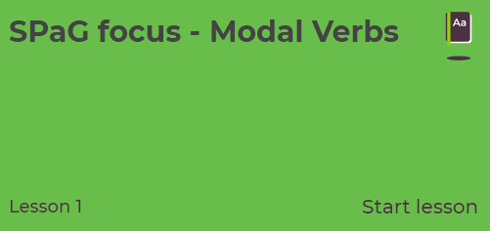  https://classroom.thenational.academy/lessons/spag-focus-modal-verbs/activities/3  Year 4 Imperative and Modal Verbs. Today you are going to look imperative (bossy) verbs and learn about modal verbs. Complete the lesson from Oak academy by clicking on the link.  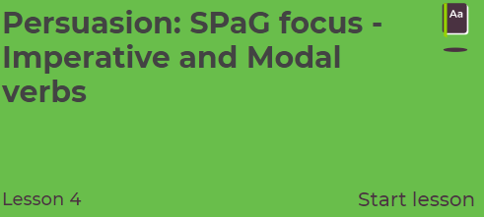  https://classroom.thenational.academy/lessons/persuasion-spag-focus-imperative-and-modal-verbs | This week, you are going to use White Rose again. The worksheets are attached below the Blog for you to print or work from on-line.  Y4 ADDITION  1s, 10s, 100s and 1,000s  https://vimeo.com/425562383  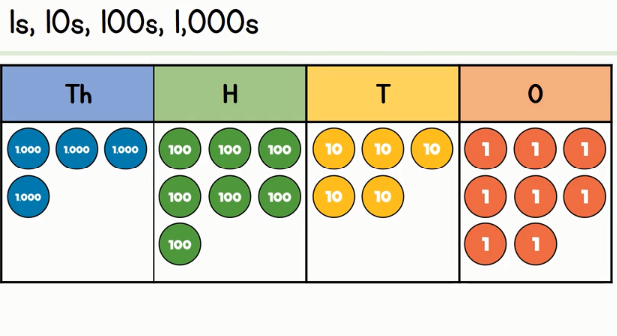  Y5 ADDITION AND SUBTRACTION  Add whole numbers with more than 4 digits (column method)  https://vimeo.com/425568996  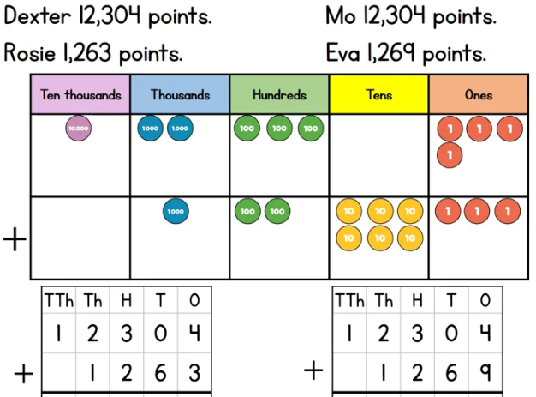 | HISTORY/DT  Let’s begin this ‘delicious’ week by learning about the history of our most famous Cornish food – the pasty.  Watch: https://www.youtube.com/watch?v=88NJg9cXiVU  “Oggie, Oggie, Oggie!” “Oi, Oi, Oi!”  Go through this fact page (with a grown up) and find some ‘tasty facts’, the relationship between pasties and The Knockers and what this old Cornish saying really means. https://www.historic-uk.com/CultureUK/The-Cornish-Pasty/  ACTIVITY: DESIGN A NEW CORNSH PASTY FILLING. Remember, it needs to be savoury first and then something sweet and yummy!  Write a paragraph beside it to explain what ingredients you have chosen.  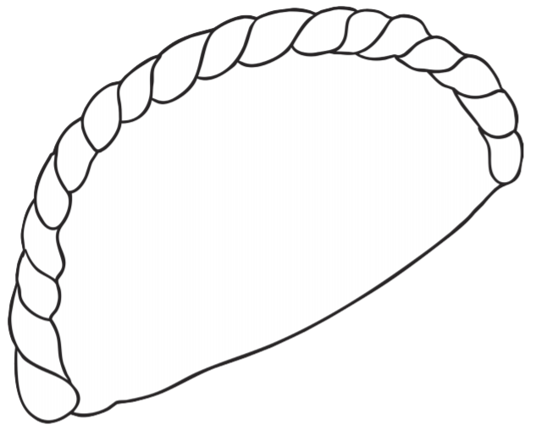 | Complete your School Games challenge and record your entry online before 4pm  Today’s event  ATHLETICS:  Here is the link to all of the Activity Cards:  http://www.activecornwall.org/cornwallschoolgames/the-virtual-games
S  E  S  S  I  O  N  2 | COMPREHENSION  Watch the film of the fantastic story about the Mousehole Cat  https://www.youtube.com/watch?v=htJFkZQ7w0U  Answer the VIPERS questions.  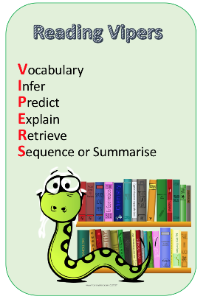  Check your answers.  Think about which VIPERS you didn’t get right, this is your feedback and your next steps for learning. | Year 4  Add two 4-digit numbers - no exchange  https://vimeo.com/425562628  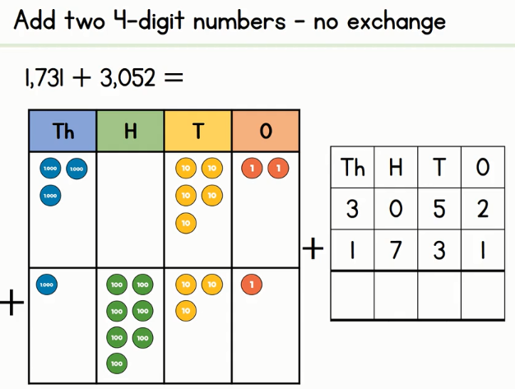  Year 5  Subtract whole numbers with more than 4 digits (column method)  https://vimeo.com/425569172  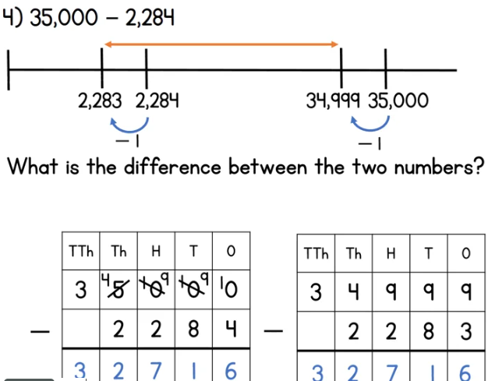 | DT- Create your favourite Cornish food.  “You will need to build up your calorie intake so that you have enough energy to take part in the Virtual School Games this week.”  LET’S MAKE SOME SCRUMMY CORNISH FOOD!  ACTIVITY: choose a recipe (attached to the blog) and create your favourite Cornish treat. I’ve attached a recipe for pasties, Cornish fairings and a link to make a Cornish Cream Tea. Take your pick or try them all!  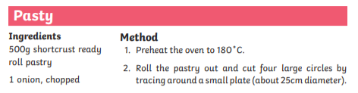  Link to Cornish Cream Tea: https://www.bbc.co.uk/cbbc/joinin/matilda-and-the-ramsay-bunch-blog-2018-recipe-cornish-cream-tea | Complete your School Games challenge and record your entry online before 4pm  Today’s event  BOWLS/BOCCIA:  AIM: Knock down all your ‘skittles’ in one go.  AIM: Get close to a target as possible.
S  E  S  S  I  O  N  3 | FEATURES  Your writing task this week is a set of instructions for a recipe. Today you are going to find features of instruction writing so you know how these are used to create a set of instructions.  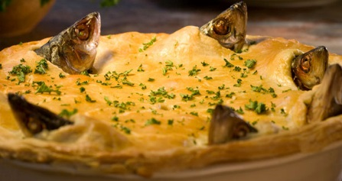  Read the recipe for Stargazy Pie and highlight the features. I have attached a document below the Blog entitled Features of Instruction Writing.  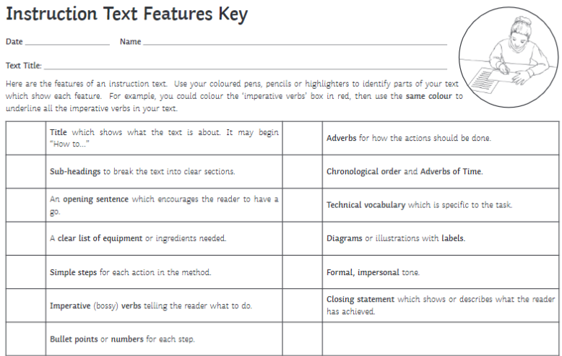  Use a colour pencils or highlighters and create a key so you know what the different features look like. | Year 4  Add two 4-digit numbers – one exchange  https://vimeo.com/425562776  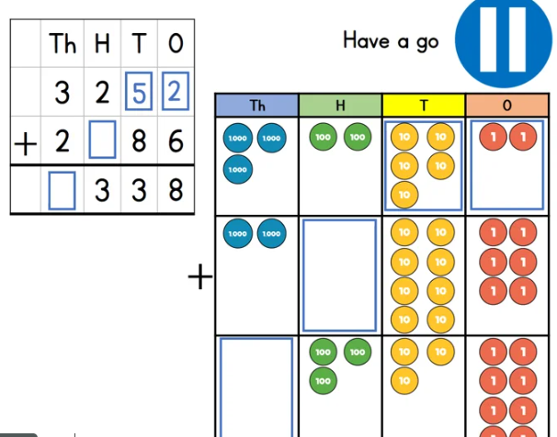  Year 5  Round to estimate and approximate  https://vimeo.com/425569901  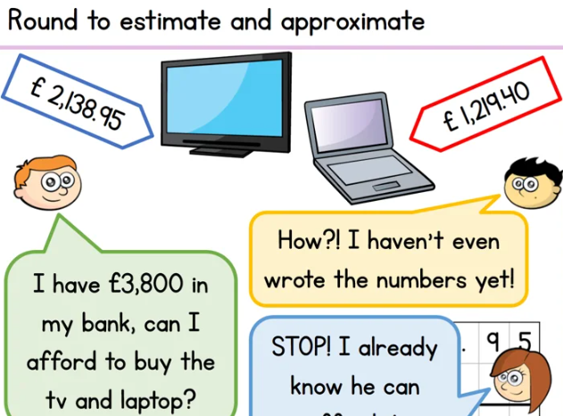 | ART – CREATE A STARGAZEY PIE! Watch (Tom Bawcock’s Eve celebrations in Mousehole) https://www.youtube.com/watch?v=FMnIdV8dfss  This is the song they chant – can you learn it? (bigger version below)  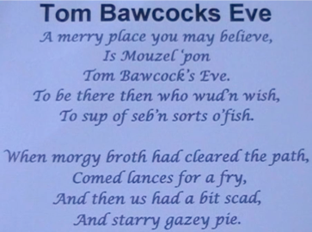  ACTIVITY: Stargazy Pie was made with Herrings, Pilchards and Mackerel. CREATE THIS USING SALT DOUGH AND PAINT IT! (not edible) https://www.bbcgoodfood.com/howto/guide/how-make-salt-dough-recipe  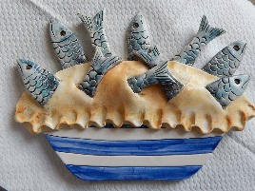 | Complete your School Games challenge and record your entry online before 4pm  Today’s event  DANCE/GYMNASTICS:  AIM: Perform a Hip Hop routine of your choice  AIM: Perform a sequence using a variety of skills.
S  E  S  S  I  O  N  4 | WRITING  Time to be creative. You need to come up with an idea for a New Cornish Stargazy Pie. Is this going to be filled with mackerel, potatoes or perhaps you are going to make it a sweet pie full of luscious Cornish berries? When you have decided on your ingredients, you need to write the recipe. Use the success criteria below to guide you.  Success criteria  Use the features of instruction writing  Use the layout  Try using some modal verbs to give options  I have attached a Recipe template below the Blog for you to use or you can make your own.  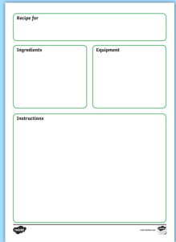 | Year 4  Add two 4-digit numbers – more than one exchange  https://vimeo.com/425563010  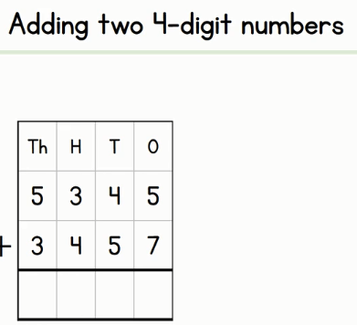  Year 5  Inverse operations (addition and subtraction)  https://vimeo.com/425575598  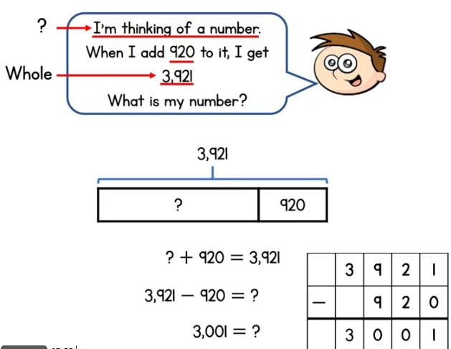 | SCIENCE – NUTRITION Let’s look at the Science behind what we eat and learn about the food pyramid. Intro: https://www.youtube.com/watch?v=mMHVEFWNLMc  Now let’s sort these groups into a food pyramid. Think about which ones are the most important when you watch the video https://www.youtube.com/watch?v=0KbA8pFW3tg  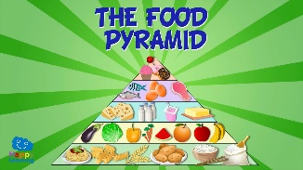  “Why do you think carbohydrates is at the bottom and sweets/fats are the smallest section at the top?”  ACTIVITY: CREATE A PERSONAL FOOD PYRAMID WITH ALL THE YUMMY FOODS YOU LIKE TO EAT (Attached below with an example)  CHALLENGE: Look at the ingredients for a Cornish Pasty – which ingredient goes in which food group? Is it healthy? (Recipe on blog) | Complete your School Games challenge and record your entry online befOre 4pm  Today’s event  VOLLEYBALL:  AIM: Serve the ball into a desginated area in 2 minutes.  AIM: Keep the ball off the ground using different parts of your body.  AIM: Get as many balls over your head and catch in 2 minutes.
S  E  S  S  I  O  N  5 | EDITING  When you have finished writing your recipe, have a go at editing.  Follow these four steps:  - Choose one sentence to improve.  - Improve the sentence by changing it into a different sentence type.  - Consider your adjectives, adverbs and verbs. Have you got interesting adjectives, strong verbs and said how these verbs are done?  - Check all the spellings and punctuation.  Share your recipe with an adult and try to decide if the recipe would actually work. | MATHLETICS  Practise your skills by completing the tasks set on Mathletics.  Have a go at Mathletics Live, perhaps you are lucky enough to log-in at the same time as other Tallanders so you can play against each other.  Scroll down below grid for resources | ART  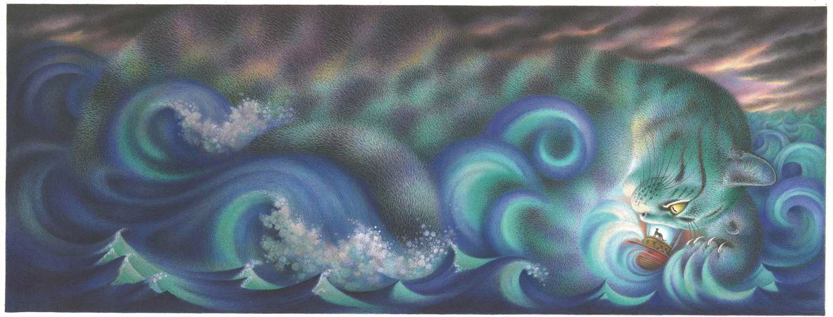  In the tale of the Mousehole Cat, the storm itself is referred to as Storm Cat. (Bigger image below)  Think of your favourite animal and use your imagination to create a Storm (animal) seascape using your skills at mixing and blending colours. How about a Storm Tiger and blend orange/yellow and browns together?  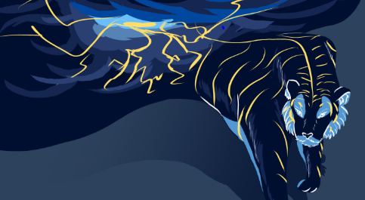  (Look at this Storm Tiger by Dinah Conteh – she used blues and oranges) |  | Complete your School Games challenge and record your entry online before 4pm  Today’s event  TENNIS:  AIM: Get as many balls into a target in 60 seconds as you can  AIM: As many continuous shots as possible in a rally in 2 minutes.  AIM: As many continuous volleys as possible in 2 minutes.

Scroll down below grid for resources

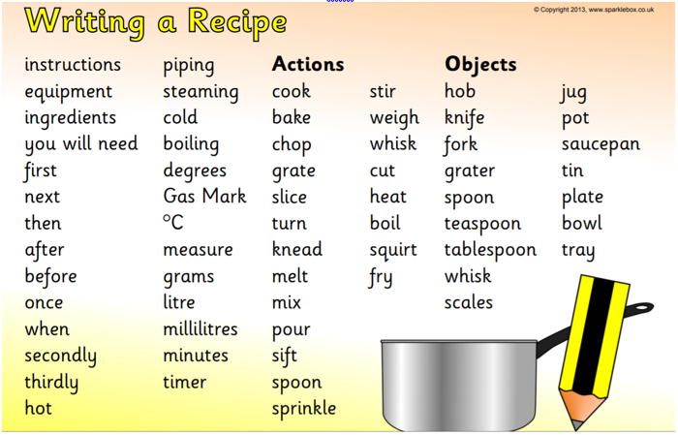

SESSION 1 ENQUIRY – CREATE A PASTY FILLING

SESSION 3 – TOM BAWCOCK’S SONG
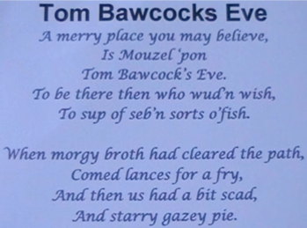
SESSION 4 FOOD PYRAMID
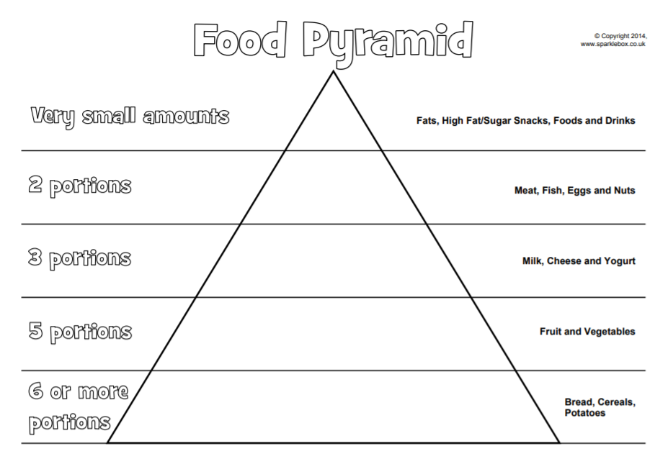
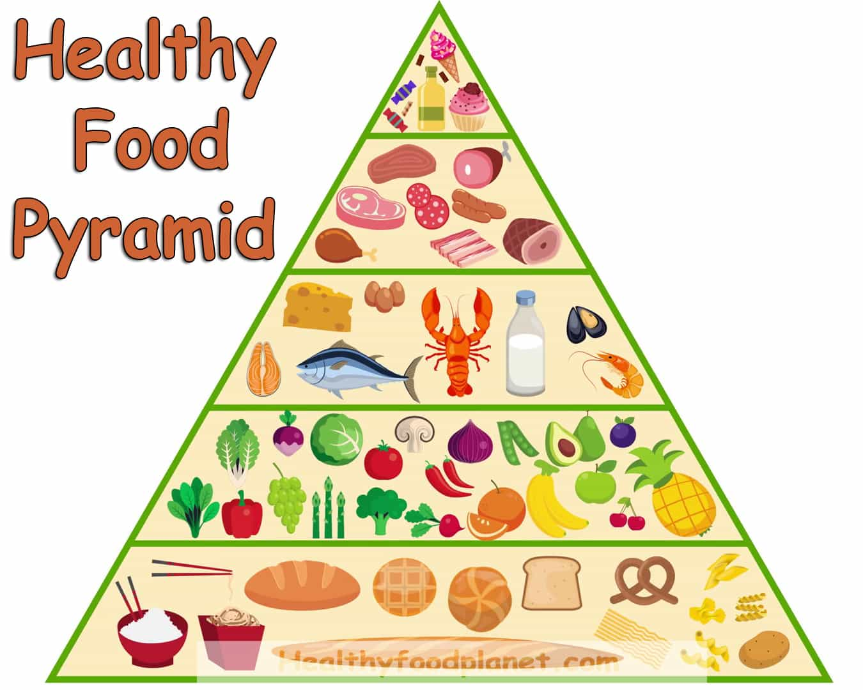 Example

SESSION 5 ENQUIRY – SEASCAPE PAINTING

