 | ENGLISH | MATHS | ENQUIRY | ACTIVE
S  E  S  S  I  O  N  1 | This week we are learning all about giants. The BFG is one of the most famous giants!  Comprehension  Read the extract from The BFG. (Attached below the grid.)  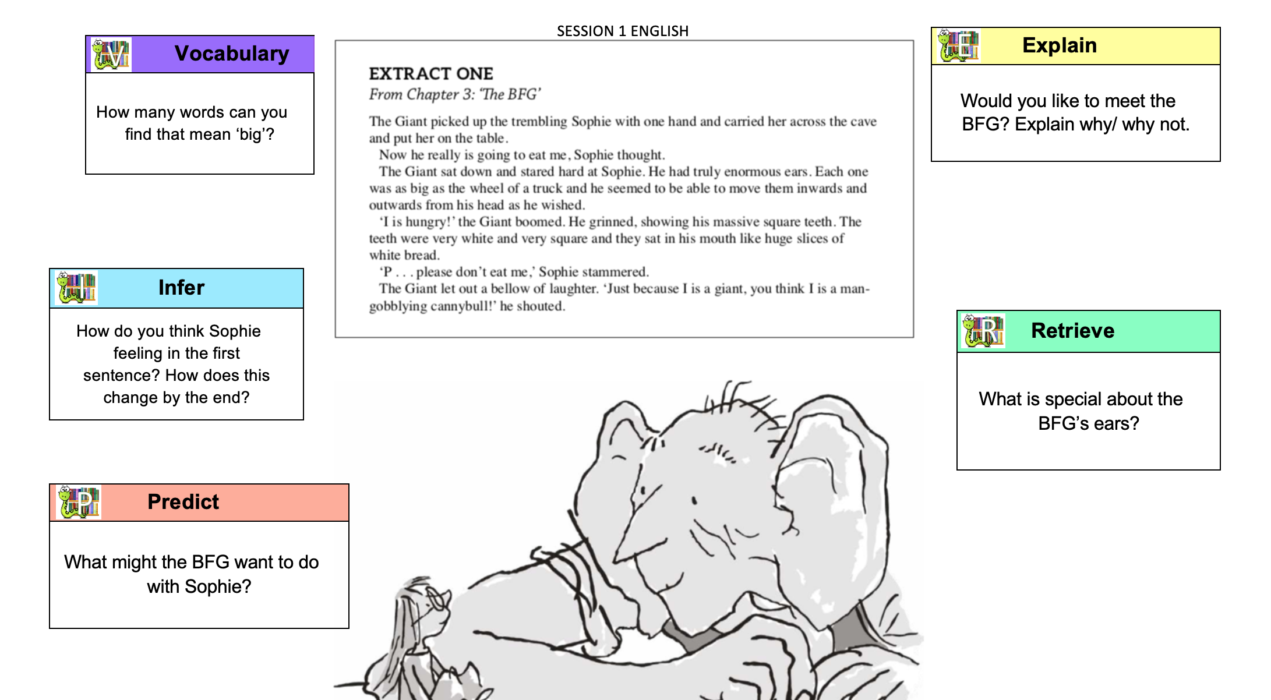  Have a go at answering the VIPERS questions. | What coins and notes do we use in the uk?  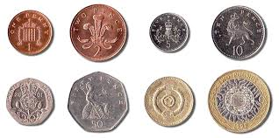  You could use real or play coins or look at this picture:  Can you name all of the coins and notes?  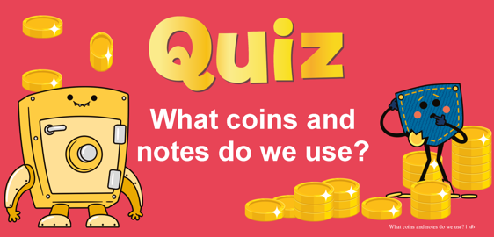  Have a go at the quiz attached to the blog. | HISTORY- ART  Cornish folk law suggests that the giant Cormoran and his wife Cormelian built St Michael’s Mount as a stronghold (fortress) to steal the villagers’ sheep and cows and keep them for themselves. If you walk up the main path, you will find a heart-shaped stone. What do you think this represents?  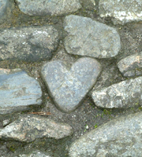  Let’s find out. Mum/Dad, you might need to help read this: http://www.bbc.co.uk/cornwall/content/articles/2007/04/04/gardens_stmichaelsmount_feature.shtml  ACTIVITY: Look at this picture of a footprint of another Cornish giant named BOLSTER. Expand the picture and create a setting to show where this stone could be.  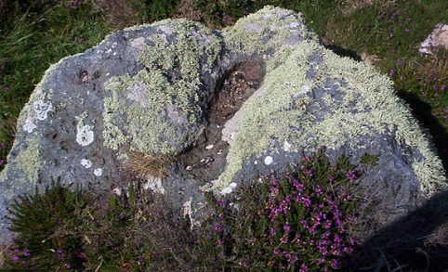  (Bigger images below grid)  Challenge: Research the myth behind this giant and compare it with the tale of Cormoran. | MONDAY’S 60 SECOND PE CHALLENGE:  AROUND THE WORLD  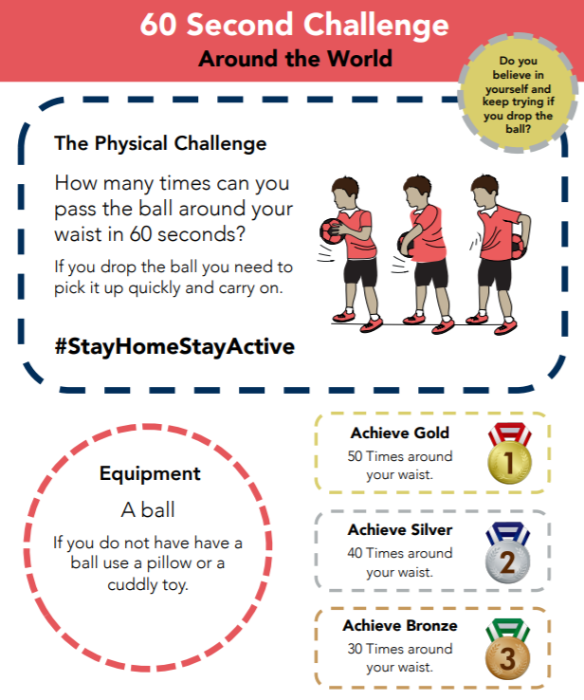  How many times can you pass a ‘ball’ around your waist in 60 seconds?  Remember to keep a record of all your attempts and see how much quicker you get!  Can you achieve GOLD by Friday?
S  E  S  S  I  O  N  2 | Vocabulary  THE BFG has many WEIRD and WONDERCRUMP words in his vocabulary!  Some of them have POSITIVE (good) meanings and some have NEGATIVE (bad) meanings.  Read extract 2 below and fill in the table (Attached to the blog) with the positive and negative words you can find.  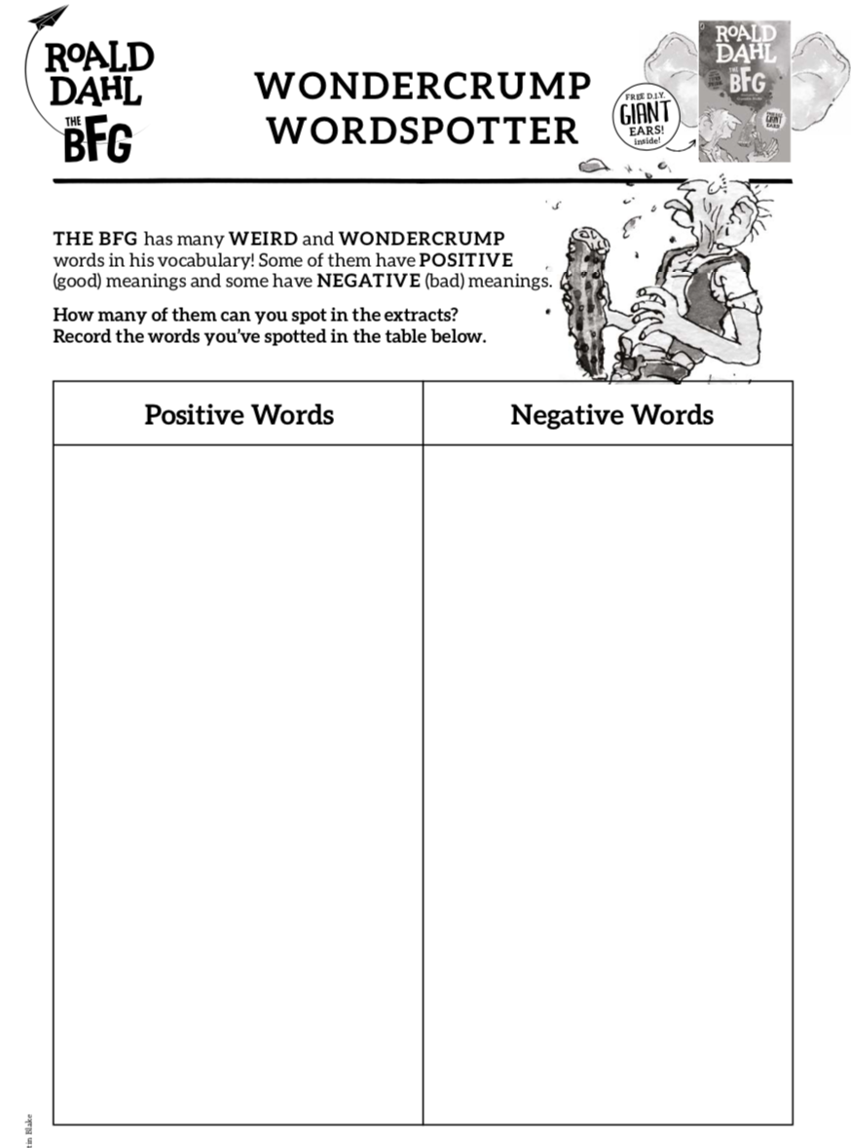  Challenge:  Are these words verbs, nouns or adjectives? How do you know? | Can you remember which coins are which?  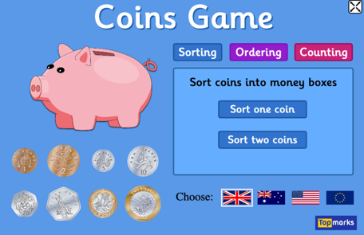  Have a go at this money sorting game:  https://www.topmarks.co.uk/money/coins-game  Use either your real/play coins or a picture of the different coins and put them in order from smallest to largest. (If using a picture, you could draw out the coins in order.)  What do you notice about their sizes? Are they in size order? What about their colour? | SCIENCE - ROCK FORMATION  Cormoran used granite rock to make his stronghold which is now the landmark, St Michael’s Mount. Granite is a strong, non-porous (doesn’t let in water) igneous rock, made from molten lava reaching the surface. The green rock Cormelian wanted to use was weaker – possibly sedimentary but Cormoran knew it was too weak to keep out the villagers. So how did Cormoran know which type of rock to use? Let’s look at the three types of rocks you can find on Earth. Let’s play rock detective!  Watch https://www.youtube.com/watch?v=tNs1gqkYerg  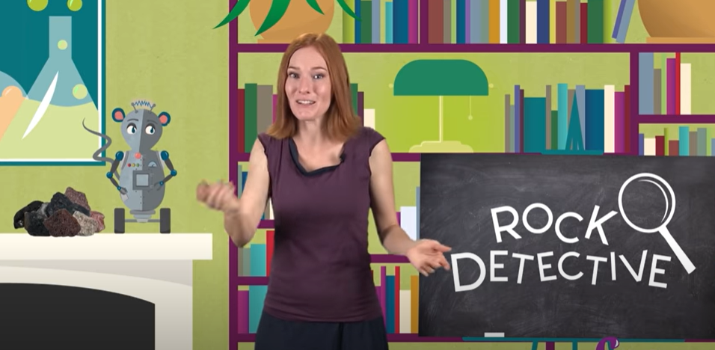  Then, go on a rock hunt and gather a range of rocks/pebbles or stones. Fill out the sheet about their properties. Can you tell if they are igneous, sedimentary or metamorphic from what you see?  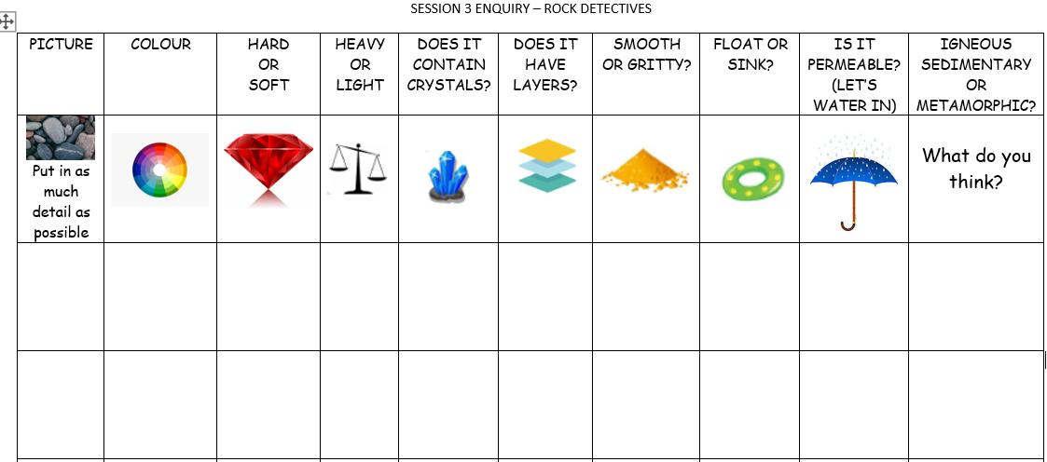  (Worksheet attached to blog SESSION 2 ENQUIRY Rock Detectives). | FOR THE REST OF THE WEEK, WE ARE GOING TO PRACTISE FOR THE SCHOOL ‘VIRTUAL’ GAMES WHICH ARE ON THE 22ND-26TH JUNE.  A letter will be sent to you this week with further details.  Each day, we will practise an event. Remember to carry on with your 60 second challenge as well!  Today’s event  ATHLETICS:  AIM: How many speed bounces in 30 seconds
S  E  S  S  I  O  N  3 | Vocabulary  Read back through extract 2 from yesterday and have a look at all of the weird and wonderful words that you found. Today, you are going to be making up your own imaginary words!  Think of two words and combine them to make a new word!  Make up at least 5 new words.  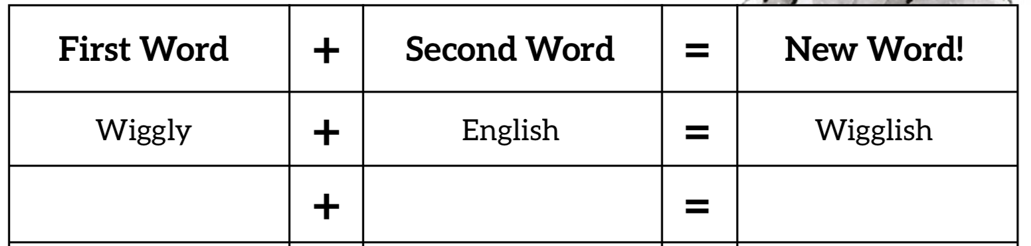  Challenge: Use some of your made up words in a sentence. | 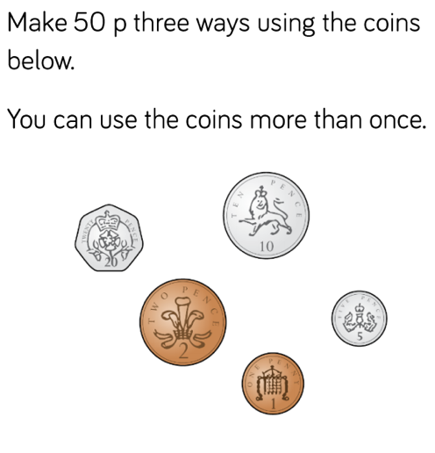  How many answers can you find to these questions?  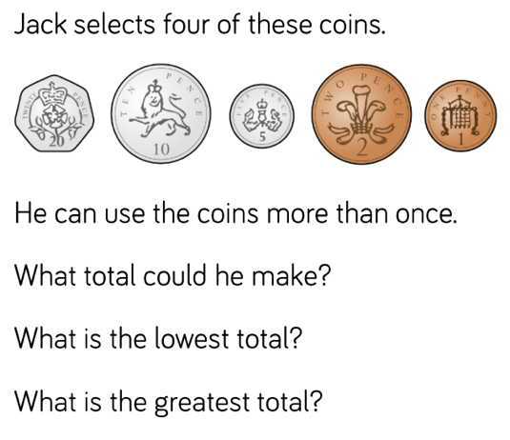 | ART/DT: - Create a stronghold out of natural objects. Make it sturdy enough (just like Cormoran) so it doesn’t fall down and let in any unwanted villagers!  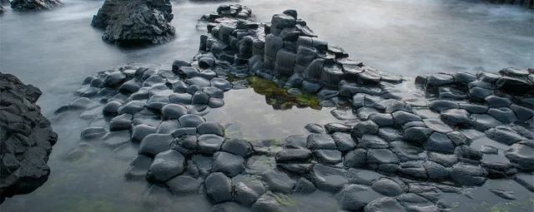  Make it part of your active exercise - either on your daily walk or in your back garden! | Today’s event  BOWLS/BOCCIA:  AIM: Knock down all your ‘skittles’ in one go.  AIM: Get close to a target as possible.
S  E  S  S  I  O  N  4 | Character description  Read extracts one and two below. What can you find out about the BFG? Fill in the character description (attached to the blog.)  Success Criteria:  . Capital letters and full stops  . Finger spaces  . Adjectives  . Exciting vocabulary (e.g. enormous instead of big)  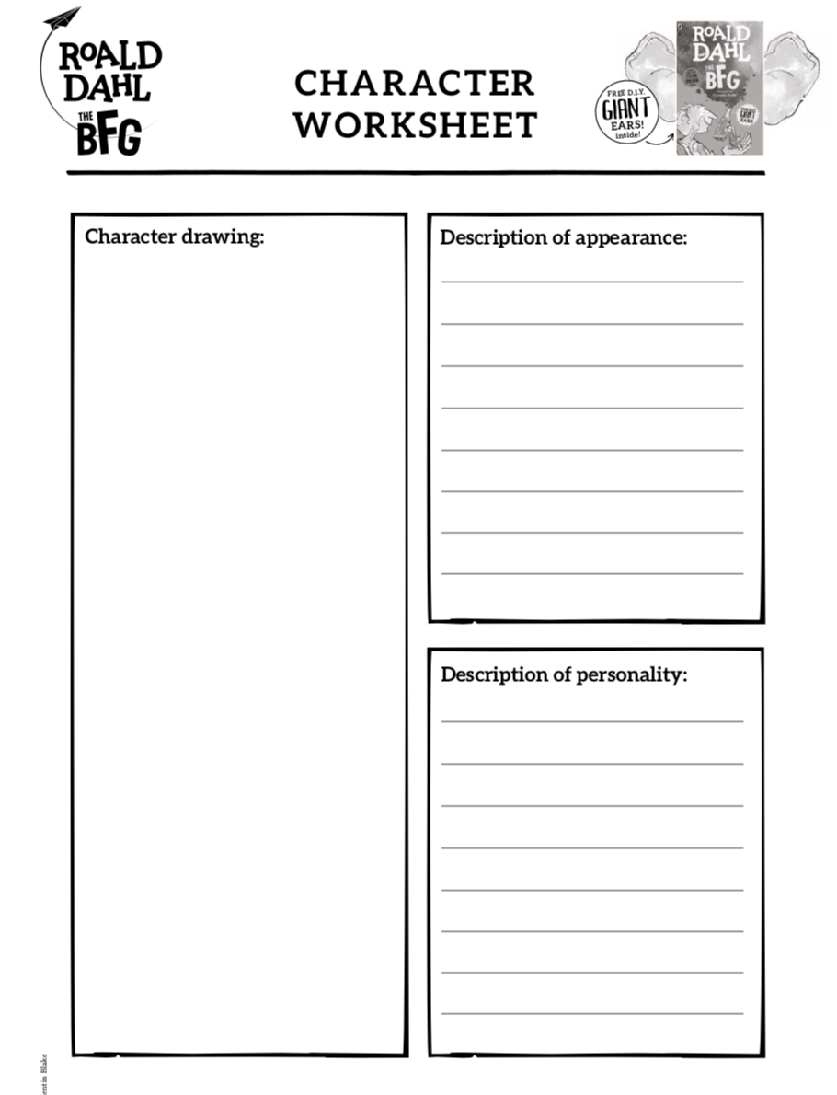 | Play this toy shop money game.  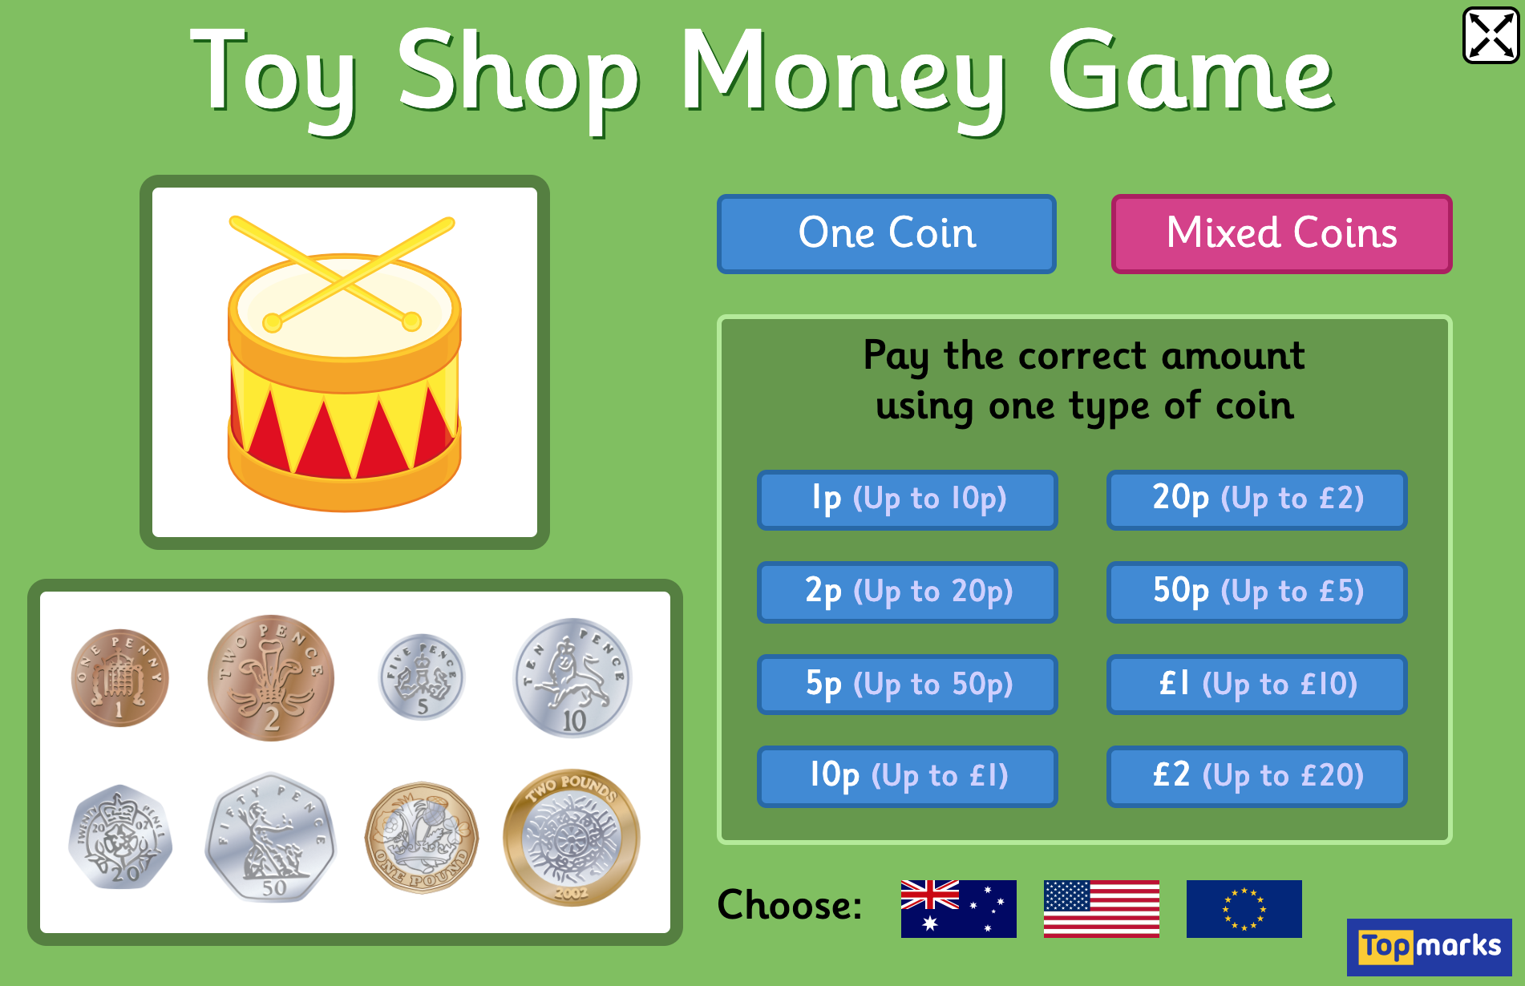  https://www.topmarks.co.uk/money/toy-shop-money  You can make it harder by using mixed coins and by making larger totals. | ART/DT  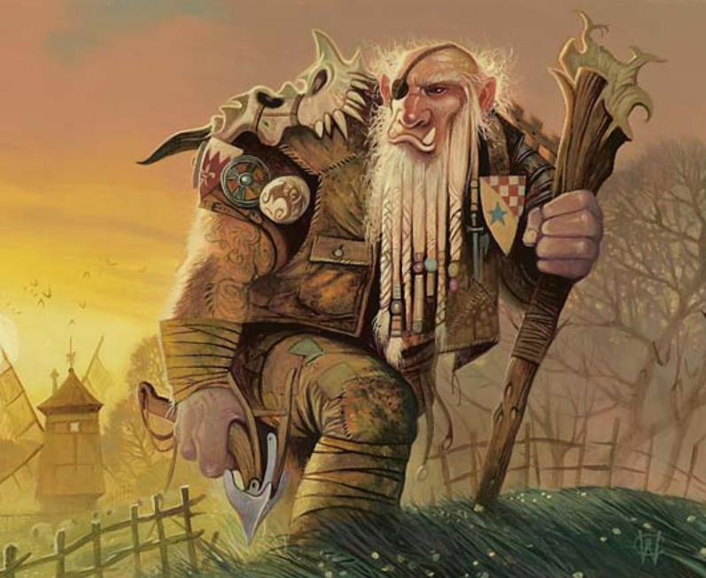  Polperro is in trouble! A giant has turned up and is threatening to take over the village. You need to help the villagers defeat this beast.  Activity: Come up with a daring plan to rid Polperro of this ‘giant’ problem. Name it  “How to trap a Cornish Giant”  and draw pictures/create a comic strip/do a puppet show with your toys to show each step.  HERE’S MY IDEA: First, I would carefully dig a hole and cover it with leaves and sticks. Then I would rest a delicious, hot pasty on top of it. After I had hidden behind a nearby tree, I would make a sound to get his attention. As soon as the giant smells the tasty pasty his tummy will rumble, and he will want to eat it. Once he goes to pick it up, he falls into the hole.  I bet you can think of a better plan! | Today’s event  DANCE/GYMNASTICS:  AIM: Perform a Hip Hop routine of your choice  AIM: Perform a sequence using a variety of skills.
S  E  S  S  I  O  N  5 | WRITING TASK  The BFG collects dreams. Have a look at the dream labels below. Choose two of these dreams. Imagine the BFG has mixed them up with his gigantic egg beater. What would happen in the dream?  Write about your new dream. What would happen? Remember to include a beginning, middle and end.  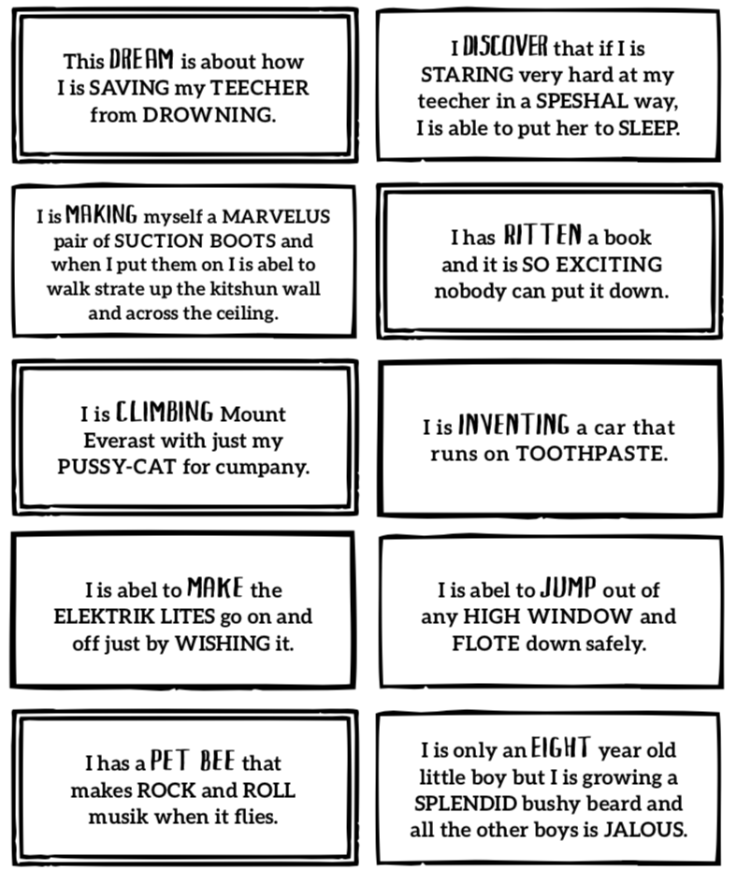  Success Criteria:  . Capital letters and full stops  . Finger spaces  . Adjectives  . Exciting vocabulary  . Speech marks for speech  . A beginning, middle and end | Set up your own shop  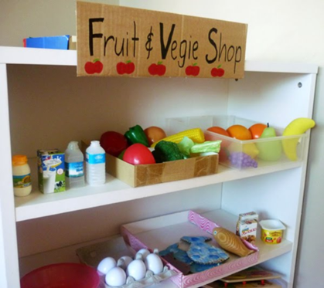  Decide what you are going to sell and draw/make it. How much will it cost?  You could use real or play coins or make your own!  Which coins could you use to buy which items? | This afternoon, practise some of the remaining activities:  TENNIS:  AIM: Get as many balls into a target in 60 seconds as you can  AIM: As many continuous shots as possible in a rally in 2 minutes.  AIM: As many continuous volleys as possible in 2 minutes.  VOLLEYBALL:  AIM: Serve the ball into a desginated area in 2 minutes.  AIM: Keep the ball off the ground using different parts of your body.  AIM: Get as many balls over your head and catch in 2 minutes.  Here is the link to all of the Activity Cards:  http://www.activecornwall.org/cornwallschoolgames/the-virtual-games  Click on the activity you want to practise and all the information and demo videos are there.

Explain
Would you like to meet the BFG? Explain why/ why not.
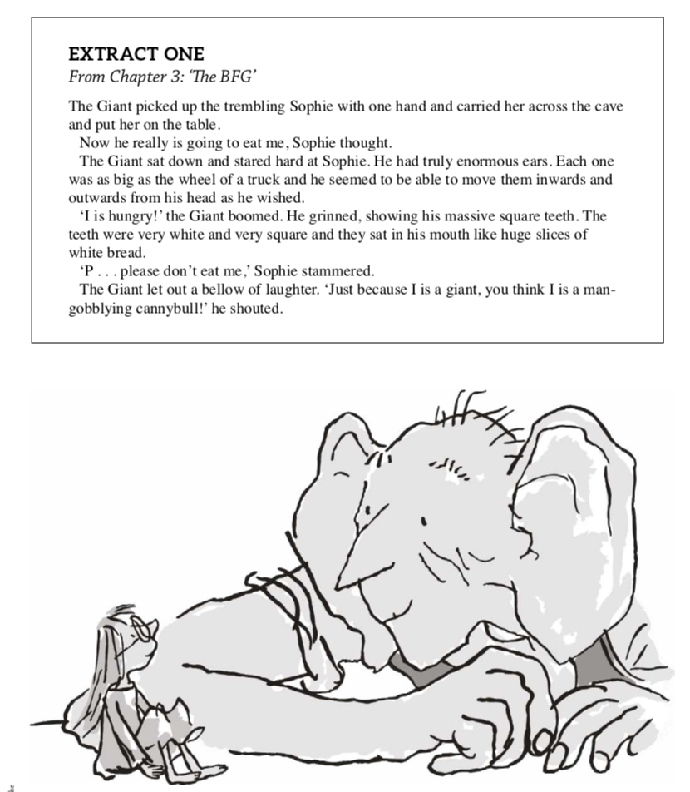
SESSION 1 ENGLISH
Vocabulary
How many words can you find that mean ‘big’?

Retrieve
What is special about the BFG’s ears?

Infer
How do you think Sophie feeling in the first sentence? How does this change by the end?

Predict
What might the BFG want to do with Sophie?

ENQUIRY - THE GIANT’S HEART – ST MICHAEL’S MOUNT
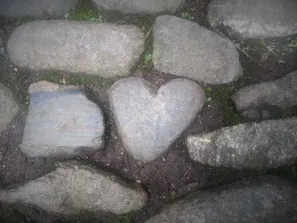

BOLSTER‘S FOOTPRINT – CHAPEL PORTH, CORNWALL
Will your setting be:
- in a forest
- near to a town
- by a beach
- an entrance to hidden cave
- a gateway to a magical land

Use your imagination!

SESSION 1 – PE 60 SECOND CHALLENGE

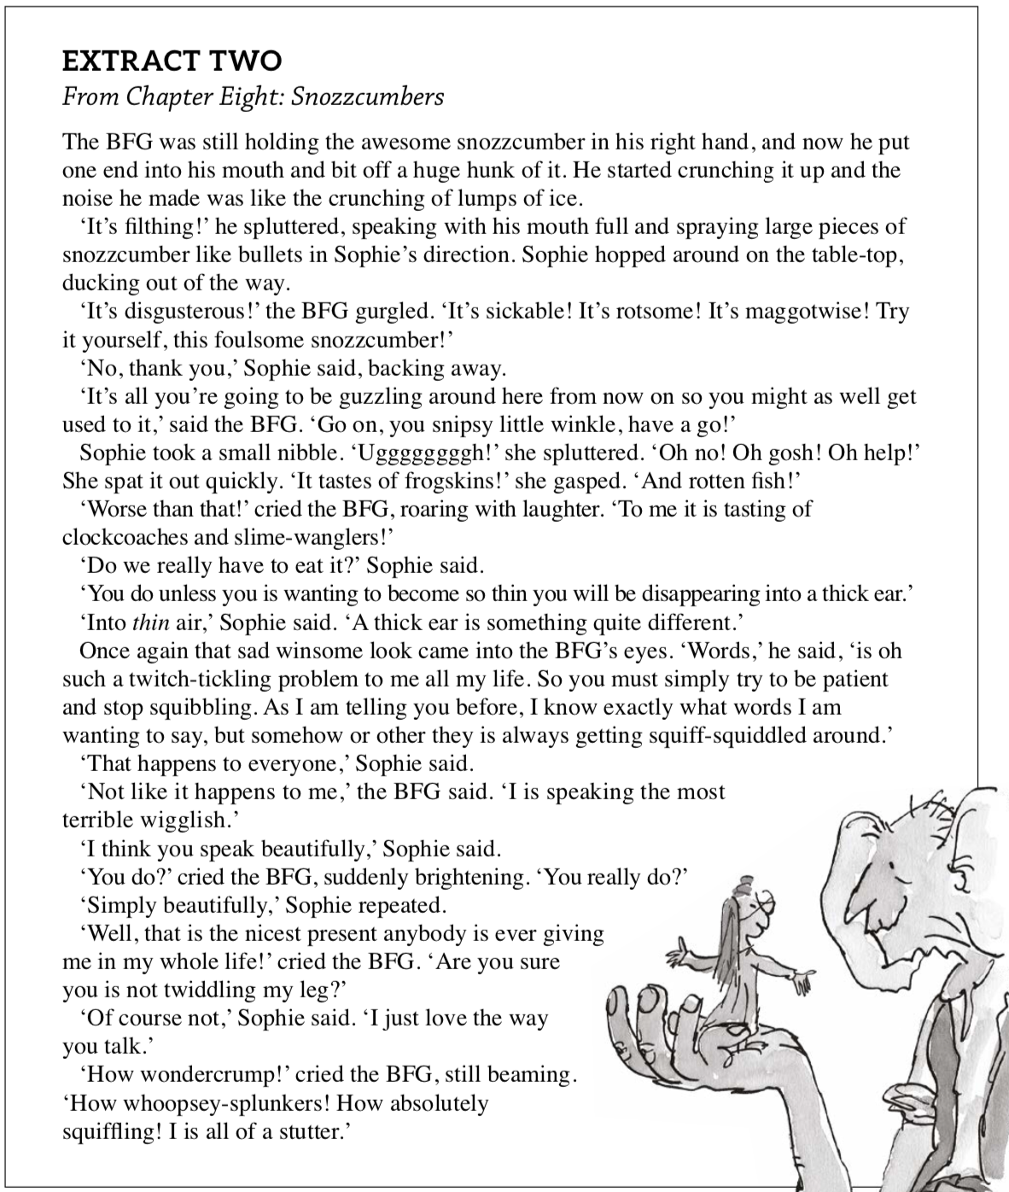
ENGLISH - SESSION 2

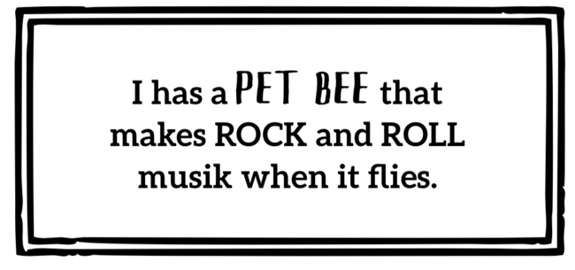
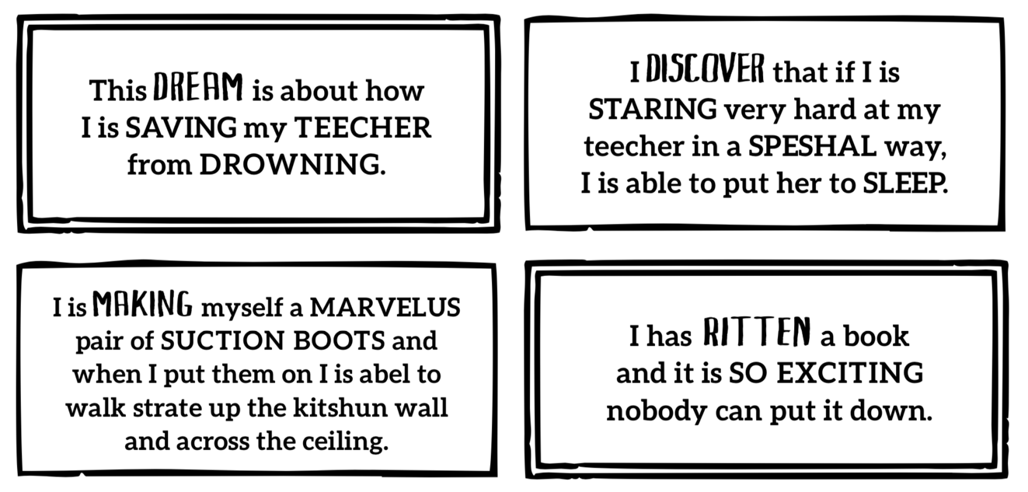
ENGLISH – SESSION 5

