ROCK DETECTIVES
PICTURE | COLOUR | HARD  OR  SOFT | HEAVY OR LIGHT | DOES IT CONTAIN CRYSTALS? | DOES IT HAVE LAYERS? | SMOOTH OR GRITTY? | DOES IT FLOAT OR SINK? | IS IT PERMEABLE?  (LETS WATER IN) | IGNEOUS  SEDIMENTARY OR  METAMORPHIC?
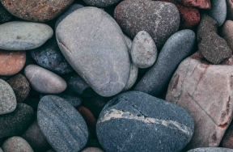  Put in as much detail as possible |  | 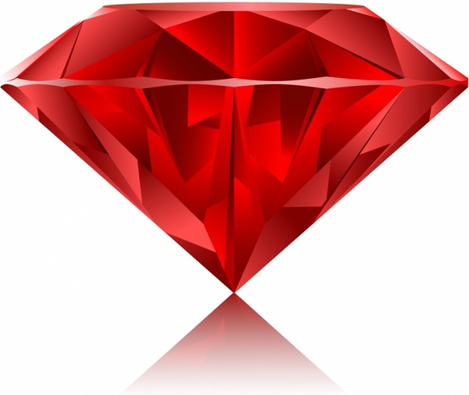 |  |  |  |  |  | 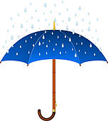 | What do you think?

