THE GIANT’S HEART – ST MICHAEL’S MOUNT
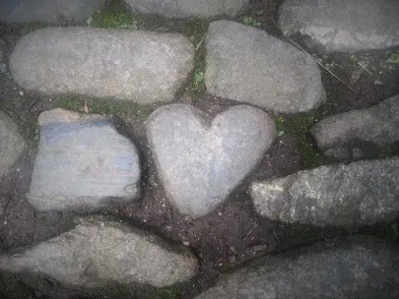

BOLSTER‘S FOOTPRINT – CHAPEL PORTH, CORNWALL
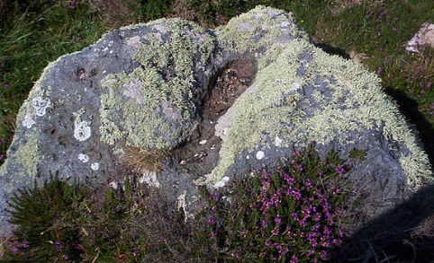
Will your setting be:
- in a forest?
- near to a town?
- by a beach?
- an entrance to hidden cave?
- a gateway to a magical land?

Use your imagination!

