English | MATHS | ENQUIRY | Active
This week we will be learning the story of Cormoran the Cornish giant and then writing the sequel to this story.  Often, mythical creatures have a language of their own and Giants are not excluded from that. Today you are going to explore the language of the BFG and have a go at creating synonyms to use in your Cormoran sequel.  - Read the extract from the BFG on the first page of the BFG worksheet.  - Find all the made-up words and sort them into the diagram on the second page, deciding whether these are negative or positive words.  - Using the table on the third page, have a go at creating your own synonyms like Roald Dahl. You could use some Cornish words to create these. | Watch the following video which explains how to carry out long multiplication using the formal method.  https://www.youtube.com/watch?v=DaQlieZH1kk  Complete the worksheet attached to the blog.  The most important thing to remember when doing long division is that when you are multiplying the tens digit your answer will be a multiple of 10, so you will need to put a zero in the ones column.  There are some more worked examples here if you want to look at them before getting started:  https://www.splashlearn.com/math-vocabulary/multiplication/long-multiplication#:~:text=Long%20Multiplication,and%2055%20%C3%97%2020%20%3D%201100. | HISTORY- ART  Cornish folk law suggests that the giant Cormoran and his wife, Cormelian, built St Michael’s Mount as a stronghold (fortress) from which they could steal the villagers’ sheep and cows and keep them for themselves. If you walk up the main path, you will find a heart-shaped stone. What do you think this represents?  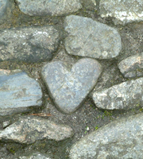  Go to this link to find out more about Cormoran and also Bolster, another Cornish giant.  https://www.nationaltrust.org.uk/features/giants-of-cornwall  Look at this picture of a footprint of Bolster. Where do you think this footprint could be? What do you think the landscape around it looks like? Draw the surrounding scene that the footprint is set in.  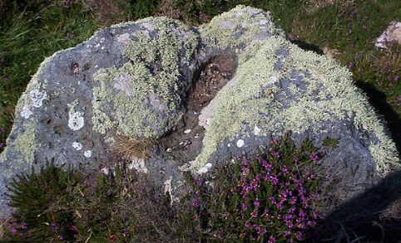  There is a larger image attached to the blog. | MONDAY’S 60 SECOND PE CHALLENGE:  AROUND THE WORLD  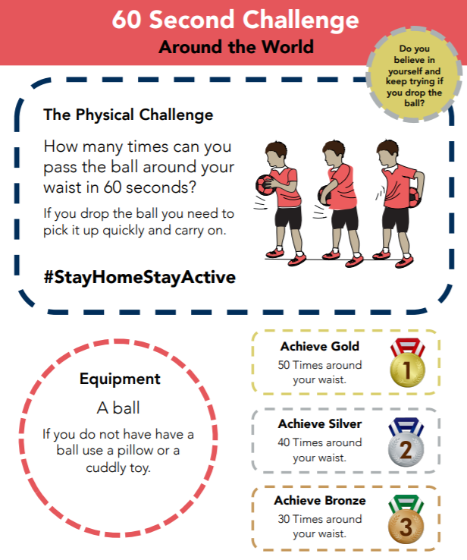  How many times can you pass a ‘ball’ around your waist in 60 seconds?  Remember to keep a record of all your attempts and see how much quicker you get!  Can you achieve GOLD by Friday?
READING COMPREHENSION  Read the story about Cormoran the Cornish Giant:  https://worldstories.org.uk/reader/cormoran-the-cornish-giant/english/667#  Read the text carefully and answer the VIPERS questions.  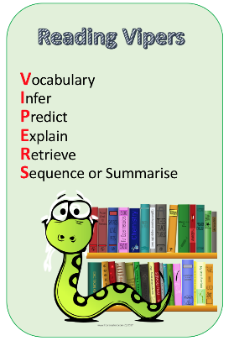  Check your answers.  Think about which VIPERS you didn’t get right, this is your feedback and your next steps for learning. | Watch the following video, which explains the chunking method of long division:  https://www.youtube.com/watch?v=vyay77atBZM  Complete the worksheet (long division – no remainders) that is attached to the blog. | SCIENCE - ROCK FORMATION  Cormoran used granite rock to make his stronghold which is now the landmark, St Michael’s Mount. Granite is a strong, non-porous (doesn’t let in water) igneous rock, formed when molten lava reached the surface. The green rock Cormelian wanted to use was weaker – possibly sedimentary – but Cormoran knew it would have been too weak to keep out the villagers.  So how did Cormoran know which type of rock to use? Let’s look at the three types of rocks you can find on Earth.  Watch: https://www.youtube.com/watch?v=tNs1gqkYerg  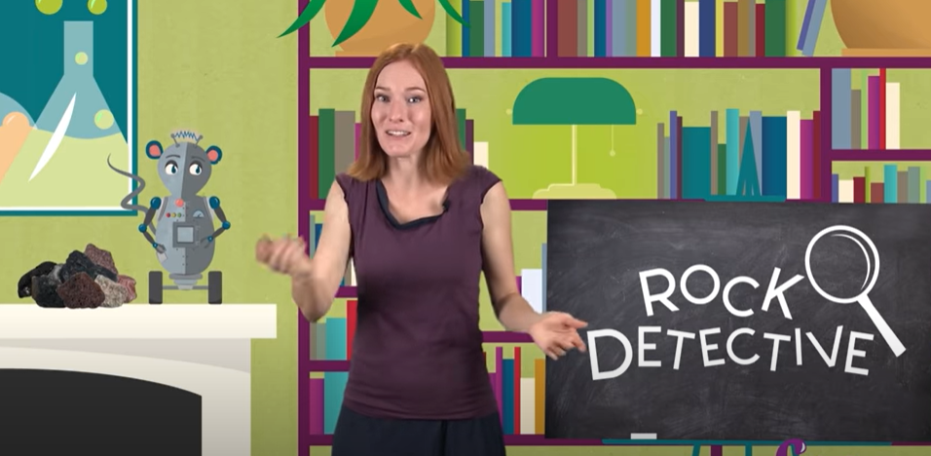  Then, go on a rock hunt and gather a range of rocks, pebbles or stones. Examine the rocks and fill out the ‘rock hunt’ sheet noting their different properties. Can you work out if they are igneous, sedimentary or metamorphic from what you see?  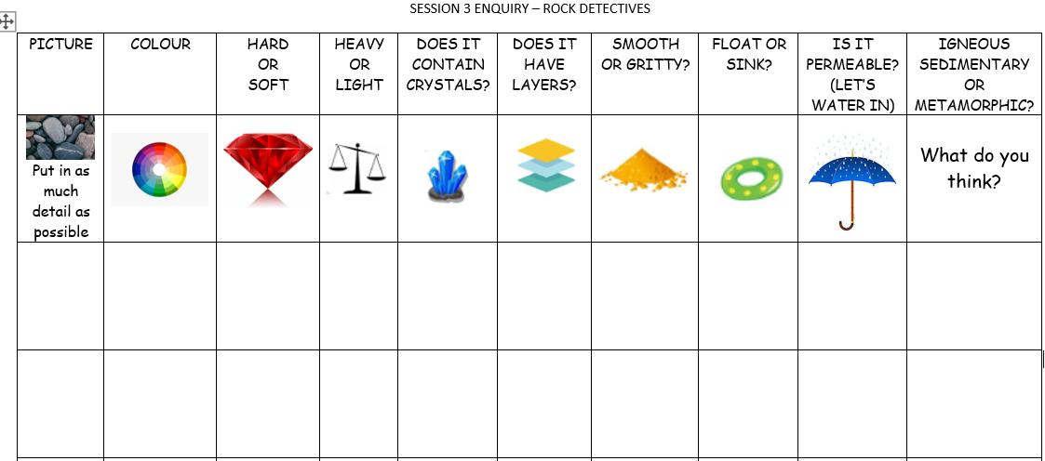 | FOR THE REST OF THE WEEK, WE ARE GOING TO PRACTISE FOR THE SCHOOL ‘VIRTUAL’ GAMES WHICH ARE ON THE 22ND-26TH JUNE.  A letter will be sent to you this week with further details.  Each day, we will practise an event. Remember to carry on with your 60 second challenge as well!  Today’s event  ATHLETICS:  AIM: How many speed bounces can you do in 30 seconds
Comprehension  Follow the link to Pobble 365 – Sleeping Giant: https://www.pobble365.com/sleeping-giants  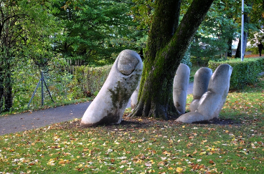  Answer the questions in the Question time section.  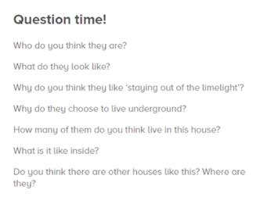  Imagine Cormoran has now emerged from the ground. Draw a full size picture of him. These might inspire your drawing:  https://www.youtube.com/watch?v=MYaAq4tmnV0  https://www.youtube.com/watch?v=gXTNpiK9Py8 | Today we will look at division where there are remainders. Try to get into the habit of writing your remainders as a fraction like was shown on yesterday’s video. (Note though that the answer sheet just gives them as a remainder).  Complete the worksheet attached to the blog (Long division – with remainders). Watch the video from yesterday again if you need a recap about the chunking method.  IF you are feeling very confident about the chunking method then you may want to try the formal method of long division. You can watch this video which explains the method.  https://www.youtube.com/watch?v=VGM68brg_zw  There is also a worked example here:  https://www.mathsisfun.com/long_division.html  This will be new learning for most of you though and may not be something you have seen before so please don’t worry if you are unsure of it – you can carry on using the chunking method if you are more confident with this. | ART/DT: - Create a stronghold out of natural objects. Make it sturdy enough (just like Cormoran) so it doesn’t fall down and let in any unwanted villagers!  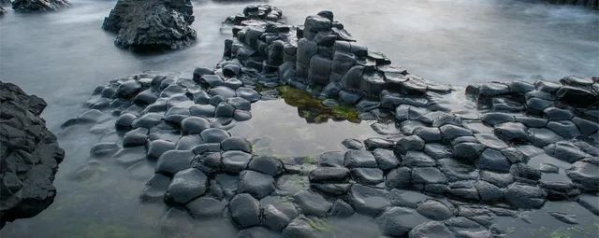  Make it part of your active exercise - either on your daily walk or in your back garden!  OR  Create Top Trumps cards for Cormoran and Bolster. Can you find any other Cornish giants to add to the pack?  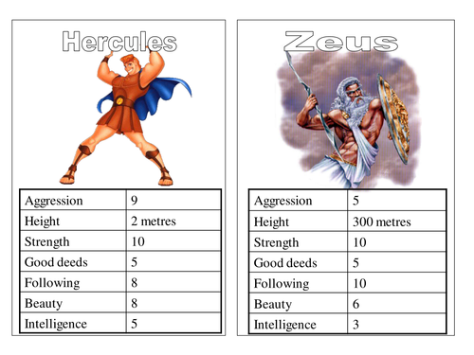  Think about: Height/strength/ugliness/speed/good or bad deeds/intelligence.  You can use the template attached to last week’s blog if you would like. | Today’s event  BOWLS/BOCCIA:  AIM: Knock down all your ‘skittles’ in one go.  AIM: Get as close to a target as possible.
Today you are going to write the first part of your sequel. Before you start, have a go at using these 2 new sentence types. Look at the mats below the Blog.  Emotion, noun sentence  The more, the more sentence.  Have ago at writing some sentences for your sequel using these sentence structures. For example:  Exhausted, Cormoran climbed out of the enormous crater.  The more he pushed, the more compact the soil became; pressing like a solid wall against his tired shoulders.  Success criteria:  - Use the story starter from the link to yesterday’s picture to start your story.  - Use details of Cormoran’s story within your story  - Use a variety of sentence structures  - Use examples of your made up language from Monday’s lesson | You are lost in the forest and must crack the code to escape.  Solve the clues on the ‘lost in the forest’ clue sheet to discover the code and escape the forest. | ART/DT  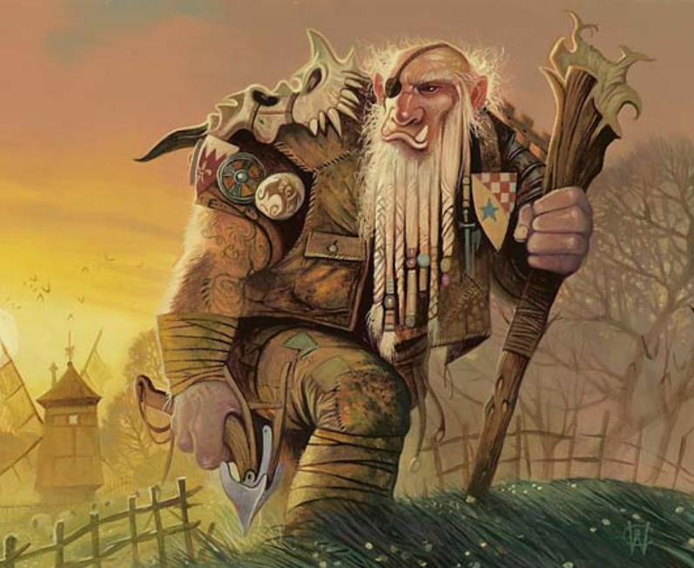  Polperro is in trouble! A giant has turned up and is threatening to take over the village. You need to help the villagers defeat this beast.  Come up with a daring plan to rid Polperro of this ‘giant’ problem. Name it “How to trap a Cornish Giant”.  You can choose how you would like to show your plan. You could draw pictures, create a comic strip or do a puppet show to show each step. Be as creative as you like.  Here’s my plan: Carefully dig a hole and cover it with leaves and sticks. Then rest a delicious, hot pasty on top of it, hide nearby and make a sound to get his attention. As soon as the giant smells the tasty pasty, he will want to eat it. Once he goes to pick it up, he falls into the hole.  I bet you can think of a better one though! | Today’s event  DANCE/GYMNASTICS:  AIM: Perform a Hip Hop routine of your choice  AIM: Perform a sequence using a variety of skills.
Today you are going to finish writing your sequel and edit your writing.  When you have finished writing your writing, follow these four steps:  - Choose one sentence to improve.  - Improve the sentence by changing it into a different sentence type.  - Consider your adjectives, adverbs and verbs. Have you got interesting adjectives, strong verbs and said how these verbs are done?  - Check all the spellings and punctuation.  Now you are ready to share your sequel with someone in your house. I would really like to read it too, so please email me a copy | Complete the arithmetic questions that are attached to the blog.  You do not have to time yourself – you can work through them at your own pace.  If you do want to time yourself then allow yourself 30 minutes to complete all the questions.  Use the answers to check it when you’ve finished. | This afternoon, practise some of the remaining activities to get ready for the Virtual School Games:  TENNIS:  AIM: Get as many balls into a target in 60 seconds as you can  AIM: As many continuous shots as possible in a rally in 2 minutes.  AIM: As many continuous volleys as possible in 2 minutes.  VOLLEYBALL:  AIM: Serve the ball into a desginated area in 2 minutes.  AIM: Keep the ball off the ground using different parts of your body.  AIM: Get as many balls over your head and catch in 2 minutes.  Here is the link to all of the Activity Cards:  http://www.activecornwall.org/cornwallschoolgames/the-virtual-games  Click on the activity you want to practise and all the information and demo videos are there.

