8.6 | ENGLISH | MATHS | ENQUIRY | ACTIVE
S  E  S  S  I  O  N  1 | CREATIVE LANGUAGE  This week you will learn the story of Cormoran the Cornish giant and your writing task is to write the sequel to this story.  Often, mythical creatures have a language of their own and Giants are not excluded from that. Today you are going to explore the language of the BFG and have a go at creating your synonyms to use in your Cormoran sequel.  - Read the extract from the BFG  - Find all the made-up words and sort them into the diagram deciding whether these are negative or positive words.  - Have a go at creating your own synonyms like Roald Dahl. You could use some Cornish words to create these. | This week, you are going to use the national home school Oak Academy for maths. Click on the link and follow the instructions. The tasks are all on the video, so no need to print/use worksheets. You just need some paper to jot down your workings out.  Y4 MONEY  https://www.thenational.academy/year-4/maths/measures-money-the-price-of-stamps-year-4-wk4-2#slide-1  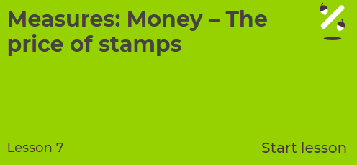  Y5 TRANSLATION  https://www.thenational.academy/year-5/maths/an-introduction-to-translation-year-5-wk1-1  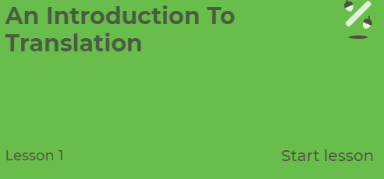 | HISTORY- ART Cornish folk law suggests that the giant Cormoran and his wife Cormelian built St Michael’s Mount as a stronghold (fortress) to steal the villagers’ sheep and cows and keep them for themselves. If you walk up the main path, you will find a heart-shaped stone. What do you think this represents?  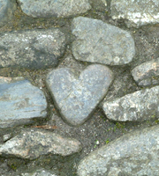  Let’s find out. http://www.bbc.co.uk/cornwall/content/articles/2007/04/04/gardens_stmichaelsmount_feature.shtml  ACTIVITY: Look at this picture of a footprint of another Cornish giant named BOLSTER. Expand the picture and create a setting to show where this stone could be.  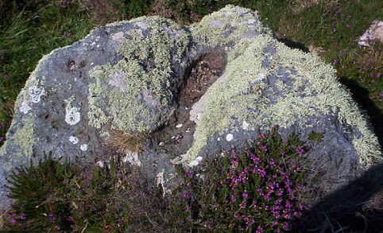  Scroll down below grid for bigger image.  Research the myth behind this giant and compare it with the tale of Cormoran. | MONDAY’S 60 SECOND PE CHALLENGE:  AROUND THE WORLD  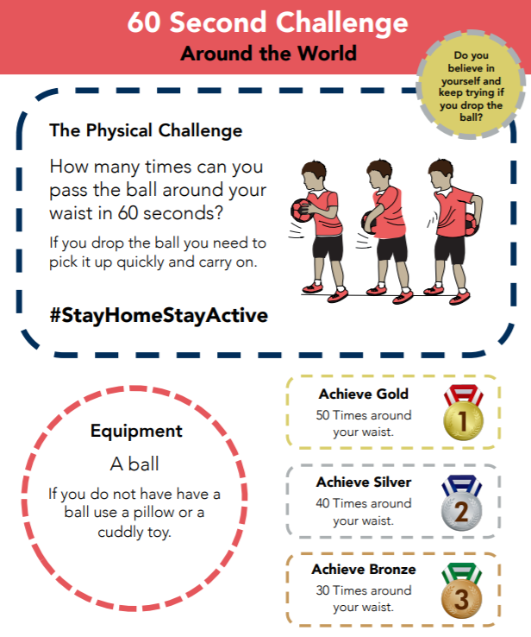  How many times can you pass a ‘ball’ around your waist in 60 seconds?  Remember to keep a record of all your attempts and see how much quicker you get!  Can you achieve GOLD by Friday?  Scroll down below grid for card.
S  E  S  S  I  O  N  2 | READING COMPREHENSION  Read the story about Cormoran the Cornish Giant  https://worldstories.org.uk/reader/cormoran-the-cornish-giant/english/667#  Read the text carefully and answer the VIPERS questions.  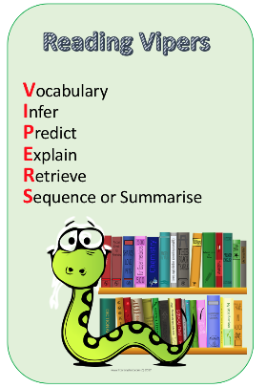  Check your answers.  Think about which VIPERS you didn’t get right, this is your feedback and your next steps for learning. | Year 4  https://www.thenational.academy/year-4/maths/measures-money-coin-purse-challenge-year-4-wk4-4  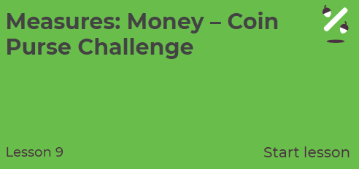  Year 5  https://www.thenational.academy/year-5/maths/describing-translations-year-5-wk1-2  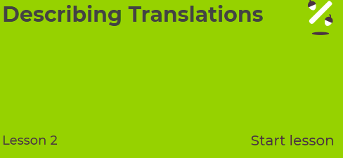 | SCIENCE - ROCK FORMATION  Cormoran used granite rock to make his stronghold which is now the landmark, St Michael’s Mount. Granite is a strong, non-porous (doesn’t let in water) igneous rock, made from molten lava reaching the surface. The green rock Cormelian wanted to use was weaker – possibly sedimentary but Cormoran knew it was too weak to keep out the villagers. So how did Cormoran know which type of rock to use? Let’s look at the three types of rocks you can find on Earth. Let’s play rock detective! Watch https://www.youtube.com/watch?v=tNs1gqkYerg  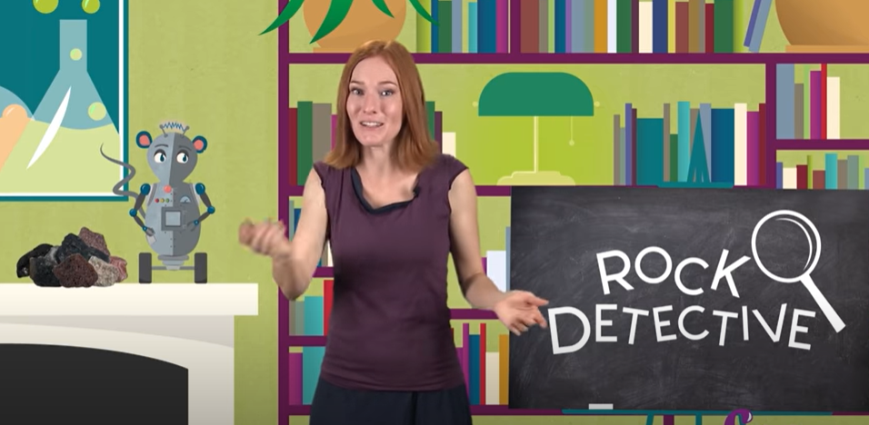  Then, go on a rock hunt and gather a range of rocks/pebbles or stones. Fill out the sheet about their properties. Can you tell if they are igneous, sedimentary or metamorphic from what you see?  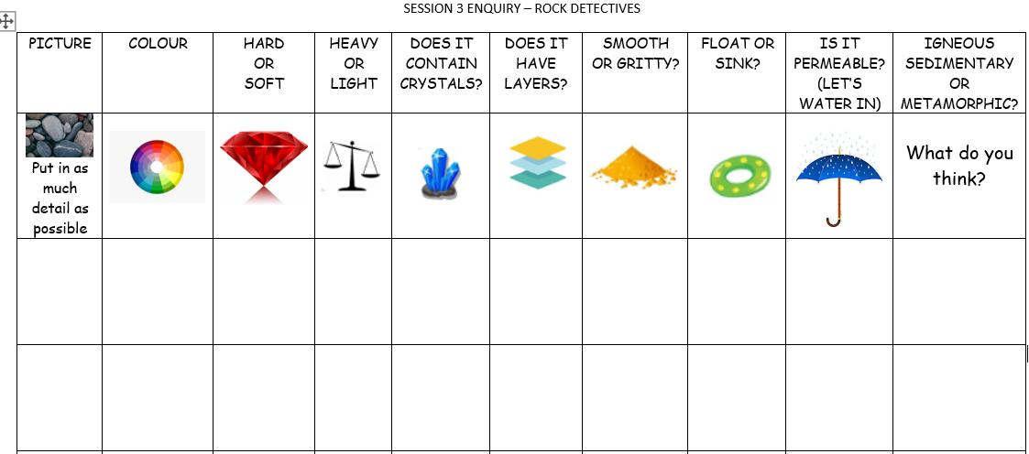  (Worksheet attached to blog SESSION 2 ENQUIRY Rock Detectives). | FOR THE REST OF THE WEEK, WE ARE GOING TO PRACTISE FOR THE SCHOOL ‘VIRTUAL’ GAMES WHICH ARE ON THE 22ND-26TH JUNE.  A letter will be sent to you this week with further details.  Each day, we will practise an event. Remember to carry on with your 60 second challenge as well!  Today’s event  ATHLETICS:  AIM: How many speed bounces in 30 seconds
S  E  S  S  I  O  N  3 | COMPREHENSION  Follow the link to Pobble 365 – sleeping giant. https://www.pobble365.com/sleeping-giants  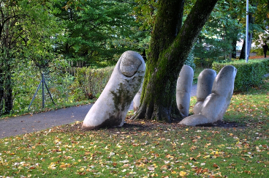  Answer the questions in the Question time section.  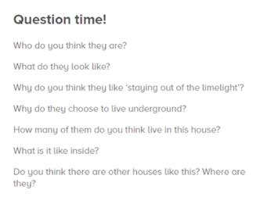  ACTIVITY: Imagine Cormoran has now emerged from the ground. Draw a full size picture of him. These might inspire your drawing:  https://www.youtube.com/watch?v=MYaAq4tmnV0  rhttps://www.youtube.com/watch?v=gXTNpiK9Py8 | Year 4  https://www.thenational.academy/year-4/maths/measures-money-buying-fruit-year-4-wk5-2  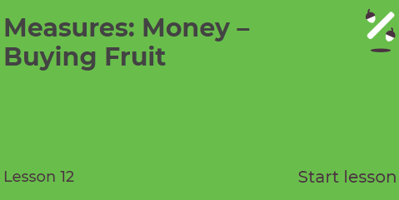  Year 5  https://www.thenational.academy/year-5/maths/describing-positions-and-coordinates-year-5-wk1-3  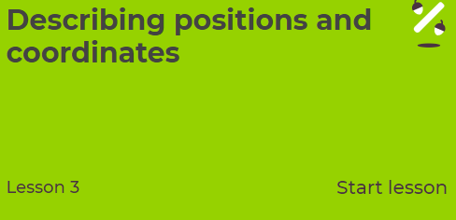 | ART/DT: - Create a stronghold out of natural objects. Make it sturdy enough (just like Cormoran) so it doesn’t fall down and let in any unwanted villagers!  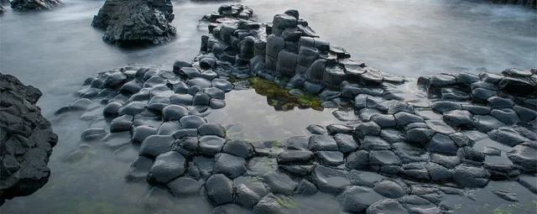  Make it part of your active exercise - either on your daily walk or in your back garden!  Or Create TOP TRUMP cards for Cormoran, Bolster and The lonely Giant  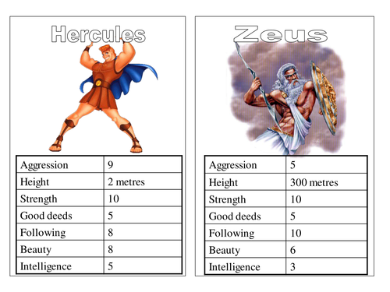  Think about: Height, strength/ugliness/speed/good or bad deeds/intelligence.  Scroll down below grid for templates. | Today’s event  BOWLS/BOCCIA:  AIM: Knock down all your ‘skittles’ in one go.  AIM: Get as close to a target as possible.
S  E  S  S  I  O  N  4 | WRITING  Today you are going to write the first part of your sequel. Before you start, have a go at using these 2 new sentence types. Look at the mats below the Blog.  Emotion, noun sentence  The more, the more sentence.  Have ago at writing some sentences for your sequel using these sentence structures. For example:  Exhausted, Cormoran climbed out of the enormous crater.  The more he pushed, the more compact the soil became pressing like a solid wall against his tired shoulders.  Success criteria  Use the story starter  Use the story of Cormoran  Use a variety of sentence structures  Use examples of your made up language | Year 4  https://www.thenational.academy/year-4/maths/measures-money-souvenirs-year-4-wk5-3  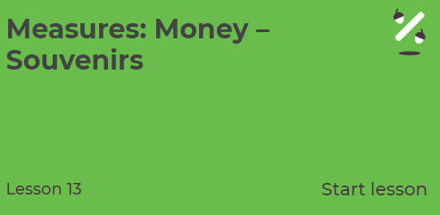  Year 5  https://www.thenational.academy/year-5/maths/describe-position-after-translation-year-5-wk1-4  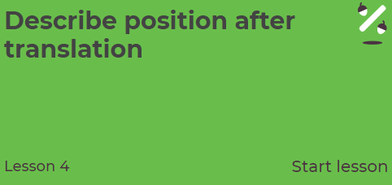 | ART/DT  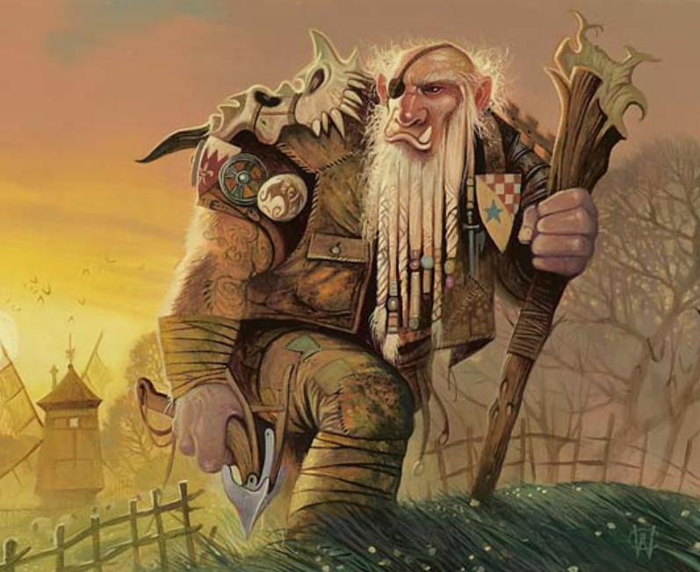  Polperro is in trouble! A giant has turned up and is threatening to take over the village. need to help the villagers defeat this beast.  Activity: Come up with a daring plan to rid Polperro of this ‘giant’ problem. Name it  “How to trap a Cornish Giant”  and draw pictures/create a comic strip/do a puppet show to show each step.  YOU COULD: Carefully dig a hole and cover it with leaves and sticks. Then rest a delicious, hot pasty on top of. Hide nearby and make a sound to get his attention. As soon as the giant smells the tasty pasty, he will want to eat it. Once he goes to pick it up, he falls into the hole.  I bet you can think of a better plan though! | Today’s event  DANCE/GYMNASTICS:  AIM: Perform a Hip Hop routine of your choice  AIM: Perform a sequence using a variety of skills.
S  E  S  S  I  O  N  5 | WRITING AND EDITING  Finish writing your sequel  When you have finished writing your sequel, have a go at editing.  Follow these four steps:  - Choose one sentence to improve.  - Improve the sentence by changing it into a different sentence type.  - Consider your adjectives, adverbs and verbs. Have you got interesting adjectives, strong verbs and said how these verbs are done?  - Check all the spellings and punctuation.  Now you are ready to share your sequel with someone in your house. I would really like to read it too, so please email me a copy | FUN AND GAMES  Year 4  Choose games from Topmarks to practise your skills learnt this week.  https://www.topmarks.co.uk/maths-games/7-11-years/money  Year 5  Find someone to play with 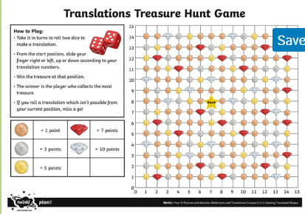  Scroll down below grid for resources | This afternoon, practise some of the remaining activities:  TENNIS:  AIM: Get as many balls into a target in 60 seconds as you can  AIM: As many continuous shots as possible in a rally in 2 minutes.  AIM: As many continuous volleys as possible in 2 minutes.  VOLLEYBALL:  AIM: Serve the ball into a desginated area in 2 minutes.  AIM: Keep the ball off the ground using different parts of your body.  AIM: Get as many balls over your head and catch in 2 minutes.  Here is the link to all of the Activity Cards:  http://www.activecornwall.org/cornwallschoolgames/the-virtual-games  Click on the activity you want to practise and all the information and demo videos are there.

Scroll down below grid for resources

BOLSTER‘S FOOTPRINT – CHAPEL PORTH, CORNWALL
Will your setting be:
- in a forest
- near to a town
- by a beach
- an entrance to hidden cave
- a gateway to a magical land

Use your imagination!

