Killigarth Class - Home Learning Weekly Planner
Summer Term Enquiry – Where and what in the world is Cornwall? Week beginning: 15st June 2020
This week’s questions: Pirates!!
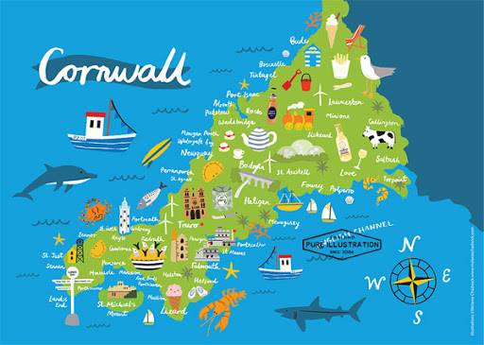
See page 2 for phonics and spelling learning for this week

Personal, Social and Emotional Development |  | Communication and Language |  | Physical Development
Listen to the story All Are Welcome by Alexandra Penfold and Suzanne Kaufman https://www.youtube.com/watch?v=Vc8IEcr1Uwc  Complete this craft activity that would encourage a child to focus on the different physical features of people from different countries. Maybe look at a different country each day and choose a person from that country and make a puppet of them for example you might set out to create an Indian girl see if the children can notice that the Indian girl was wearing a lot of sparkly sequins on her outfit and added these to her paper doll puppet. Each day build a ‘puppet’ from one country and then stick them around the room and discuss diversity how we are all different but equal.  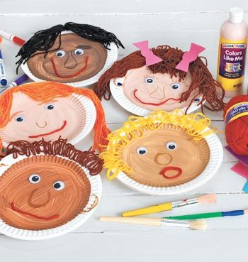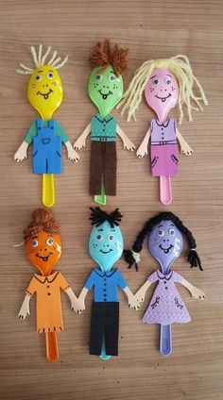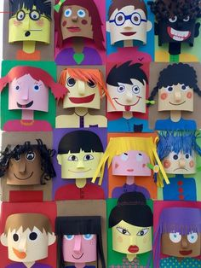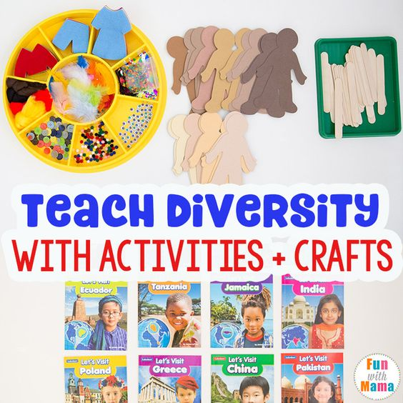 |  | 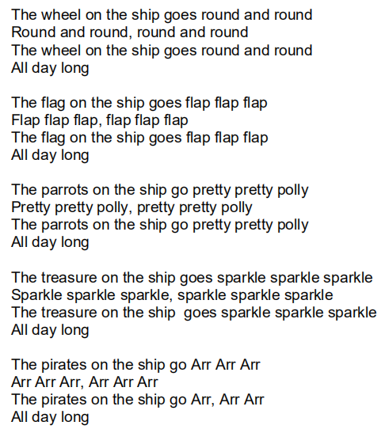  Try the songs together (attached at the bottom of the blog) Here’s one of them: |  | Moving and Handling:  Can you practice your fine motor skills and thread a pirate treasure necklace maybe using bit of bright coloured drinking straws/beads/painted pasta/fimo beads etc.  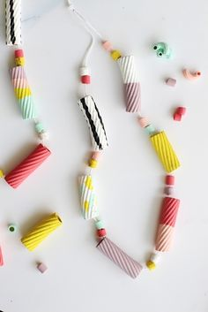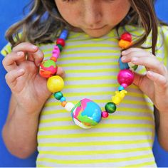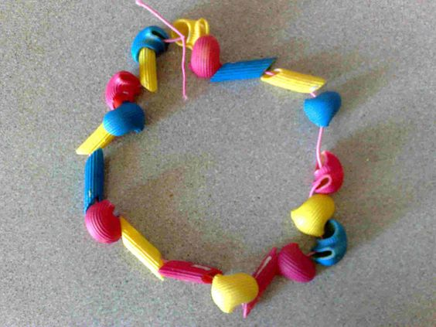  Have a go at walking the plank! Balancing and jumping off landing steadily. What can you jump off? How high? But PLEASE don’t break any bones!  As in previous weeks take some time to maybe do a different Cosmic Yoga or PE with Joe Wicks.  https://www.youtube.com/watch?v=LhYtcadR9nw  https://www.youtube.com/watch?v=sX05HHni9Wk
Literacy |  | Mathematics | Understanding the World |  | Expressive Arts and Design
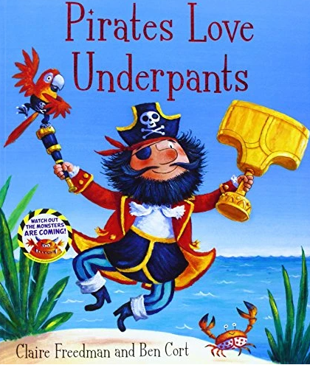  Ahoy me hearties! Join the Pants Pirates on a special treasure hunt. Grab your cutlass and sail on the Pirate Ship Black Bloomer past angry crocs, sharks in fancy pants and through gurgling swamps on a quest to find...the Pants of Gold! You'll be yo-ho-ho-ing until the sails come down! These next two weeks we’re going to be looking at the book ‘Pirates Love Underpants’  Session 1: Spend time watching the video of the story following the link: https://www.youtube.com/watch?v=-QCQJEmSado. Talk about the story together, what did you enjoy? What happened at the end? Which pirate was your favourite?  Session 2: Dress up as a pirate and act out the story, can you make any stick puppets of the characters? Here’s a link https://www.twinkl.co.uk/resource/t-t-9467-pirate-stick-puppets.  Session 3: Design your own pair of underpants that you would wear if you were hunting for the gold pair! (resource attached on the blog).  Session 4: In the story the Pirates are on the hunt for the golden pants, this is their treasure. Can you write a list of 5 things that you treasure the most? Can be people, objects, places, things you like to do. (sheet attached on the blog, but please free to write them down on any piece of paper).  READING:  What other Pirate stories do you know or can find? (please let us know).  Try this word search attached at the bottom of our class blog. | Monday - Watch Numberblocks – Fifteen  https://www.bbc.co.uk/iplayer/episode/m00029tw/numberblocks-series-3-fifteen  When Teaching 15 remind children its 10 and 5 just like 13 is 10 and 3 etc. Take a look at the place value layout attached to the planning. When children make piles of 15 get them to place them in 10s and ones coloums. Go around your house or garden and make 15 piles of 15 things e.g. sticks, spoons, a tower of 15 bricks etc. Can you have a go at doing 15 things e.g 15 star jumps? Run between 2 markers 15 times?  Tuesday  Go around your house and garden and see if you can see the number 15 on anything, if you can’t how can you make the number 15? 15 times Using string? Straws? Bricks? What unusual things can you think of to make the number 15?  Wednesday  Have 2 signs on the table 15 and not 15. Give the children a number of items e.g. pencils, a piece of paper with dots on, some Lego bricks etc. Ask them to place them in the correct piles.  Thursday  Children throw up 15 counters/balls/bricks etc in to a tray and see where they land, How many obvious piles are there? Can they make that into a partitioning model e.g. 3 and 2 and 6 and 4 make 15 or even simpler 8 and 7 make 15 too. Complete discussing ways of making 15.  Friday  Give your child ten counters (Lego bricks, past shapes, buttons, sweets) and ask them questions such as: What do you add to 3 to make 15? Using your adding and subtracting skills can you come up with some ways to add and subtract totalling 15? I would love to see some of your number sentences.  HAVE A GO AT A DIFFERENT CHALLENGE OR GAME FROM LAST WEEK ATTACHED TO THE BOTTOM OF THIS PLANNING PAGE. |  | Research Pirates in Cornwall, what can you find out? What town do people believe Pirates visited? Can you find that town on a map of Cornwall or the UK?  Design your own treasure map, using the template provide (attached at the bottom of the blog). Can you mark where the treasure is and can the adults and family members find your treasure?  Can your treasure map lead the pirates to the golden pants?  You can make a map look even older by using a teabag and staining it.  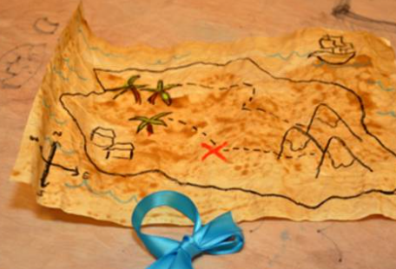 |  | Make some Pirate costumes and send us a picture to see you all pirated up! Here are some suggestions.  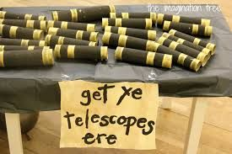  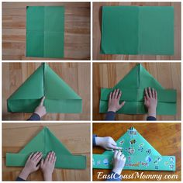  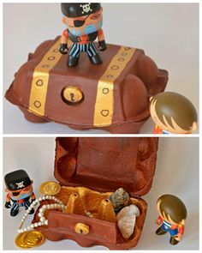
We are keen to add any learning you have done at home to our Facebook page and Weekly Blog page so please take a photo and email it over to us any day or time
Phonics
We have come to the end of Phase 3 Letters and sounds so thought this would be a good time to have a recap and ensure all children are secure with the sounds we have learnt before starting something new. Any revision games you can think of do have a go at and here are some of our suggestions of quick daily activities.

Remember the phonics play website…We might suggest activities on there. It is free to sign up using the Username: march20 and Password: home

We follow a simple structure every day using ‘Letters and Sounds’ which usually last 20-25 minutes. We understand this may be difficult with siblings and other things going on at home.
Revisit – (2/3 minutes) - In this section we practise sounds we know already very quickly, concentrating on pronouncing and using the actions. We often pay more attention to the digraphs (two sounds making one sound, your children are very good at these ☺ This can be done using an online games (detailed below) or your cards in book bags.
Teach- (5/10 minutes) - This is where we have new learning. We will introduce a sound using an action and thinking about where it is positioned in a word. The children enjoy saying the new sound in different ways; shouting it at the neighbours, whispering it to the cat, walking around the room saying it, using cuddly toys/puupets to whisper it wrongly, or adults getting it wrong.
Practise – (5/10 minutes) - In this section we will read and write words containing the new sound, look at the letter shapes that are in the word and sound buttoning them for reading. We often sky-write a new sound, use our whole body to write, focussing on the shapes we need to make, on our friend’s backs, chalk outside, painting with water on the ground/wall, using our bodies. On an application day (Tue and Thur) it’s great to use some of these ideas, the writing doesn’t have to be done only on paper.

Monday 15th June | Tuesday 16th June | Wednesday 17th June | Thursday 18th June | Friday 19th June
Recap sounds – oir  If you can’t remember how its pronounced have a look here.  https://www.youtube.com/watch?v=T3rWZYN5jno  Revisit – Play Flashcards on the Phonics play website recapping all of the phase 2 and 3 sounds. You could challenge yourself to have a go once each day and see if you can beat your time and the number you get correct.  https://www.phonicsplay.co.uk/member-only/Flashcards.html  OR use your sound cards and flip through them all to make sure you know them.  Practice –  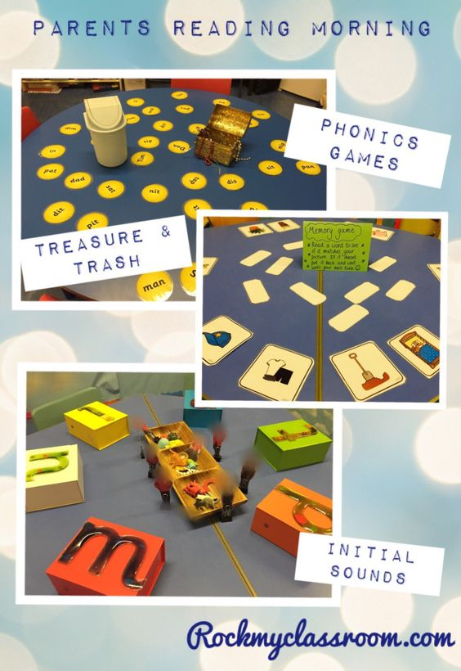  Make your own treasure and trash game! You need half real half fake words. Some real ones could be... air, hair, pair, chair, dairy, fair, fairy, airport, hairbrush, stairs, and fake ones plair, hizair, dlair, gair, sair, kair, children have to sort them into real and fake words.  You could mix it up and use other words and sort them into piles or words with air and words without air in.  OR  You could also have a go at buried treasure on phonics play.  https://www.phonicsplay.co.uk/member-only/BuriedTreasure2.html  Apply –  Can you write a sentence using as many of these words as possible in one sentence? | Recap sounds – ure  If you can’t remember how its pronounced have a look here.  https://www.youtube.com/watch?v=YwCzf71flBA  Revisit – Play Flashcards on the Phonics play website recapping all of the phase 2 and 3 sounds. You could challenge yourself to have a go once each day and see if you can beat your time and the number you get correct.  https://www.phonicsplay.co.uk/member-only/Flashcards.html  OR use your sound cards and flip through them all to make sure you know them.  Practice –  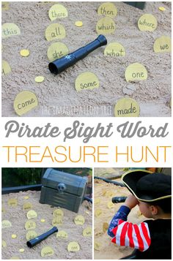  Get your grownup to make some gold coins and write some words on them. Pure, cure, secure, mature, manure, injure, picture, mixture.  Can you go on a hunt around your house to find the treasure using your telescope to help you search?  Apply –  Make a scroll by ripping up a piece of paper and maybe even pitting tea over it or burning the edges and write a secret pirate message about where the treasure is. E.g. the treasure in secure under the manure. | Recap sounds – er  If you can’t remember how its pronounced have a look here. https://www.youtube.com/watch?v=KK8_kUg3454  Revisit – Play Flashcards on the Phonics play website recapping all of the phase 2 and 3 sounds. You could challenge yourself to have a go once each day and see if you can beat your time and the number you get correct.  https://www.phonicsplay.co.uk/member-only/Flashcards.html  OR use your sound cards and flip through them all to make sure you know them.  Practice –  Read the words in the wordsearch and see if you can find them.  Apply –  Write down this sentence for the children, chop it up and ask them to go on a pirate treasure hunt around the house or garden looking for pieces of paper with sentences on, they may want to take their telescopes.  When they have found the words they have to put them together to make a sentence.  Possible sentences  I got a letter from a farmer.  My ladder is much longer than her ladder.  Get a hammer and bang in a nail. | Recap sounds – tricky words  Revisit – Play Flashcards on the Phonics play website recapping all of the phase 2 and 3 sounds. You could challenge yourself to have a go once each day and see if you can beat your time and the number you get correct.  https://www.phonicsplay.co.uk/member-only/Flashcards.html  OR use your sound cards and flip through them all to make sure you know them.  Practice  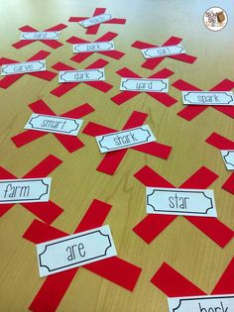  Make some x marks the spots out of paper and write a tricky word on each one. Hide a piece of treasure under each one too and the children have to jump on them and say the tricky word. If they get it correct they get to keep the treasure. How many piece of treasure can they win?  Tricky Words.  I, no, to, the, go, into, he, be, her, she, you, was, we, all, they, me, are, my. | Recap sounds – tricky words  Revisit – Play Flashcards on the Phonics play website recapping all of the phase 2 and 3 sounds. You could challenge yourself to have a go once each day and see if you can beat your time and the number you get correct.  https://www.phonicsplay.co.uk/member-only/Flashcards.html  OR use your sound cards and f  lip through them all to make sure you know them.  Practice – Ask the children to write the tricky words down then a grown up goes and hides the tricky words around the house or garden and the child goes hunting for them with their telescope. How many can they find?  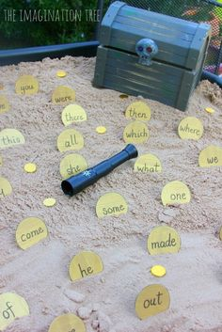  Tricky Words.  I, no, to, the, go, into, he, be, her, she, you, was, we, all, they, me, are, my.


