 | ENGLISH | MATHS | ENQUIRY | ACTIVE
S  E  S  S  I  O  N  1 | This week, we are learning about giants. We will look at the myth surrounding Cormoran, the Cornish Giant and from Get epic, a tale of a Lonely Giant. Our writing task this week is to write a sequel story to The Lonely Giant.  READING COMPREHENSION  Read the story about Cormoran the Cornish Giant  https://worldstories.org.uk/reader/cormoran-the-cornish-giant/english/667#  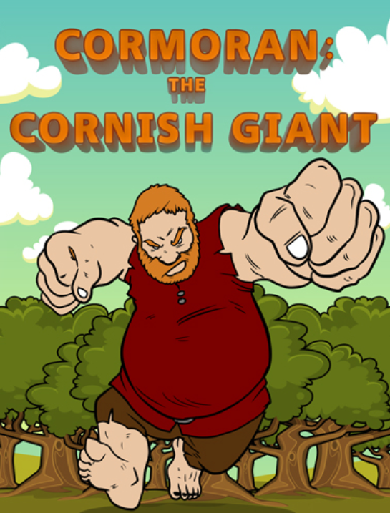  Read the text carefully and answer the VIPERS Cormoran questions (attached to blog).  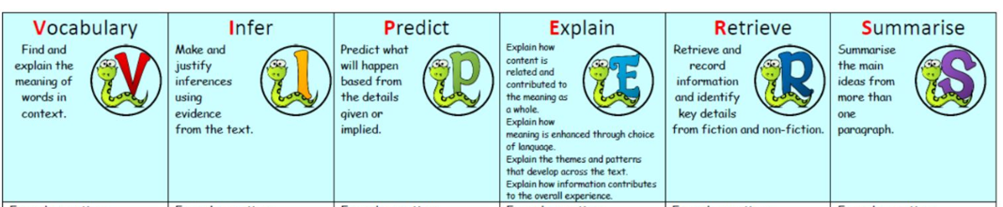I’ve included the answers so check them and think about which VIPERS you didn’t get right. This is your feedback and your next steps for learning. | We have been learning to tell the time. How’s it going? Today we are going to remind ourselves about how a day is separated into am and pm (different parts of the day).  Watch: https://www.youtube.com/watch?v=zaOc-4TA4lk  Then complete the sheet, thinking about what activities you might do during these times of the day.  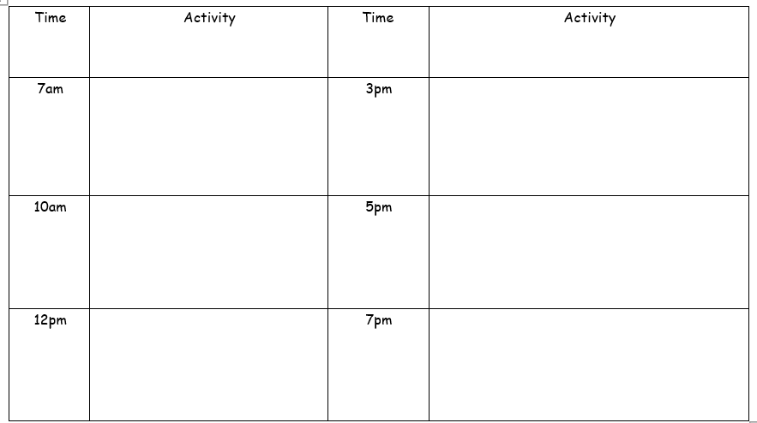 | HISTORY- ART Cornish folk law suggests that the giant Cormoran and his wife Cormelian built St Michael’s Mount as a stronghold (fortress) to steal the villagers’ sheep and cows and keep them for themselves. If you walk up the main path, you will find a heart-shaped stone. What do you think this represents?  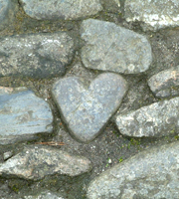  Let’s find out. Mum/Dad, you might need to help read this: http://www.bbc.co.uk/cornwall/content/articles/2007/04/04/gardens_stmichaelsmount_feature.shtml  ACTIVITY: Look at this picture of a footprint of another Cornish giant named BOLSTER. Expand the picture and create a setting to show where this stone could be.  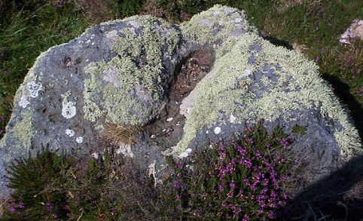  (Bigger images below grid)  Research the myth behind this giant and compare it with the tale of Cormoran. | MONDAY’S 60 SECOND PE CHALLENGE:  AROUND THE WORLD  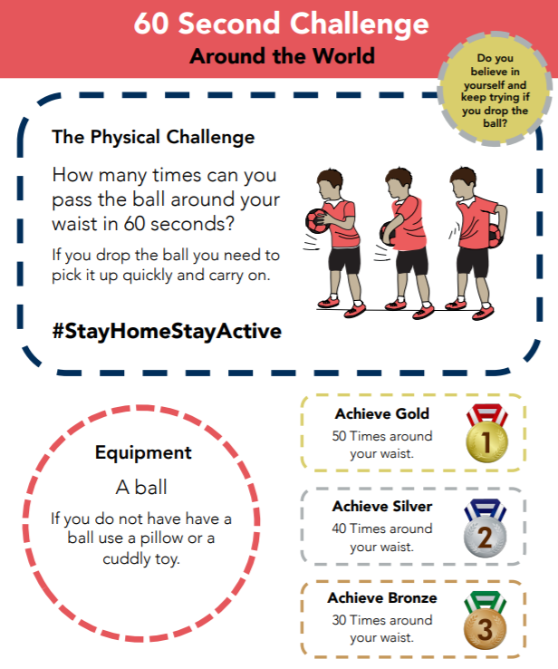  How many times can you pass a ‘ball’ around your waist in 60 seconds?  Remember to keep a record of all your attempts and see how much quicker you get!  Can you achieve GOLD by Friday?
S  E  S  S  I  O  N  2 | COMPREHENSION  Follow the link to Pobble 365 – sleeping giant. https://www.pobble365.com/sleeping-giants  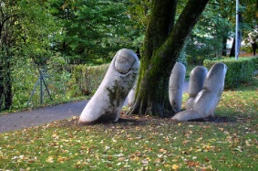  Answer the questions in the ‘Question time’ section  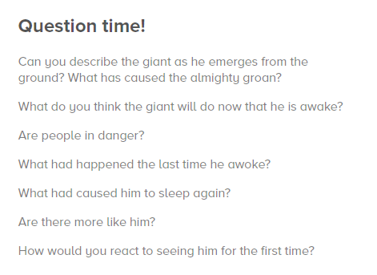  ACTIVITY: Imagine Cormoran has now emerged from the ground. Draw a full-size picture of him. These might help you draw:  https://www.youtube.com/watch?v=MYaAq4tmnV0 https://www.youtube.com/watch?v=gXTNpiK9Py8 | We are going to learn about telling time using the 24-hour clock. Why 24 hours? There are 24 hours in one day! You made a foldable clock face last week to show the 12-hour clock and 5-minute intervals:  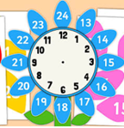  Now you need to add the 24-hour times to it. This is a nice suggestion (adding petals to the outside).  Now practise by matching these 24-hour digital times to the time in words (bigger version below grid).  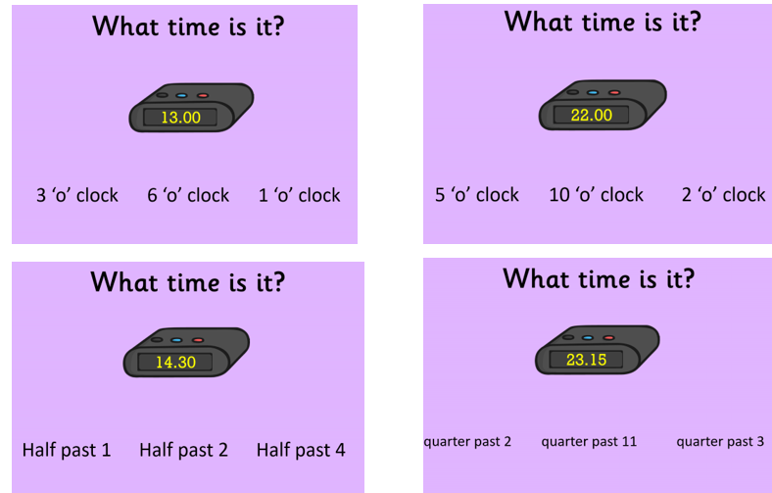 | SCIENCE - ROCK FORMATION  Cormoran used granite rock to make his stronghold which is now the landmark, St Michael’s Mount. Granite is a strong, non-porous (doesn’t let in water) igneous rock, made from molten lava reaching the surface. The green rock Cormelian wanted to use was weaker – possibly sedimentary but Cormoran knew it was too weak to keep out the villagers. So how did Cormoran know which type of rock to use? Let’s look at the three types of rocks you can find on Earth. Let’s play rock detective!  Watch https://www.youtube.com/watch?v=tNs1gqkYerg  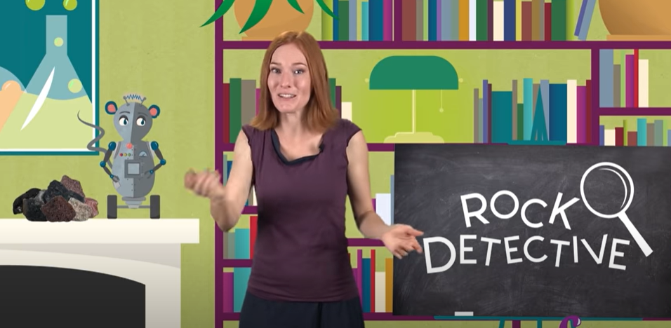  Then, go on a rock hunt and gather a range of rocks/pebbles or stones. Fill out the sheet about their properties. Can you tell if they are igneous, sedimentary or metamorphic from what you see?  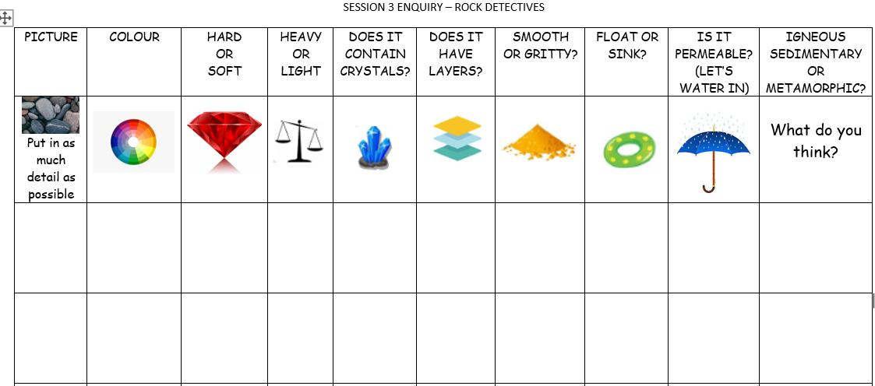  (Worksheet attached to blog SESSION 2 ENQUIRY Rock Detectives). | FOR THE REST OF THE WEEK, WE ARE GOING TO PRACTISE FOR THE SCHOOL ‘VIRTUAL’ GAMES WHICH ARE ON THE 22ND-26TH JUNE.  A letter will be sent to you this week with further details.  Each day, we will practise an event. Remember to carry on with your 60 second challenge as well!  Today’s event  ATHLETICS:  AIM: How many speed bounces in 30 seconds
S  E  S  S  I  O  N  3 | COMPREHENSION  Click on the link and either read or use the ‘Read Aloud’ button to read The Lonely Giant https://www.getepic.com/app/read/35849  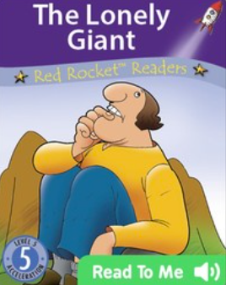  Activity: SEE BELOW SESSION 3 ENGLISH (BELOW GRID) | Go through this power point and practise using the 24-hour format.  Click on:  slideshow – from current slide  to make it interactive.  Activities included | ART/DT: - Create a stronghold out of natural objects. Make it sturdy enough (just like Cormoran) so it doesn’t fall down and let in any unwanted villagers!  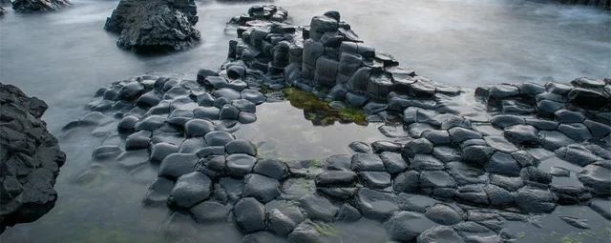  Make it part of your active exercise - either on your daily walk or in your back garden!  Or Create TOP TRUMP cards for Cormoran, Bolster and The lonely Giant  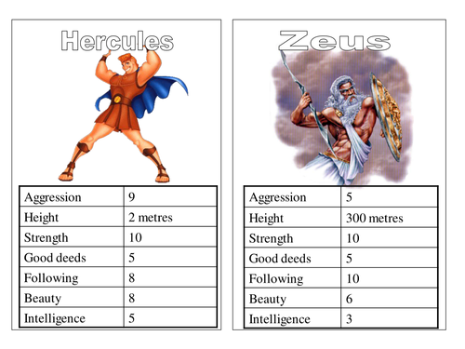  Think about: Height, strength/ugliness/speed/good or bad deeds/intelligence.  “I’ll attach some templates below for you to use or as a base to create from.”  ART/DT  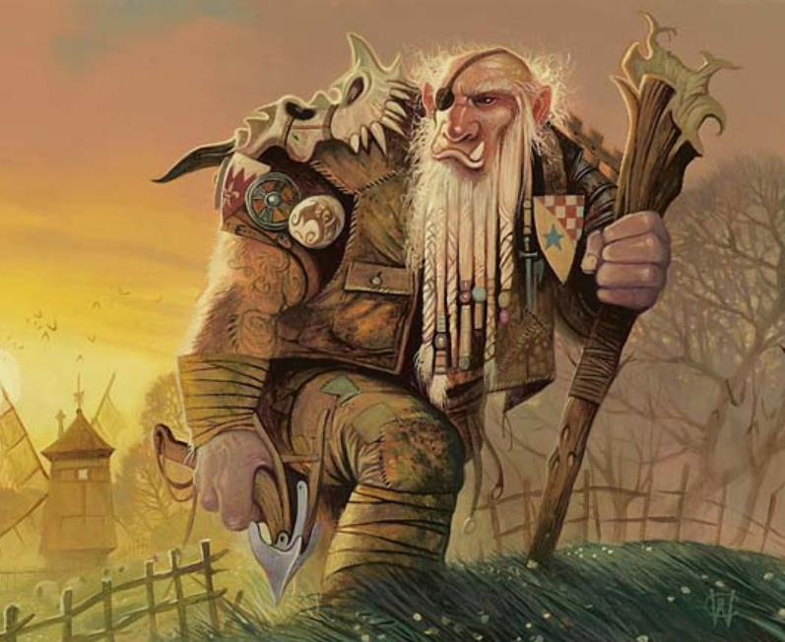  Polperro is in trouble! A giant has turned up and is threatening to take over the village. You need to help the villagers defeat this beast.  Activity: Come up with a daring plan to rid Polperro of this ‘giant’ problem. Name it  “How to trap a Cornish Giant”  and draw pictures/create a comic strip/do a puppet show with your toys to show each step.  HERE’S MY IDEA: (First, I would carefully dig a hole and cover it with leaves and sticks. Then I would rest a delicious, hot pasty on top of it. After I had hidden behind a nearby tree, I would make a sound to get his attention. As soon as the giant smells the tasty pasty his tummy will rumble, and he will want to eat it. Once he goes to pick it up, he falls into the hole.)  I bet you can think of a better plan! | Today’s event  BOWLS/BOCCIA:  AIM: Knock down all your ‘skittles’ in one go.  AIM: Get close to a target as possible.
S  E  S  S  I  O  N  4 | SPaG  Tomorrow, you will be writing the sequel to The Lonely Giant. What happens to him next? Who does he help and how are they in trouble? Does he become friends with the Gentle Giant?  You will probably need to write some speech in your story, so today we are going to look at the overuse of ‘said’.  “Before we start. Using ‘said’ occasionally is fine, but not repeatedly. Said doesn’t tell the reader how someone is saying the words, how they are feeling or what their voice sounds like. Using a better word helps the reader understand the character of the person speaking.”  Look at the following text (attached to the grid) and then follow the activities and change the word ‘said’ to avoid repetition.  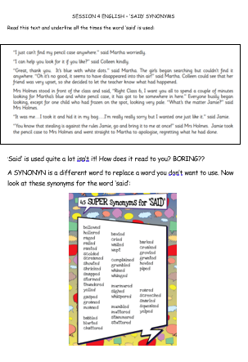  (SESSION 4 – Synonyms for said) | 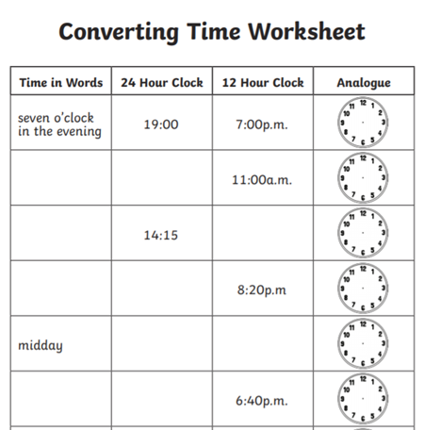  See below grid  Then,  Complete your Mathletics task today  https://login.mathletics.com/ |  | Today’s event  DANCE/GYMNASTICS:  AIM: Perform a Hip Hop routine of your choice  AIM: Perform a sequence using a variety of skills.
S  E  S  S  I  O  N  5 | WRITING TASK  Write a sequel story for The Lonely Giant.  “The Lonely Giant said that he would be ready to help anyone who needs it so that he can make friends and never be lonely again. Who/what/how do people get into trouble. Who does he make friends with?”  Success Criteria:  - full punctuated sentences  - use 2A sentences to add description (two adjectives and a comma) The kind, gentle giant helped the frightened boy to find his way home.  - use more powerful ‘said’ words  I’ve attached a WOW words mat and fronted adverbials mat to help you with your story. Don’t forget the ‘said’ synonyms list in yesterday’s lesson.  Extension: Draw a front cover for your book. |  | This afternoon, practise some of the remaining activities:  TENNIS:  AIM: Get as many balls into a target in 60 seconds as you can  AIM: As many continuous shots as possible in a rally in 2 minutes.  AIM: As many continuous volleys as possible in 2 minutes.  VOLLEYBALL:  AIM: Serve the ball into a desginated area in 2 minutes.  AIM: Keep the ball off the ground using different parts of your body.  AIM: Get as many balls over your head and catch in 2 minutes.  Here is the link to all of the Activity Cards:  http://www.activecornwall.org/cornwallschoolgames/the-virtual-games  Click on the activity you want to practise and all the information and demo videos are there.
SESSION 1 MATHS – AM AND PM
Draw a picture of what activity you could be doing at these times:
Time | Activity | Time | Activity
7am |  | 3pm
10am |  | 5pm
12pm |  | 7pm

SESSION 1 ENQUIRY
THE GIANT’S HEART – ST MICHAEL’S MOUNT
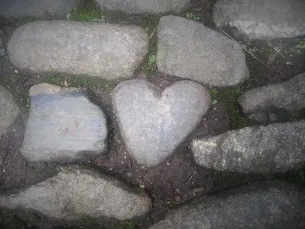
BOLSTER‘S FOOTPRINT – CHAPEL PORTH, CORNWALL
Will your setting be:
- in a forest
- near to a town
- by a beach
- an entrance to hidden cave
- a gateway to a magical land

Use your imagination!

SESSION 1 – PE 60 SECOND CHALLENGE

SESSION 2 MATHS – WHAT TIME IS IT?
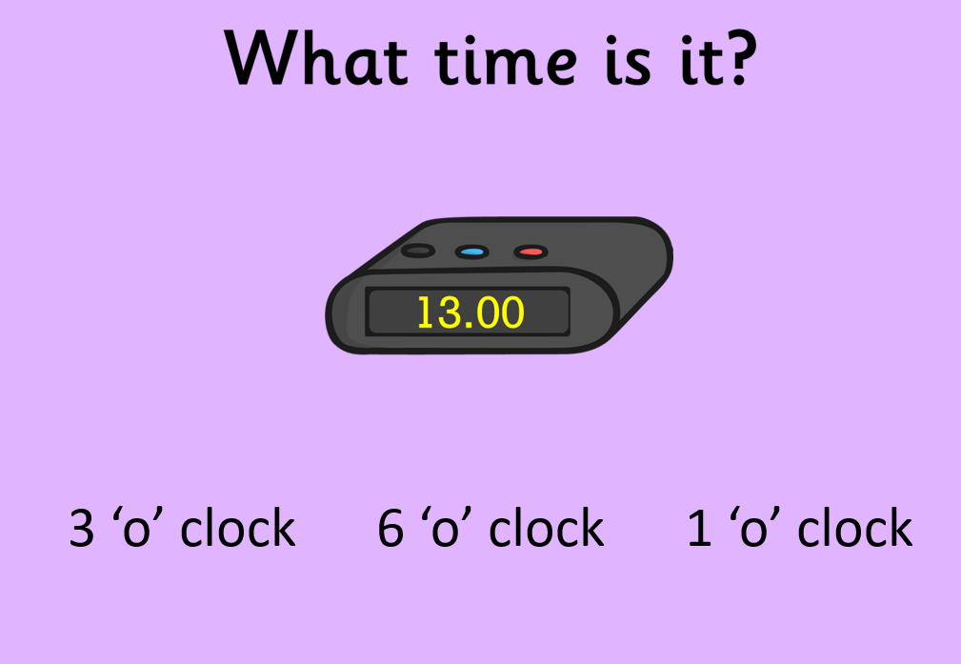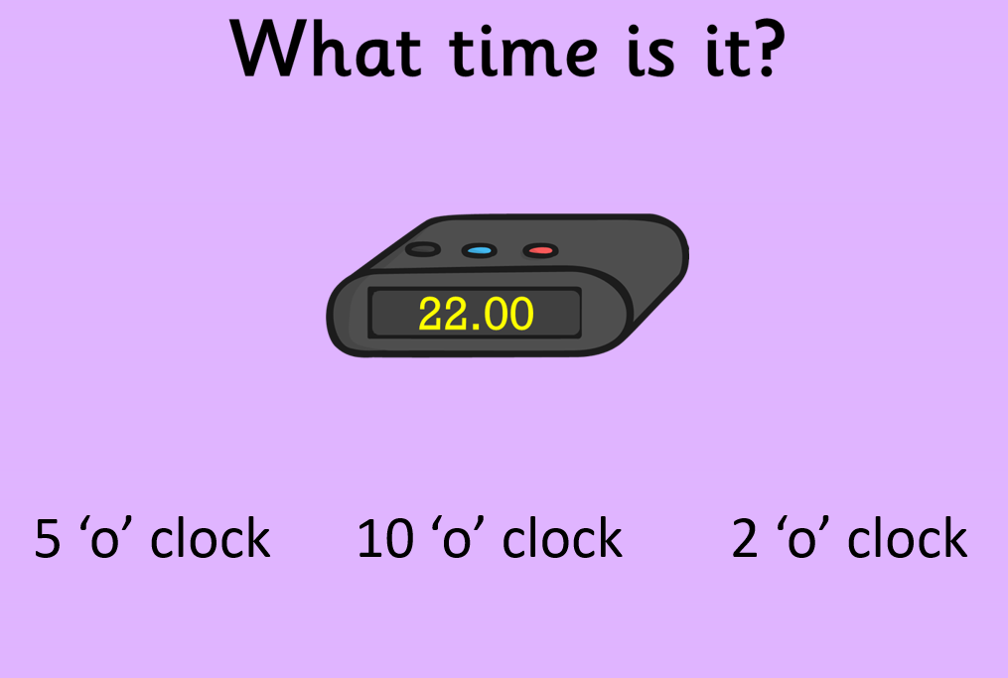
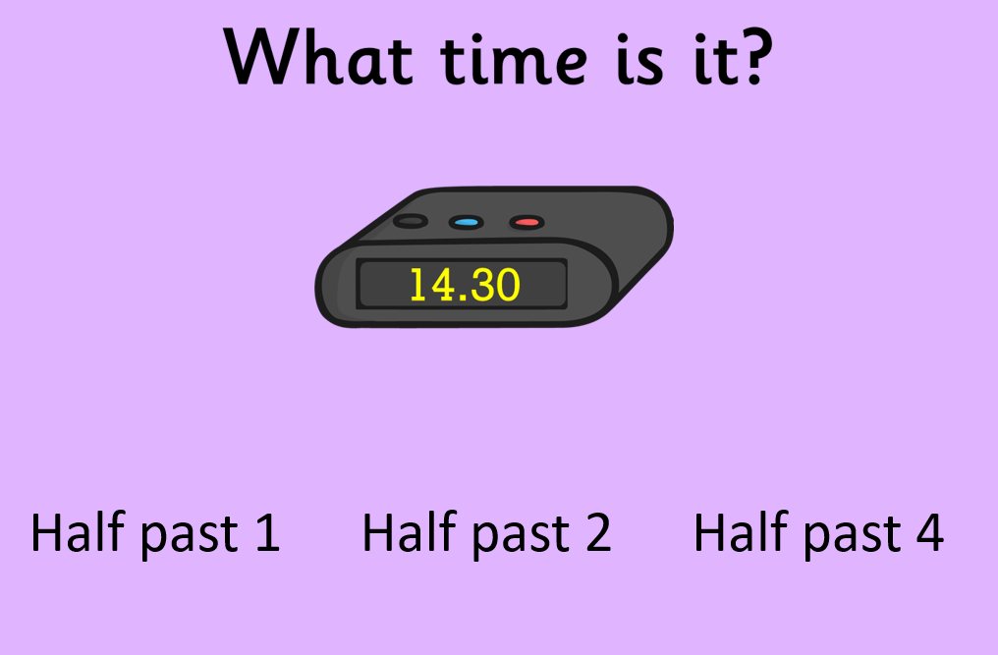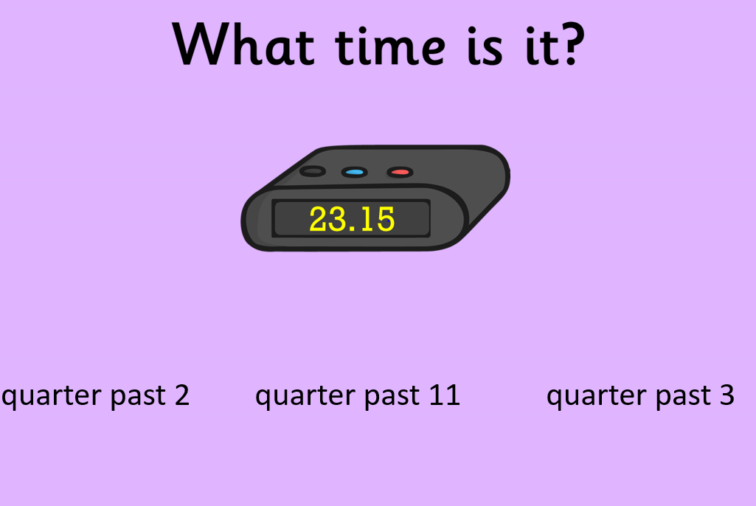

SESSION 3 ENGLISH – VOCABULARY
Re-read the book and put as many interesting words as you can into the grid. Think about the words used the describe his movements, how he felt and how others saw him. Can you find the simile in the story?
Now use the WOW WORDS word mat I’ve attached to write down GIANT size words you would like to use in your story. Find at least two words each to describe the Giant’s:
Character:

Feelings:

Size:

Interesting words I have found:
Nouns (person, place, thing)
Adjectives (describes the noun)
Verbs
(action words)
Adverbs
(ly)
SESSION 3 – TOP TRUMP CARDS
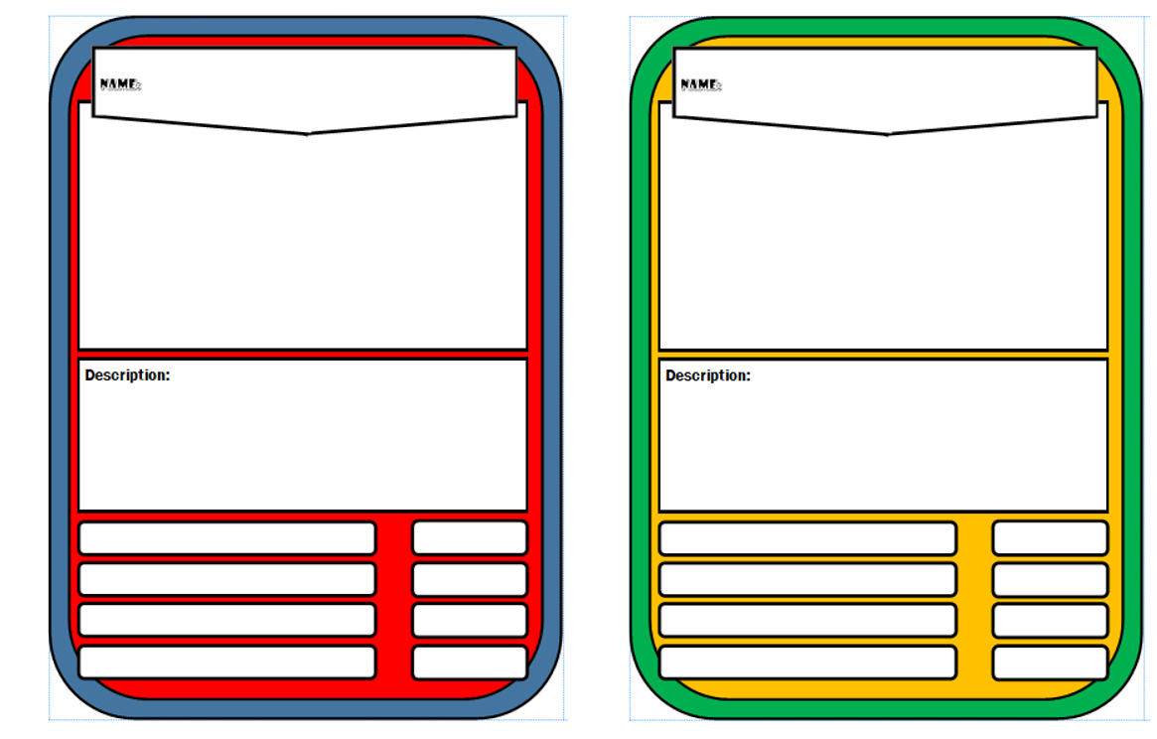

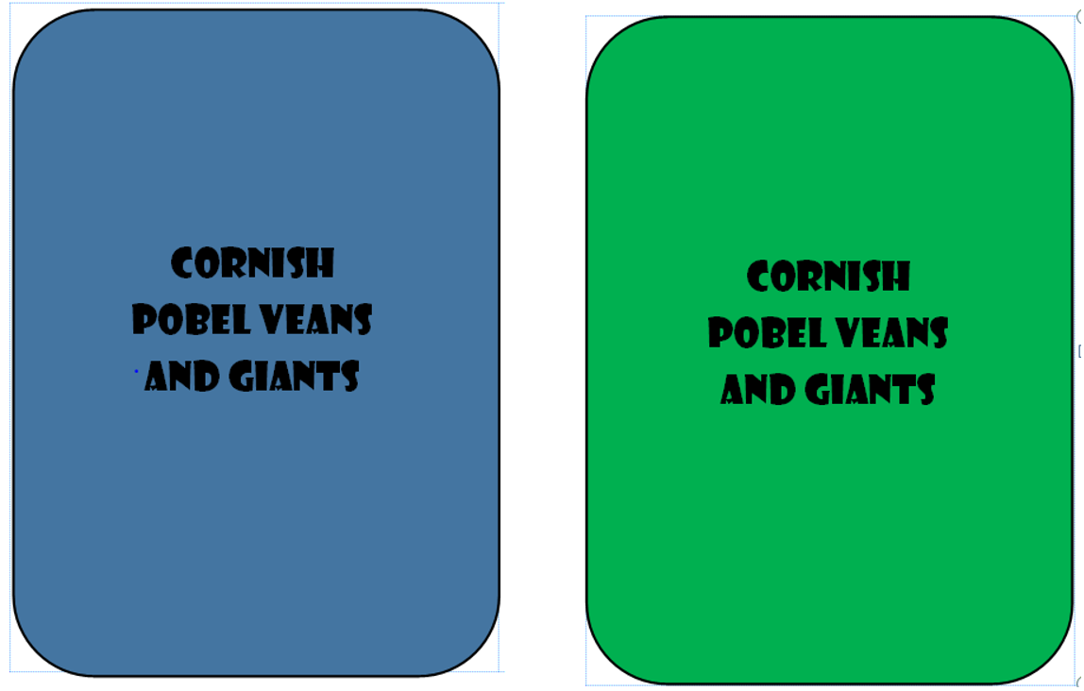
SESSION 4- TIME
