SESSION 4 ENGLISH – ‘SAID’ SYNONYMS
Read this text and underline all the times the word ‘said’ is used:

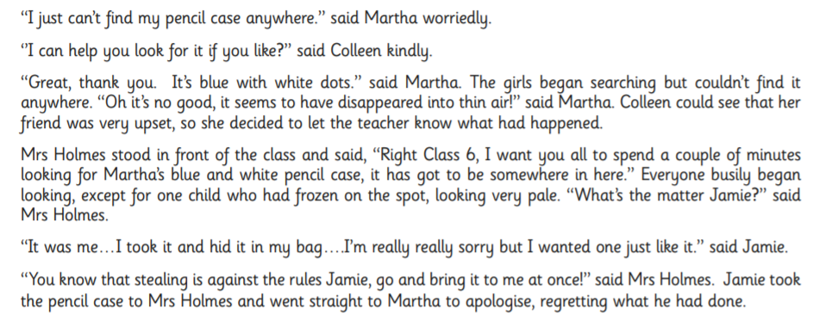

‘Said’ is used quite a lot isn’t it! How does it read to you? BORING??
A SYNONYN is a different word to replace a word you don’t want to use. Now look at these synonyms for the word ‘said’:
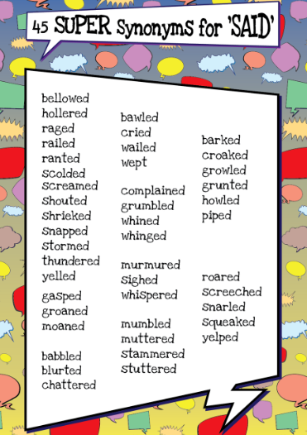
Replace the word ‘said’ with a more powerful synonym from the list.
Tip: THINK ABOUT HOW THE PERSON WOULD SAY THEIR WORDS. A scared little girl would not ‘roar’ her words, but she might have ‘whispered’ or ‘stammered’.

“I just can’t find my pencil case anywhere,” __________ Martha worriedly.

“What’s the matter Jamie?” _________________ Mrs Holmes.

“It was me… I took it and hid it in my bag… I’m really sorry but I wanted one just like it.” ________________ Jamie.

“You know stealing is against the rules, Jamie, go and bring it to me at once!”
________________________ Mrs Holmes. (Think what the ! means)

FINALLY:
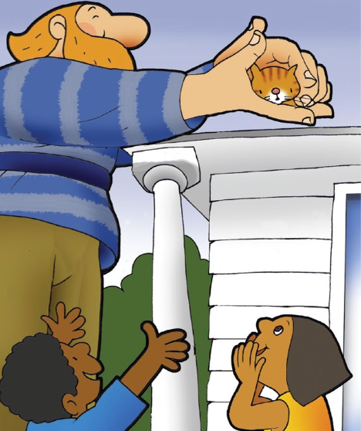
Here’s a part of our story, The Lonely Giant. Have a go at writing a conversation between the Giant and the children. They will need to ask for help first.
USE THE SUPER SYNONYMS LIST FOR ‘SAID’

