NOTE TO PARENTS: Over the next two weeks, we are going to explore the mythical creatures which underpin many a Cornish myth. This week we will learn about the magical POBEL VEAN (Little People) who were said to dwell in Cornwall. We will look at the history of Cornish Piskies, Buccas and The Knockers. However, many tales (particularly surrounding the Cornish Piskie) can be quiet dark and scary so please stick to the activities and sites that we suggest (unless supervised) as they have been checked and deemed age appropriate.
8.6 | ENGLISH | MATHS | ENQUIRY | ACTIVE
S  E  S  S  I  O  N  1 | READING COMPREHENSION  Today you are going to read the story about John the fisherman and the Piskies attached below the Blog.  Read the text carefully and answer the VIPERS questions.  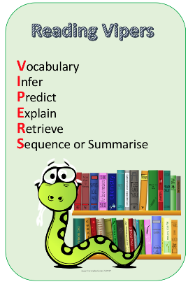  Check your answers.  Think about which VIPERS you didn’t get right, this is your feedback and your next steps for learning. | AREA AND PERIMETER  Watch the lesson and pause the video when asked, Find the worksheet you need attached below the blog. Check your answers. Remember, mistakes are good because you need to work out why and where you went wrong, so practising your learning.  Year 4 – Summer Term Week 4 lesson 2 Perimeter of rectangles.  https://whiterosemaths.com/homelearning/year-4/  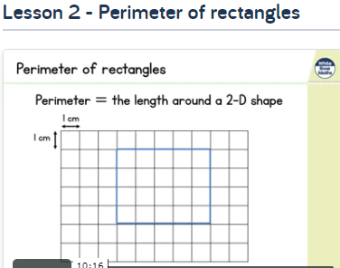  Year 5 –Summer Term Week 3 lesson 4 Calculate perimeter  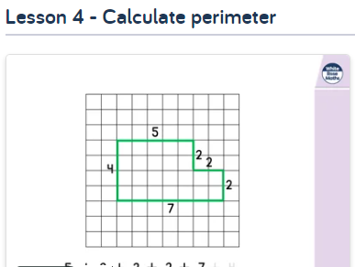  https://whiterosemaths.com/homelearning/year-5/ | LOCAL HISTORY  Cornish myths, like legends such as King Arthur, have been around for centuries. Do you know the difference between a myth and a legend? A legend has an element of fact within it and real people become larger than life, but a myth usually explains local beginnings and has supernatural/magical creatures in it. POBEL VEANS are the ‘Little People’ of Cornish folk law and we will look into the three main creatures which supposedly dwelled in Cornwall.  Read through the ‘Pobel Vean’ word document and decide whether you believe in the myths. Why do you think they existed?  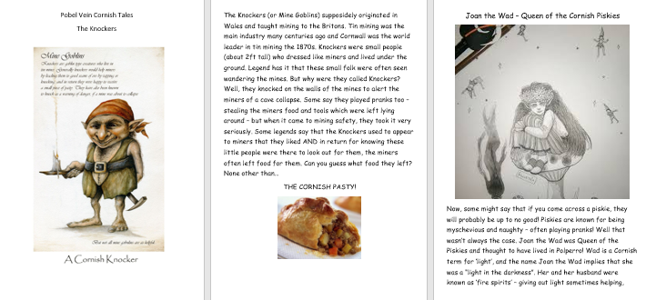  ACTIVITY: Complete the table below the grid  Do you know any other myths, which have similar features? (pixies/mermaids/fairies) | WEEKLY PE CHALLENGE  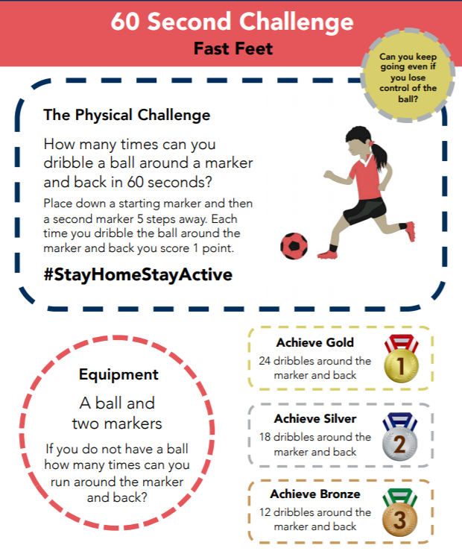  SEE BELOW FOR BIGGER PICTURE  Make a record each day and see if you can achieve gold by the end of the week!
S  E  S  S  I  O  N  2 | Character description - planning  Today and tomorrow, you are going to plan and write a character description of John, the fisherman. You need to consider both his personality (what kind of person he is) and his appearance (what he might look like).  Start by looking at PPT character description to remind you of the language devices we use to write character descriptions and to find inspiration for your work.  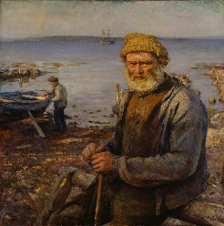  Now you need to fill in the planning sheet with as much detail as you can. Remember the more words and phrases you generate today, the more you have to use for your writing.  I have attached some vocabulary mats for character descriptions below the Blog. | AREA AND PERIMETER  Year 4 – Summer Term Week 4 lesson 3  Perimeter of rectilinear shapes  https://whiterosemaths.com/homelearning/year-4/  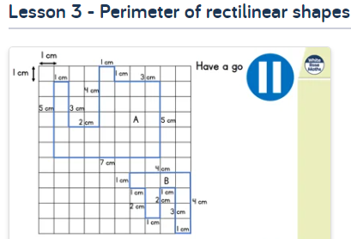  Year 5 –Summer Term Week 4 lesson 1  Area of rectangles  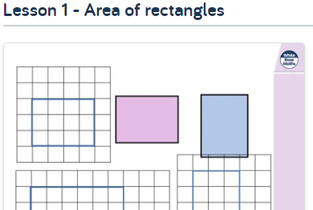  https://whiterosemaths.com/homelearning/year-5/ | SCIENCE – Gravity  In myths, magical creatures often defy gravity. They often fly, hover, or float above the ground.  We, unfortunately do not defy gravity. Our feet are firmly on the ground and when we jump – we always land (sometimes on other parts of our body – ouch!)  Let’s conduct a few experiments into just how gravity works:  https://www.science-sparks.com/gravity-experiments-for-kids-galileo/  Look at the table (SESSION 2 ENQUIRY) and collect the items in the list. Predict which will hit the ground first and why you think that is.  REMEMBER: Drop them from the same height to ensure it is a fair test.  Surprised at what you find? Watch this to reveal the science behind gravity – and explain the crazy paper result! https://www.youtube.com/watch?v=dxcx35x5L9Y | ACTIVE  Try some activities from  #ThisIsPE  https://www.youtube.com/playlist?list=PLYGRaluWWTojV3An2WEgsQ4qGFy_91jDL  You can choose from lots of different skills. How fast are you at Fast Feet?
S  E  S  S  I  O  N  3 | Character description – writing  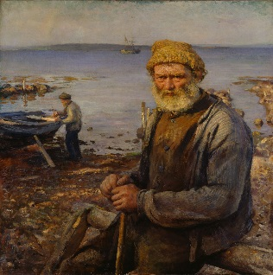  Today you need to use your planning to write the description of John.  SUCCESS CRITERIA  - Describe how he looks  - Describe his personality  - Use a variety of language devices  - Use a variety of sentence types  I have attached some different sentence types mats below the Blog.  - 2A sentence  - Simile sentence  - 3 bad-(dash) question?  - NOUN, who/ which/ where sentences. | AREA AND PERIMETER  Year 4 – Summer Term Week 4 lesson 4 Area counting squares.  https://whiterosemaths.com/homelearning/year-4/  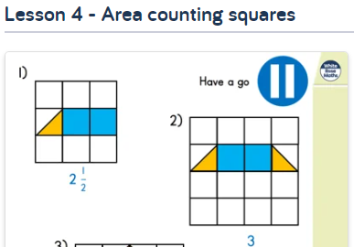  Year 5 – Oak Academy Finding perimeter and converting units of measurements.  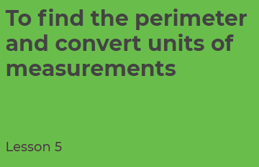  https://www.thenational.academy/year-5/maths/to-find-the-perimeter-and-convert-units-of-measurements-year-5-wk3-5  Click on the link and click to find lesson video (you don’t need to do the quiz). Follow the learning and have a go at the independent task. | ART/ - Design your own Pobel Vean.  You are going to design your own ‘little person’ who might live in this home.  Click on link:  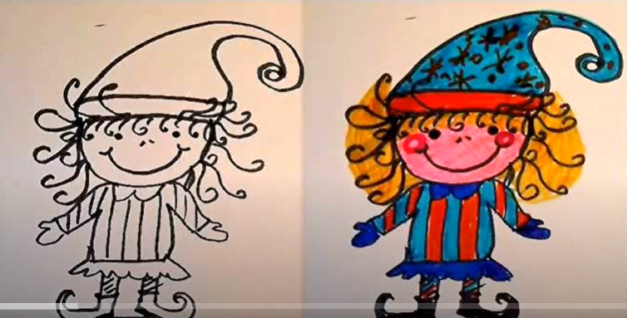  https://www.youtube.com/watch?v=BdsH_9n7COs  What will they wear? Will they carry something? Where will they live? Are they kind and helpful or mischievous and naughty? Assign a specific characteristic/special power to your Pobel Vean.  Give it a name and send me a photo!  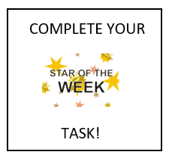 | ACTIVE  Choose 2 activities:  - Joe Wicks PE  - Super Movers  - iMovers  or  Go Noodle – GoNoodle for Families https://family.gonoodle.com/channels/zumba-kids  Try a new routine!
S  E  S  S  I  O  N  4 | Follow the link to Pobble 365 – Small Folk https://www.pobble365.com/small-folk  Answer the questions in the Question time section.  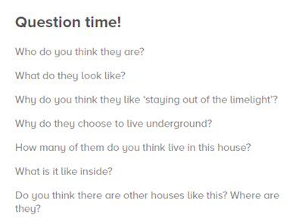  ACTIVITY: Imagine the picture is the home of the Pobel Vean you created yesterday. Draw one of the rooms inside the house. Remember to add some items that shows it is the home of your Pobel Vean – so if he/she is a master sword fighter – there will be a collection of swords. If he/she is a healer, there will lots of lotions and potions. | AREA AND PERIMETER  Complete the set tasks on Mathletics on area and perimeter.  Year 4  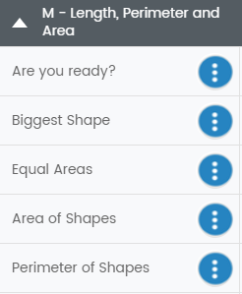  Year 5  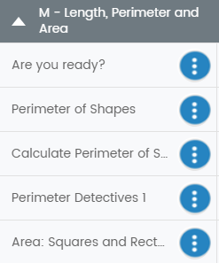 | ART/DT  Create a Top Trumps card for your Pobel Vean.  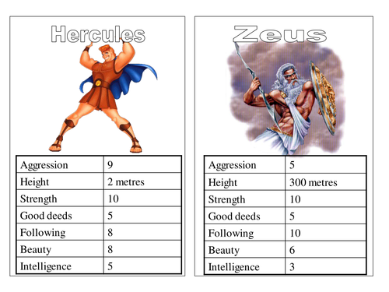  Think about:  Height, magical power (invisibility, mind control, emits light, moves things) /ugliness/speed/good or bad deeds/intelligence.  Templates attached below for you to use or as a base to create from.  Extension: Create a set of Pobel Veans, Joan the Wad, The Knockers and The Buccas. Is your creature faster than a Knocker but less powerful than Joan?  (We are studying giants next week so we can add more creatures to our ‘set’) | ACTIVE  Choose an indoor Shake Up activity from:  https://www.nhs.uk/change4life/activities/indoor-activities  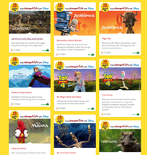
S  E  S  S  I  O  N  5 | DESCRIPTIVE WRITING  You have a problem that needs solving and the only person who can help is your Pobel Vean. Think about what characteristic you have assigned to your Pobel Vean and how this will help them solve your problem. You need to write them a letter to persuade them to help you solve your problem.  Perhaps you have lost your confidence to ride your bike and you know your Pobel Vean could make a potion to fix this. Perhaps you have lost that special gift your friend gave you and your Pobel Vean can see into the past.  Success criteria  Use letter format  Use features of persuasion  Clearly describe your problem and how you want it solved  Use a variety of sentence structures  - 2A sentence  - Simile sentence  - 3 bad-(dash) question?  - NOUN, who/ which/ where sentences. | NUMBER FLUENCY  Last week we looked at subtract the tens strategy for an easier way to subtract 1 digit numbers from 2 digit numbers. This week, we are going to investigate how to use compensation to make subtraction easier.  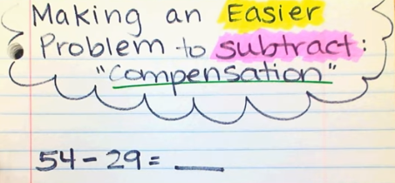  https://www.youtube.com/watch?v=KO_qBYnOPV4  Watch the video and have a go at this.  I have added some practice sums below the blog.  Once you have tried this strategy, spend time practising your times tables. I have added ultimate challenges below the blog or if you prefer, use Hit the Button, TTR or go outside to bounce a ball, skip, jump. | DT: Create your own Piskie Dwelling  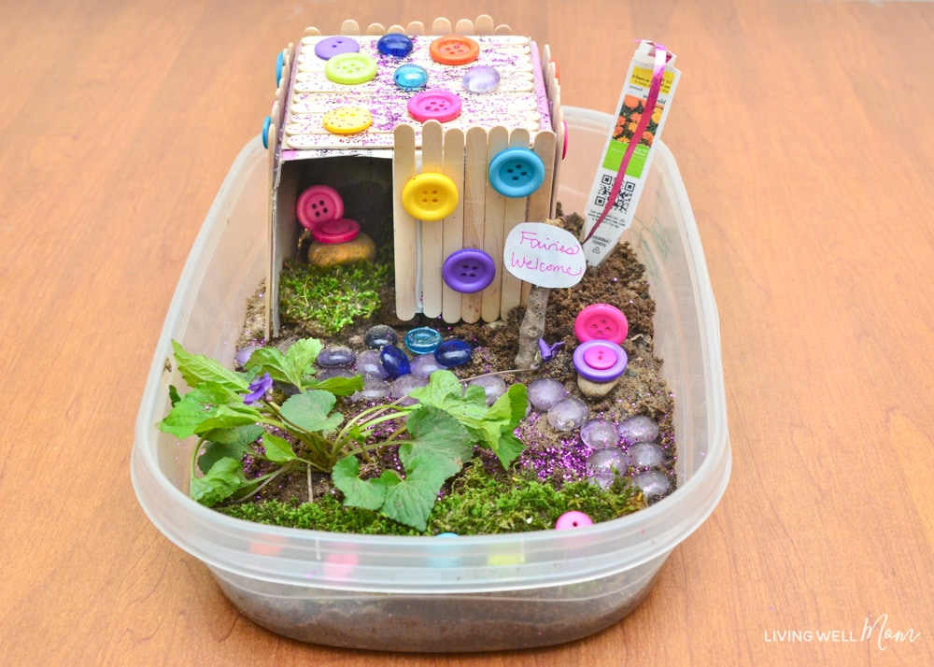  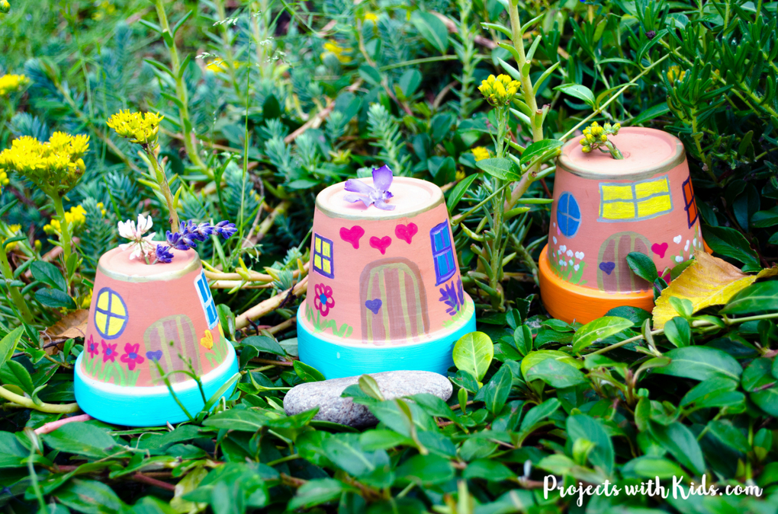  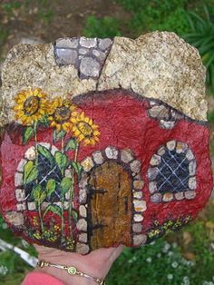 | ACTIVE  Choose 1 activity:  - Joe Wicks PE Workout  - iMovers  OR  Choose a PE activity from  Youth Sport Trust  https://www.youthsporttrust.org/pe-home-learning

