ITEMS | PREDICTION: Which will land first? Will they land at the same time? | Why do you think this will happen? | OBSERVATION: Were your predictions correct?  Can you explain why this happened?
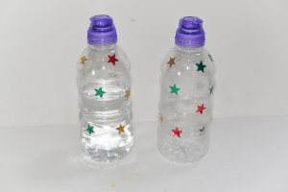
2 X bottles. One half full and one empty
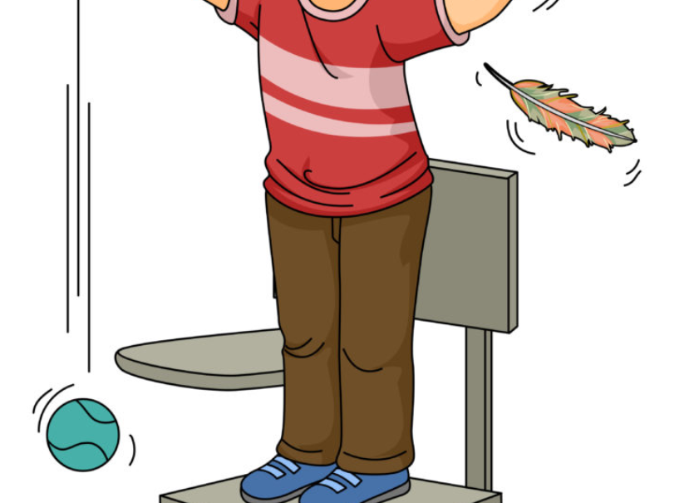
1 x feather and 1 x tennis ball
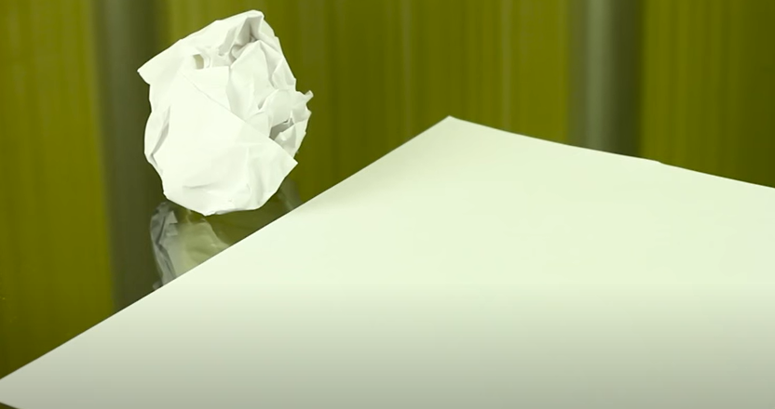
Two same sized pieces of paper – one crumpled and one flat.
Two objects the same weight but different in size.

