NOTE TO PARENTS: Over the next two weeks, we are going to explore the mythical creatures which underpin many a Cornish myth. This week we will learn about the magical POBEL VEAN (Little People) who were said to dwell in Cornwall. We will look at the history of Cornish Piskies, Buccas and The Knockers. However, many tales (particularly surrounding the Cornish Piskie) can be quiet dark and scary so please stick to the activities and sites that we suggest (unless supervised) as they have been checked and deemed age appropriate. Many thanks, Mrs Eccles.
English | MATHS | ENQUIRY | Active
READING COMPREHENSION  Today you are going to read the story about John the fisherman and the Piskies attached to the Blog.  Read the text carefully and answer the VIPERS questions.  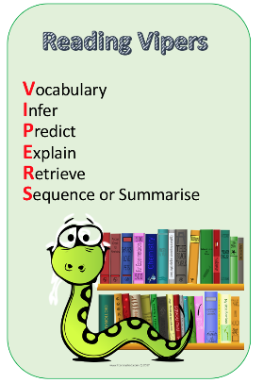  Check your answers.  Think about which VIPERS you didn’t get right, this is your feedback and your next steps for learning. | https://whiterosemaths.com/homelearning/year-6/  Go to the above link and watch the video for Summer Term Week 6, Lesson 1 (Fractions to percentages)  Complete the worksheet attached to the blog for today. | LOCAL HISTORY  Cornish myths, like legends such as King Arthur, have been around for centuries. Do you know the difference between a myth and a legend? A legend has an element of fact within it and real people become larger than life, but a myth usually explains local beginnings and has supernatural/magical creatures in it. POBEL VEANS are the ‘Little People’ of Cornish folk law and we will look into the three main creatures which supposedly dwelled in Cornwall.  Read through the ‘Pobel Vean’ information sheet that is attached to the blog with an adult and discuss whether you believe in the myths. Why do you think they existed?  Complete the Pobel Vean activity table attached to the blog.  Do you know any other myths which have similar features? (pixies/mermaids/fairies) | Weekly PE challenge  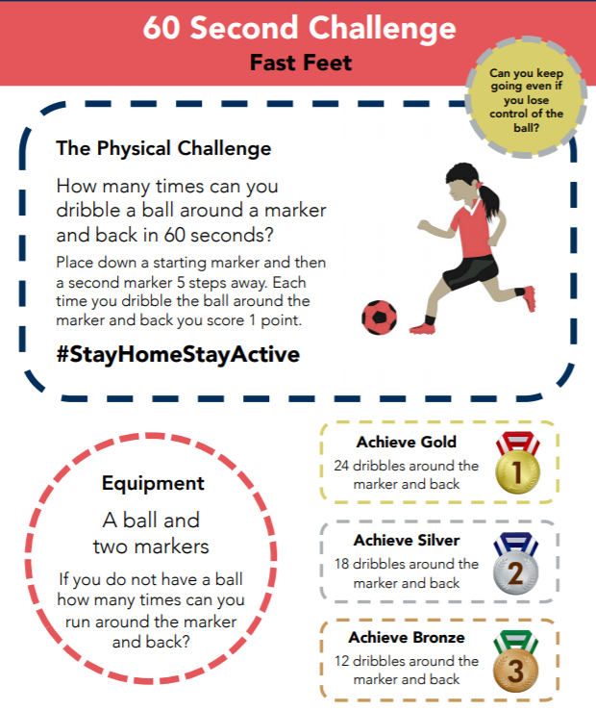  SEE BELOW FOR BIGGER PICTURE  Make a record each day and see if you can achieve gold by the end of the week!
Character description - planning  Today and tomorrow, you are going to plan and write a character description of John, the fisherman. You need to consider both his personality (what kind of person he is) and his appearance (what he might look like).  Start by looking at the character description PowerPoint to remind you of the language devices we use to write character descriptions and to find inspiration for your work.  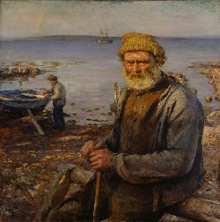  Now you need to fill in the planning sheet with as much detail as you can. Remember the more words and phrases you generate today, the more you have to use for your writing.  I have attached some vocabulary mats for character descriptions to the Blog. | https://whiterosemaths.com/homelearning/year-6/  Go to the above link and watch the video for Summer Term Week 6, Lesson 2 (Equivalent FDP)  Complete the worksheet attached to the blog for today. | SCIENCE – Gravity  In myths, magical creatures often defy gravity. They often fly, hover, or float above the ground.  We, unfortunately do not defy gravity. Our feet are firmly on the ground and when we jump – we always land (sometimes on other parts of our body – ouch!)  Let’s conduct an experiments into just how gravity works:  Look at the gravity worksheet that is attached to the blog and collect the items in the list. Predict which will hit the ground first and state why you think that is.  Drop each pair of items from the same height at the same time and observe what happens. Which object hits the ground first?  Watch this video for an explanation of your results. https://www.youtube.com/watch?v=dxcx35x5L9Y  If you’d like to try some more gravity experiments, there are lots of different ones to try here:  https://www.science-sparks.com/gravity-experiments-for-kids-galileo/ | Have a look at this website. #ThisIsPE  https://www.youtube.com/playlist?list=PLYGRaluWWTojV3An2WEgsQ4qGFy_91jDL  Choose an activity of your choice.
Character description – writing  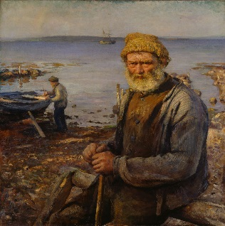  Today you need to use your planning to write the description of John.  SUCCESS CRITERIA:  - Describe how he looks  - Describe his personality  - Use a variety of language devices  - Use a variety of sentence types  I have attached some different sentence types mats below the Blog. How many can you include in your description?  - 2A sentence  - Simile sentence  - 3 bad-(dash) question?  - NOUN, who/ which/ where sentences. | https://whiterosemaths.com/homelearning/year-6/  Go to the above link and watch the video for Summer Term Week 6, Lesson 3 (Order FDP)  Complete the worksheet attached to the blog for today. | ART - Design your own Pobel Vean. https://www.pobble365.com/small-folk Take a look at this picture.  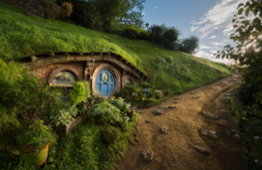  You are going to design your own ‘little person’ who might live in this home.  Watch this video for a guide to how to draw a pixie.  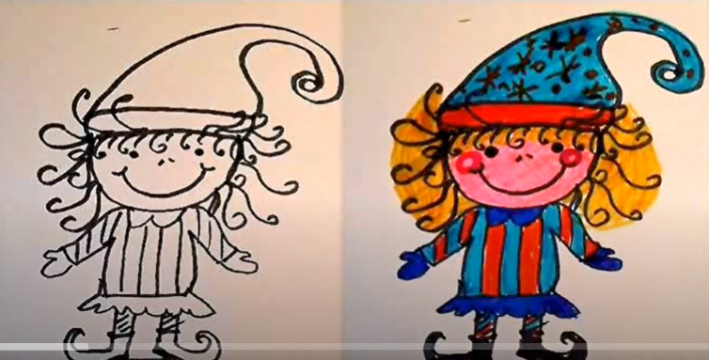  https://www.youtube.com/watch?v=BdsH_9n7COs  What will they wear? Will they carry something? Where will they live? Are they kind and helpful or mischievous and naughty?  Give it a name and send me a photo! | Choose 2 activities:  - Joe Wicks Workout  - Super Movers  - iMovers  Then practice your 60 second challenge
Follow the link to Pobble 365 – Small Folk https://www.pobble365.com/small-folk  Answer the questions in the Question time section.  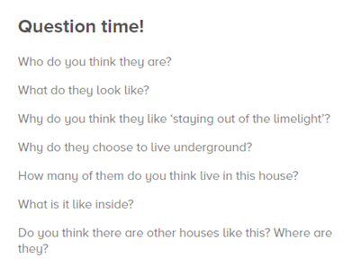  Imagine the picture is the home of the Pobel Vean you created yesterday. Draw one of the rooms inside the house. Remember to add some items that show it is the home of your Pobel Vean – so if he/she is a master sword fighter – there will be a collection of swords. If he/she is a healer, there will be lots of lotions and potions. | https://whiterosemaths.com/homelearning/year-6/  Go to the above link and watch the video for Summer Term Week 6, Lesson 4 (Percentages of Amounts)  Complete the worksheet attached to the blog for today. | ART/DT  Create a Top Trumps card for your Pobel Vean.  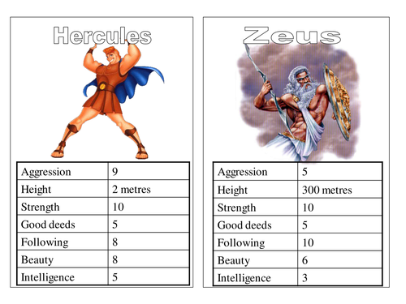  Think about:  Height, magical power (invisibility, mind control, emits light, moves things) / ugliness/speed/good or bad deeds/intelligence.  There is a template attached to the blog if you would like to use it.  Extension: Why not create a set of Pobel Veans? Create cards for Joan the Wad, The Knockers and The Buccas. Is your creature faster than a Knocker but less powerful than Joan?  (We are studying giants next week so we can add more creatures to our ‘set’) | Choose an indoor Shake Up activity from:  https://www.nhs.uk/change4life/activities/indoor-activities  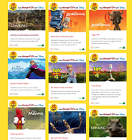
DESCRIPTIVE WRITING  You have a problem that needs solving and the only person who can help is your Pobel Vean. Think about what characteristic you have assigned to your Pobel Vean and how this will help them solve your problem. You need to write them a letter to persuade them to help you solve your problem.  Perhaps you have lost your confidence to ride your bike and you know your Pobel Vean could make a potion to fix this. Perhaps you have lost that special gift your friend gave you and your Pobel Vean can see into the past.  Success criteria:  - Use letter format  - Use features of persuasion  - Clearly describe your problem and how you want it solved  - Use a variety of sentence structures:  - 2A sentence  - Simile sentence  - 3 bad-(dash) question?  - NOUN, who/ which/ where sentences. | Complete the arithmetic questions that are attached to the blog.  You do not have to time yourself – you can work through them at your own pace.  If you do want to time yourself then allow yourself 30 minutes to complete all the questions.  Use the answers to check it when you’ve finished. | DT: Create your own Piskie Dwelling  Have a go at building your own piskie garden like the ones in the pictures below. You can use flowers from your garden/daily walk to decorate it.  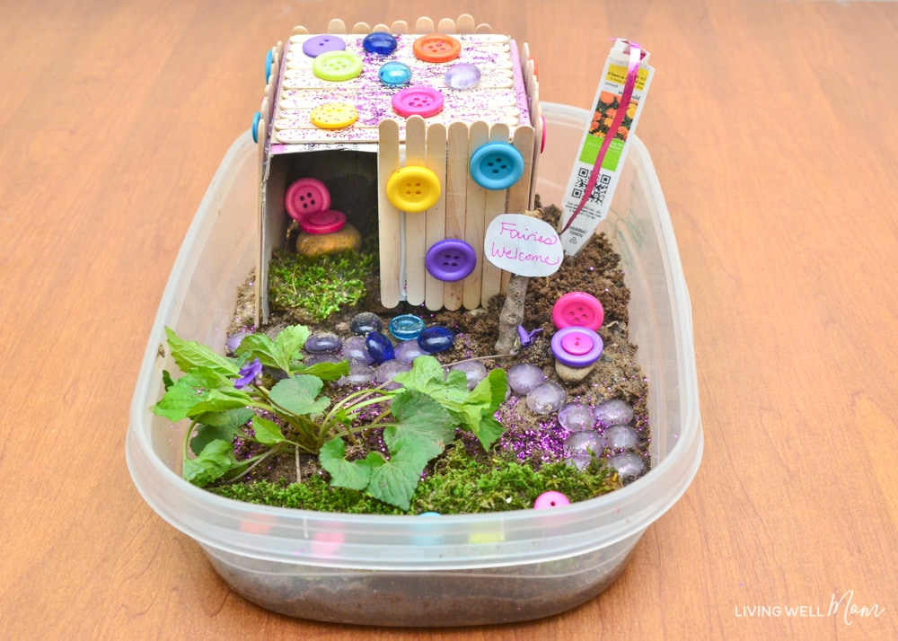  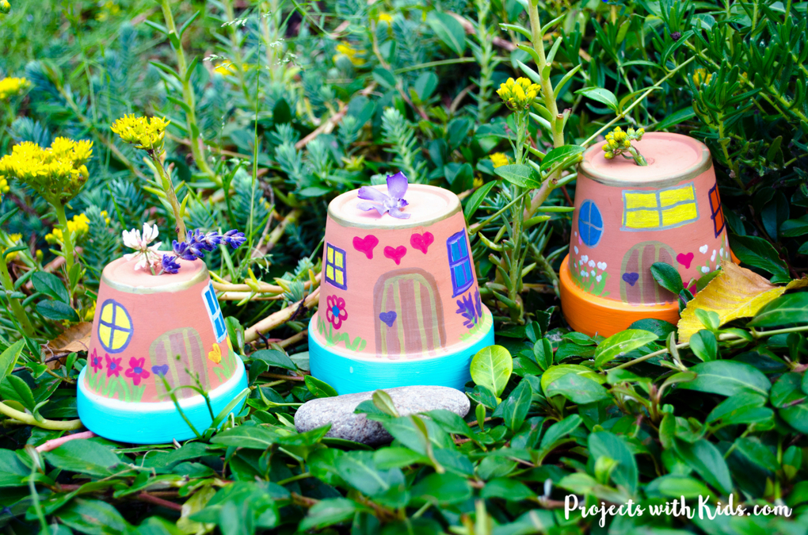  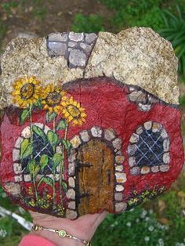 | Choose 1 activity:  - Joe Wicks (The Body Coach TV) Workout  - iMovers  PLUS:  Little Sports children’s fitness videos https://www.youtube.com/watch?v=L-8wW40jTzc

