NOTE TO PARENTS: Over the next two weeks, we are going to explore the mythical creatures which underpin many a Cornish myth. This week we will learn about the magical POBEL VEAN (Little People) who were said to dwell in Cornwall. We will look at the history of Cornish Piskies, Buccas and The Knockers. However, many tales (particularly surrounding the Cornish Piskie) can be quite dark and scary so please stick to the activities and sites that we suggest (unless supervised) as they have been checked and deemed age appropriate. Many thanks, Miss Chadwick.
 | ENGLISH | MATHS | ENQUIRY | ACTIVE
S  E  S  S  I  O  N | Follow the link to Pobble 365 – Small Folk https://www.pobble365.com/small-folk  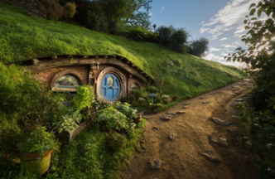  Now imagine who might live there. Answer these questions:  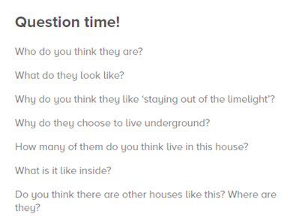 | This week is all about times tables!  How fast can you write out your 2, 5 and 10 times tables? Start a timer and write them out. Remember to write them like this:  1 x 2 = 2  2 x 2 = 4  Etc.  Which times table was the easiest to remember? Did you find any of them tricky?  Check your answers using the times tables grid attached to the blog. Did you get them all right? Practise any you got wrong then see if you can write them all out correctly and beat your first time.  If you are feeling confident with your 2s, 5s and 10s, have a go at your 3 times tables!  Choose a times table supermovers to dance along to!  https://www.bbc.co.uk/teach/supermovers/times-table-collection/z4vv6v4 | LOCAL HISTORY  Cornish myths, like legends such as King Arthur, have been around for centuries. Do you know the difference between a myth and a legend? A legend has an element of fact within it and real people become larger than life, but a myth usually explains local beginnings and has supernatural/magical creatures in it. POBEL VEANS are the ‘Little People’ of Cornish folk law and we will look into the three main creatures which supposedly dwelled in Cornwall.  Read through the ‘Pobel Vean’ word document with an adult and discuss whether you believe in the myths. Why do you think they existed?  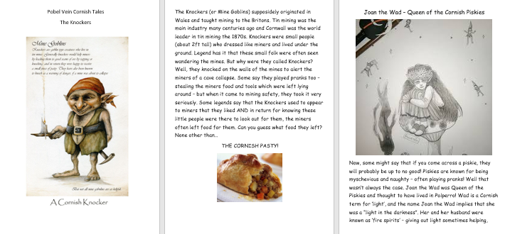  ACTIVITY: Complete the table below the grid  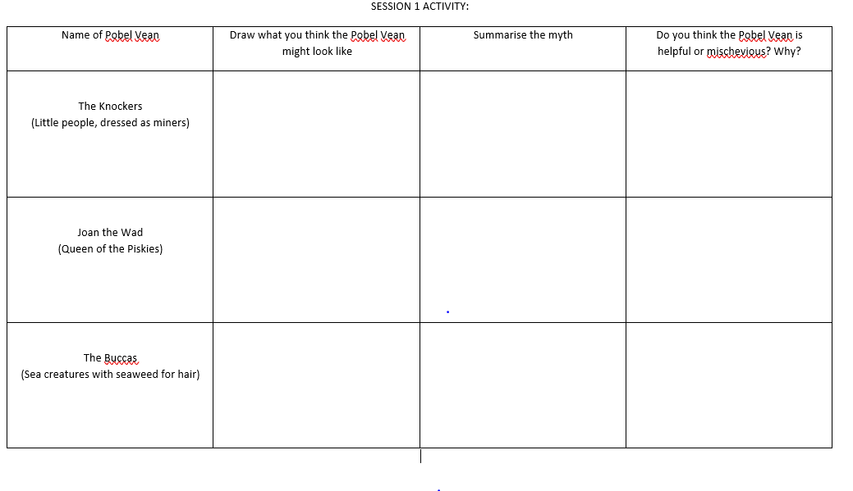  Do you know any other myths which have similar features? (pixies/mermaids/fairies) | Weekly PE challenge  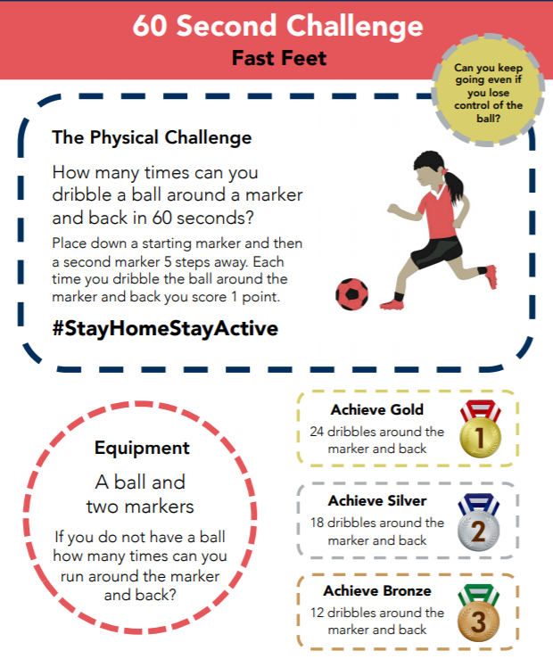  SEE BELOW FOR BIGGER PICTURE  Make a record each day and see if you can achieve gold by the end of the week!
S  E  S  S  I  O  N  2 | We all know what an adjective is but what is an adverb?  Remember that a verb is a doing word! So an adverb is a word that describes a verb.  e.g.  The girl ran quickly.  The door opened creakily.  Here is a song to explain:  https://www.youtube.com/watch?v=yo8pzuE97EA  Use what you know about adverbs to complete the Sick Sentences task on Pobble 365. Add as much detail as possible! You could use the adverb word mat attached to the blog to help you.  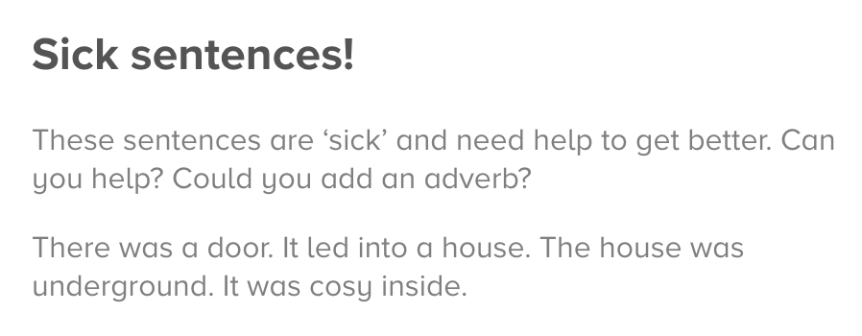 | Create your own dot-to-dot using the 2, 5 or 10 times tables. Challenge: use 3 times tables!  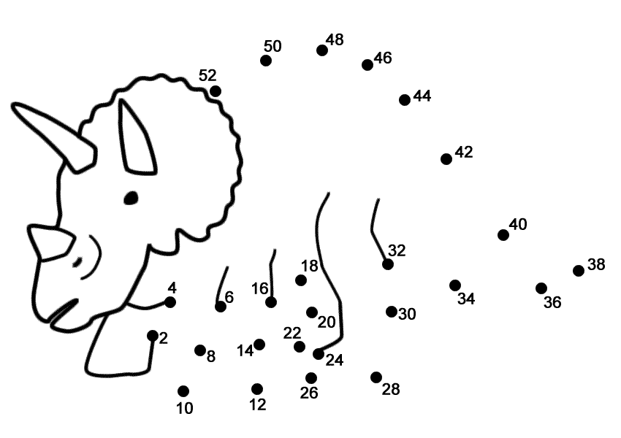  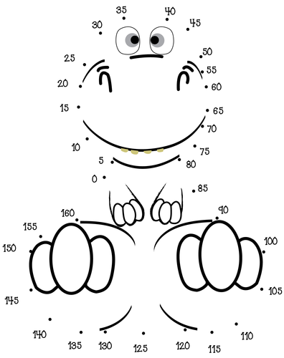 | SCIENCE – Gravity  In myths, magical creatures often defy gravity. They often fly, hover, or float above the ground.  We, unfortunately, do not defy gravity. Our feet are firmly on the ground and when we jump – we always land (sometimes on other parts of our body – ouch!)  Let’s conduct a few experiments into just how gravity works:  https://www.science-sparks.com/gravity-experiments-for-kids-galileo/  Look at the table (SESSION 2 ENQUIRY) and collect the items in the list. Predict which will hit the ground first and why you think that is.  REMEMBER: Drop them from the same height to ensure it is a fair test.  Surprised at what you find? Watch this to reveal the science behind gravity – and explain the crazy paper result! https://www.youtube.com/watch?v=dxcx35x5L9Y | Have a look at this website. #ThisIsPE  https://www.youtube.com/playlist?list=PLYGRaluWWTojV3An2WEgsQ4qGFy_91jDL  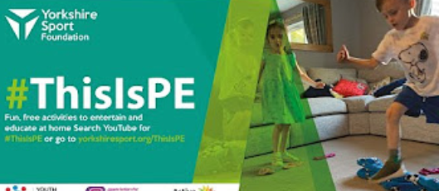  Choose an activity of your choice.
S  E  S  S  I  O  N  3 | Follow the link to Pobble 365 – Small Folk https://www.pobble365.com/small-folk  ACTIVITY: Draw one of the rooms inside the house. It could be the bedroom, living room or kitchen. What do you think is in there? A smelly, old sock draped over a chair? Fresh flowers in a vase/mug near a window? A bubbling stew pot over an open fire? Use your imagination.  Challenge: Describe your room using a range of adjectives and adverbs. | Play Stone Age Stu to practise your 2, 5 and 10 times tables.  https://mathsframe.co.uk/en/resources/resource/544/Stone-Age-Stu-Times-Tables  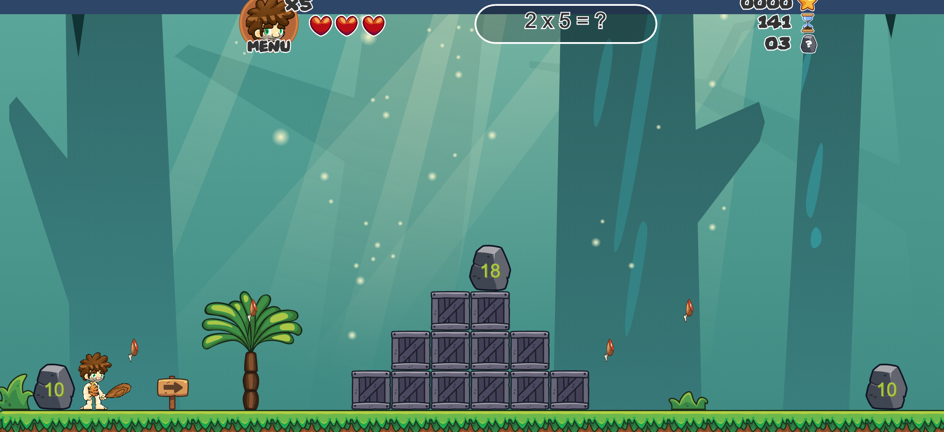  Use the arrow keys on your keyboard to move, space to hit and ctrl to jump.  Then choose a supermovers to dance along to:  https://www.bbc.co.uk/teach/supermovers/times-table-collection/z4vv6v4 | ART - Design your own Pobel Vean. https://www.pobble365.com/small-folk Take another look at the picture from English this morning.  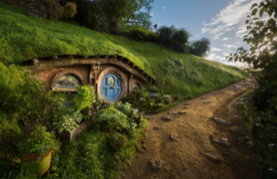  You are going to design your own ‘little person’ who might live in this home.  Click on link:  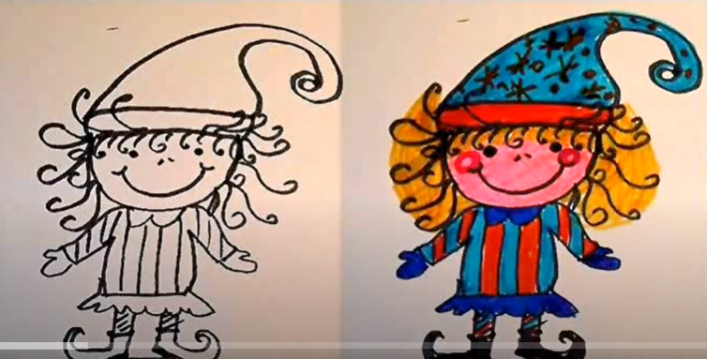  https://www.youtube.com/watch?v=BdsH_9n7COs  What will they wear? Will they carry something? Where will they live? Are they kind and helpful or mischievous and naughty? Give it a name and send me a photo! | Choose 2 activities:  - Joe Wicks Workout  - Super Movers  - iMovers  Then practice your 60 second challenge
S  E  S  S  I  O  N  4 | CHARACTER DESCRIPTION  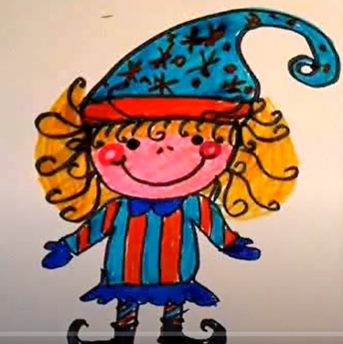  Now you have created a Cornish Pobel Vean, write a character description for it. Break your character description into three sections:  Appearance: What do they look like? Describe their clothes, physical appearance.  Personality: How do they act? Are they kind, helpful, grumpy? Do they stomp around or skip and jump?  Character: How do other people see them? Would you be happy and seek their help or be frightened and run and hide if you saw them?  Year 1: Write at least one sentence for each section.  Year 2: Write at least two sentences for each section.  Remember:  Finger spaces,  Capital letters and full stops,  Adjectives and adverbs. | Create your own times tables flowers. Write your target times table in the middle (Choose 2, 5, 10 or for a challenge 3), then on the inner petals write the numbers 1 to 12. Write the answers on the outer petals then colour it in!  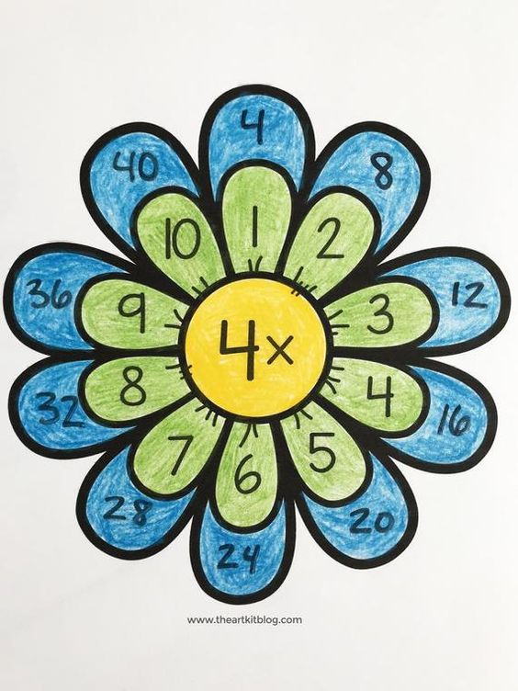 | ART/DT  Create a Top Trumps card for your Pobel Vean.  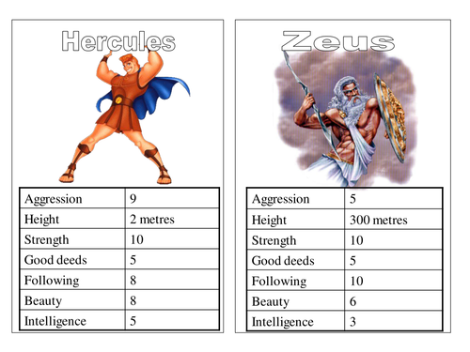  Think about:  Height, magical power (invisibility, mind control, emits light, moves things) / ugliness/speed/good or bad deeds/intelligence.  “I’ll attach some templates below for you to use or as a base to create from.”  Challenge: Why not create a set of Pobel Veans? Create cards for Joan the Wad, The Knockers and The Buccas. Is your creature faster than a Knocker but less powerful than Joan?  (We are studying giants next week so we can add more creatures to our ‘set’) | Choose an indoor Shake Up activity from:  https://www.nhs.uk/change4life/activities/indoor-activities  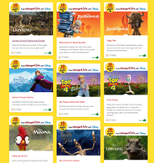
S  E  S  S  I  O  N  5 | IMAGINATIVE WRITING  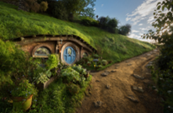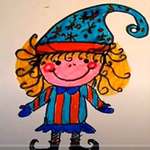  Imagine that you are out walking in the forest one day. You come across the Pobel Vean you created, standing outside the house you described.  What happened next…  Write a short story (Year 1 at least 3 sentences, Year 2 at least 5 sentences).  Success criteria:  - Finger spaces,  - Capital letters and full stops,  - Adjectives and adverbs,  - Conjunctions (and, but, so, if, because) | Create your own times table board game! Have a look at these for some inspiration:  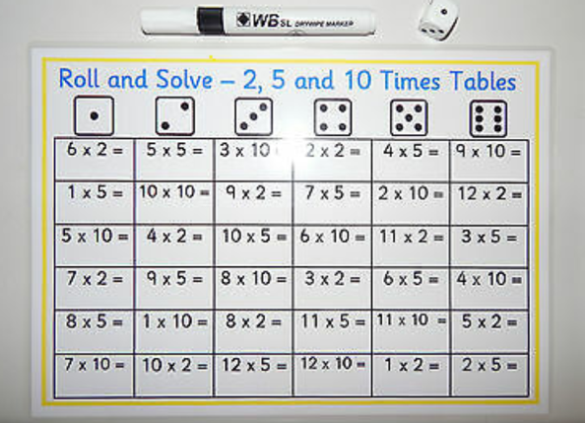  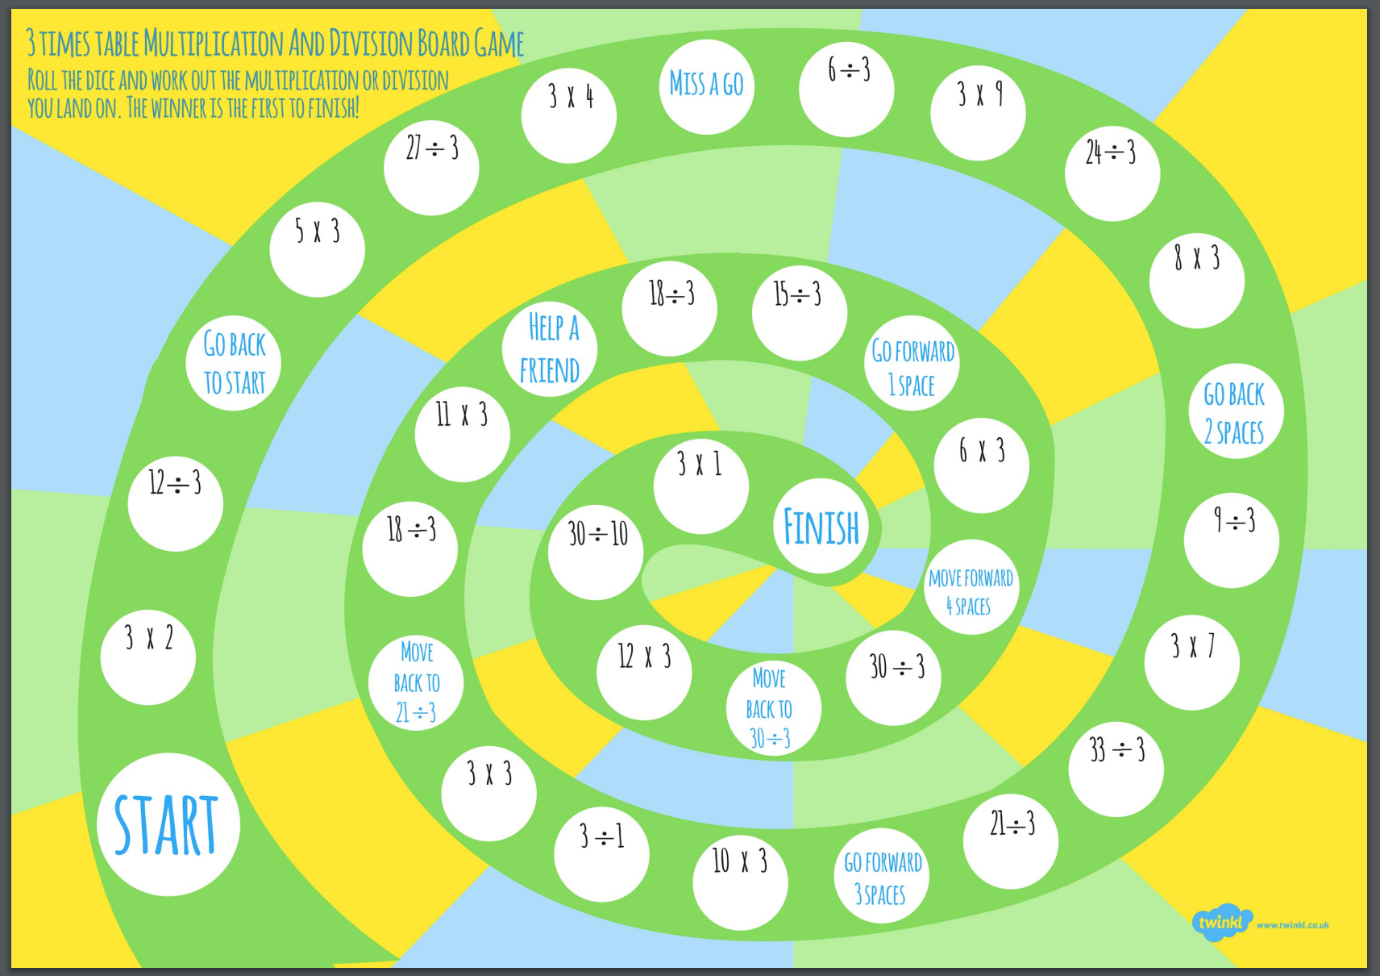 | DT: Create your own Piskie Dwelling  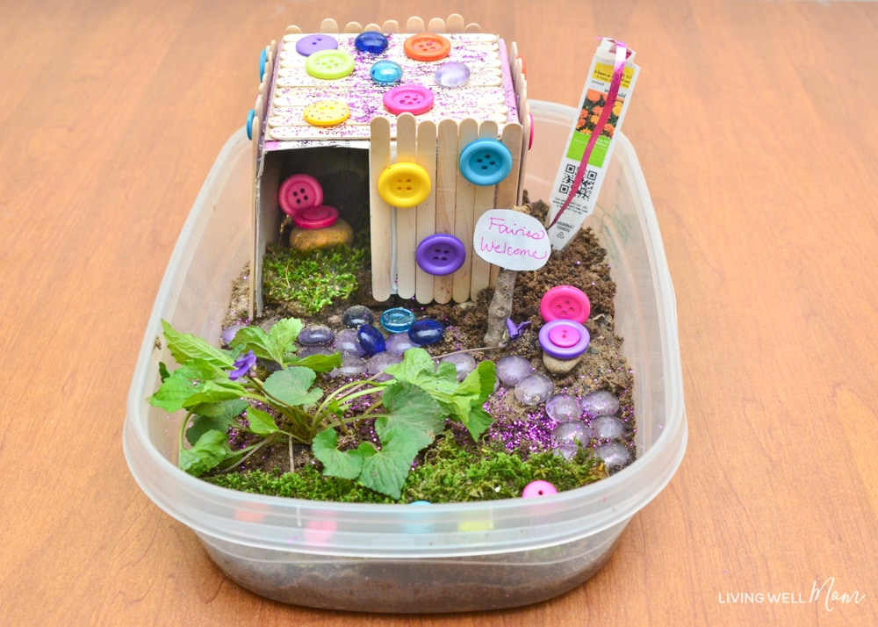  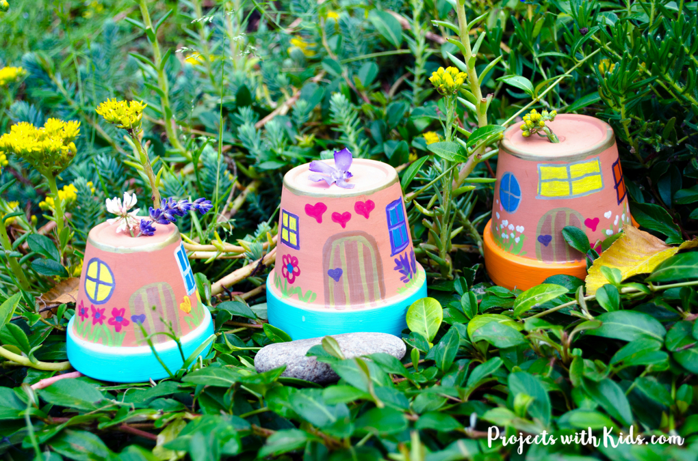  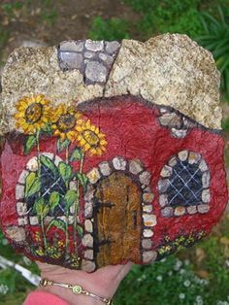 | Choose 1 activity:  - Joe Wicks (The Body Coach TV) Workout  - iMovers  PLUS:  Little Sports children’s fitness videos https://www.youtube.com/watch?v=L-8wW40jTzc
SESSION 1 ACTIVITY:
Name of Pobel Vean | Draw what you think the Pobel Vean might look like | Do you think this Pobel Vean is kind-hearted or not? Why?
The Knockers (Little people, dressed as miners)

Joan the Wad (Queen of the Piskies)

The Buccas (Sea creatures with seaweed for hair)

SESSION 1 ACTIVE – WEEKLY CHALLENGE

ITEMS | WHICH WILL LAND FIRST (OR WILL THEY BE TOGETHER?) | WERE YOUR PREDICTIONS RIGHT?
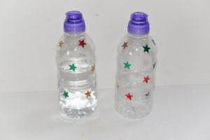
2 X bottles. One half full and one empty
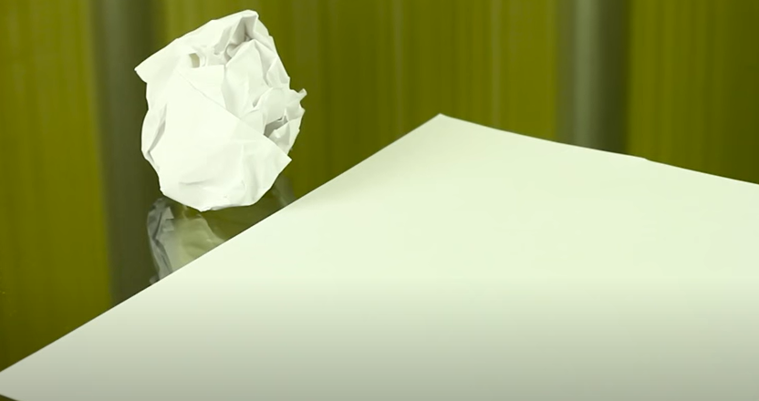
Two same sized pieces of paper – one crumpled and one flat.
Two objects the same size.
Two objects the same weight but different in size
SESSION 2 – ENQUIRY

Which result surprised you the most and why? ____________________________________________________________________________________________________
SESSION 4 ENQUIRY – TOP TRUMPS
