NOTE TO PARENTS: Over the next two weeks, we are going to explore the mythical creatures which underpin many a Cornish myth. This week we will learn about the magical POBEL VEAN (Little People) who were said to dwell in Cornwall. We will look at the history of Cornish Piskies, Buccas and The Knockers. However, many tales (particularly surrounding the Cornish Piskie) can be quiet dark and scary so please stick to the activities and sites that we suggest (unless supervised) as they have been checked and deemed age appropriate. Many thanks, Miss Randle.
 | ENGLISH | MATHS | ENQUIRY | ACTIVE
S  E  S  S  I  O  N  1 | READING COMPREHENSION  Read the Cornish tale (SESSION 1 READING COMP) of John the Fisherman and then answer the VIPERS questions:  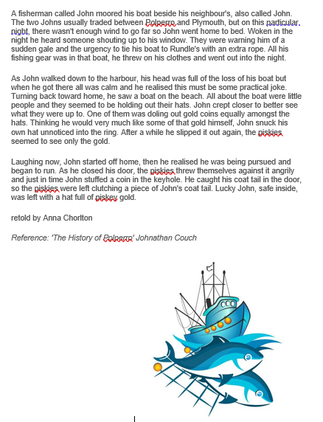  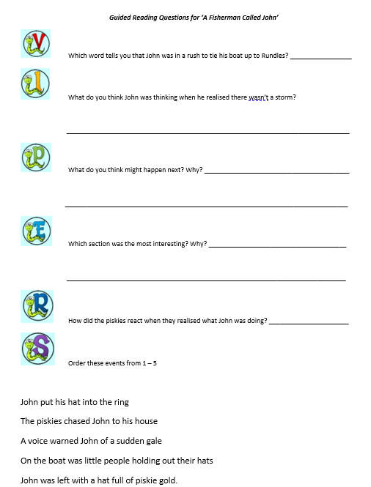 | We are going to compare time using analogue and digital clocks this week. In order to do this, we need to practise telling time to the nearest five minutes. Discuss: How many minutes in one hour? How many minutes in half an hour? When the minute hand is showing quarter past, how many minutes has passed?  Create this clock either using two paper plates or folded paper. (Bigger version below grid) This allows children to fold back an hour number and reveal the minutes past.  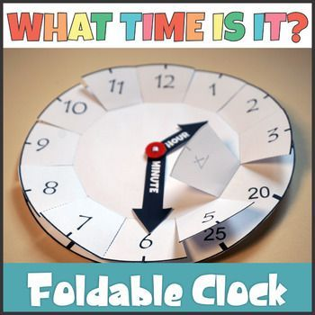  Then create a time and discuss how many minutes past it relates to. (E.g. quarter past one means the same as fifteen minutes past the hour of one)  Ask: What happens if I move the minute hand to the 8? How many minutes past one is it now? Repeat. | LOCAL HISTORY  Cornish myths, like legends such as King Arthur, have been around for centuries. Do you know the difference between a myth and a legend? A legend has an element of fact within it and real people become larger than life, but a myth usually explains local beginnings and has supernatural/magical creatures in it. POBEL VEANS are the ‘Little People’ of Cornish folk law and we will look into the three main creatures which supposedly dwelled in Cornwall.  Read through the ‘Pobel Vean’ word document with an adult and discuss whether you believe in the myths. Why do you think they existed?  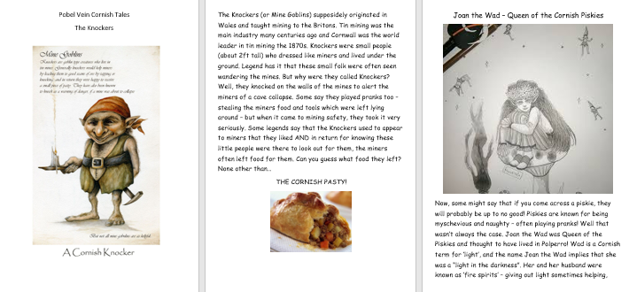  ACTIVITY: Complete the table below the grid  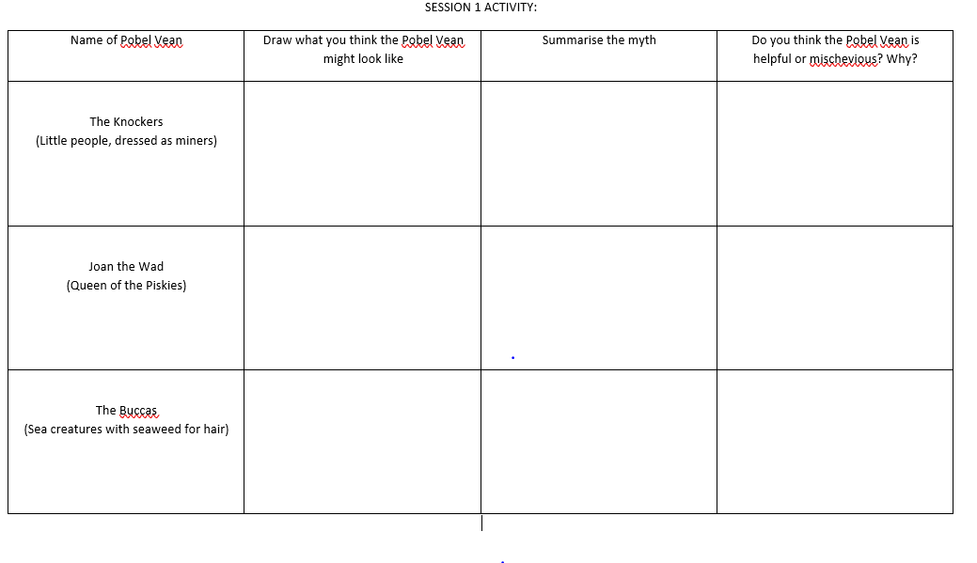  Do you know any other myths which have similar features? (pixies/mermaids/fairies) | Weekly PE challenge  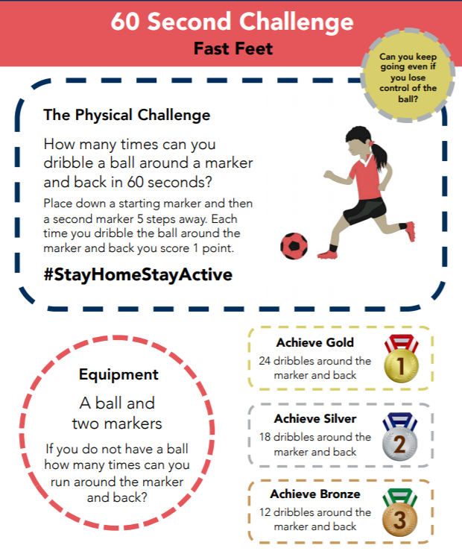  SEE BELOW FOR BIGGER PICTURE  Make a record each day and see if you can achieve gold by the end of the week!
S  E  S  S  I  O  N  2 | SPaG - Grammar  We are going to be writing a character description later on this week and using similes to compare one thing to another is a great way to add effect.  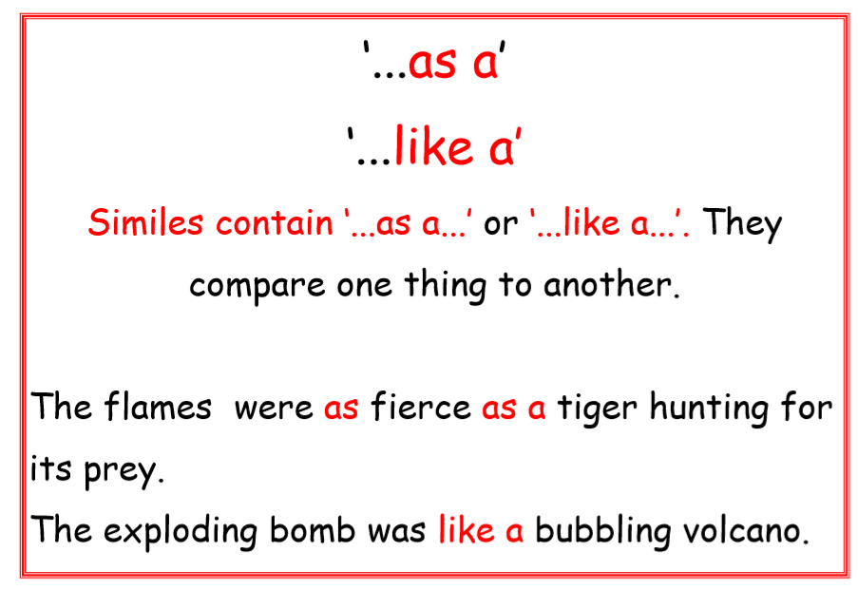  Look at these two examples. You can use: like a ____ or as _____ as a _______  Go through this SIMILES PDF to explain how to use these correctly. (Attached to blog) When you see a ? just click on it to reveal part of the simile.  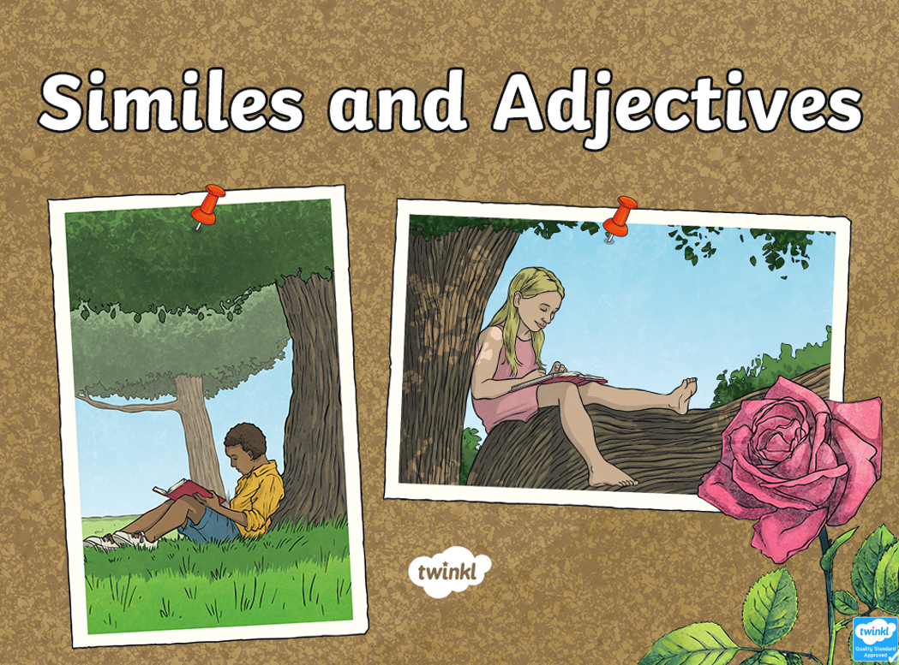  Once you have done the activities on the power point, collect 3 items from your house and write a simile the describe them. (I’ve attached a simile word mat for support) | Vocabulary you need this week:  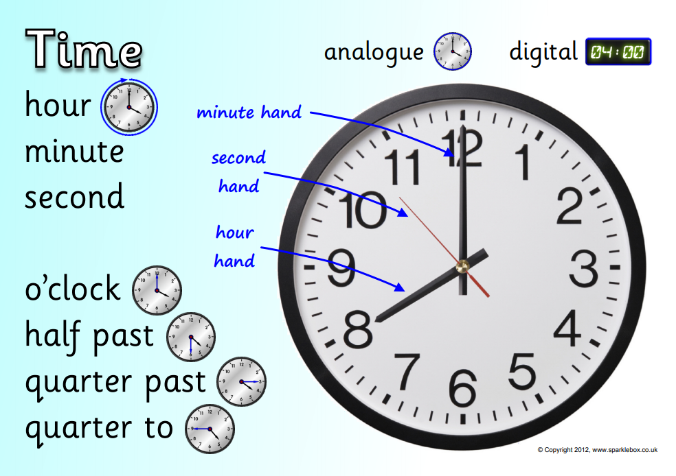  Today, we will begin to read time to the nearest five minutes. Use the clock you made yesterday to help you. Begin by watching:  https://www.youtube.com/watch?v=h6RNkQ7lU8Y  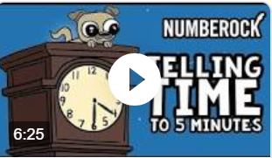  Then complete the worksheet below the grid. (We are just sticking with minutes past so we avoid confusion between conversions)  Challenge: Make a note of what time you eat lunch/dinner/play outside/have a bath/go to bed. Can you write them down in digital times AND words using the vocabulary mat above? E.g Lunchtime – 12:20 – twenty minutes past twelve | SCIENCE – Gravity  In myths, magical creatures often defy gravity. They often fly, hover, or float above the ground.  We, unfortunately do not defy gravity. Our feet are firmly on the ground and when we jump – we always land (sometimes on other parts of our body – ouch!)  Let’s conduct a few experiments into just how gravity works:  https://www.science-sparks.com/gravity-experiments-for-kids-galileo/  Look at the table (SESSION 2 ENQUIRY) and collect the items in the list. Predict which will hit the ground first and why you think that is.  REMEMBER: Drop them from the same height to ensure it is a fair test.  Surprised at what you find? Watch this to reveal the science behind gravity – and explain the crazy paper result! https://www.youtube.com/watch?v=dxcx35x5L9Y | Have a look at this website. #ThisIsPE  https://www.youtube.com/playlist?list=PLYGRaluWWTojV3An2WEgsQ4qGFy_91jDL  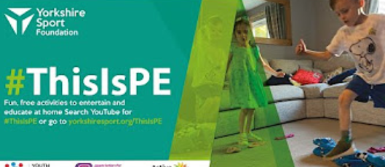  Choose an activity of your choice.
S  E  S  S  I  O  N  3 | Follow the link to Pobble 365 – Small Folk https://www.pobble365.com/small-folk  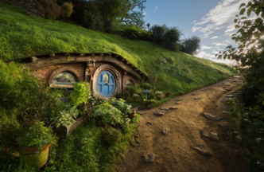  Now imagine who might live here:  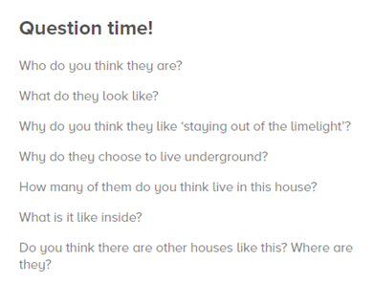  ACTIVITY: Draw one of the rooms inside the house. It could be the bedroom, living room or kitchen. What do you think is in their? A smelly, old sock draped over a chair? Fresh flowers in a vase/mug near a window? A bubbling stew pot over an open fire? USE YOUR IMAGINATION  Challenge: Describe your room using a range of similes. (See similes word mat attached)  The old sock was as smelly as a rotten tomato. The bubbling stew pot was hot like a flaming candle. | Play Topmarks today and have a go at time to the minute (use your clock to work out the minutes between five minute intervals).  https://mathsframe.co.uk/en/resources/resource/116/telling-the-time  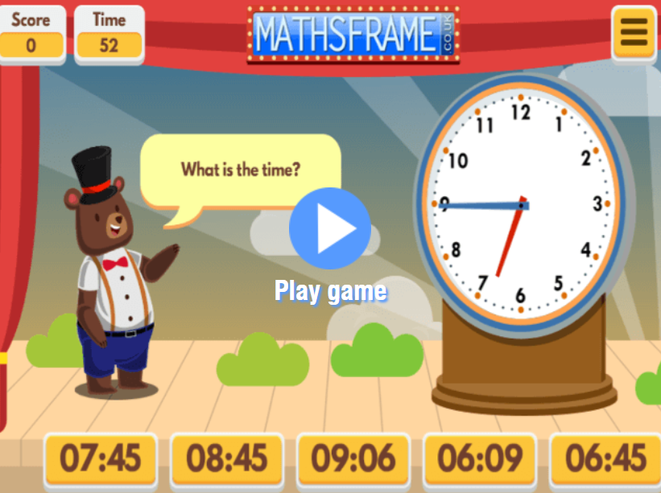  Then, do a times table activity:  Either TT Rockstars  https://ttrockstars.com/  Topmarks (Click on mixed tables)  http://www.learnyourtables.co.uk/en/index2.htm  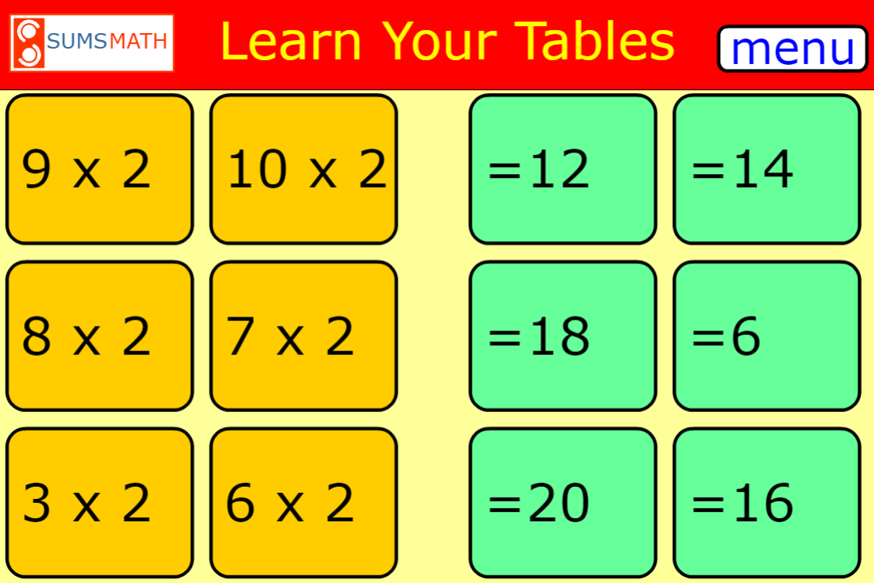  Other times tables games  https://www.timestables.co.uk/ | ART/ - Design your own Pobel Vean. https://www.pobble365.com/small-folk Take another look at the picture from English this morning.  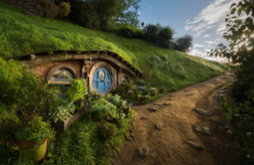  You are going to design your own ‘little person’ who might live in this home.  Click on link:  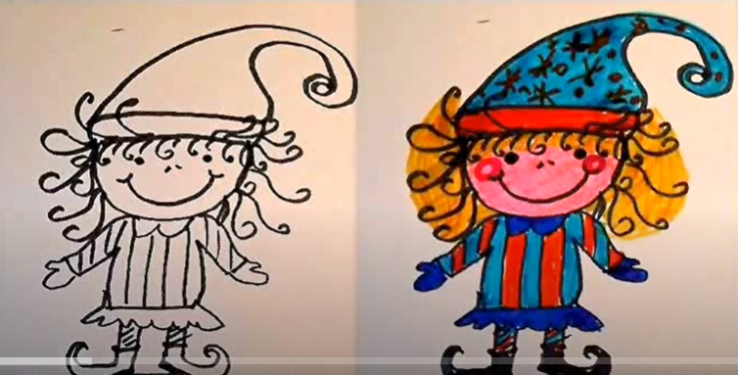  https://www.youtube.com/watch?v=BdsH_9n7COs  What will they wear? Will they carry something? Where will they live? Are they kind and helpful or mischievous and naughty? Give it a name and send me a photo!  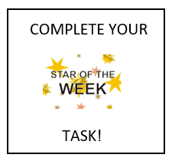 | Choose 2 activities:  - Joe Wicks Workout  - Super Movers  - iMovers  Then practice your 60 second challenge
S  E  S  S  I  O  N  4 | CHARACTER DESCRIPTION  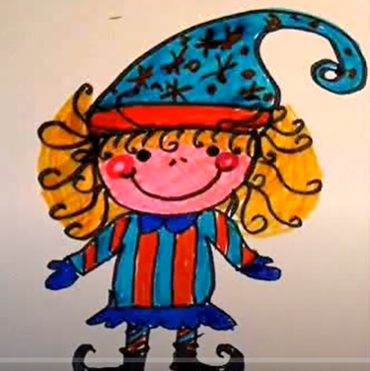  Now you have created a Cornish Pobel Vean. Write a character description for it. Remember, a character description is broken down into three sections:  Appearance: What do they look like? Describe their clothes, physical appearance.  Personality: How do they act? Are they kind, helpful, grumpy? Do they stomp around or skip and jump?  Character: How do other people see them? Would you be happy and seek their help or be frightened and run and hide if you saw them?  “This is a great opportunity to show off the SPaG you have learnt from the last few weeks. Use plenty of adjectives and similes and don’t forget to check you have used ‘a’ or ‘an’ correctly.”  WORD MATS ATTACHED TO SUPPORT | TIME DURATION  We are going to investigate periods of time. Begin by showing 1:30 on the clock and agree that it represents 30 minutes past one.  Ask, “If I told you that lunch was in 10 minutes, what time would it be?” Show them how to move the minute hand counting 5 when you reach the number seven and 10 when you reach the number eight. Agree that ‘lunch’ would be 1:40 or forty minutes past one because 30mins +10 mins equals 40 mins.  OK SO FAR…? Let’s keep it simple.  GO THROUGH ATTACHED POWER POINT  Activity on there! | ART/DT  Create a Top Trumps card for your Pobel Vean.  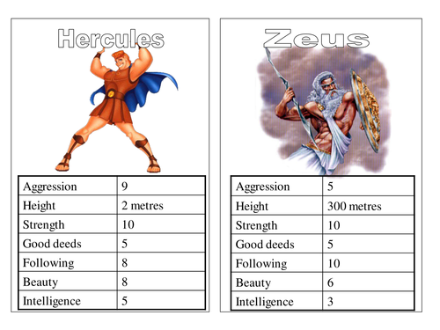  Think about:  Height, magical power (invisibility, mind control, emits light, moves things) / ugliness/speed/good or bad deeds/intelligence.  “I’ll attach some templates below for you to use or as a base to create from.”  Extension: Why not create a set of Pobel Veans? Create cards for Joan the Wad, The Knockers and The Buccas. Is your creature faster than a Knocker but less powerful than Joan?  (We are studying giants next week so we can add more creatures to our ‘set’) | Choose an indoor Shake Up activity from:  https://www.nhs.uk/change4life/activities/indoor-activities  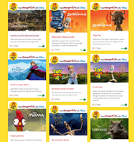
S  E  S  S  I  O  N  5 | IMAGINATIVE WRITING  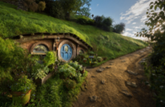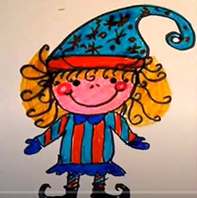  Imagine that you are out walking in the forest once day. You come across the Pobel Vean you created, standing outside the house you described.  What happened next…  Write a short story (no more than 100 words).  Success criteria:  - full, punctuated sentences  - use of similes and adjectives  - no overuse of ‘said’ if using speech  (Fantasy story, adjectives and similes word mats attached) | TIME DURATION  Have a go at the worksheet attached to the grid.  It’s a TV guide showing start times of programes. Work through the questions using your homemade clock for support.  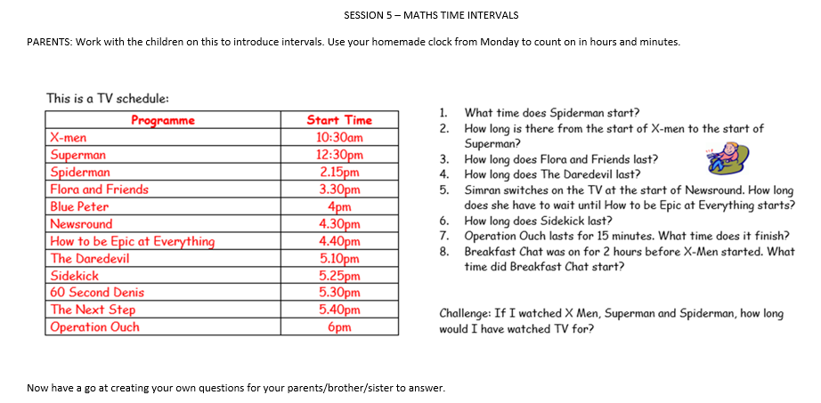 | DT: Create your own Piskie Dwelling  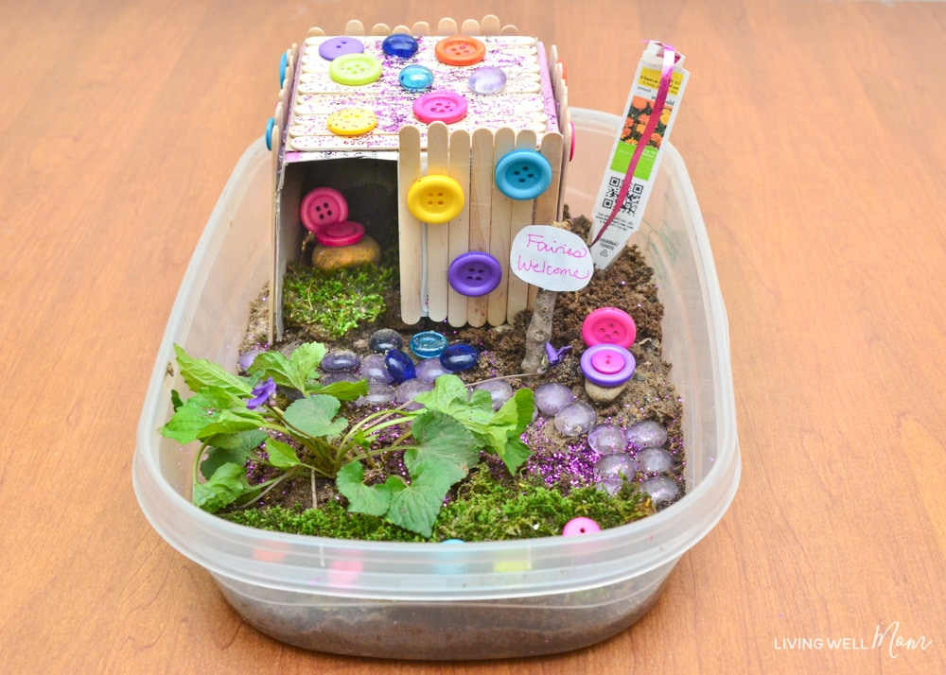  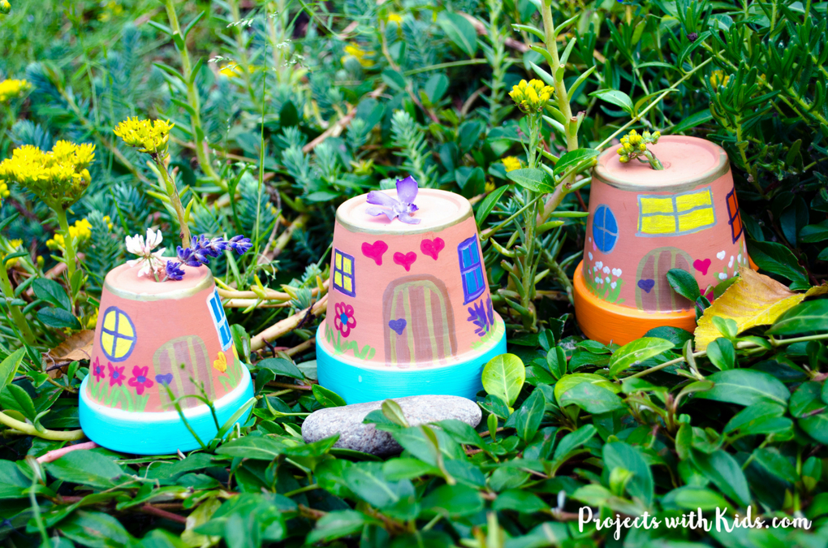  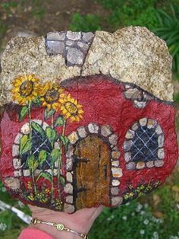 | Choose 1 activity:  - Joe Wicks (The Body Coach TV) Workout  - iMovers  PLUS:  Little Sports children’s fitness videos https://www.youtube.com/watch?v=L-8wW40jTzc

SESSION 1 MATHS – FOLDABLE CLOCK EXAMPLE
IF YOU HAVEN’T THE RESOURCES TO CREATE THIS, USE THE IMAGE BELOW
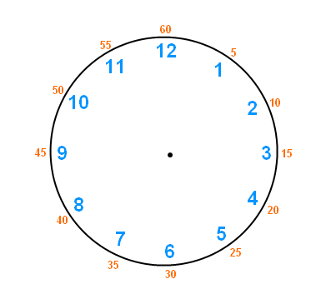
SESSION 1 ACTIVITY:
Name of Pobel Vean | Draw what you think the Pobel Vean might look like | Summarise the myth | Do you think this Pobel Vean is kind-hearted or not? Why?
The Knockers (Little people, dressed as miners)

Joan the Wad (Queen of the Piskies)

The Buccas (Sea creatures with seaweed for hair)

SESSION 1 ACTIVE – WEEKLY CHALLENGE

SESSION 2 MATHS
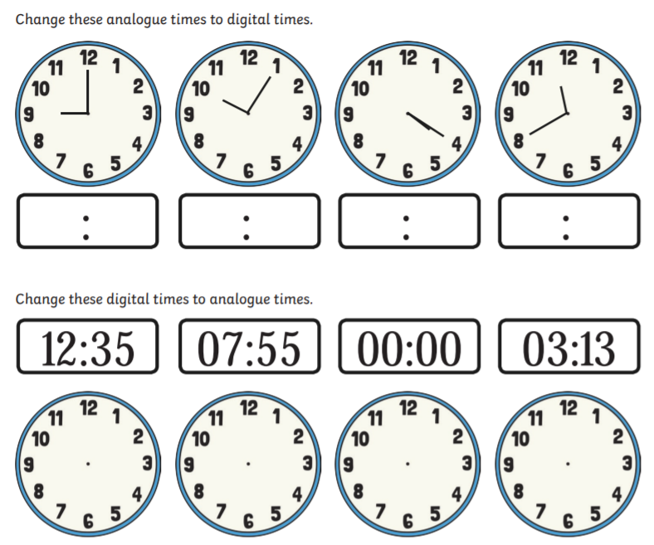
If you can’t print this off, then write down the digital times and create the analogue time on your clock.

ITEMS | WHICH WILL LAND FIRST (OR WILL IT BE TOGETHER) | WHY DO YOU THINK THAT WILL HAPPEN? | WERE YOUR PREDICTIONS RIGHT?
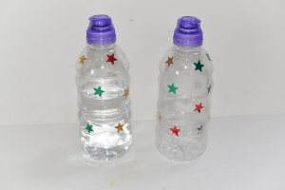
2 X identical bottles. One half full and one empty
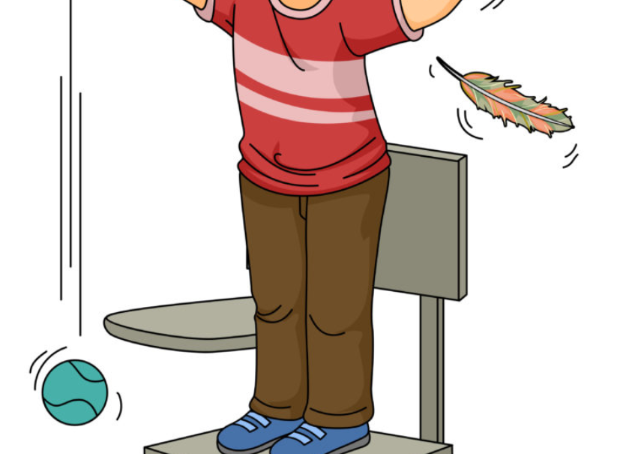
1 x feather and 1 x tennis ball
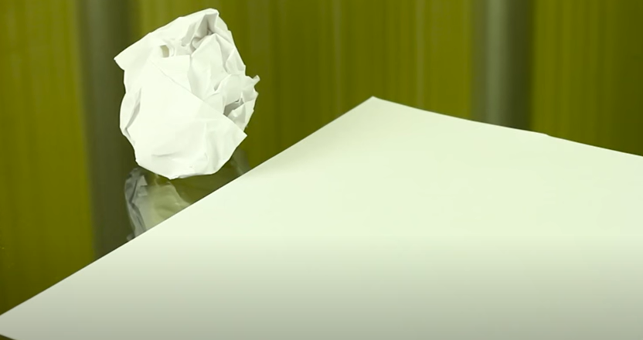
Two same sized pieces of paper – one crumpled and one flat.
Two objects the same weight but different in size
SESSION 2 – ENQUIRY

Which result surprised you the most and why? ____________________________________________________________________________________________________
SESSION 4 ENQUIRY – TOP TRUMPS
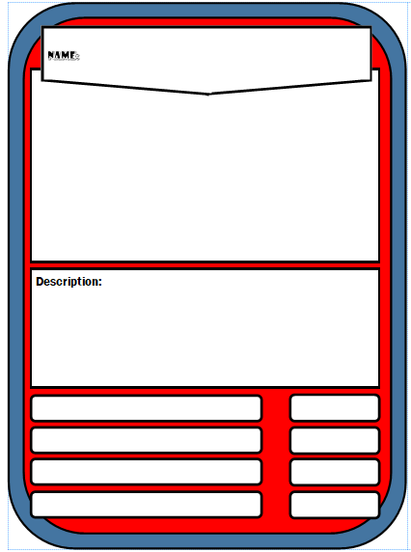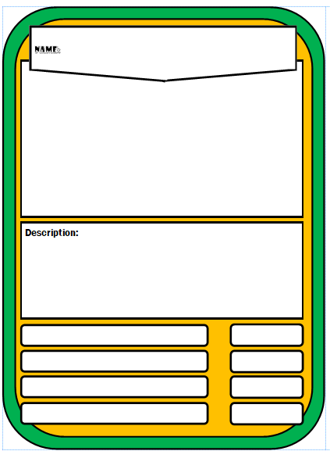
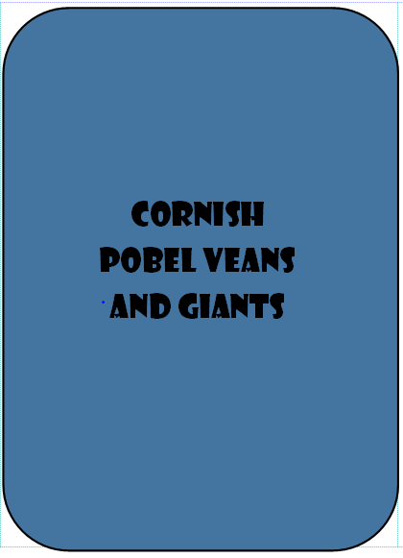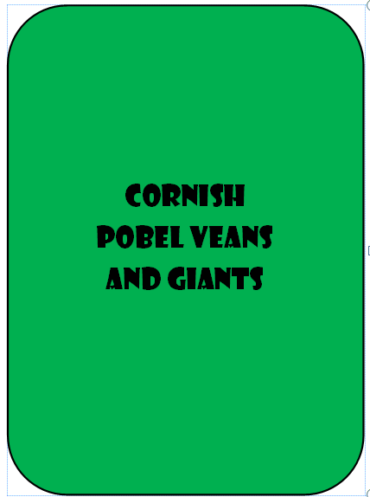

SESSION 5 – MATHS TIME INTERVALS
PARENTS: Work with the children on this to introduce intervals. Use your homemade clock from Monday to count on in hours and minutes.

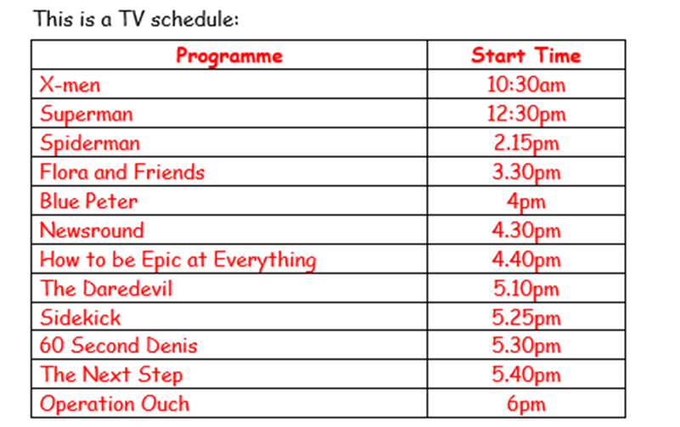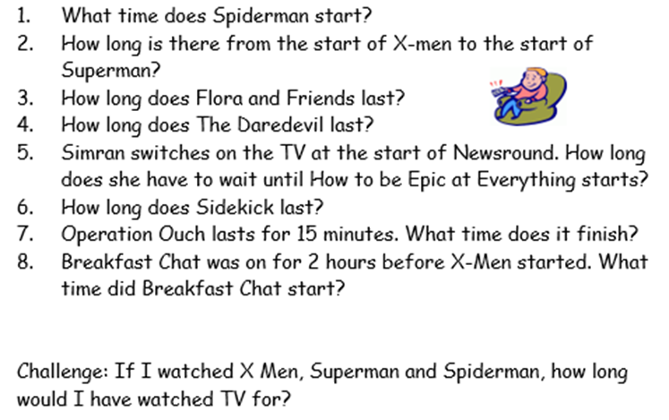

CHALLENGE: Now have a go at creating your own questions for someone in your household to answer.

