Pobel Vean Cornish Tales
The Knockers
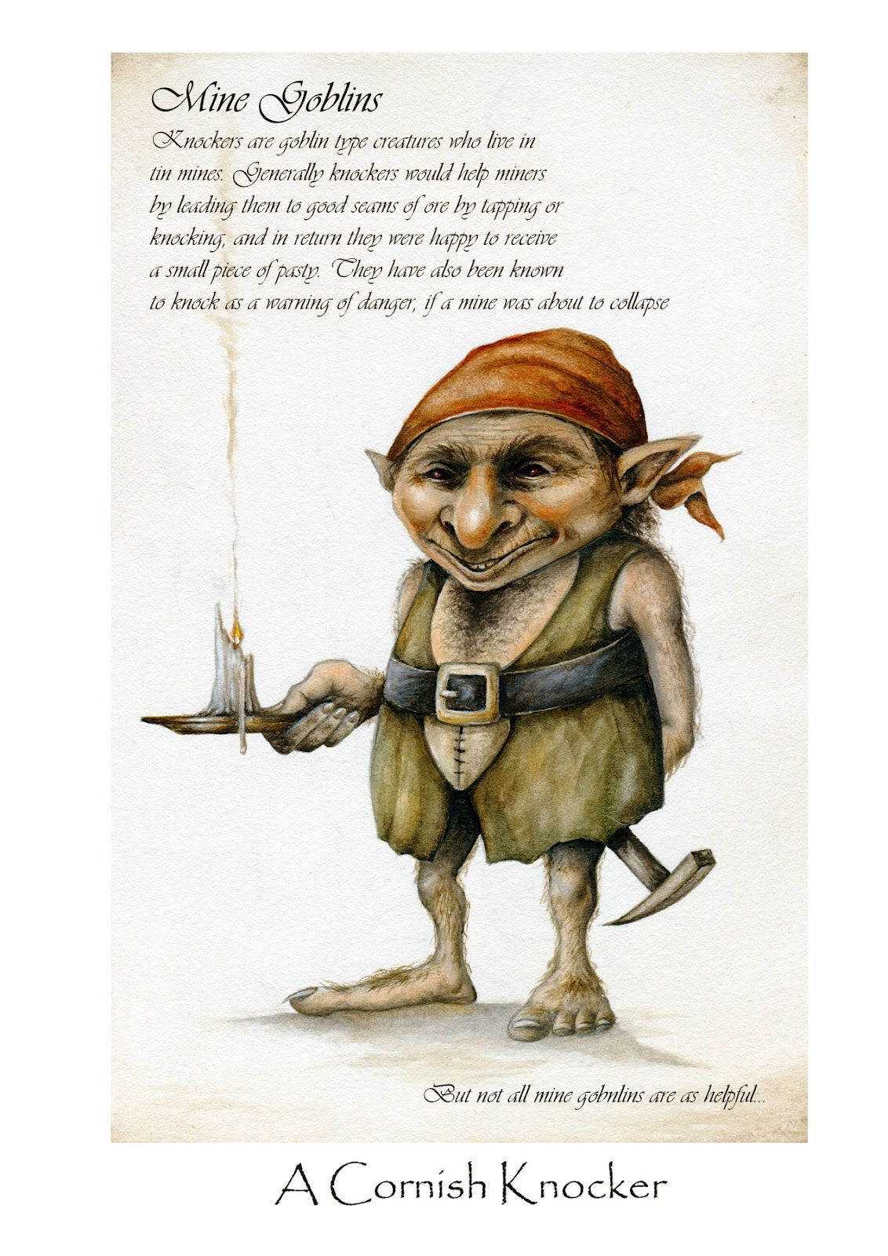
The Knockers (or Mine Goblins) supposidely originated in Wales and taught mining to the Britons. Tin mining was the main industry many centuries ago and Cornwall was the world leader in tin mining the 1870s. Knockers were small people (about 2ft tall) who dressed like miners and lived under the ground. Legend has it that these small folk were often seen wandering the mines. But why were they called Knockers? Well, they knocked on the walls of the mines to alert the miners of a cave collapse. Some say they played pranks too – stealing the miners food and tools which were left lying around – but when it came to mining safety, they took it very seriously. Some legends say that the Knockers used to appear to miners that they liked AND in return for knowing these little people were there to look out for them, the miners often left food for them. Can you guess what food they left? None other than…
THE CORNISH PASTY!
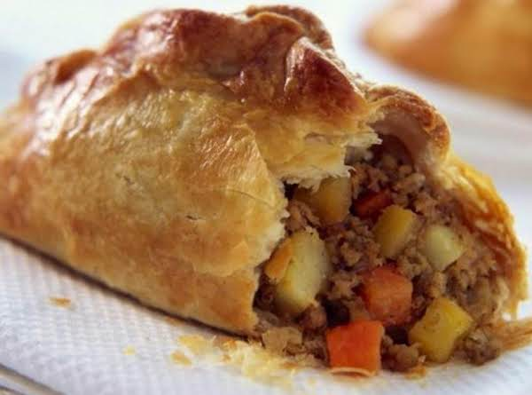

Joan the Wad – Queen of the Cornish Piskies
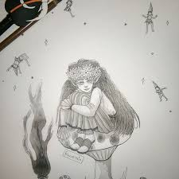
Now, some might say that if you come across a piskie, they will probably be up to no good! Piskies are known for being myschevious and naughty – often playing pranks! Well that wasn’t always the case. Joan the Wad was Queen of the Piskies and thought to have lived in Polperro! Wad is a Cornish term for ‘light’, and the name Joan the Wad implies that she was a “light in the darkness”. Her and her husband were known as ‘fire spirits’ – giving out light sometimes helping, sometimes tricking lost travellers on the Cornish moors into believing they were following a lantern or torch! Some say, if they were feeling mischevious, travellers would notice the light, follow it and roam the moors for sometimes days until they found their own way home – pesky piskies!

Cornish people used to chant a rhyme about them:
‘Jack the Lantern, Joan the Wad
That tickled the maid and made her mad
Light me home, the weather’s bad.’
However, other folk believed that if you were to call upon the help of Joan The Wad, she would follow your request and lead you back to safety!

‘Good fortune will nod, if you carry upon you Joan the Wad.’
This saying is shared by many a Cornish folk. They believe that if you carry a lucky charm of Joan The Wad, good fortune will follow, and you would always be able to find your way home. What do you think...?
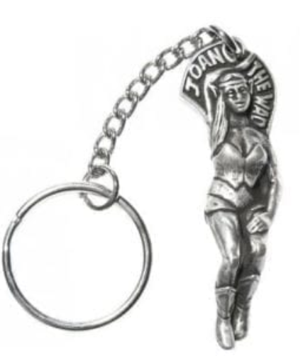

The Buccas
These small folk were the sea-version of The Knockers. They mainly dwelled in the seas off Newlyn and Mousehole and legend says that they came ashore as hobgoblins during stormy weather.
The Buccas helped local fishermen by driving fish into the nets and crabs into the pots of fishing vessels in exchange for a portion of their catch. There was one very famous Sea Bucca legend, a creature who inhabited Lamorna Cove near the town of Mousehole. He was supposed to have been a handsome prince cursed by a witch. He had a brown eel-like body and a tangle of seaweed for hair. He loved children and didn’t want them to ever go hungry so he helped the Lamorna fishermen with their catch and they would leave food for him on the beach in return.
Bucca’s voices were supposed to be carried by the wind and when a South Westerly storm was brewing, fishermen used to refer to it as ‘Bucca Calling’.

