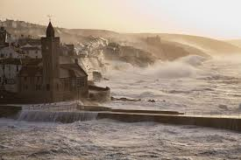
Howling through the streets like a banshee, the invisible enemy pummelled the windows and shrieked down the chimneys. Rolling dustbins clattered down the cobbled streets, leaving a trail of whirling, debris in their wake, while the squat houses crouched against the cliff side, bracing themselves against the onslaught of the gale, their doors and windows firmly locked. Still the invading army marched on.
Far below, the angry sea exploded against the cliffs, the water hurled and heaved; swelled and swirled, whipped up by the force of the storm. Down in the harbour, the fishing boats tugged fiercely at their moorings and the ropes on their masts chattered angrily. Over the noise of the wind, the sound of the church bell could be heard tolling erratically as the gale gusted through the bell tower.

