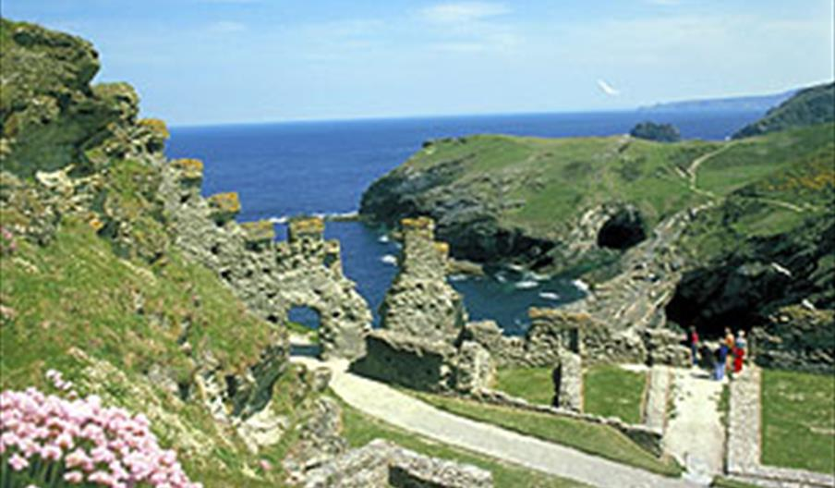**Tintagel vocabulary**

What can you see? Does it remind you of anything else?

What human characteristics might the things you can see have?

What adjectives/adverbs could you use to describe the setting?

What sounds might you hear?