 | ENGLISH | MATHS | ENQUIRY | ACTIVE
S  E  S  S  I  O  N  1 | Today is a school Inset Day so enjoy time with your family.  You might want to:  - Explore how to keep safe in the sun. Soltan have some excellent resources. I have added a link to an information video. Why not check to see, if you already know how to stay safe?  https://soltansunready.com/for-families/sun-damage-why-we-need-to-care-about-uva  - Explore how to keep safe on the beach. The RNLI have a great website. https://rnli.org/safety/beach-safety Design a poster to remind you!
S  E  S  S  I  O  N  2 | The Legend of King Arthur is surrounded by magic and mystery… but did it really happen?  Let’s find out about how a young boy called Arthur supposedly became King of England by pulling a sword from a stone.  Watch: https://www.youtube.com/watch?v=ITpSlunjRj4  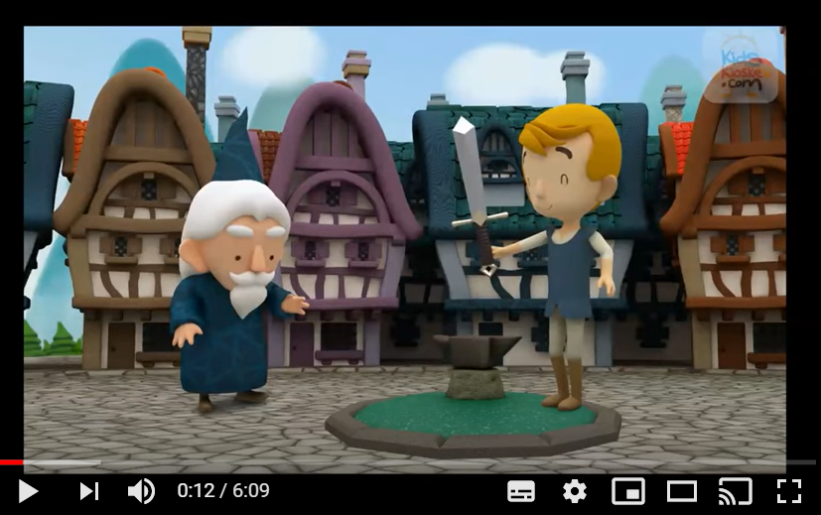  Why do you think Merlin created the sword in the stone and not just told people who Arthur was?  ACTIVITY: If you were Merlin, how would you have shown the people that Arthur was the rightful king instead of a sword in a stone?  Draw a picture. | We are going over telling the time to half past. Match the correct time to the clocks/watches. (See below grid for larger version).  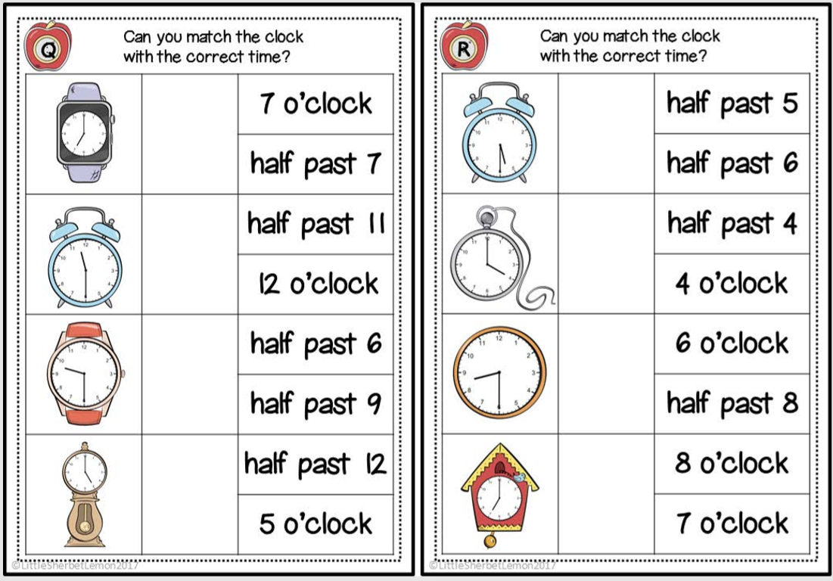  Then play  https://mathsframe.co.uk/en/resources/resource/116/telling_the_time#  Select:  (2) Read time to the hour and a half  12-hour clock  Untimed or timed – up to you!  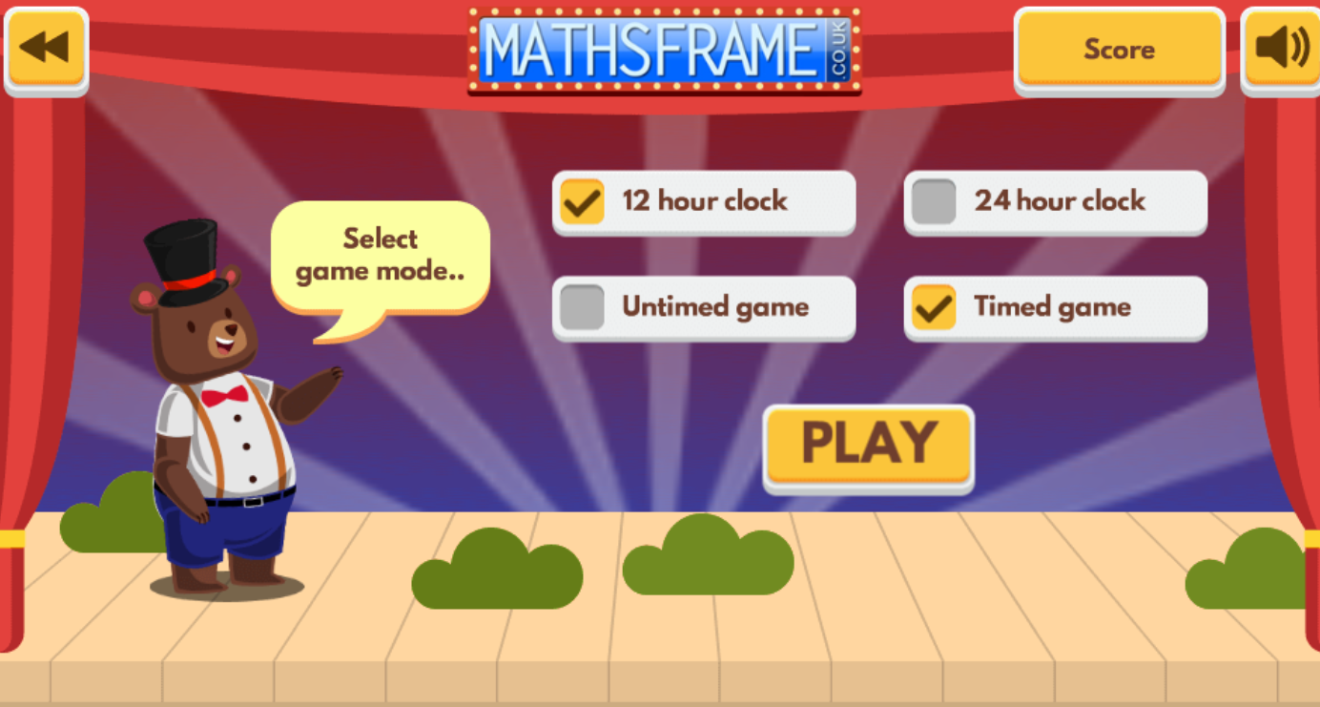 | The legend of King Arthur was set during the Middle Ages (476AD -1453AD) where knights were the wealthiest types of soldiers of their time (requiring expensive armour/weapons and a powerful war horse). Arthur was supposedly a knight.  Let’s find out who and what a knight was:  https://www.youtube.com/watch?v=pG0dMxybV_8  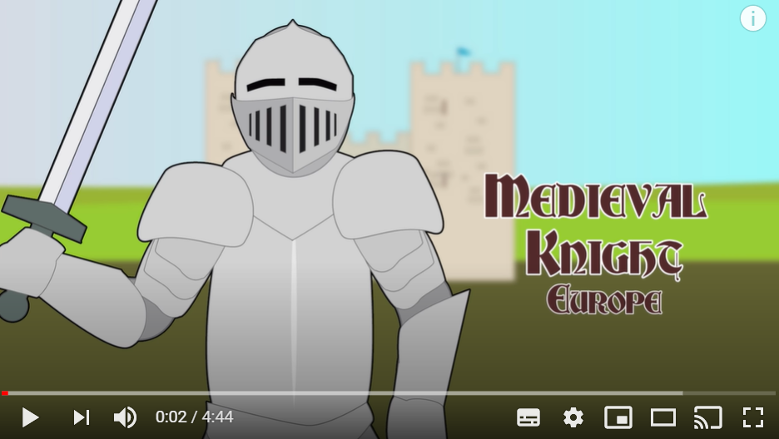  Activity: Label the knight’s armour – use an online dictionary to find any words which are tricky. You can use this or draw and label your own! (Bigger version below)  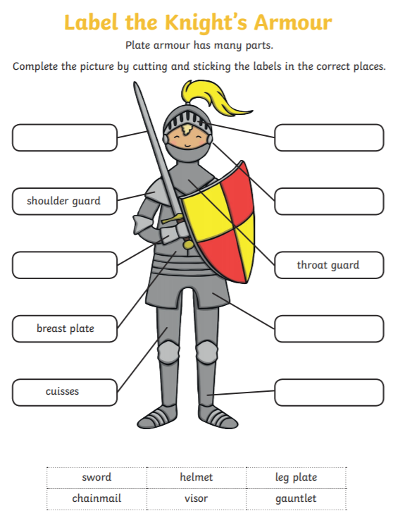 | SCAVENGER HUNT:  Make a list of the items below the grid and when you do your daily walk/play outside – see what you can find! Tick them off when you see them!  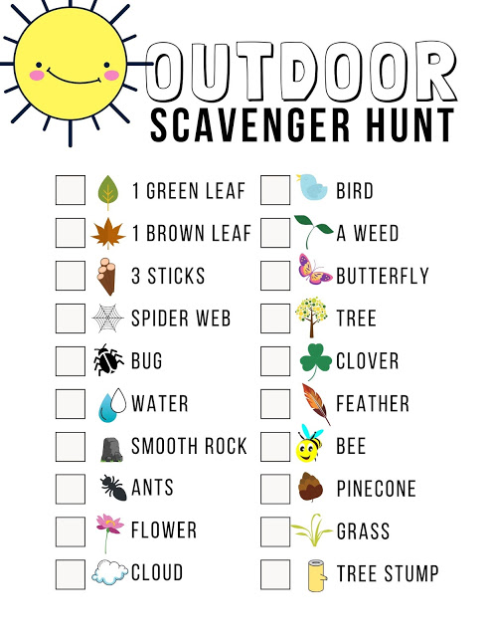
S  E  S  S  I  O  N  3 | Read up to page 17 of ‘Zac’s King Arthur Adventure’ on Get Epic  https://www.getepic.com/app/read/10580  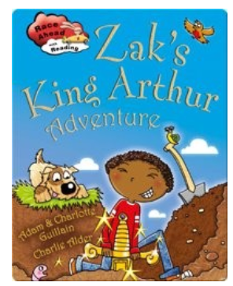  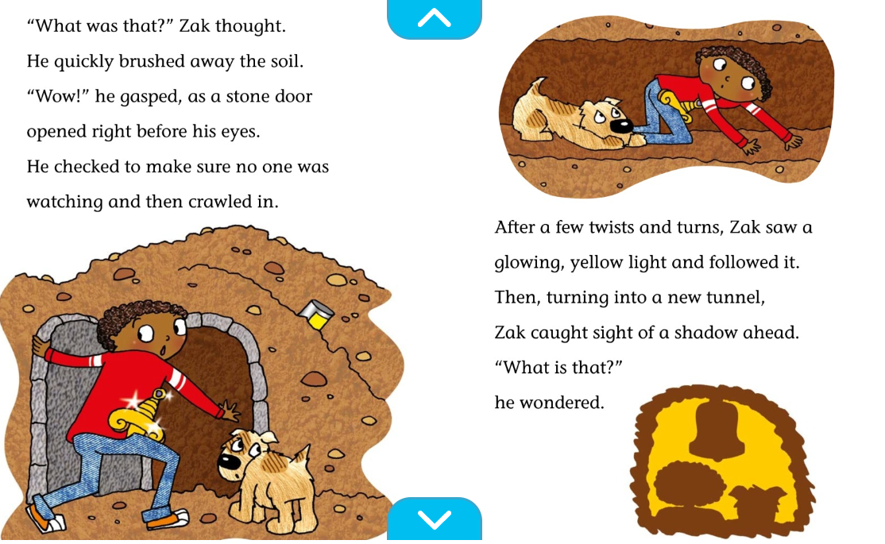  Where do you think the tunnel leads to?  Draw a picture of what Zac might find!  Then read the rest of the book and see if you were right!  (Remember to click on any words you don’t understand and it will tell you their meaning) | We are moving on to quarter of the hour. Remember – the hour hand needs to be in the correct place so practise, practise, practise!  Go though power point and practise positioning the hands correctly on your homemade clocks  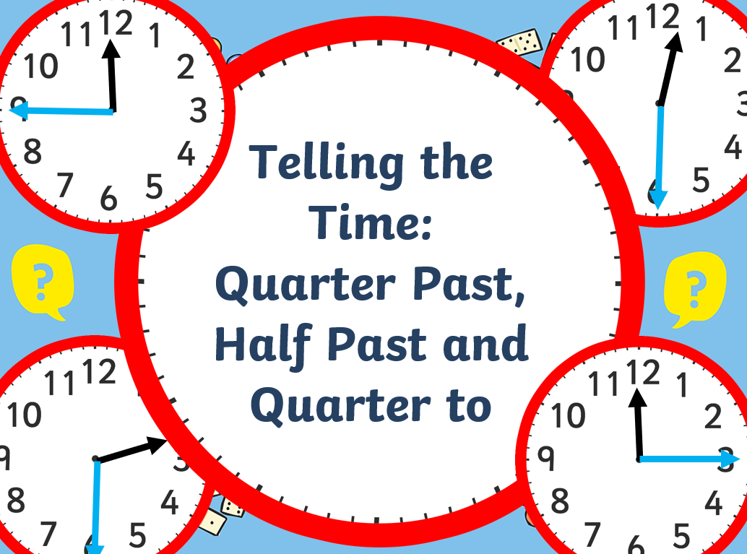  Then scroll to below the grid and have a go at:  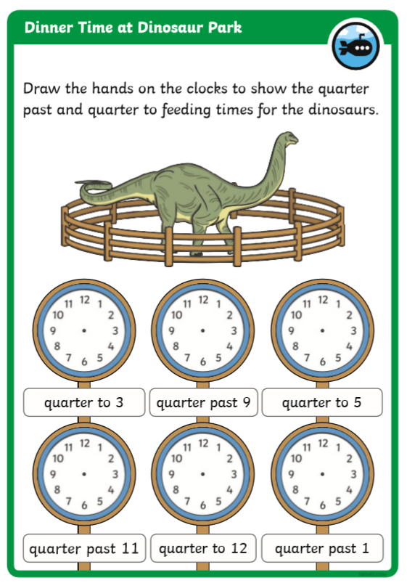  (if you can’t print it off, then just tell a grown up where the minute and hour hand should point to! | GEOGRAPHY/HISTORY  Cornwall is an area of great importance in the legend of King Arthur. Research these places and find out why they are so important!  (See sheet at bottom of grid)  Tintagel Castle  Bossiney Mound  Dozmary Pool  http://www.arthur-online.co.uk/index.php/the-trail | Choose 1 activity:  - Super Movers  - iMovers  PLUS:  Let’s Dance! https://www.youtube.com/playlist?list=PLJnn5H8Y_tYE3LdXoJIG_azMC2l5TjCON
S  E  S  S  I  O  N  4 | READING COMPREHENSION  Read the Knights and Dragons powerpoint (attached to the blog) (Get Mum or Dad to read it with you if you need some support)  On the top bar of your screen click:  Enable editing  Slideshow  From beginning slide  And then click on the question marks to view and answer questions as you read.  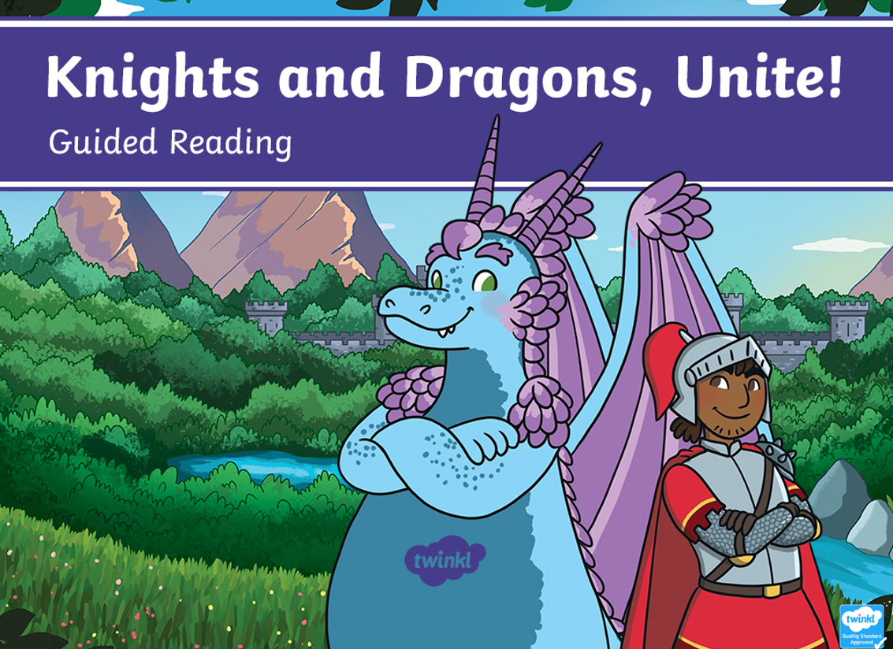 | It’s important to understand and spell the correct vocabulary for time so begin with reading time to quarter of the hour by playing:  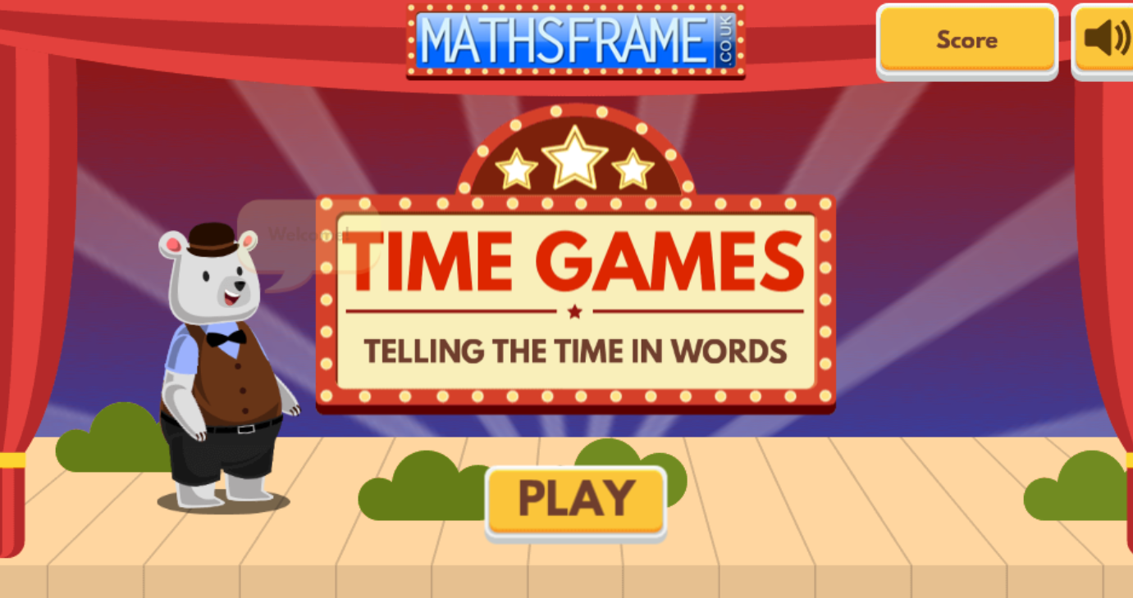  https://mathsframe.co.uk/en/resources/resource/117/telling_the_time_in_words#  Click (3) Read time to the quarter hour  then practise your spellings of these key words:  half hour  ‘o’ clock time  quarter minute  past hand  using a spelling strategy such as  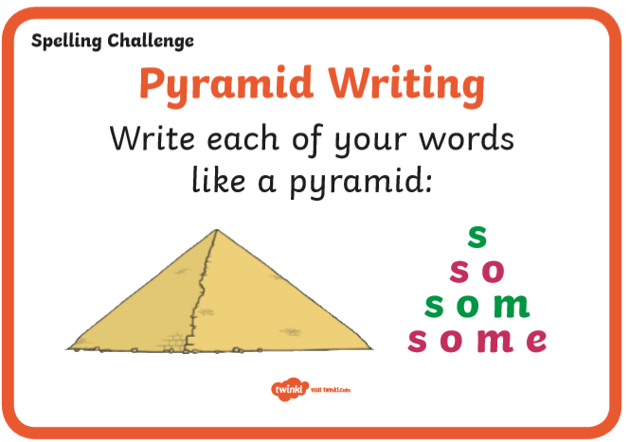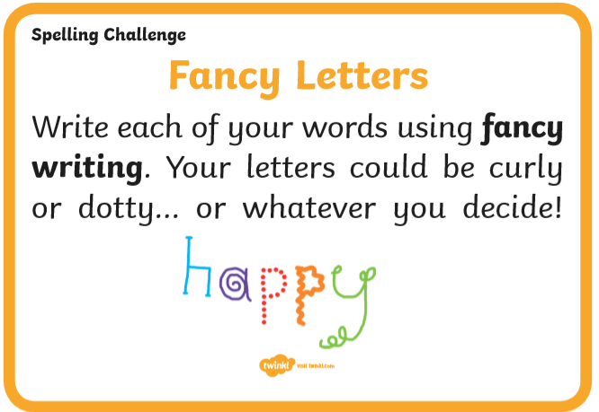 | ART/DT  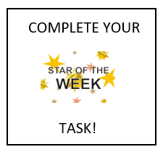  In the times of King Arthur, men who fought were known as knights. They dressed in armour to protect themselves and carried swords and shields. But how did you tell one knight from the other when they had their armour on?  Go through the power point ‘Coat of Arms’ and identify what you need to design your own. Then either use the template attached to draw your own shield or if you are feeling creative – make your own!  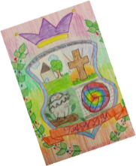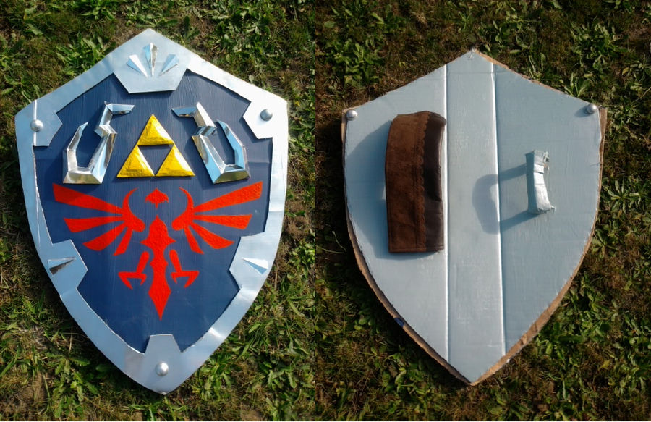  Now create a medieval name for yourself! Use this name generator and let me know what you have chosen. Maybe you are Sim the Dragonslayer or Giselle the Valiant:  https://www.fantasynamegenerators.com/knight-names.php  HISTORY/ART/DT  Arthur’s sword was called Excalibur. Have a go at drawing the sword in the stone.  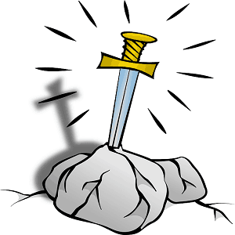  Here’s some links for ideas: https://www.youtube.com/watch?v=euC5dvtod80 https://www.youtube.com/watch?v=Xi4G6LVhy5M  or  Create King Arthur’s Excalibur to go with your Coat of Arms  https://www.youtube.com/watch?v=sjnIhp_TBPc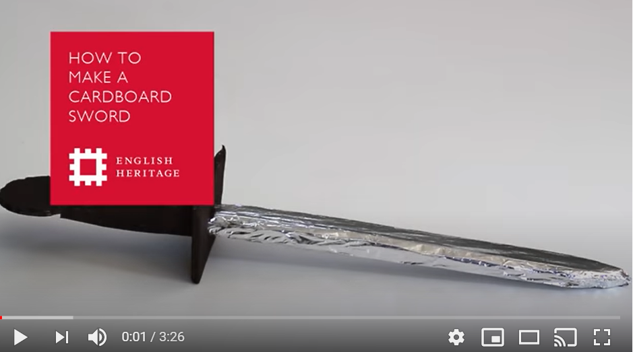 | Choose an indoor Shake Up activity from:  https://www.nhs.uk/change4life/activities/indoor-activities  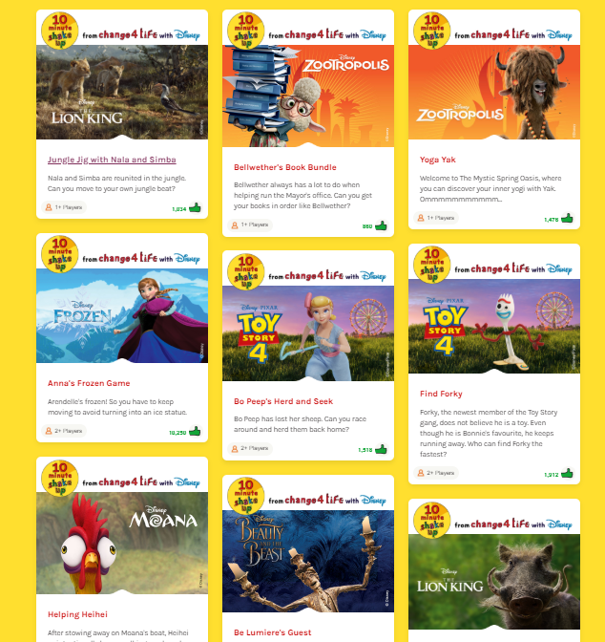
S  E  S  S  I  O  N  5 | WRITING  Today you are going to pretend that you want to be a knight.  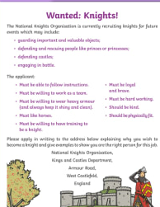  The castle is looking for a new knight. Write an application to persuade them to choose you.  Don’t forget to you need to tell them all the things you are good at and how this will help you be the best knight ever.  (See attached larger version Session 5 Wanted Knights!) | Complete your tasks on  https://login.mathletics.com/ |  | Choose 1 activity:  - Joe Wicks (The Body Coach TV) Workout  - iMovers  PLUS:  Go Noodle – GoNoodle for Families https://family.gonoodle.com/channels/zumba-kids
SESSION 2 ACTIVE

SESSION 2 MATHS

SESSION 2 ENQUIRY
SESSION 3 MATHS
Success criteria:
- For quarter past, the hour hand needs to be just after the hour and the minute hand on the 3! 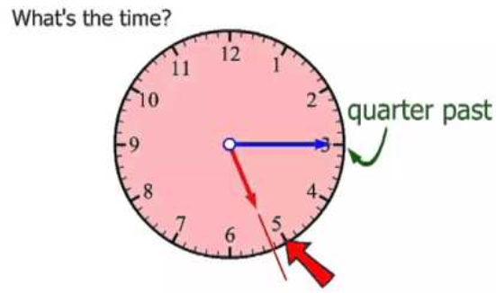

- For quarter to, the hour hand needs to be just before the next hour and the minute hand on the 9!

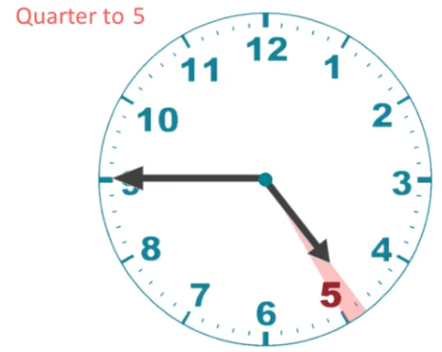

SESSION 3 ENQUIRY
Tintagel castle Bossiney Mound Dozmary Pool
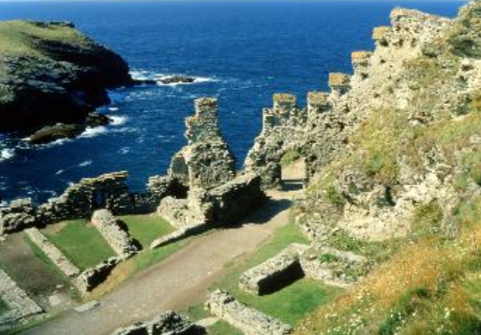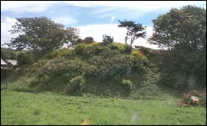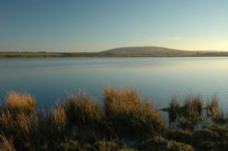

_________________________________ _________________________________ ____________________________________
_________________________________ _________________________________ ____________________________________
_________________________________ _________________________________ ____________________________________

Can you find something else out about Cornwall and its links to King Arthur?

