1.6 | ENGLISH | MATHS | ENQUIRY | ACTIVE
S  E  S  S  I  O  N  1 | INSET DAY  Today is a school inset day so a day off to enjoy time with your family. | You might want to explore how to keep safe in the sun.  Soltan have some excellent resources. I have added a link to an information video.  Why not check to see, if you already know how to stay safe?  https://soltansunready.com/for-families/sun-damage-why-we-need-to-care-about-uva | 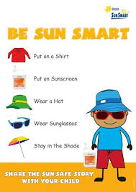
S  E  S  S  I  O  N  2 | READING FOR INFORMATION  Listen to the story of how Arthur became King.  ttps://www.bbc.co.uk/bitesize/clips/zvmw2hv  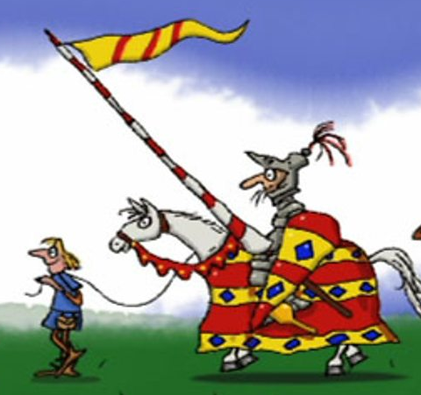  Jot down the key events of the story on the grid below the Blog. Think about  Why were they looking for a new king?  Who was the magician?  What challenge did he set?  Who tried the challenge?  Why did Arthur pull the sword from the stone?  What happened to Arthur afterwards? | MULTIPLICATION AND DIVISION  Watch the lesson and pause the video when asked, Find the worksheet you need attached below the blog. Check your answers. Remember, mistakes are good because you need to work out why and where you went wrong, so practising your learning.  Year 4 – Summer Term Week 3 lesson 1 Multiply 2-digit by 1 digit number  https://whiterosemaths.com/homelearning/year-4/  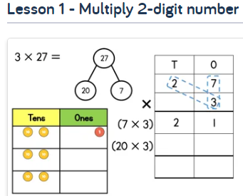  Year 5 –Summer Term Week 3 lesson 1 Multiply 2-digit numbers (area model)  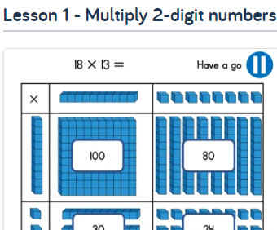  https://whiterosemaths.com/homelearning/year-5/ | HISTORY/GEOGRAPHY  Comparing historical sources and evidence.  https://www.getepic.com/app/read/61411  Read the pages 13-18  Which of these sites do you think is Camelot? Why?  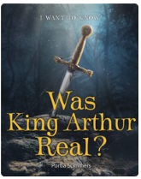  Find Cornwall on Google Maps. Next, locate Tintagel. Which place names are connected with King Arthur?  Click on the castle icon and investigate the setting. Can you see why this might be Camelot? | ACTIVE  Try some activities from  #ThisIsPE  https://www.youtube.com/playlist?list=PLYGRaluWWTojV3An2WEgsQ4qGFy_91jDL  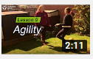  You can choose from lots of different skills. How fast are you at Fast Feet?
S  E  S  S  I  O  N  3 | READING COMPREHENSION  Today you are going to read a different version of the legend of Arthur.  Choose the document below the Blog, Reading Comprehension Y4 or Y5.  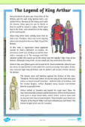  Read the text carefully and answer the questions.  Check your answers. How are you doing with your VIPERS?  Compare the facts with yesterday’s version.  What is different?  What is the same? | MULTIPLICATION AND DIVISION  Year 4 – Summer Term Week 3 lesson 2 Multiply 3-digit by 1 digit number  https://whiterosemaths.com/homelearning/year-4/  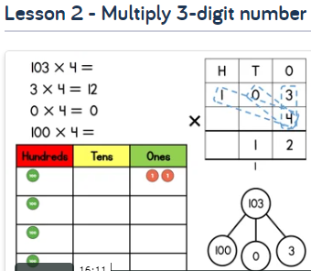  Year 5 –Summer Term Week 3 lesson 2 Multiply 4-digit by 2-digit numbers  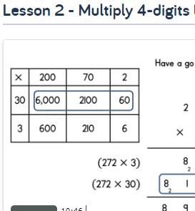  https://whiterosemaths.com/homelearning/year-5/ | HISTORY  The legend of King Arthur is set in the Anglo Saxon period, which lasted for 600 years, from 410 AD to 1066 AD. However, some history sources say this can’t be as King Arthur was a knight and the Age of the Knights was the period from 1066 AD - 1500 AD.  Read the document Historical sources.  Investigate some of the claims of the legend of King Arthur and decide if you think these are true or false, don’t forget to say WHY.  He was reincarnated as a chough.  He is buried at Trevithy Quoit.  His sword, Excalibur, was thrown in Dozmary pool.  Read the information about Trevethy Quoit and Dozmary Pool  https://www.cornwallwildlifetrust.org.uk/wildlife-explorer/birds/crows-and-shrikes/chough | ACTIVE  Choose 2 activities:  - Joe Wicks PE  - Super Movers  - iMovers  or  Go Noodle – GoNoodle for Families https://family.gonoodle.com/channels/zumba-kids  Try a new routine!
S  E  S  S  I  O  N  4 | WRITING  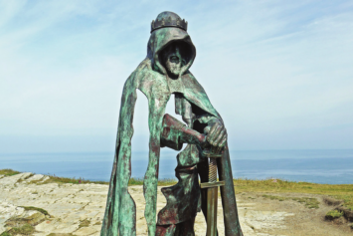  THE STATUE  - Who is this?  - How did he get there?  - Why is his hood up?  - Why is he standing there on the cliff?  - Where is the cliff?  - Why is he not solid, why can you see through him?  Write a drabble (a 100 word story) about this statue using your new knowledge about King Arthur.  Success Criteria  - Get straight to what you’re trying to say.  - Use as few words as possible.  - No wasted words, you have to be precise. | MULTIPLICATION AND DIVISION  Year 4 – Summer Term Week 3 Lesson 3 Divide 2-digit by 1 digit number  https://whiterosemaths.com/homelearning/year-4/  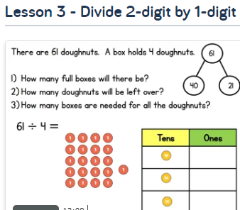  Year 5 –Summer Term Week 3 lesson 3 Divide with remainders  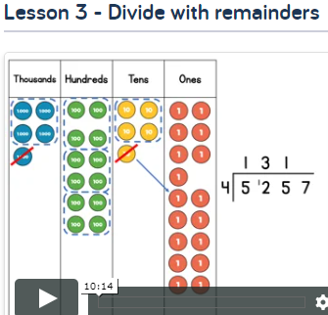  https://whiterosemaths.com/homelearning/year-5/ | ART  Draw the sword in the stone  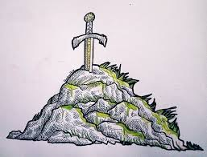  How to draw:  https://www.youtube.com/watch?v=euC5dvtod80  more detailed drawing  https://www.youtube.com/watch?v=qs6vd5JmMSQ  (sorry about the slightly annoying voice)  Last time I asked you to draw swords/weapons for your Greek myths you were amazing, so I’m prepared to be amazed again. | ACTIVE  Now that we can go outside more, often there’s a chance to try out  National Trust - 50 things to do before you are 11 ¾  https://nt.global.ssl.fastly.net/documents/50-things-activity-list.pdf
S  E  S  S  I  O  N  5 | WRITING/GRAMMAR  Prepositional phrases.  Reminder of these with this excellent song  https://www.youtube.com/watch?v=byszemY8Pl8  Now complete the mini test attached below the Blog to check your understanding.  You are going to use your drawing of the sword in the stone from yesterday to write a detailed description, include details of the hilt, the stone and the inscription.  Think carefully about prepositional phrases as they clarify to the reader exactly WHERE something is located in relation to other things. The velvety, emerald grass was creeping up alongside the deep, dark crevices on the far left of the stone.  Use our different sentence types, mats below the Blog.  - 2A sentence  - Simile sentence  - BOYS sentence  Year 5 also use  NOUN, who/ which/ where sentences. | NUMBER FLUENCY  How quickly and confidently can you subtract 1 digit numbers from 2 digit numbers?  So 83 – 8 =  What strategies do you use?  Today we are going to investigate  Subtract the tens strategy  https://www.youtube.com/watch?v=h_lW2jWQjzM  Watch the video and have a go at this.  I have added some practice sums below the blog.  Once you have tried this strategy, spend time practising your times tables. I have added ultimate challenges below the blog or if you prefer, use Hit the Button, TTR or go outside to bounce a ball, skip, jump. | ART  Look at PowerPoint about a knight’s armour.  Label the knight’s armour so you are familiar with the different parts and what they do.  Now design your own armour for a knight.  Be as creative as you like, you can draw, stitch, computer animate, make a collage or …  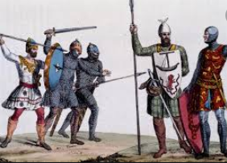 | ACTIVE  Choose 1 activity:  - Joe Wicks PE Workout  - iMovers  OR  Choose a PE activity from  Youth Sport Trust  https://www.youthsporttrust.org/pe-home-learning

