ENGLISH | MATHS | ENQUIRY | ACTIVE
Monday the 1st June is an INSET day. Around this time of year, we would usually talk to the children about sun safety. With the beautiful weather that we are enjoying at the moment, it is even more important that we all know how to enjoy the sun safely. Here is a link to a sun safety poster challenge on the Soltan website. I have also attached the powerpoint to the blog post. Spend today looking through the powerpoint, talking about how to keep safe in the sun and making a sun safety poster.

https://soltansunready.com/for-families/sun-ready-poster-project

Create a reading den!  Do you have a favourite place to read? Take a look at where these authors like to read:  https://literacytrust.org.uk/news/authors-favourite-reading-spots-children-read-summer/  You can download some good instructions for making a den from http://www.wordsforlife.org.uk/getlost-summer  using chairs, blankets or bedspreads, cushions and clothes pegs. An internet search for ‘reading den’ will bring up many more ideas, or you might prefer just to go your own way and let your imagination run wild!  When making a den, you’re going to need to think of the following:  • Where do you want to make your den? - will you build an outdoors or indoors den?  • Size – how big will your den be? Is it just for you or for more people? Will you want to be able to stretch out to read or are you happy to curl up?  • Strength – how can you make a strong den that won’t easily fall over, trip anybody up, or bury you by collapsing?! • Permanence – how long do you want your den to stay up for?  Build yourself a reading den that will be the envy of all your friends!  Try out your den – enjoy a book!  Send me a picture of you reading in your den!  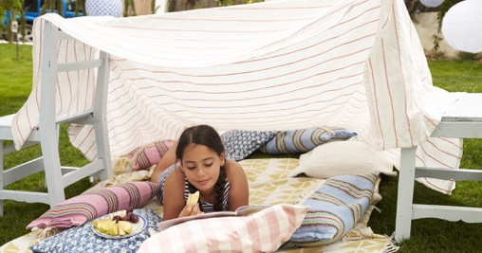 | Practise your left and right by copying the cha cha slide (Make sure you have lots of space!)  https://www.youtube.com/watch?v=I1gMUbEAUFw  Now play this game using up, down, left and right to help the pirate find the treasure:  https://pbskids.org/peg/games/hungry-pirates | Geography  Where in the World is Cornwall? Use a map of the world like this one here:  https://geology.com/world/world-map.shtml  Explore the map.  Which is the biggest country?  Do you recognise the names of any other countries?  Can you find a country that is on an island all by itself?  Find and click on the UK.  What four countries make up the UK?  Where is Cornwall?  Have a look at this illustrated map of Cornwall:  https://i.etsystatic.com/8314604/r/il/69fee8/1544757174/il_1588xN.1544757174_l2fq.jpg  Have you been to any of those places? | Choose 2 activities:  - Joe Wicks Workout  - Super Movers  - iMovers  - Sea themed Yoga Poses  (Select 3 poses and practise the same all week as you will add new ones weekly as you build up to compile your own ‘underwater’ yoga sequence (adding music) as the enquiry progresses).  - Pirate just dance (A pirate you shall be):  https://www.youtube.com/watch?v=oe_HDfdmnaM  - A pirate workout:  https://www.youtube.com/watch?v=jcHDT_gEm3I  - Pirate Yoga:  https://www.youtube.com/watch?v=T_0P5grVoyg  Design a pirate obstacle course complete with plank to walk.
Can you write instructions for someone else to follow so they can build your den?  Take a look at these instructions for inspiration:  http://www.wordsforlife.org.uk/sites/default/files/Get-Lost-This-Summer-Den-activity.pdf  Remember to include:  . Capital letters and full stops!  . A title,  . An opening sentence/introduction,  . A list of things you will need,  . Numbered instructions,  . Time conjunctions (First, next, then, after that, finally),  . Pictures | Use an object – a toy or a shape and have a go at turning it in different directions.  What does a quarter turn look like?  What about a half tun?  Can you make it do a three-quarter turn?  How can you turn it so that it ends up back in the same position?  Quarter turn:  Half turn:  Three quarter turn:  Challenge:  Can you turn your objects clockwise and anticlockwise? What is the difference? What would happen if you turned the same object a half turn clockwise and a half turn anticlockwise?  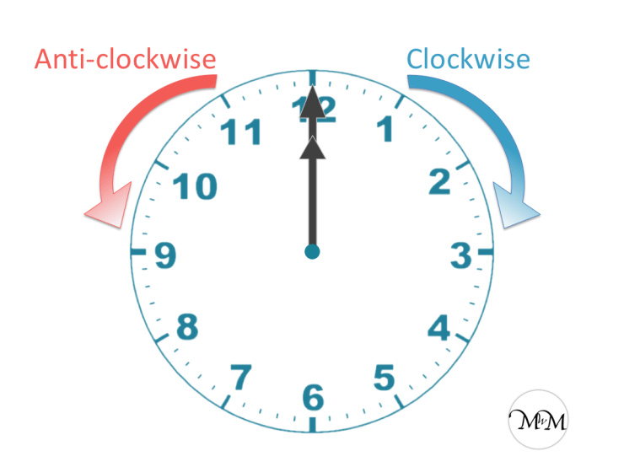 | What makes Cornwall special?  Watch this aerial tour of Cornwall. Do you recognise any of these places? Can you spot your house?  https://www.visitcornwall.com/video/cornwall-aerial-tour  What do you notice about the video?  What are the buildings like?  What colours do you see?  Can you see lots of big roads and buildings?  Is there anywhere you have not visited that you would like to?  Research some facts about Cornwall.  https://www.funkidslive.com/take-me-out/attractions/things-to-do-around-the-uk/cornwall/#  https://www.sykescottages.co.uk/blog/fascinating-facts-about-cornwall/  Challenge:  Can you use some of the facts you have found to make a poster about Cornwall? | Choose 2 activities from the list above.
Log in to Get Epic.  1. Try browsing for books (see instructions below/attached to the blog). This will show all the books and you can choose things you are interested in.  2. Next try searching for books (see instructions below/attached to the blog). This will let you narrow down the books. You can also make sure they aren’t too hard or too easy.  Choose at least 4 books to read. You can read as many as you like! | Practise what you have learned on Tuesday and Wednesday by joining in with this supermovers:  https://www.bbc.co.uk/teach/supermovers/ks1-maths-position-&-direction/zhh9scw  Now watch this clip:  https://www.bbc.co.uk/bitesize/clips/z7kwmp3  Write out these sentences to describe how the animals are moving.  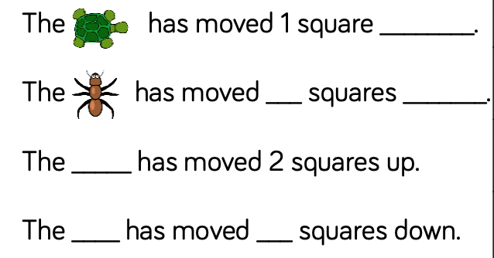  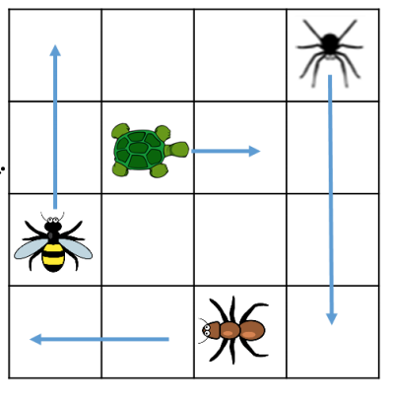 | Cornwall is full of legends. Read about some of them here:  https://www.cornwalls.co.uk/myths-legends  Choose one of the legends, e.g. the hurlers, the cock-crow stone, the mermaid of Zennor, the beast of bodmin moor etc. and research it. Read the story of the legend.  Do you believe that it happened? Why/why not?  Choose one part of the story to draw as a picture.
Review your book.  Choose your favourite of the books you have read and write a short book review about it. You could use these sentence starters to help you (they are also attached to the blog as a template to write on):  I chose this book because…  The best bit about it was…  You would like to read this book if…  The next book I am going to try is…because… | Describe the route that Dennis takes to get to school:  How many different ways can you find for the bee to move to the honey?  Use all of the vocabulary you have learned this week (left, right, forwards, backwards, half turn, quarter turn, clockwise, anticlockwise)  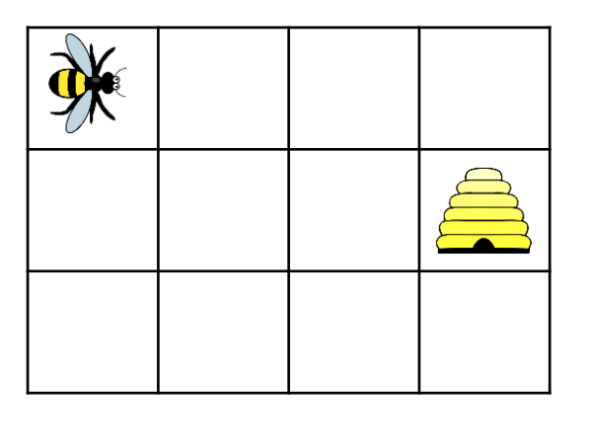 | Art  Cornwall is home to many artists. Have a look at these colourful paintings of Cornwall by artist John Dyer:  https://www.johndyergallery.com/39-john-dyer  Choose your favourite place in Cornwall and create a piece of art inspired by John Dyer. He simplifies the shapes in his paintings. Look at a photo of the place you have chosen. How could you simplify it? Can you use bright colours like him?  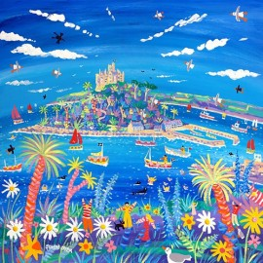 | Choose 2 activities from the list above.

How to browse books on GetEpic:

Click ‘Explore’ and choose ‘recommended’
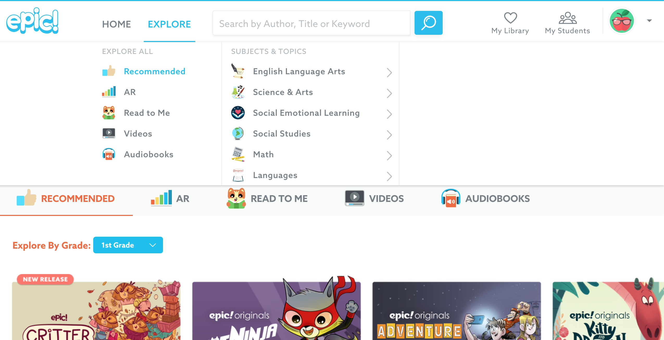
You can look through books that you may like.

How to search on GetEpic:

Click on the search bar and type in something that you would like to read about.
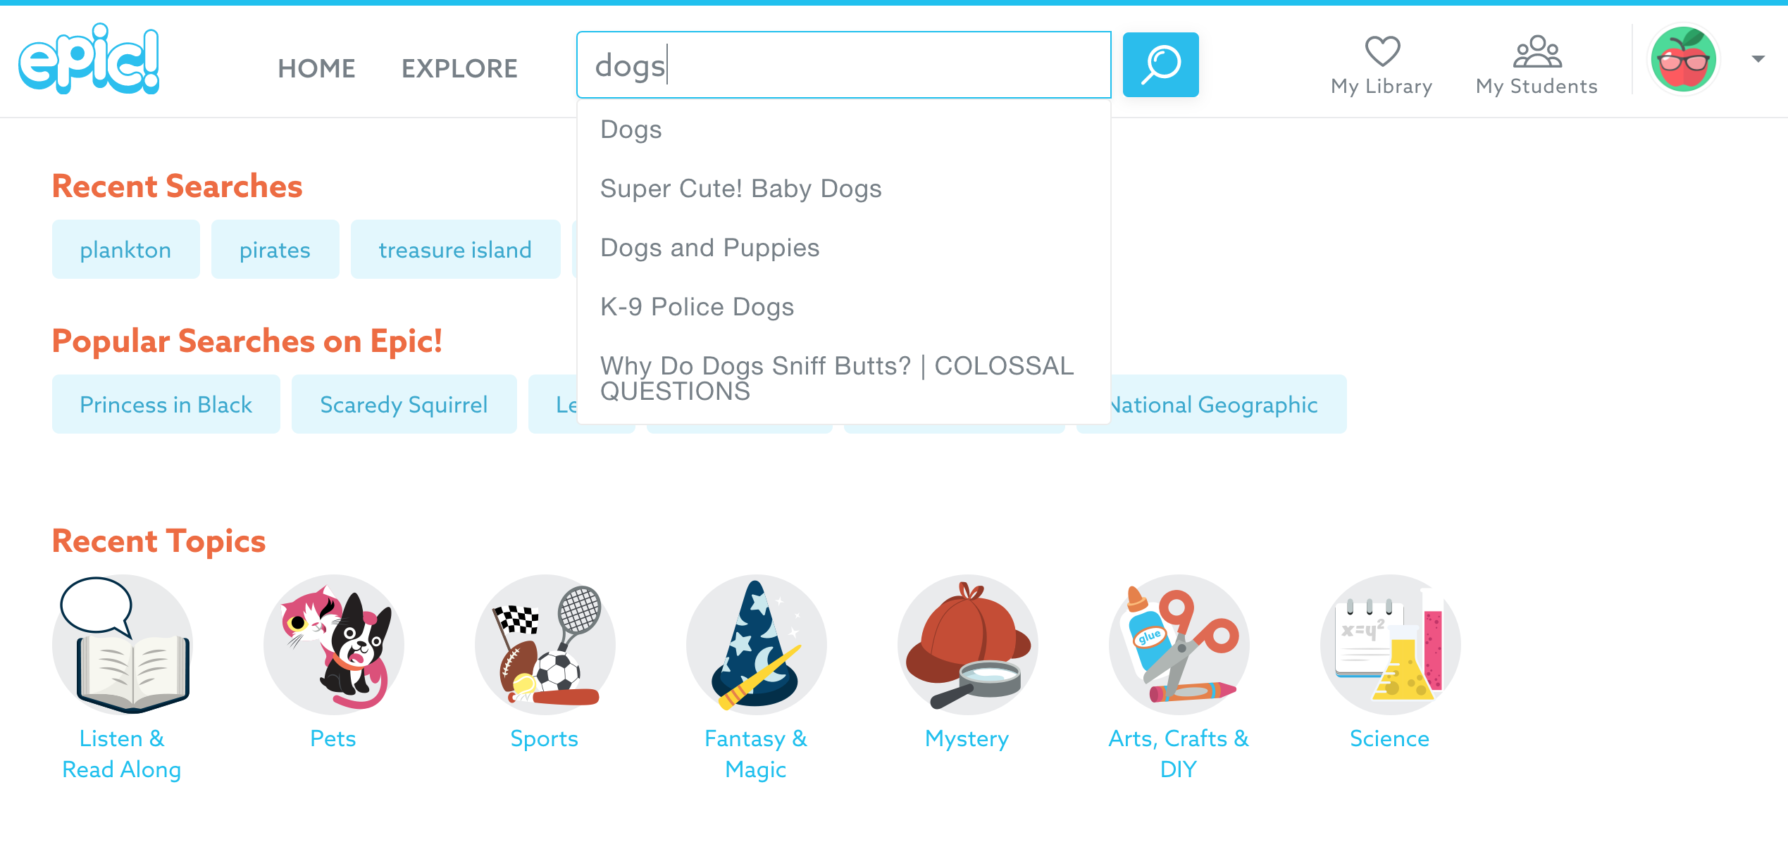

Make sure you click on your age.
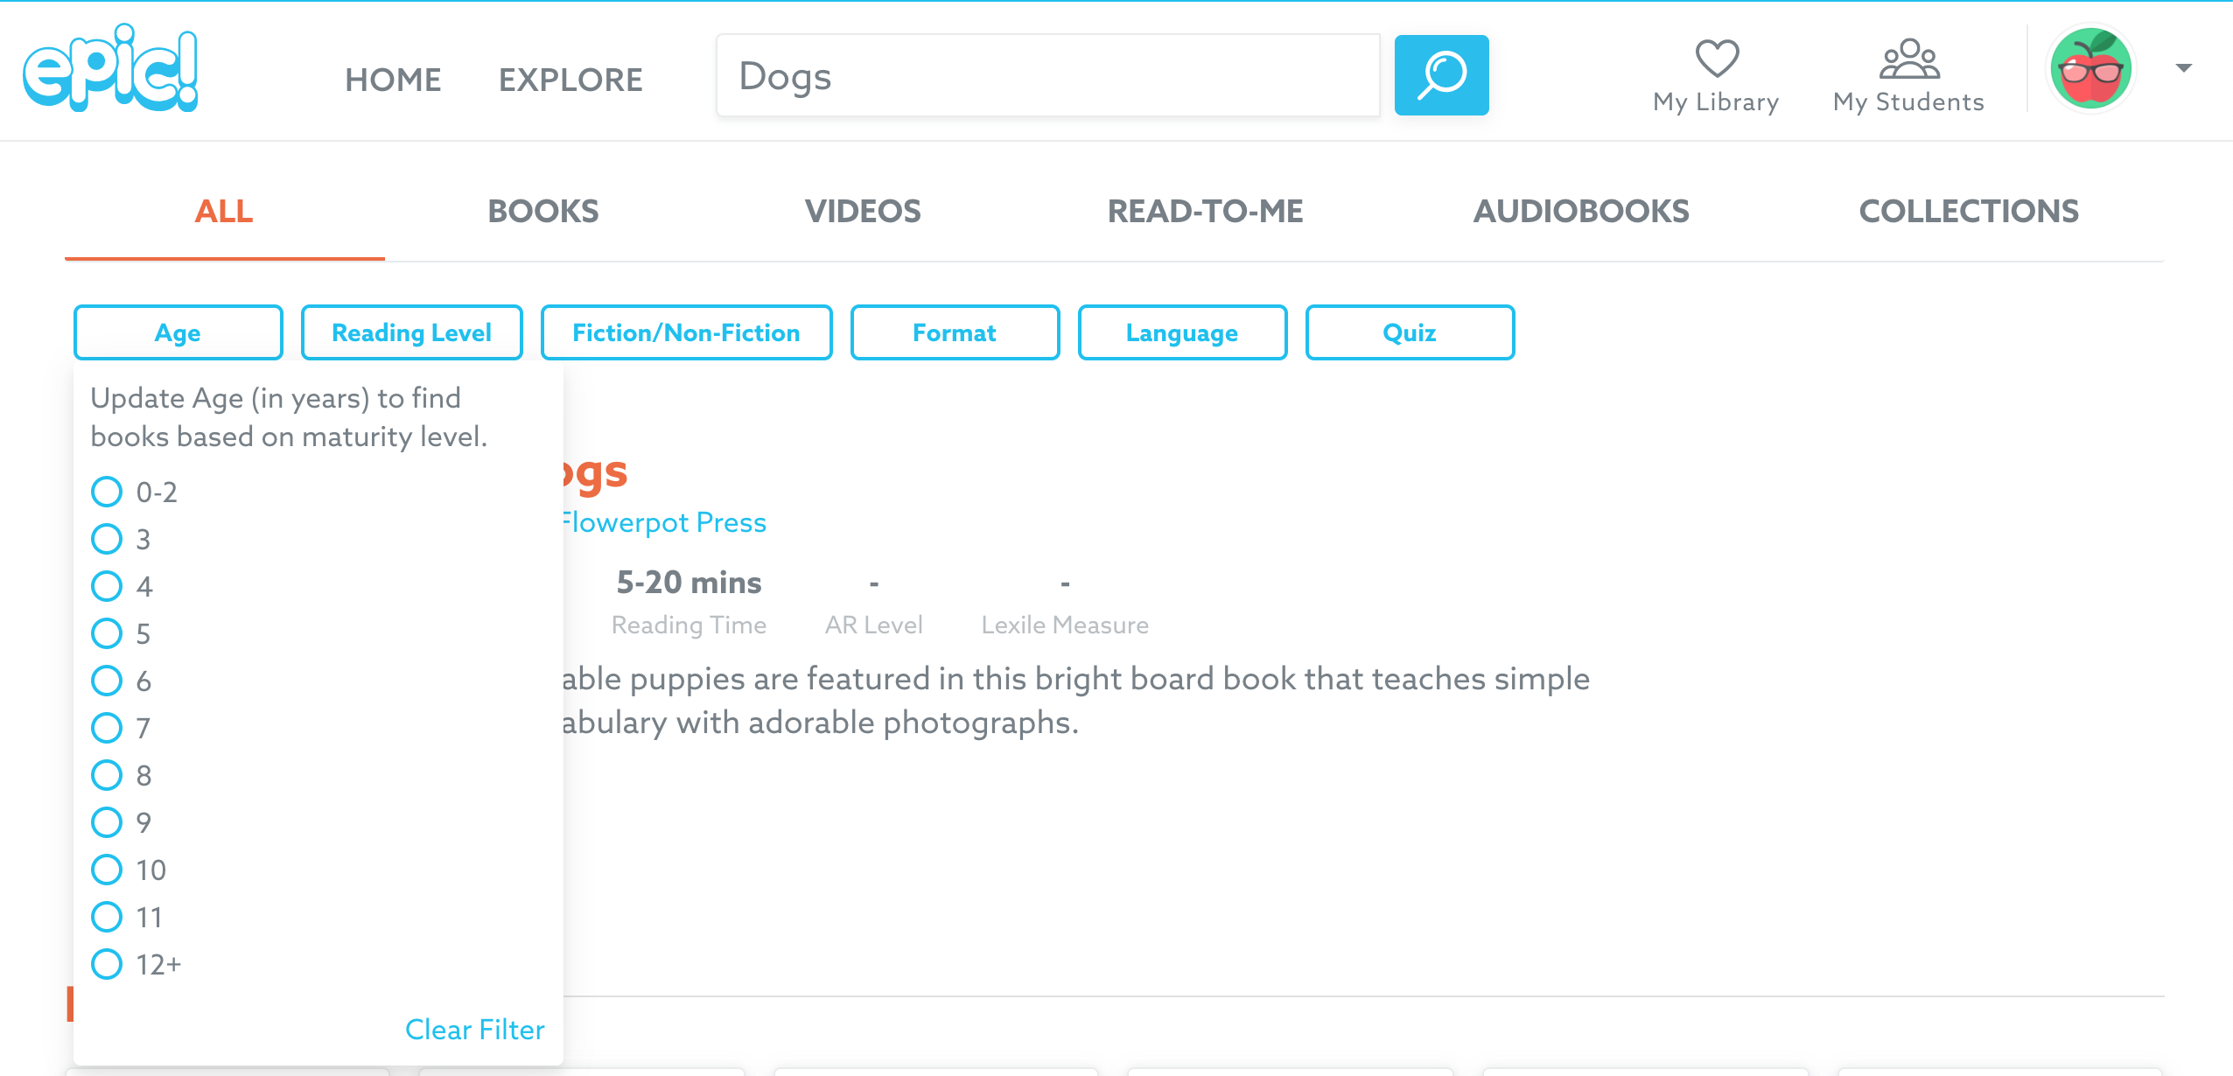

You can search by ‘fiction’ (stories) or ‘non-fiction’ (facts)

