How to browse books on GetEpic:

Click ‘Explore’ and choose ‘recommended’
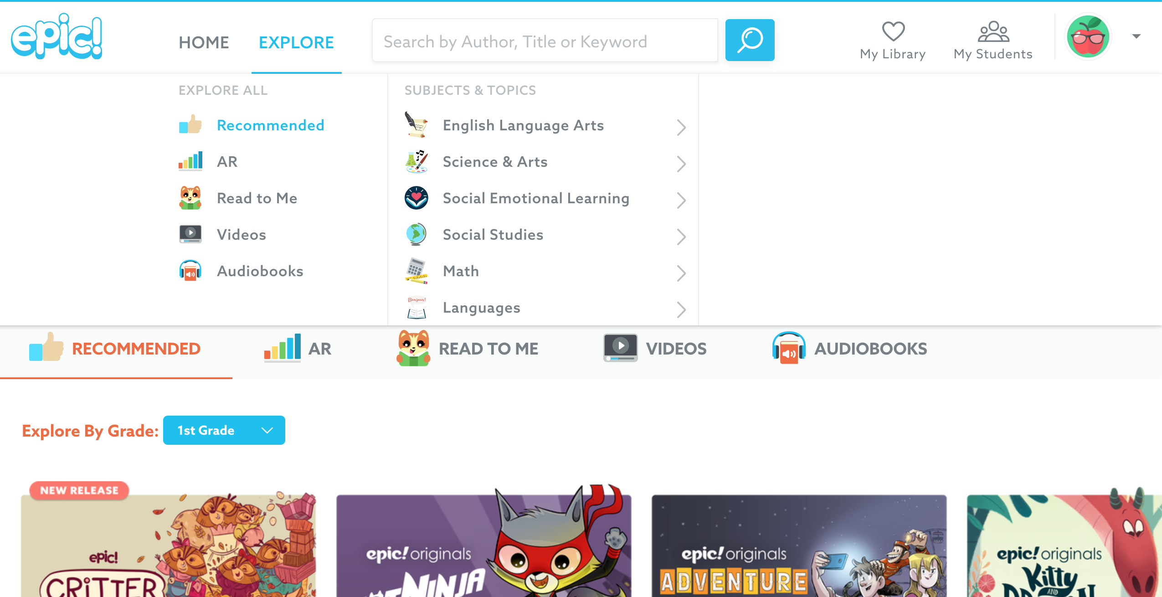
You can look through books that you may like.

How to search on GetEpic:

Click on the search bar and type in something that you would like to read about.
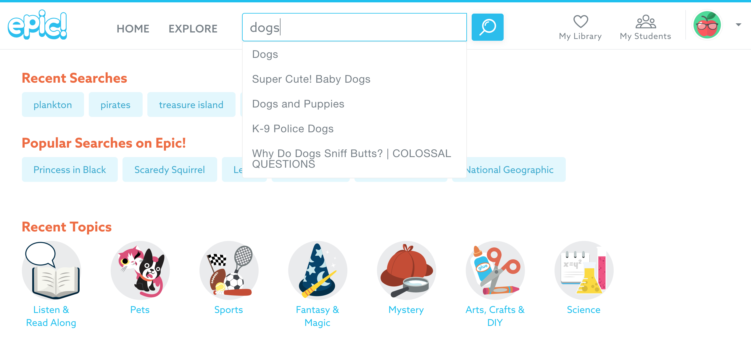

Make sure you click on your age.
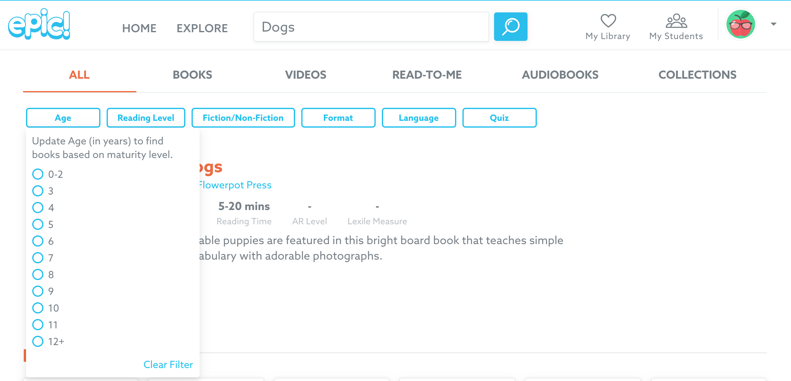

You can search by ‘fiction’ (stories) or ‘non-fiction’ (facts)

