ENGLISH | MATHS | ENQUIRY | ACTIVE
Have a look at the powerpoint attached to the blog. It shows the different sentence types.  Write your own statement, command, question and exclamation sentences.  Challenge:  Can you use a conjunction in your statement? (and, so, because, but) | Our maths focus this week is on fractions.  How many names of 2D shapes can you remember?  Draw these shapes as accuratley as you can (Using a ruler!).  Now have a go at cutting them in half. (With scissors or by drawing a line). Remember that half means two equal parts.  Challenge: Can you find any other ways to cut your shape in half? | Science  Watch this video all about different types of plankton:  https://www.youtube.com/watch?v=xFQ_fO2D7f0  What different types of plankton are there? What else can you find out about plankton? What animals eat it?  You could have a go at drawing your own plankton. | Choose 2 activities:  - Joe Wicks Workout  - Super Movers  - iMovers  - Sea themed Yoga Poses  (Select 3 poses and practise the same all week as you will add new ones weekly as you build up to compile your own ‘underwater’ yoga sequence (adding music) as the enquiry progresses).  - Pirate just dance (A pirate you shall be):  https://www.youtube.com/watch?v=oe_HDfdmnaM  - A pirate workout:  https://www.youtube.com/watch?v=jcHDT_gEm3I  - Pirate Yoga:  https://www.youtube.com/watch?v=T_0P5grVoyg  Design a pirate obstacle course complete with plank to walk.
Have a look at the picture ‘Strange Ship’ on pobble 365:  https://www.pobble365.com/the-strange-ship  And have a go at answering the questions in the ‘Question Time’ section.  You could do this as a discussion with an adult. Try to use as much detail as you can to answer the questions. | Today you will be finding half of an amount. You could use any objects – beads, buttons, lego pieces, pencils. Start with the total and then split the objects into two equal groups.  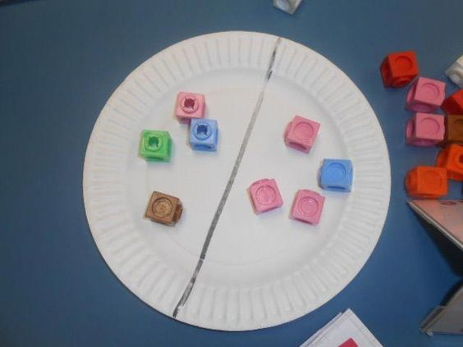  Find:  Half of 8  Half of 6  Half of 10  Half of 14  Half of 18  Challenge:  Half of 22  Half of 26  Half of 30  Half of 36 | Using your knowledge of food chains from last week, design and create a piece of art to represent an underwater food chain. Use different animals from last week! Can you choose animals from a different ocean?  This will take 2 days. Spend the first day researching and planning and the second day creating.  Here are some ideas:  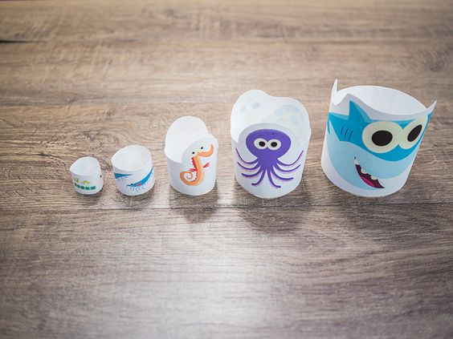  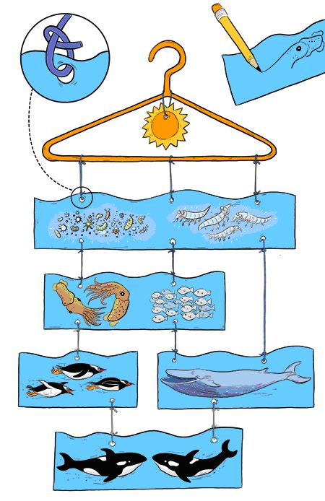  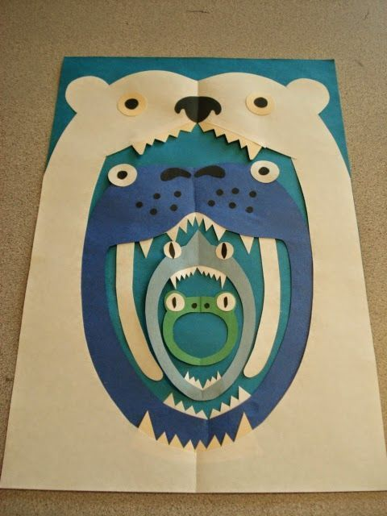  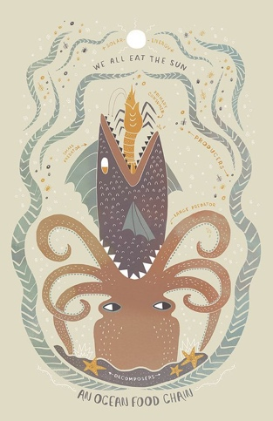 | Choose 2 activities from the list above.
Have a go at the ‘Sick Sentences’ section on Pobble 365. Can you rewrite the sentences by adding adjectives?  https://www.pobble365.com/the-strange-ship  Challenge:  Continue writing the story of the strange ship. Can you use all four sentence types from Monday?  Remember: capital letters, full stops, finger spaces and adjectives, | Now you are going to have a go at finding quarters.  First, either draw or print off some 2D shapes.  Now have a go at cutting them into quarters. (With scissors or by drawing a line). Remember that a quarter is one of four equal parts.  Challenge: Can you find any other ways to cut your shape in quarters?
Spend the next two days writing your own pirate adventure story!  Look at the story map you made for ‘Treasure Island’ and use the story to help you write your own. Include the character you designed last week and try to add as much description and detail as you can. I can’t wait to read it!  Remember to use:  capital letters,  full stops,  finger spaces,  adjectives,  statement, command, exclamation and question sentences.  When you have finished, you might like to draw some illustrations to go with your story. | Now you are going to find a quarter of an amount. Just like on Tuesday, you could use any objects – beads, buttons, lego pieces, pencils. Start with the total and then split the objects into four equal parts.  Find:  A quarter of 8  A quarter of 16  A quarter of 12  A quarter of 20  Now have a go at this quiz:  https://www.educationquizzes.com/ks1/maths/year-1-fractions-quarters/ | R.E  Watch this video introducing Hinduism:  https://www.bbc.co.uk/bitesize/topics/zh86n39/articles/zmpp92p  Read the information underneath and then complete the activities below.  Hindus celebrate Diwali.  Watch this video all about Diwali:  https://www.bbc.co.uk/bitesize/clips/zmwmpv4  Can you think of something that you celebrate? How is it similar and different from Diwali? | Choose 2 activities from the list above.
 | If you shared this food between 2 people how much would they eat each? What about 4 people?  Can you make your own picnic and share the food between 2 or 4 people? (You could draw your food or use real food!) | Catch Up Time  Use this time as a chance to catch up with any work from the last few weeks that you have not been able to do yet.

