Ascension Day spiral
Draw round a CD and then draw a spiral inside it. Think about wishes, thought and blessings for others and write or draw them inside the spiral.
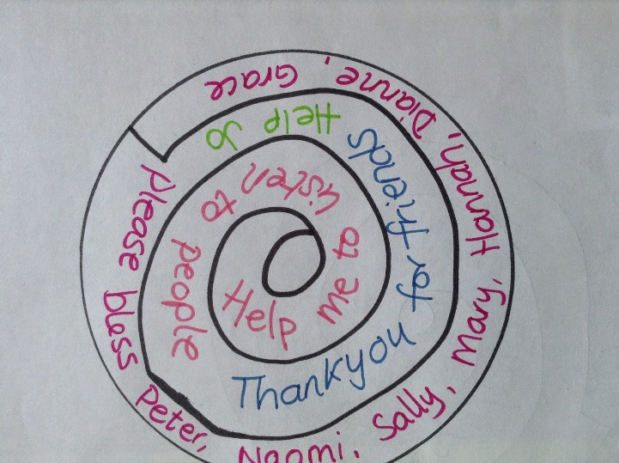
Cut the spiral out and thread a piece of string through the top so that you can hold the thread and the spiral will dangle down (see picture below).
The spiral will spin slightly just by virtue of being held, but when held over a bulb or source of heat, the spiral will spin much more because of the rising of hot air. Even though we can't see the hot air, it is still there, rising up. The movement of the spiral gives a 'rising' or 'ascending' visual.
