FOOD CHAIN NESTING DOLLS
At the bottom of the ocean food chain is phytoplankton, very tiny plants that float through the ocean. They get their energy from the sun. In the process, they produce half of the air we breathe. Thanks, phytoplankton! 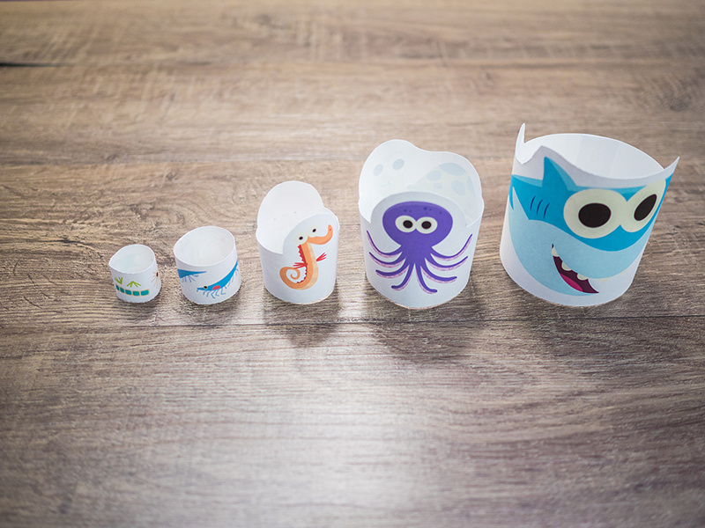Phytoplankton is eaten by zooplankton, very tiny animals that float through the ocean. They come in all different shapes; some look like tiny shrimp.
Zooplankton is eaten by small animals like seahorses and jellyfish.
They are both eaten by medium-sized animals like sea turtles and octopus.
And both of them are eaten by big animals like sharks. A shark is too big and fierce to be eaten by anything, so it’s called a top predator: it’s at the top of the food chain.
But an important thing to remember is that the creatures at the top could not live without the creatures at the bottom.
Even though the blue whale is the biggest animal of all, it doesn’t eat sharks. Instead, blue whales eat huge amounts of a very tiny creatures: a type of zooplankton called krill.
Here’s how to make your food chain nesting dolls:
https://youtu.be/Rbjw7IUAeRg

