Year 4 Problem Solving with Money

Activities available from nrich.org
https://nrich.maths.org/public/topic.php?group_id=15&code=7

Money Bags
Ram divided 15 pennies among four small bags.
He labelled each bag with the number of pennies inside it.
He could then pay any sum of money from 1p to 15p without opening any bag.
How many pennies did Ram put in each bag?

The Money Maze

Age 7 to 11
Go through the maze, collecting and losing your money as you go. You may not go through any cell more than once, and can only go into a cell through a gap, for example, you may not go from 5 to 6, or from 7 to 3.
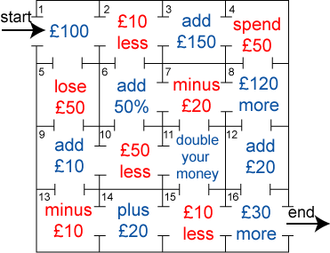
Which route gives you the highest return? How much is it?
Which route gives you the lowest return? How much is it?

