18.5 | ENGLISH | MATHS | ENQUIRY | ACTIVE
S  E  S  S  I  O  N  1 | READING COMPREHENSION  We are starting at the bottom of the food chain by looking at plankton.  You may know all about Sheldon J. Plankton, (he’s a type of zooplankton called a copepod) but he is not at the bottom of the food chain, because he eats phytoplankton.  Read pages 1-13 on GetEpic to learn about ocean food chains.  https://www.getepic.com/app/read/61547  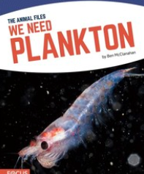  Take notes of the key terms and answer the questions on the questions attached below the blog – Plankton Questions | TIMES TABLE TARGET PRACTICE  Practise your target times tables using the games. If you are fluent in all, it’s time to work on rapid recall – can you improve the speed every time? Or are you ready for rapid recall of addition and subtractions facts? I have added some mental maths practice below the Blog.  Hit the button  https://www.topmarks.co.uk/maths-games/hit-the-button  Times Table Rockstars  You might prefer to practice your times tables outside, bouncing a ball, jumping, skipping. I would love to hear of how you have practiced this week and if you have learnt your target times-table. | SCIENCE/ART  Watch the film  The Secret Life of Plankton  https://www.youtube.com/watch?v=xFQ_fO2D7f0  The film shows the beautiful shapes and designs of the different phytoplankton and zooplankton in our oceans. Your task is to design your own plankton. For inspiration, look at the examples in the Creative Plankton document below the Blog.  Be as creative as you like, you can draw, make or bake your personal plankton. Don’t forget to name it.  Great Earworm for ocean food chains  https://www.youtube.com/watch?v=ttOZKOGdjR8 | Choose 1 activity:  - Joe Wicks Workout  - Super Movers  - iMovers  PLUS:  Build an obstacle course and time yourself completing it.
S  E  S  S  I  O  N  2 | READING FOR INFORMATION https://www.getepic.com/app/read/34079  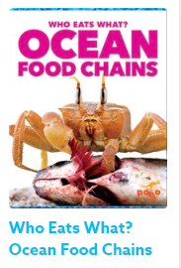  Read the book carefully and take notes of the key facts.  Go to page 23  Using the spelling strategies, practise spelling these key words. When you can spell them, use them to make a POSTER showing how a food chain works.  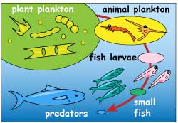 | MEASUREMENT AND CONVERTION  Year 4 – Summer Term Week 2 lesson 3 Pounds and Pence  https://whiterosemaths.com/homelearning/year-4/  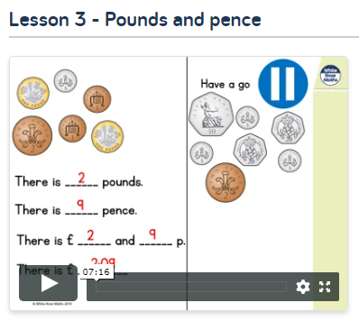  Year 5 – Oak Academy Lesson 1  To convert between seconds, minutes and hours  https://www.thenational.academy/year-5/maths/to-convert-between-seconds-minutes-and-hours-year-5-wk3-1 | SCIENCE/ART  Use your learning of food chains to create a collage  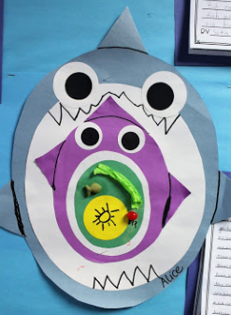  https://www.youtube.com/watch?v=jvJ8ftqeEzA  Or food chain nesting dolls  https://youtu.be/Rbjw7IUAeRg  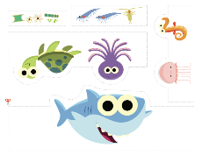  PDF with shapes attached below blog | Choose 1 activity:  - Super Movers  - iMovers  PLUS:  Let’s Dance! https://www.youtube.com/playlist?list=PLJnn5H8Y_tYE3LdXoJIG_azMC2l5TjCON  Try a new routine!  OR  Challenge someone in your house to a race: jumping, walking sideways, crawling or all of them as a relay.
S  E  S  S  I  O  N  3 | WRITING  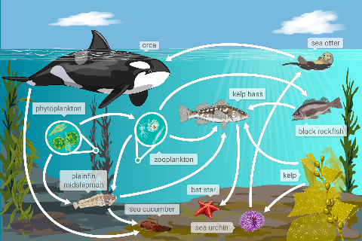  Choose one of the ocean creatures in your food chain and write a detailed description of it.  Remember to use a variety of sentences types  - 2A sentence  - Simile sentence  - BOYS sentence  Year 5 also use  NOUN, who/ which/ where sentences | MEASUREMENT AND CONVERTION  Year 4 – Summer Term Week 2 lesson 3 Ordering money  https://whiterosemaths.com/homelearning/year-4/  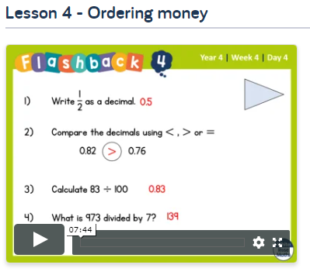  Year 5 – Oak Academy Lesson 5  Find the perimeter and convert units of measurement  https://www.thenational.academy/year-5/maths/to-find-the-perimeter-and-convert-units-of-measurements-year-5-wk3-5#slide-1 | PSHE  Go on a scavenger hunt to find as many of the items on the list as possible  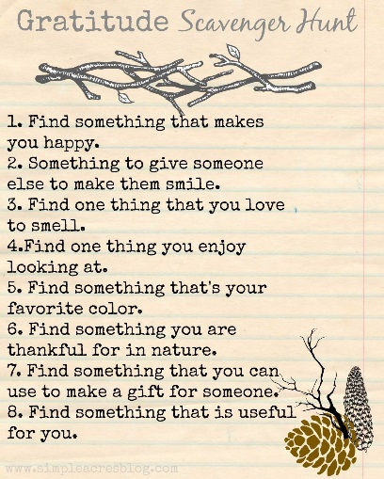 | Choose 2 activities:  - Joe Wicks PE  - Super Movers  - iMovers  or  Dance with Oti  https://www.youtube.com/channel/UC58aowNEXHHnflR_5YTtP4g
S  E  S  S  I  O  N  4 | GRAMMAR  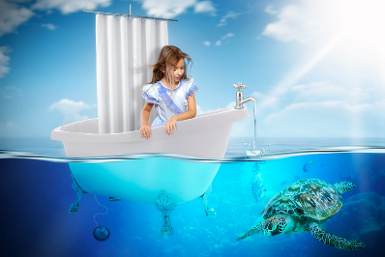  https://www.pobble365.com/an-unexpected-adventure  Click on the link and scroll down to Sentence Challenge.  Complete the challenge by thinking of verbs to go with the nouns then write these as sentences. Don’t forget to add some adjectives to expand the nouns and some adverbs to describe the verbs.  water – trickled  The warm, azure blue water trickled slowly over the curved side of the bath. | MEASUREMENT AND CONVERTION  Year 4  Play Going Shopping  http://flash.topmarks.co.uk/4020  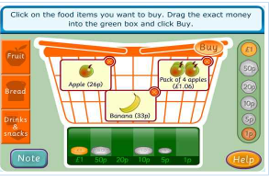  And try Y4 problem solving activities with money attached below blog  Year 5 – Complete the challenges set on  Mathletics  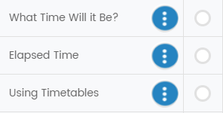 | RE  Today is Ascension Day, the 40th day of Easter. A Christian holiday that commemorates Jesus Christ's ascension into heaven.  Read the fact file attached to the blog. Now make a spiral with your thought and wishes and see these ascend by placing the spiral over a warm bulb to make it spin.  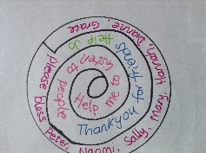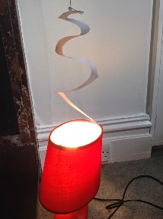  FRENCH  Go to duolingo  https://www.duolingo.com/learn  Complete your next level. | Choose 1 activity:  - Joe Wicks PE  - iMovers  PLUS:  Go Noodle – GoNoodle for Families https://family.gonoodle.com/channels/zumba-kids  Try a new routine!
S  E  S  S  I  O  N  5 | WRITING  https://www.pobble365.com/an-unexpected-adventure  Use the same image as yesterday. Today you can choose to:  Write the story of the girl’s adventure using the story starter:  She knew that it hadn’t been a good idea to leave the tap running, but now she was starting to enjoy herself…  Or  Complete Question Time  Remember you need to use full sentences starting with capitals, ending with full stops and making sense. | FUN AND GAMES  Most board and card games use maths, like strategic thinking, addition/subtraction and reasoning skills. Ask someone in your house to play a board game or card game with you.  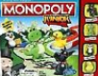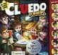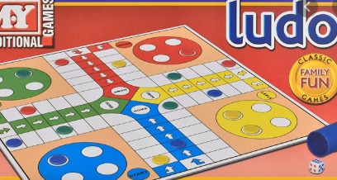  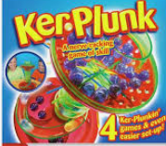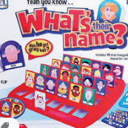 | MUSIC  Use Oak Academy for a music lesson about rhythmic patterns.  https://www.thenational.academy/online-classroom/year-4/foundation#subjects  Follow the link and choose Lesson 2  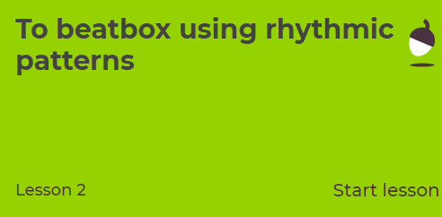  Complete the lesson following the prompts. | Choose 1 activity:  - Joe Wicks PE Workout  - iMovers  OR  Try out train like a footballer with Marcus Rasford  https://plprimarystars.com/resources/train-like-a-footballer

