 | ENGLISH | MATHS | ENQUIRY | ACTIVE
S  E  S  S  I  O  N  1 | We are going to watch Treasure Island in short clips over the next couple of weeks. This will help us understand an epic adventure in detail so that we can write our own.  Today, watch this first clip: https://www.bbc.co.uk/teach/class-clips-video/english-ks2-treasure-island-home/zk2qnrd  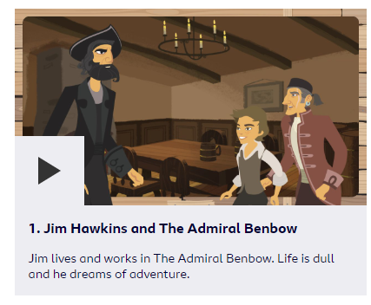  Think about what you would do if your were Jim. Would you feel frightened by the strange pirates? Then watch clip 2:  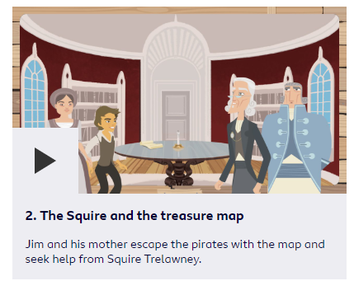  You’re about to set out on an epic treasure hunting adventure… What would you take with you on your journey?  Activity: 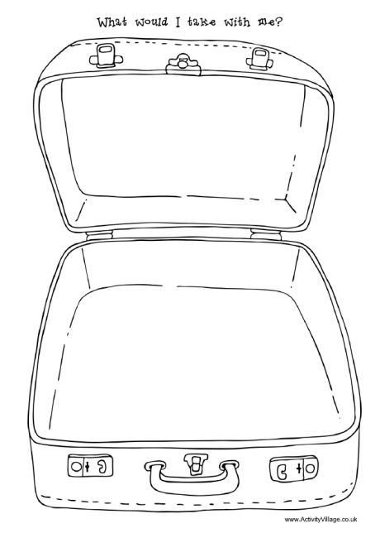 Either draw what you would take or pack a bag and send me a photo! Why would you take these things? | Last week we were identifying values of coins and making £1 from different amounts.  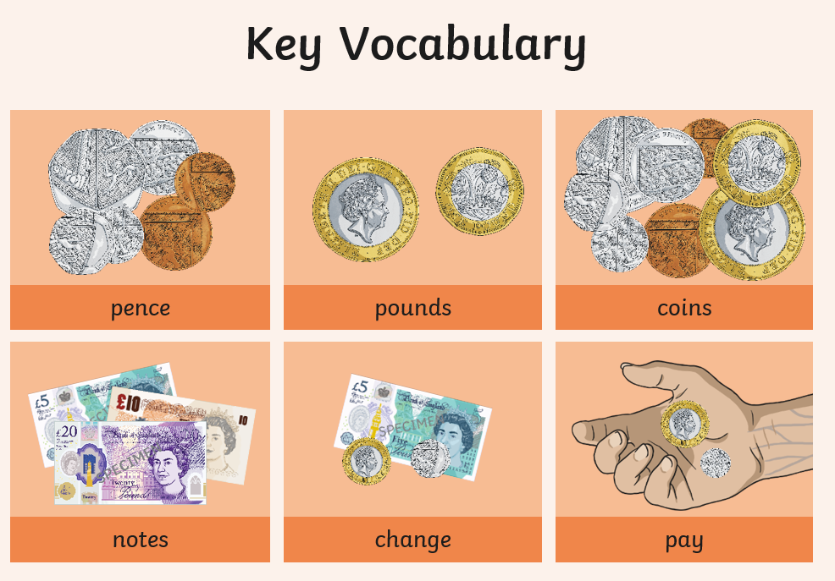  Today we will look at finding change from £1. Have a look at the activity below the grid and see the example I have provided.  Create the table (if you can’t print it) and complete the task.  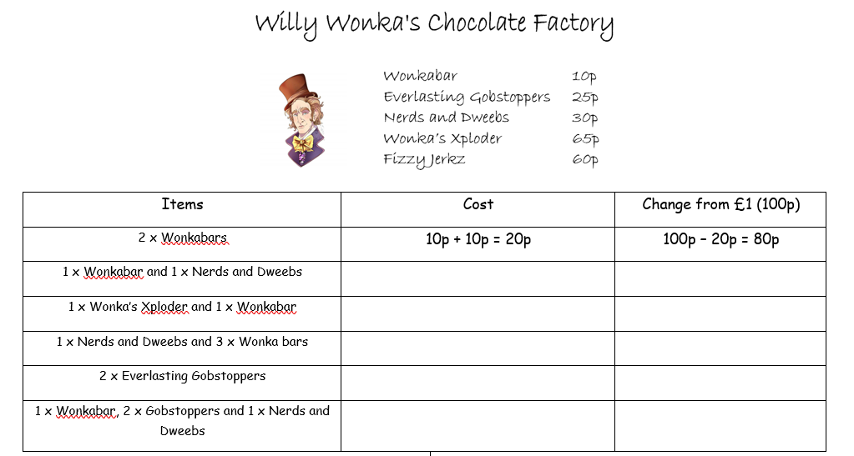 | GEOGRAPHY/SCIENCE: The importance of Phytoplankton.  What is plankton?  Phytoplankton is the main form of plankton and is vital for Earth’s survival. Why? Watch this intro:  https://www.youtube.com/watch?v=lDNsSRhf5Qk  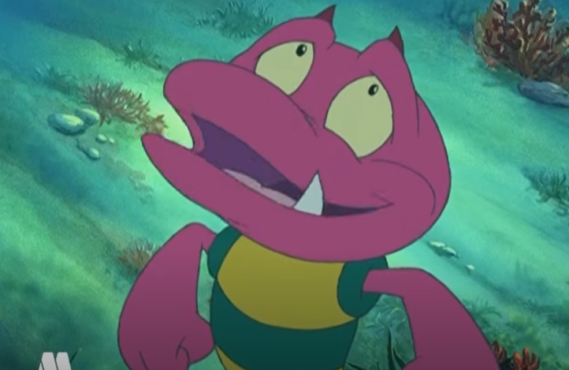  Discuss the fact that plants are responsible for the air that we breathe. Plankton produces 50% of this – half of our oxygen! What else is it important for? Watch https://www.youtube.com/watch?v=UjnYJVKysfo (Get your grown up to watch too – they will be amazed!)  ACTIVITY: Download and go through the power point on marine food chains:  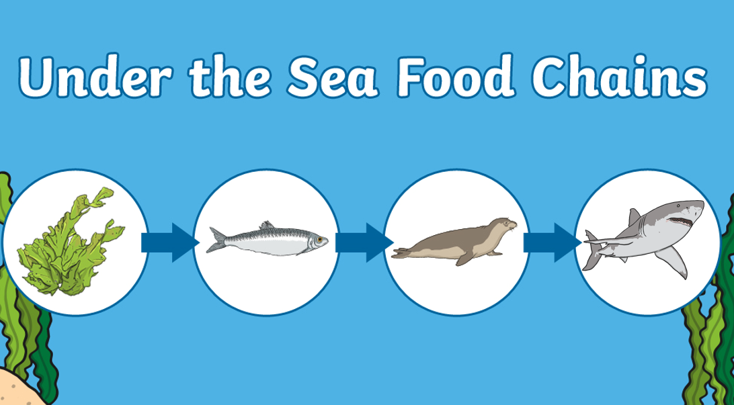  Activity included. | Choose 1 activity:  - Joe Wicks Workout  - Super Movers  - iMovers  PLUS:  - Sea themed Yoga Poses  (By now, you should have about 5-6 poses which you have been practising over the last few weeks. Now choose a routine and practise this today. On Friday, you will begin to put it to music.)
S  E  S  S  I  O  N  2 | GRAMMAR TIME  Today we are going to practise using a and an correctly before we write a noun. These two words are known as articles. An article goes before a noun to introduce it to the sentence.  There are only three articles: the, a and an. ‘The’ is used without any spelling rules at all and is used to name/identify something or someone specific – the boy/the house/the day before.  “a/an are used to identify a noun where the reader does not know which/who or what the writer is referring to – a ball/ an alien/ a hospital. These two articles have a rule though – so let’s practise!”  Download the power point and complete the activity!  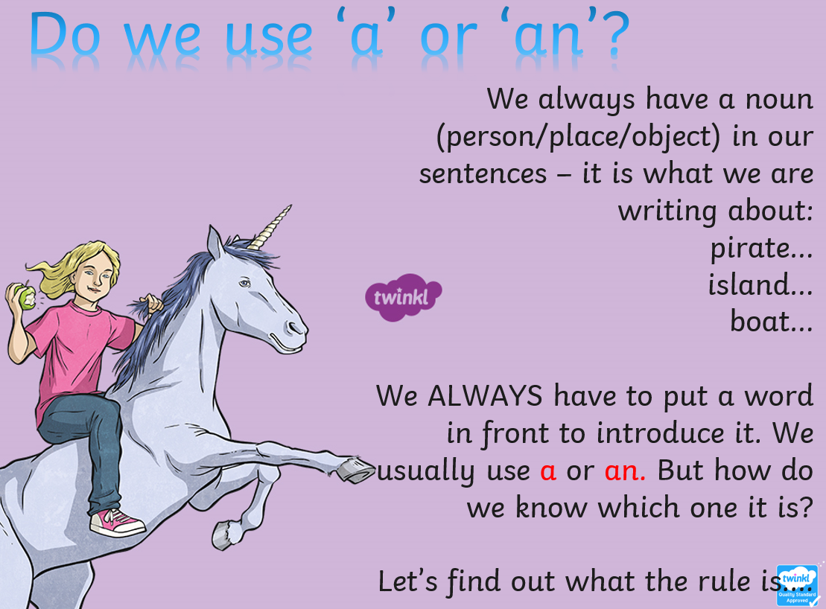 | Play Topmarks money games today.  Begin with:  - Mixed coins, exact amount, up to £1  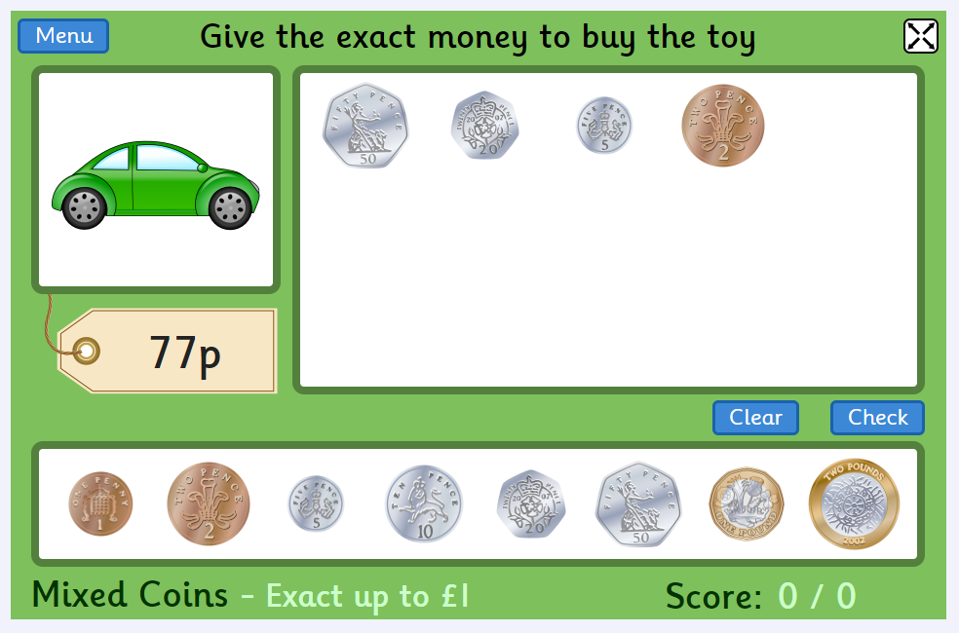  Then move onto:  - Mixed coins, give change, up to £1  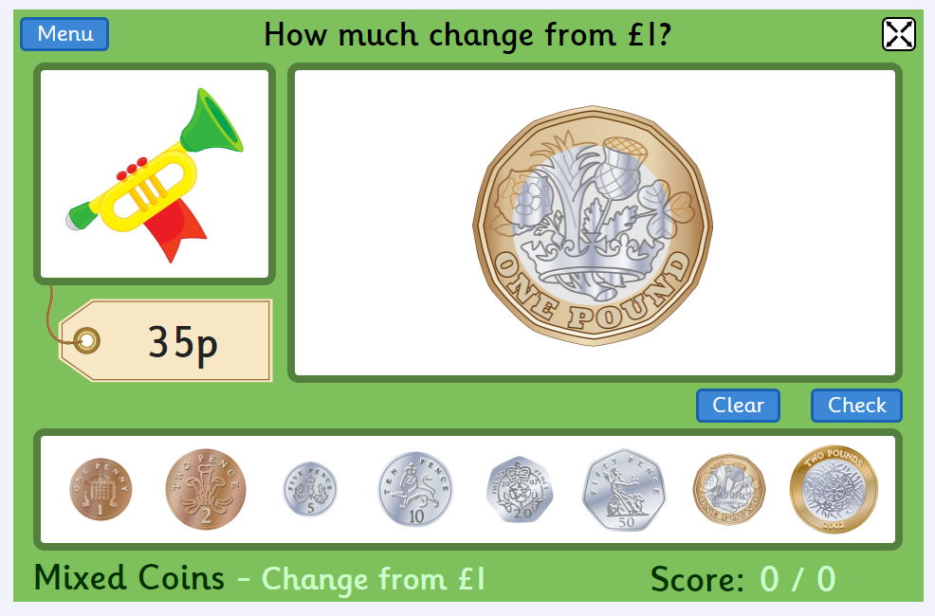 | Geography/Science/Art- RESEARCH  Now we know a little bit about our ocean’s food chains, let’s get a bit more technical. Not all sea creatures live in all waters so you can have a range of food chains depending on which ocean the creatures live in.  Can you remember the names of the 5 oceans?  ACTIVITY: Research and draw a simple food chain for each of the oceans (we know we start with phytoplankton).  CHALLENGE: What are the different challenges creatures living in the Arctic Ocean face against living in the warmer waters of the Pacific?  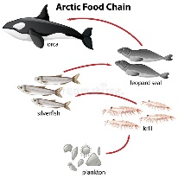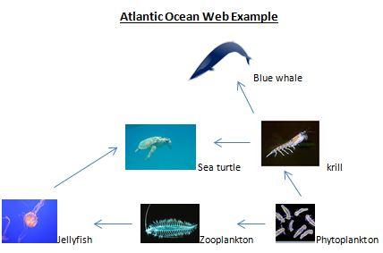  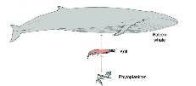  Get Epic has a range of research books and video clips such as:  https://www.getepic.com/app/read/34079  https://www.getepic.com/app/read/70545  https://www.getepic.com/app/read/7593 | Choose 1 activity:  - Super Movers  - iMovers  PLUS:  Let’s Dance! https://www.youtube.com/playlist?list=PLJnn5H8Y_tYE3LdXoJIG_azMC2l5TjCON  DON’T FORGET TO PRACTISE YOUR YOGA POSES!
S  E  S  S  I  O  N  3 | Remember our English from Session 2? Let’s look for incorrect use of the articles a and an whilst practising our reading and comprehension skills!  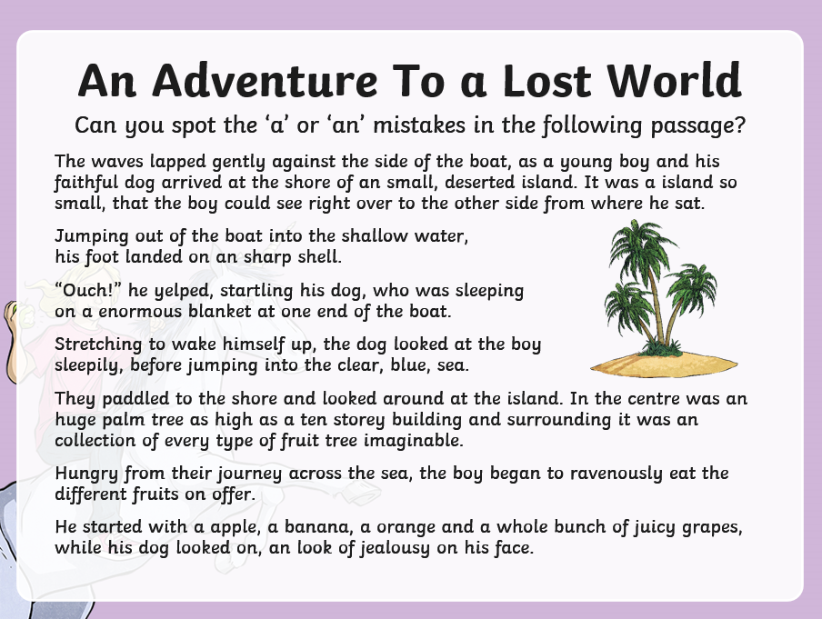  (Bigger version at the bottom of the grid.)  Then,  Have a look at the last piece of writing you have done whilst Home Learning. Have you used a and an correctly? Go back and change any mistakes!  You’ve edited your work – well done!  CHALLENGE: Why do we write an hour and not a hour? The rule is an for a vowel and h is not a vowel? (CLUE: Think of the first sound you hear!)  Can you think of anymore? 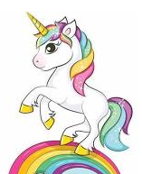 | Today, let’s extend to using notes and coins:  Watch this intro about a lady buying a train ticket and getting change from an ATM:  https://www.bbc.co.uk/bitesize/clips/z9tn34j  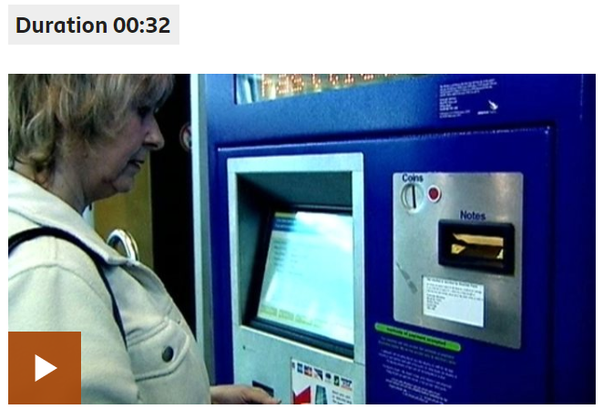  Have a go at the activity sheet attached to the blog (Session 3 Maths)  Then to finish, just discuss:  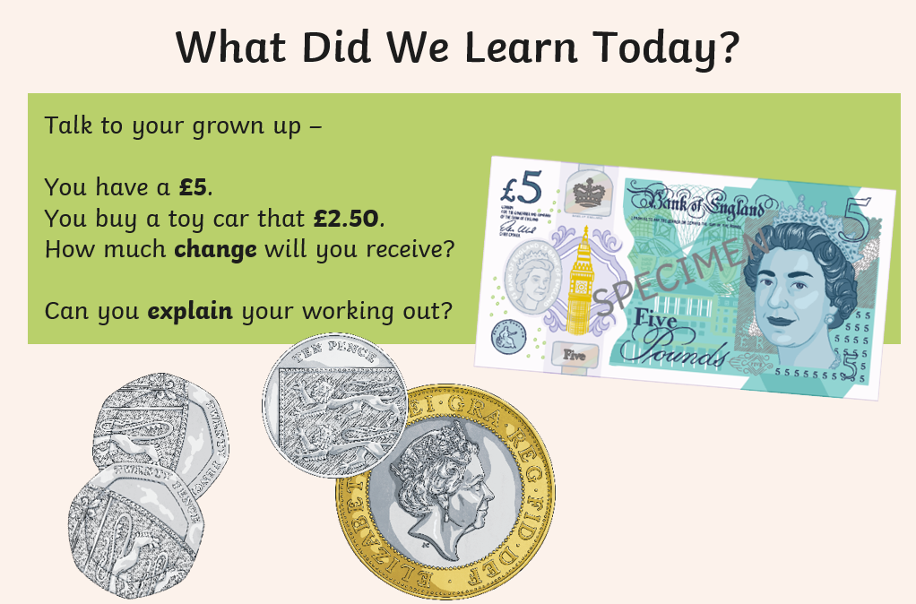  We will leave money for now but feel free to do your own thing as this is a great opportunity to support your child using money in everyday situations. | ART/DT: - Create your own under the sea food chain!  Choose your favourite food chain from Session 2 and get creative!  Here are some examples:  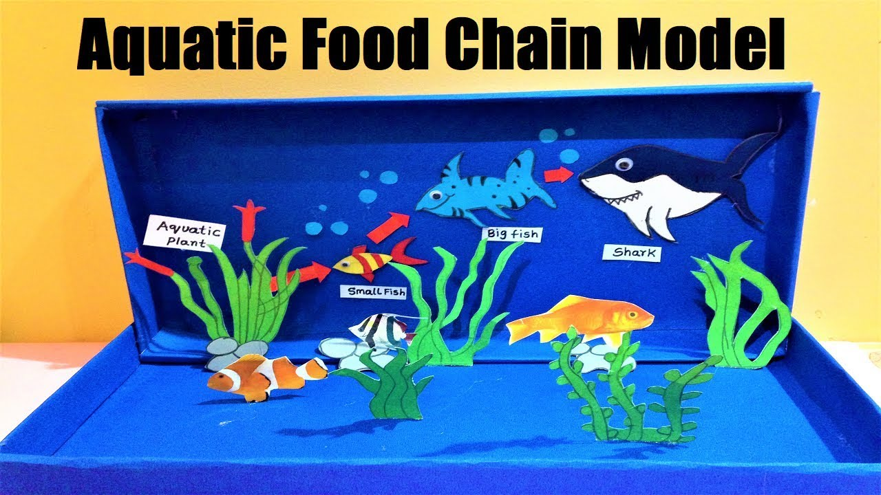  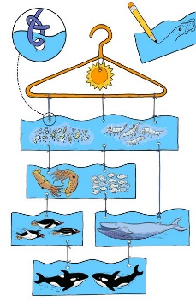  Use Session 4 and 5 as well!  Continue with your food chain creation!  If completed | Choose 2 activities:  - Joe Wicks Workout  - Super Movers  - iMovers
S  E  S  S  I  O  N  4 | Watch clips 3 and 4 of Treasure Island.  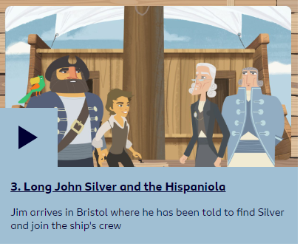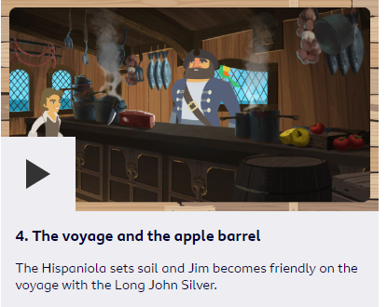  ACTIVITY: Write the next chapter of the story. Predict what will happen next. What do you think Jim and the others will do? Will the evil Long John Silver’s plan work?  Success Criteria:  - full sentences  - use articles a or an accurately  - use 2A sentences when you describe  - CHECK PUNCTUATION!  Or  Create a picture sequence of what happens next  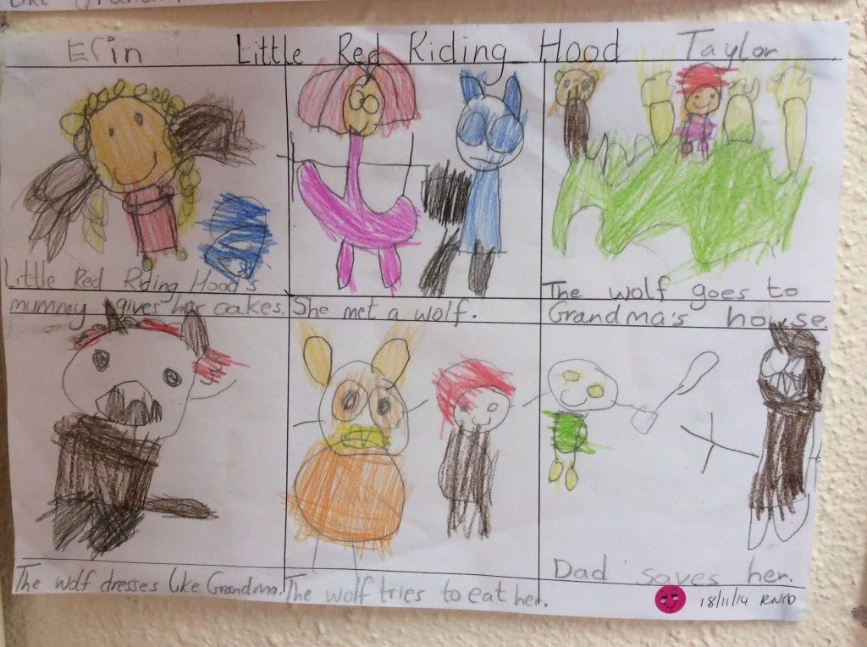 | We are moving on to telling the time – another valuable skill to have in everyday life!  Find a creative way to design a clock face. I like this using painted pebbles and sticks/hairgrips. (I’ll attach a template as a guide/starting point if needed).  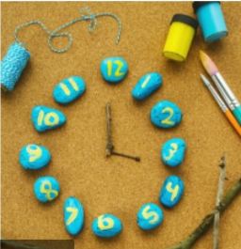  Get thinking and send in your entries by Friday evening please! |  | Choose 1 activity:  - Joe Wicks (The Body Coach TV) Workout  - iMovers  PLUS:  Go Noodle – GoNoodle for Families https://family.gonoodle.com/channels/zumba-kids
S  E  S  S  I  O  N  5 | 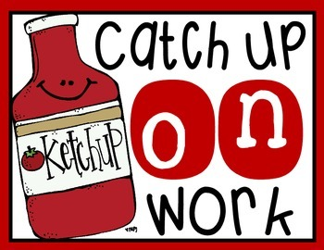  Take this session to either:  - complete the picture sentences or story writing from yesterday,  - practise your spellings from last week’s Session 5 (water, island, pressure, strange, peculiar, breath, breathe, experience, extreme, find, great, because)  - read a book of your choice on Get Epic. | We are getting warmed up for some Time activities next week.  Begin by asking if your child can show time to ‘o’clock first and then half past to assess what they can do (if you didn’t do the activity yesterday and don’t have access to a clock, then ask them where the hands would be, referring to a house clock).  PARENTS – Remember, when showing half past, the hour hand has to be half way between the hours (so half past 2 – the minute hand on 6 and the hour hand half way between the 2 and the 3). This is really important to keep reminding them as it is a frequently common error in class.  When you can identify where they are comforatble with, choose one of these games to play (attached to the grid), ‘o’ clock/half past or a mix of both.  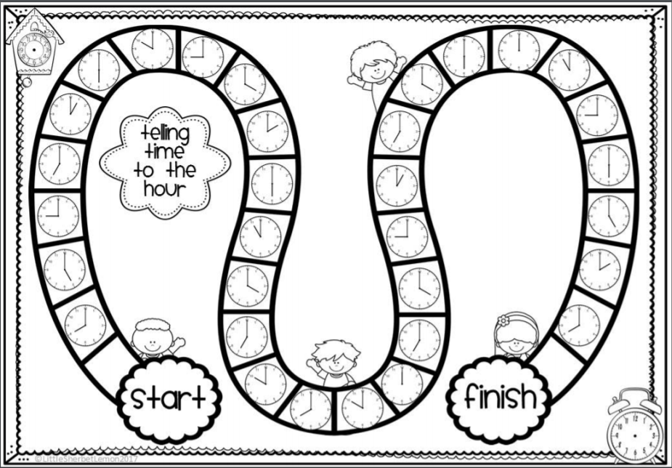  If no dice and not able to play, go to:  https://mathsframe.co.uk/en/resources/resource/116/telling-the-time  and play the interactive game | MUSIC Garage band (for iPads/mac books/phones) and yoga poses.  How’s your activity coming along? If you have not yet started, I’ll attached the poses again.  Garage band is an apple app where you can make your own music. The ideas is to link about six poses together (including transition to the poses without stopping) to the beat of the music you create.  Here’s the Garage Band app link: https://www.apple.com/uk/mac/garageband/  If not accessible, use Nickelodeon’s Music Maker: http://www.nick.co.uk/games/nickelodeon-music-maker/389w9w  for fun ocean themed music making to go with your poses!  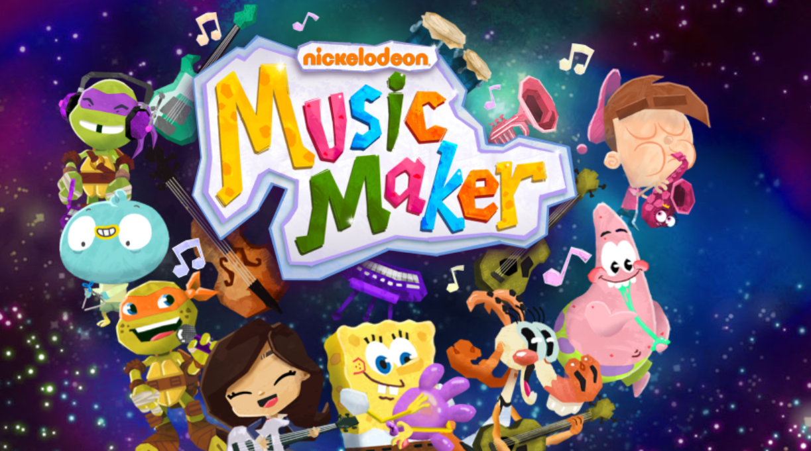  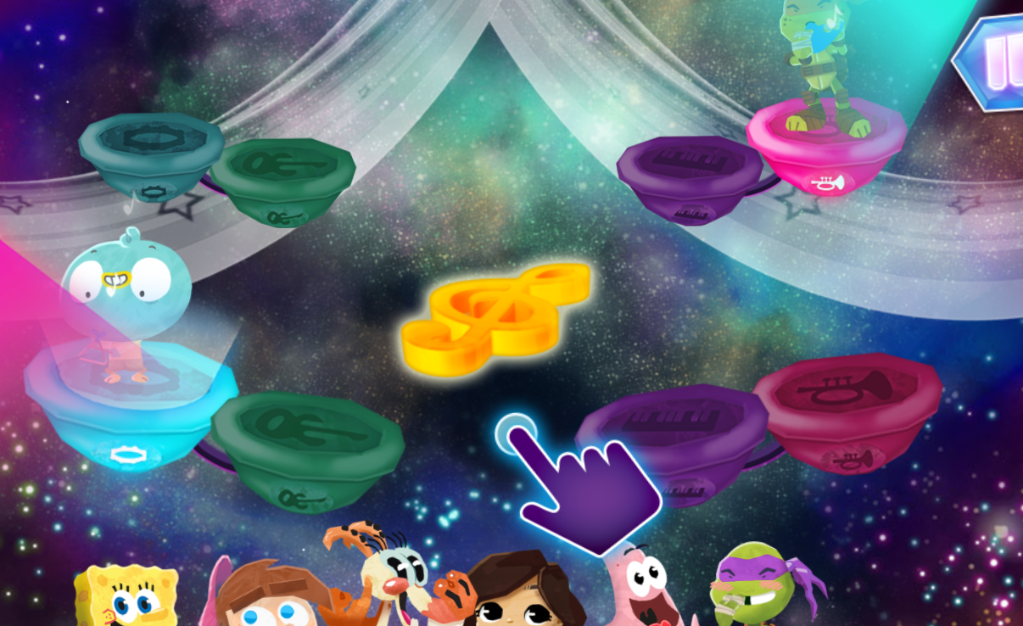 | Choose 1 activity:  - Joe Wicks (The Body Coach TV) Workout  - iMovers  PLUS:  Little Sports children’s fitness videos https://www.youtube.com/watch?v=L-8wW40jTzc

Session 1 Maths
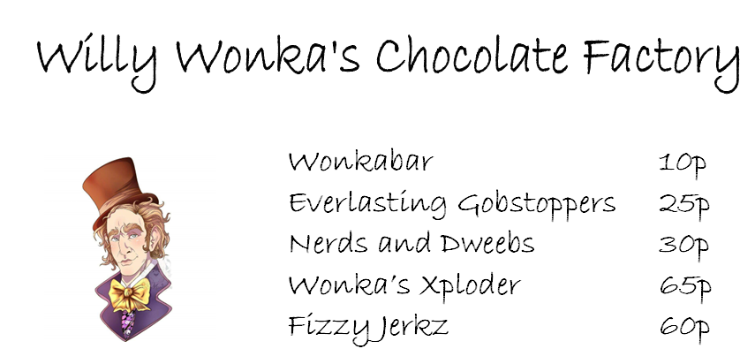
Items | Cost | Change from £1 (100p)
2 x Wonkabars | 10p + 10p = 20p | 100p – 20p = 80p
1 x Wonkabar and 1 x Nerds and Dweebs
1 x Wonka’s Xploder and 1 x Wonkabar
1 x Nerds and Dweebs and 3 x Wonka bars
2 x Everlasting Gobstoppers
1 x Wonkabar, 2 x Gobstoppers and 1 x Nerds and Dweebs

Session 3 – a and an activity
SESSION 4 – CLOCK FACE TEMPLATE
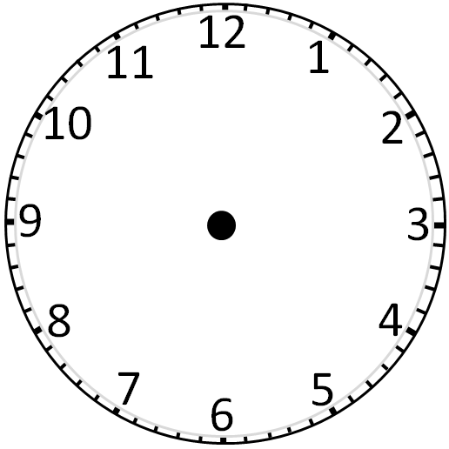
Session 5 maths
