How to play Make a Pound:
The object of this game is to be the first person to collect ten cards that exactly equal £1.00.
For this game, you need a complete deck of cards.
In this game, the cards are worth:
Ace = £0.01, Two = £0.02, Three = £0.03, Four = £0.04 and so on
Tens = £0.10, Jack = £0.11, Queen = £0.12 and King = £0.13.
To begin, shuffle the deck and deal ten cards to each player.
The game starts with one player taking a card from the deck on the table. You need to decide whether this card will help you make exactly £1 or not. If you think it will, keep it – if not, discard it by putting it down on the table next to the deck face up.
The nest player can now choose whether to take your discarded card or a new card from the deck.
Players keep taking turns drawing and discarding one card at a time.
The winner is the player who has collected cards totalling exactly £1.00.
Alternatively, for a shorter game, the player with the closest total to £1 when all cards have been taken from the deck.
You need your logic and problem solving skills:
- to decide which cards to keep and which to discard
- to think through possible ways to collect £1.00.

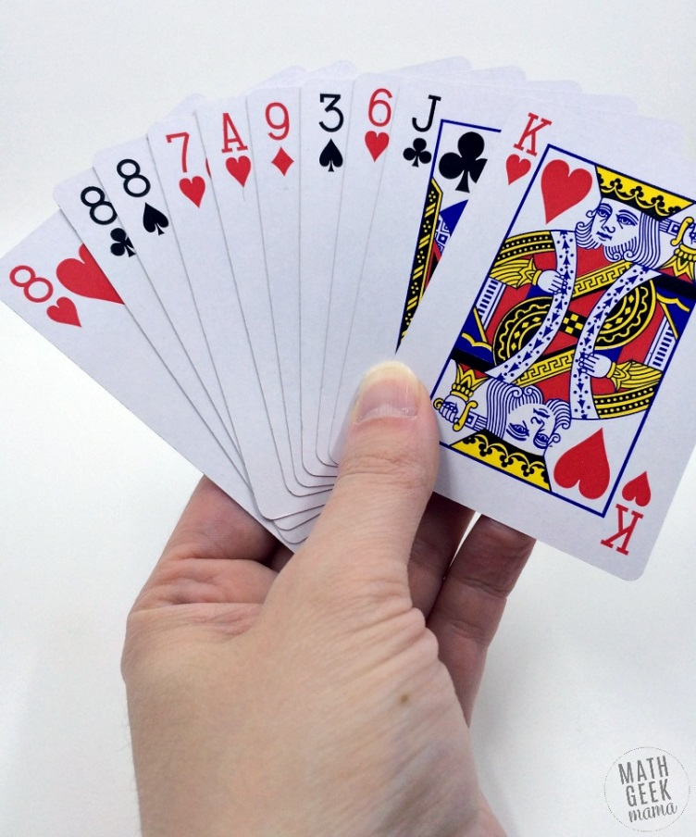
Strategy:
In the hand shown, the total would be £0.74. Therefore, you would want to start by discarding the smaller card values to try to get larger ones, and then go from there.

