11.5 | ENGLISH | MATHS | ENQUIRY | ACTIVE
S  E  S  S  I  O  N  1 | SPELLING  First activity today is homophones; words that sound the same but are spelt differently.  Complete activity sheet “Homophones” attached below the Blog.  Next, you are going to use your detective skills to spot spelling mistakes. Use the document “Correct the spelling mistakes” attached below the Blog.  Finally, choose 6 words from the STATUTORY word list and practise spelling these using the different strategies. | DECIMAL NUMBERS  This week we continue with decimal numbers and using White Rose for Year 4 and Year 5.  Use the web link to find the lessons, watch and follow the learning in the video and complete the activities when prompted using the work sheets attached and check your understanding using the answer sheet.  Year 4 – Summer Term Week 1 lesson 2 – Write decimals  https://whiterosemaths.com/homelearning/year-4/  Year 5 – Summer Term Week 1 lesson 1  Adding decimals within 1  https://whiterosemaths.com/homelearning/year-5/ | GEOGRAPHY  Start with this clip from BLUE PLANET  https://www.youtube.com/watch?v=3H6jzsFNqpM  Now for our Mariana trench investigation  https://www.youtube.com/watch?v=7tiZHrgc8Vc  Watch how James Cameron descended to the bottom of the Mariana Trench in 2012  https://www.youtube.com/watch?v=Y2tm40uMhDI  Share what you have found out with someone in your house. Did you teach them something new? | Choose 1 activity:  - Joe Wicks Workout  - Super Movers  - iMovers  PLUS:  Build an obstacle course and time yourself completing it.
S  E  S  S  I  O  N  2 | READING COMPREHENSION  Read the text attached below as Reading Comprehension Year 4 or Year 5 and answer the questions. Check your answers.  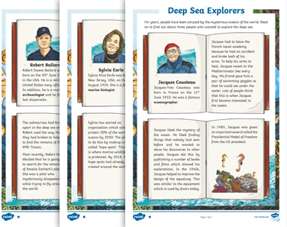  Don’t forget you are a Visible Learner.  When you have read the text, answered the questions and checked them make sure you work out why you might have answered any questions incorrectly, that’s your feedback and your next steps for learning.  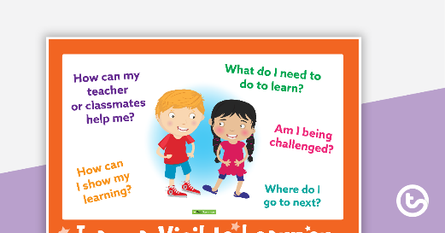 | DECIMAL NUMBERS  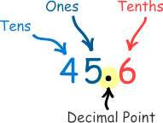  Year 4 – Summer Term Week 1 lesson 3 Compare decimals  https://whiterosemaths.com/homelearning/year-4/  Year 5 – Summer Term Week 1 lesson 2  Subtracting decimals within 1  https://whiterosemaths.com/homelearning/year-5/ | SCIENCE  Look at the PowerPoint deep-sea creatures to learn about some of the strangest creatures living in the deep.  Present the creatures in order of how strange you find them by creating a Top 8 List of Weirdest Creatures from the Deep.  Remember to use numbers  - Weirdest  - Second weirdest  Writing that makes the names stand out  ANGLERFISH  Viperfish  A short description of their weird features. | Choose 1 activity:  - Super Movers  - iMovers  PLUS:  Let’s Dance! https://www.youtube.com/playlist?list=PLJnn5H8Y_tYE3LdXoJIG_azMC2l5TjCON  Try a new routine!  OR  Challenge someone in your house to a race: jumping, walking sideways, crawling or all of them as a relay.
S  E  S  S  I  O  N  3 | GRAMMAR  Today we are going to use Oak Academy lessons for grammar. Follow the instructions to complete the lesson.  Year 4 – Fronted adverbials, access here  https://www.thenational.academy/year-4/english/story-spag-focus-fronted-adverbials-year-4-wk2-4  Scroll down and choose lesson 4  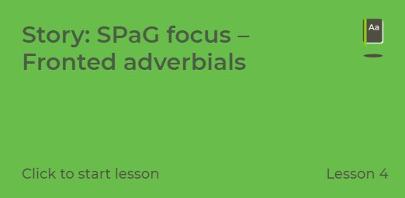  Year 5 – relative clauses, access here  https://www.thenational.academy/online-classroom/year-5/english#subjects  Scroll down and choose Lesson 4.  (You don’t need to complete the quiz)  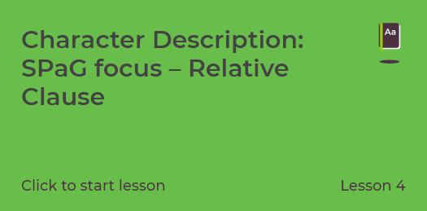 | DECIMAL NUMBERS  Year 4 – Summer Term Week 1 lesson 4 Order decimals  https://whiterosemaths.com/homelearning/year-4/  Year 5 – Summer Term Week 1 lesson 1  Complements to 1  https://whiterosemaths.com/homelearning/year-5/ | ART AND DT  Watch this film about anglerfish.  https://www.youtube.com/watch?v=B0PQrkaZ5To  Have a go at creating your own fish using a range of different materials.  Colour paper, cardboard or paper plate  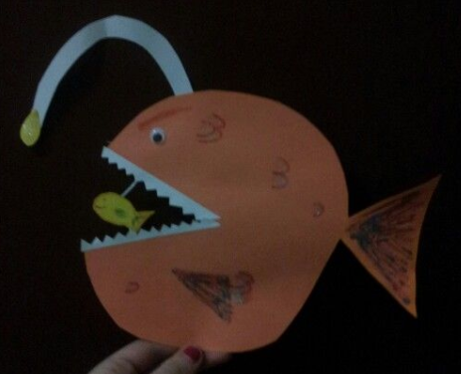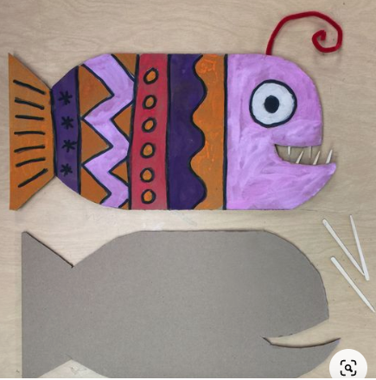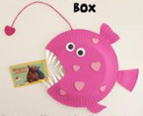  OR  Draw an anglerfish following the video.  https://www.youtube.com/watch?v=qqpegqeDBEQ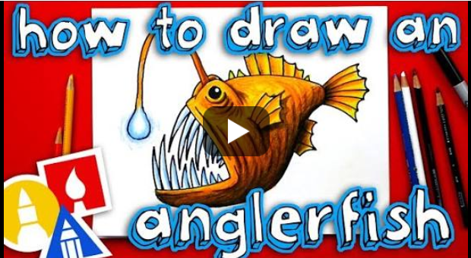  FRENCH  Go to duolingo  https://www.duolingo.com/learn  If you have completed greetings, it’s time to move to Basics 2  There are 4 small lessons at this level. Have a go at completing these.  ART/DT  Have a go at designing/making/drawing a submersible pod/submarine to explore the seabed in the abyss.  You could use Lego, build it on Minecraft, use some of the images on the Submersibles document below the Blog for inspiration or try making a submarine:  https://www.youtube.com/watch?v=aNF25kuYwaY | Choose 2 activities:  - Joe Wicks PE  - Super Movers  - iMovers  or  Dance with Oti  https://www.youtube.com/channel/UC58aowNEXHHnflR_5YTtP4g
S  E  S  S  I  O  N  4 | WRITING  We are going to use creature from the deep, to inspire your writing.  https://www.pobble365.com/creature-from-the-deep  Start by answering the questions in Question Time. Remember to use full sentences that make sense, start with a capital and end with full stops.  Complete the Sick sentences Challenge. Re-write the sentences using your grammar learning from yesterday (Y4 fronted adverbials, Y5 relative clauses), adjectives to expand the nouns and two different synonyms for big. | DECIMAL NUMBERS  Year 4 - Complete the Challenges set on Mathletics  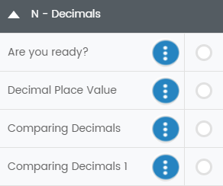  Year 5 – Summer Term Week 1 lesson 1  Adding decimals crossing the whole  https://whiterosemaths.com/homelearning/year-5 |  | Choose 1 activity:  - Joe Wicks PE  - iMovers  PLUS:  Go Noodle – GoNoodle for Families https://family.gonoodle.com/channels/zumba-kids  Try a new routine!
S  E  S  S  I  O  N  5 | WRITING  https://www.pobble365.com/creature-from-the-deep  Read the Story Starter and have a think about how you want to finish the story.  - The creature turns out to be friendly  - The people have to flee and find a new home  - A hero defeats the creature  - It is all a dream  Now write the ending. Remember to use a variety of sentences types (mats attached as reminder below Blog)  - 2A sentence  - Simile sentence  - BOYS sentence  Year 5 also use  NOUN, who/ which/ where sentences  Don’t forget the fronted adverbials with commas! | FUN AND GAMES  Use your learning of decimals to play the game “Make a Pound”.  For Make a Pound, you need a deck of cards and the instructions attached below the Blog  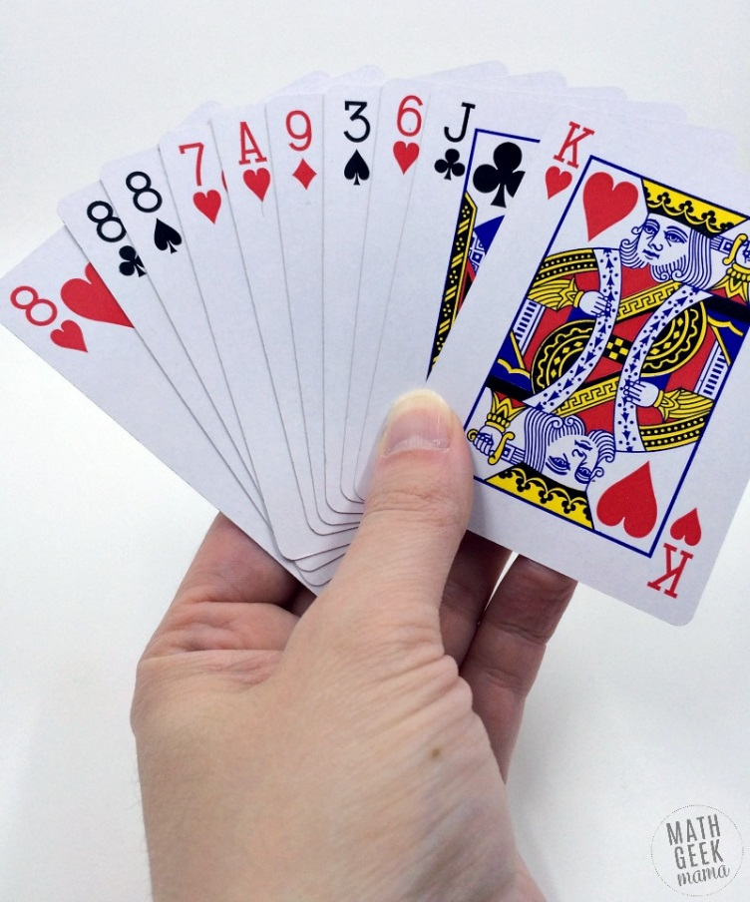  OR TRY THE ACTIVITIES ON THE DOCUMENT DECIMAL ACTIVTIES:  Make NHS Decimal Rainbows to 1  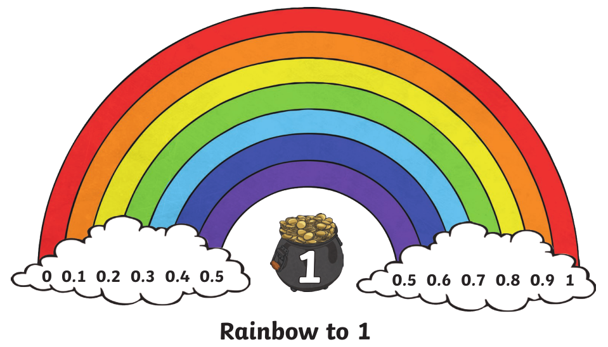  Make potions  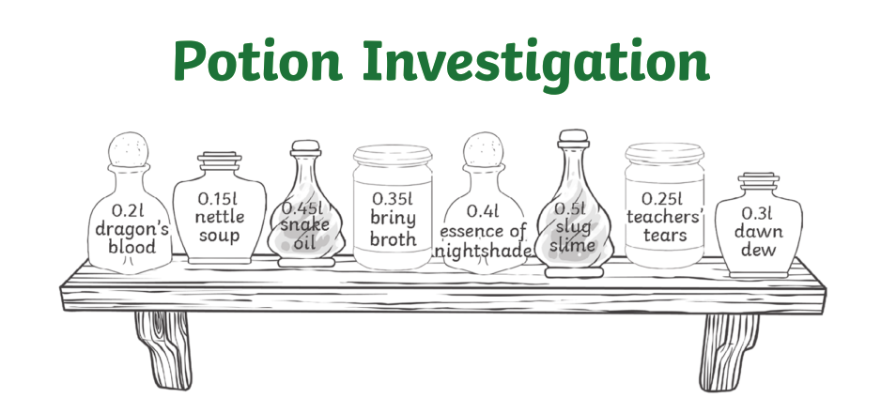 | MUSIC  Use Oak Academy for a music lesson about pulse.  https://www.thenational.academy/online-classroom/year-4/foundation#subjects  Follow the link and choose Lesson 1  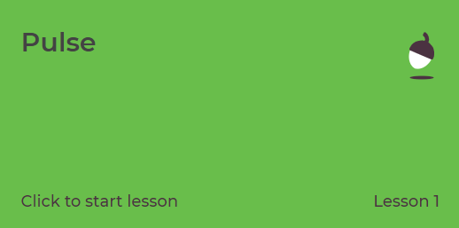  Complete the lesson following the prompts. | Choose 1 activity:  - Joe Wicks PE Workout  - iMovers  OR  Try out train like a footballer with Marcus Rasford  https://plprimarystars.com/resources/train-like-a-footballer

