 | ENGLISH | MATHS | ENQUIRY | ACTIVE
S  E  S  S  I  O  N  1 | Quick Blue Planet intro: https://www.youtube.com/watch?v=5_rsohhrtt4  “Our oceans are so deep that we cannot reach the bottom just by diving alone! So, this week we are going to learn about how Earth’s oceans are scientifically divided up into layers or zones, and find out what forms of life lurks in the deepest part of Earth’s oceans.  https://www.youtube.com/watch?v=fHVE4B-UjmM  https://www.youtube.com/watch?v=7tiZHrgc8Vc  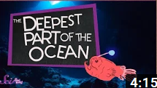  Have a go at drawing the layers of the ocean and labelling them with the amazing creatures that live there. Which layer does your favourite creature live? What features has it got to survive there?  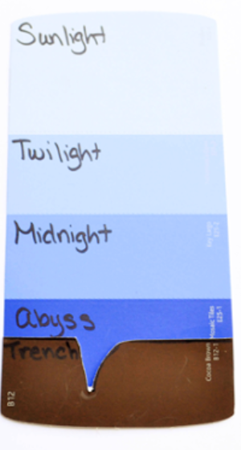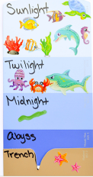  See bottom of grid for larger examples. | These next two weeks we are going to investigate money.  DENOMINATION = value of coin  Activity 1:  Take a 1p,2p,5p,10p,20p,50p coin and discuss the size, metal, shape and value. Does the bigger the coin mean the greater the value? Why do you think that is?  (GREATER THE VALUE IS DETERMINED BY THE METAL).  SESSION 1 ACTIVITY 1 Take each coin and work out how many you would need to make £1, just using the same denomination.  SESSION 1 ACTIVITY 2 Using the attached sheet for guidance, work out as many different combinations as you can for making £1 using a range of coins. E.g. 50p + 20p + 10p + 10p + 5p + 5p = £1  Email me your findings!  “Why do you need to know this? Well, think of when you go shopping. If something costs 30p, you need to know what combination of coins you will need. Also, if it costs 20p and you don’t have a 20p coin – what other could you use? We’ll go on a ‘virtual’ shopping trip tomorrow!” | Have a look at BBC Newsround for children.  https://www.bbc.co.uk/newsround  Spend the afternoon clicking onto the lighter side of news updates, as well as checking out the different links to games/activities/videos etc.  You could make this a regular activity as children can see what is going on in the world around them at a level of understanding tailored to their age. | - Sea themed Yoga Poses  So, by this time you should have practised up to six poses.  Now, you need to create a sequence, moving from on to the other without stopping. Keep it simple and smooth, thinking about the order so that you don’t fall!  Use this link for some music to help you move if you haven’t been on Garage Band to create your own!  https://www.youtube.com/watch?v=0p4CFFHBrXc  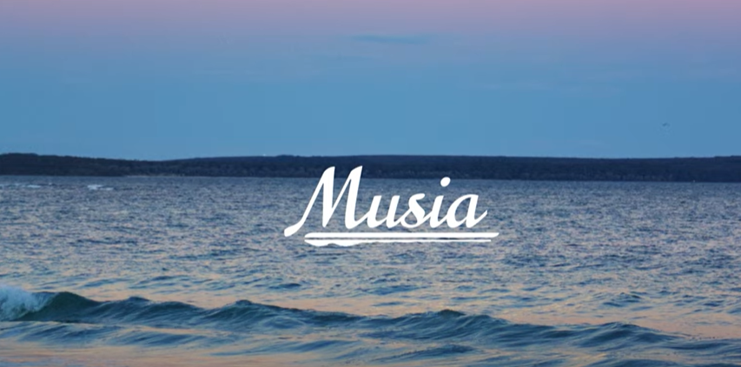
S  E  S  S  I  O  N  2 | Do you remember what the Mariana Trench was from yesterday’s learning?  Watch James Cameron, a famous movie director, in his DSV descending to study the trench. https://youtu.be/rVgTYb4grtQ  “What would a journey to the Mariana Trench look like?”  https://www.youtube.com/watch?v=eeW1DU05j7U  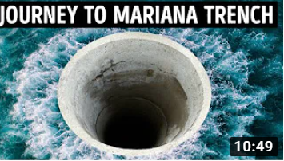  ACTIVITY: Listen carefully to the clip and answer these questions:  - What are the largest known fish species? How long can they live for?  - How deep would you find professional scuba divers?  - Which creature has ‘eyes the size of frisbees’?  - Why do you think the deepest zone is called the midnight zone?  - What is West Mata?  - What is the deepest fish ever found?  Now, can you order these creatures by the depth you would see them if descending to the Trench?  Giant Squid Orca Blue Whale Black Dragonfish White Shark Snailfish  IF YOU HAVE TIME, DRAW YOUR FAVOURITE AND TELL ME WHY YOU LIKE IT! | Today you are going to try out your money skills by going on a ‘virtual’ shopping trip. Try SESSION 2 MATHS attached:  Have a look at both shopping lists and decide where you are with your own learning (Up to £1 or do you know your pounds and pence combinations?” Answer the questions below the list and then as a challenge…  Write Miss Randle two questions to solve. (Make sure you have worked out the answers) I will answer them and send them back to you in an email.!  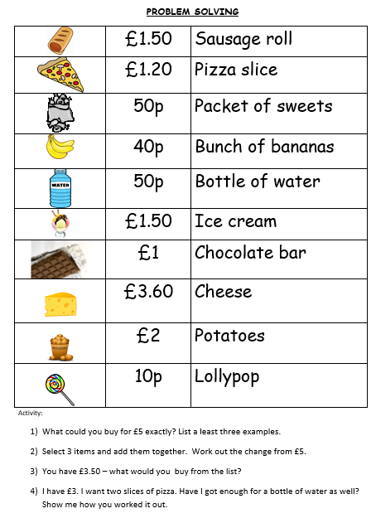  Use real money if possible, but if not then either print out the attached or have a go at drawing your own coins. | SCIENCE:  So today, we are going to create the ocean layers to better understand them.  Watch and have a go at:  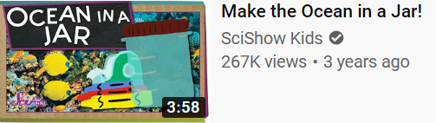  https://www.youtube.com/watch?v=15CL4D41e30  Or depending on what resources you have, have a go at this alternative:  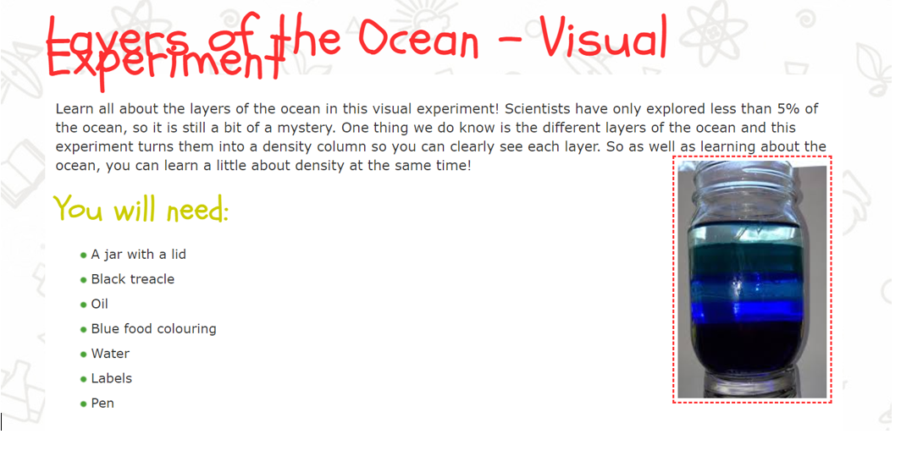 | Choose 1 activity:  - Super Movers  - iMovers  PLUS:  Let’s Dance! https://www.youtube.com/playlist?list=PLJnn5H8Y_tYE3LdXoJIG_azMC2l5TjCON  DON’T FORGET TO PRACTISE YOUR YOGA POSES!
S  E  S  S  I  O  N  3 | Read Flying Deep on Get Epic:  https://www.getepic.com/app/read/61631  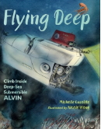  Click on any words you don’t understand, and you will get a definition.  Activity: Create a table and fill in the words or phrases you found the most exciting:  (Example from 10:00 entry)  Phrases  desolate landscape  poisonous, sooty particles (2A sentence phrase)  PHRASES – THESE ARE MORE THAN ONE WORD THAT MAKE UP PART OF A SENTENCE 2A – two adjectives (describing words)  We will use some of these phrases in our adventure story so keep them in a safe place! | GET MATHS CREATIVE!  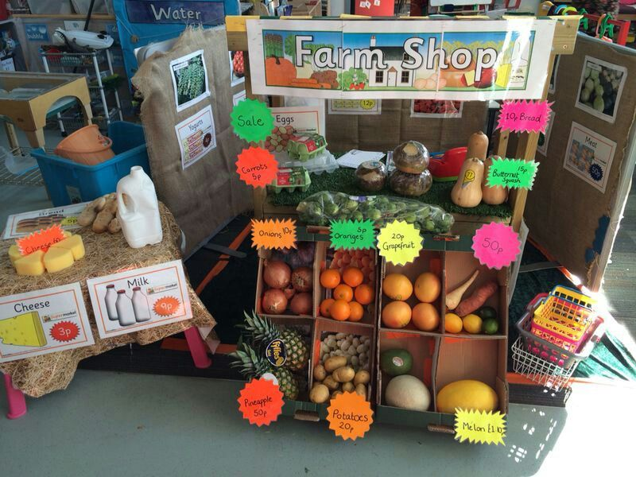  Set up shop at home and become a shop keeper.  Success criteria:  - label your favourite toys/objects to sell  - have money ready to give out as change (till/money box)  - give mum/dad/brother/sister a selection of coins  - ask your customer what they would like  - add up the items and tell them the price  - work out the change they need  PHOTOS PLEASE – I’D LOVE TO BE DOING THIS WITH YOU! | SCIENCE - So, you’ve learnt all about the Mariana Trench and how submersible vehicles are used to explore these deep zones.  Now have a go at making a submersible and see how it works for yourself!  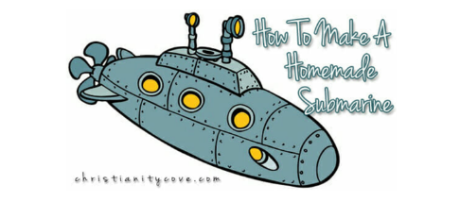  (Attached to the blog)  Or  Have a go at designing your own DSV. Explain its features and how they work. | Choose 2 activities:  - Joe Wicks Workout  - Super Movers  - iMovers
S  E  S  S  I  O  N  4 | Re-read Flying Deep on Get Epic:  https://www.getepic.com/app/read/61631  What dangers do pilots of submersibles face when exploring the deepest oceans?  ACTVITY: Create a factual poster outlining the dangers  Success criteria:  - find and retrieve the information  - draw the front cover or find a similar picture  - write the information as facts around the drawing  Have a look at these links to see some freaky inhabitants of the deepest oceans…  https://www.youtube.com/watch?v=3H6jzsFNqpM  https://www.youtube.com/watch?v=saNgbeEe9Tc | https://whiterosemaths.com/homelearning/year-3/  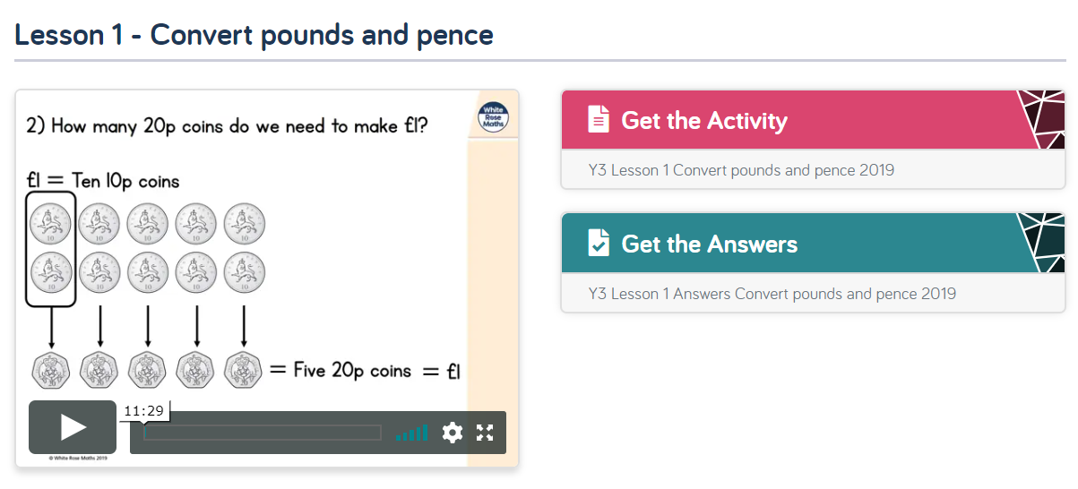  So this session aims for you to uderstand that:  100p is equal to £1  200p is equal to £2 etc.  Have a go with mum/dad and see what you can come up with. | ART and DT  Design a creature which might yet be undiscovered, living in the Midnight Zone. Here is some inspiration:  https://www.youtube.com/watch?v=saNgbeEe9Tc  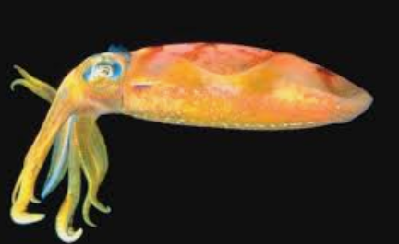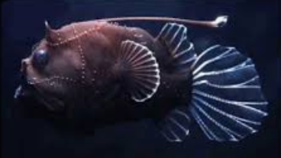  Remember:  - most don’t have big eyes/difficulty seeing  - they are dark in colour as there is no need for camouflage  - slow moving  - smaller teeth  After you have designed it, make it out of junk modelling materials.  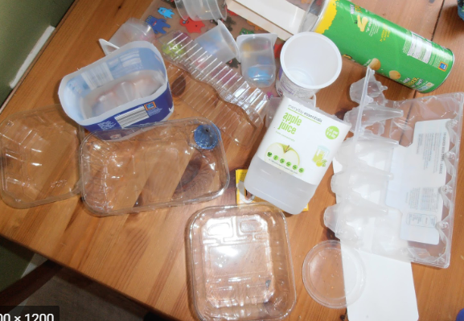 | Choose 1 activity:  - Joe Wicks (The Body Coach TV) Workout  - iMovers  PLUS:  Go Noodle – GoNoodle for Families https://family.gonoodle.com/channels/zumba-kids
S  E  S  S  I  O  N  5 | Take today to catch up on any activities you have missed or wished you had completed in previous weeks.  You could also use this time to practise your reading, spellings and times tables. Here’s a few of times table links:  https://www.topmarks.co.uk/times-tables/coconut-multiples  https://mathsframe.co.uk/en/resources/resource/399/Archery-Arithmetic-Multiplication  https://www.topmarks.co.uk/maths-games/hit-the-button  https://mathsframe.co.uk/en/resources/resource/557/Snowboard-Slalom  I will attach the spelling lists to this blog. Useful ones which link to our enquiry are:  water island pressure  strange peculiar breath  breathe extreme experience  find great because  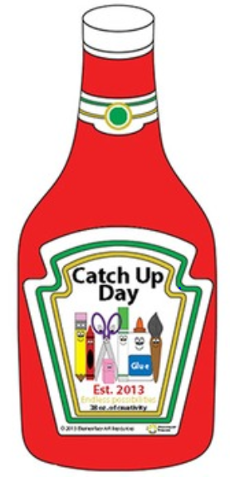 |  |  | Choose 1 activity:  - Joe Wicks (The Body Coach TV) Workout  - iMovers  PLUS:  Little Sports children’s fitness videos https://www.youtube.com/watch?v=L-8wW40jTzc  FINAL PRACTISE OF YOUR THREE YOGA POSES!

Resources:
English Session 1. They used paint samples but be creative with paints/felt tips/crayons/oil pastels etc.
