PROBLEM SOLVING
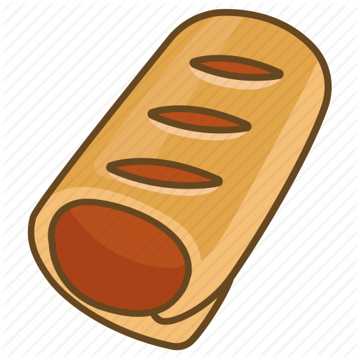 | £1.50 | Sausage roll
 | £1.20 | Pizza slice
 | 50p | Packet of sweets
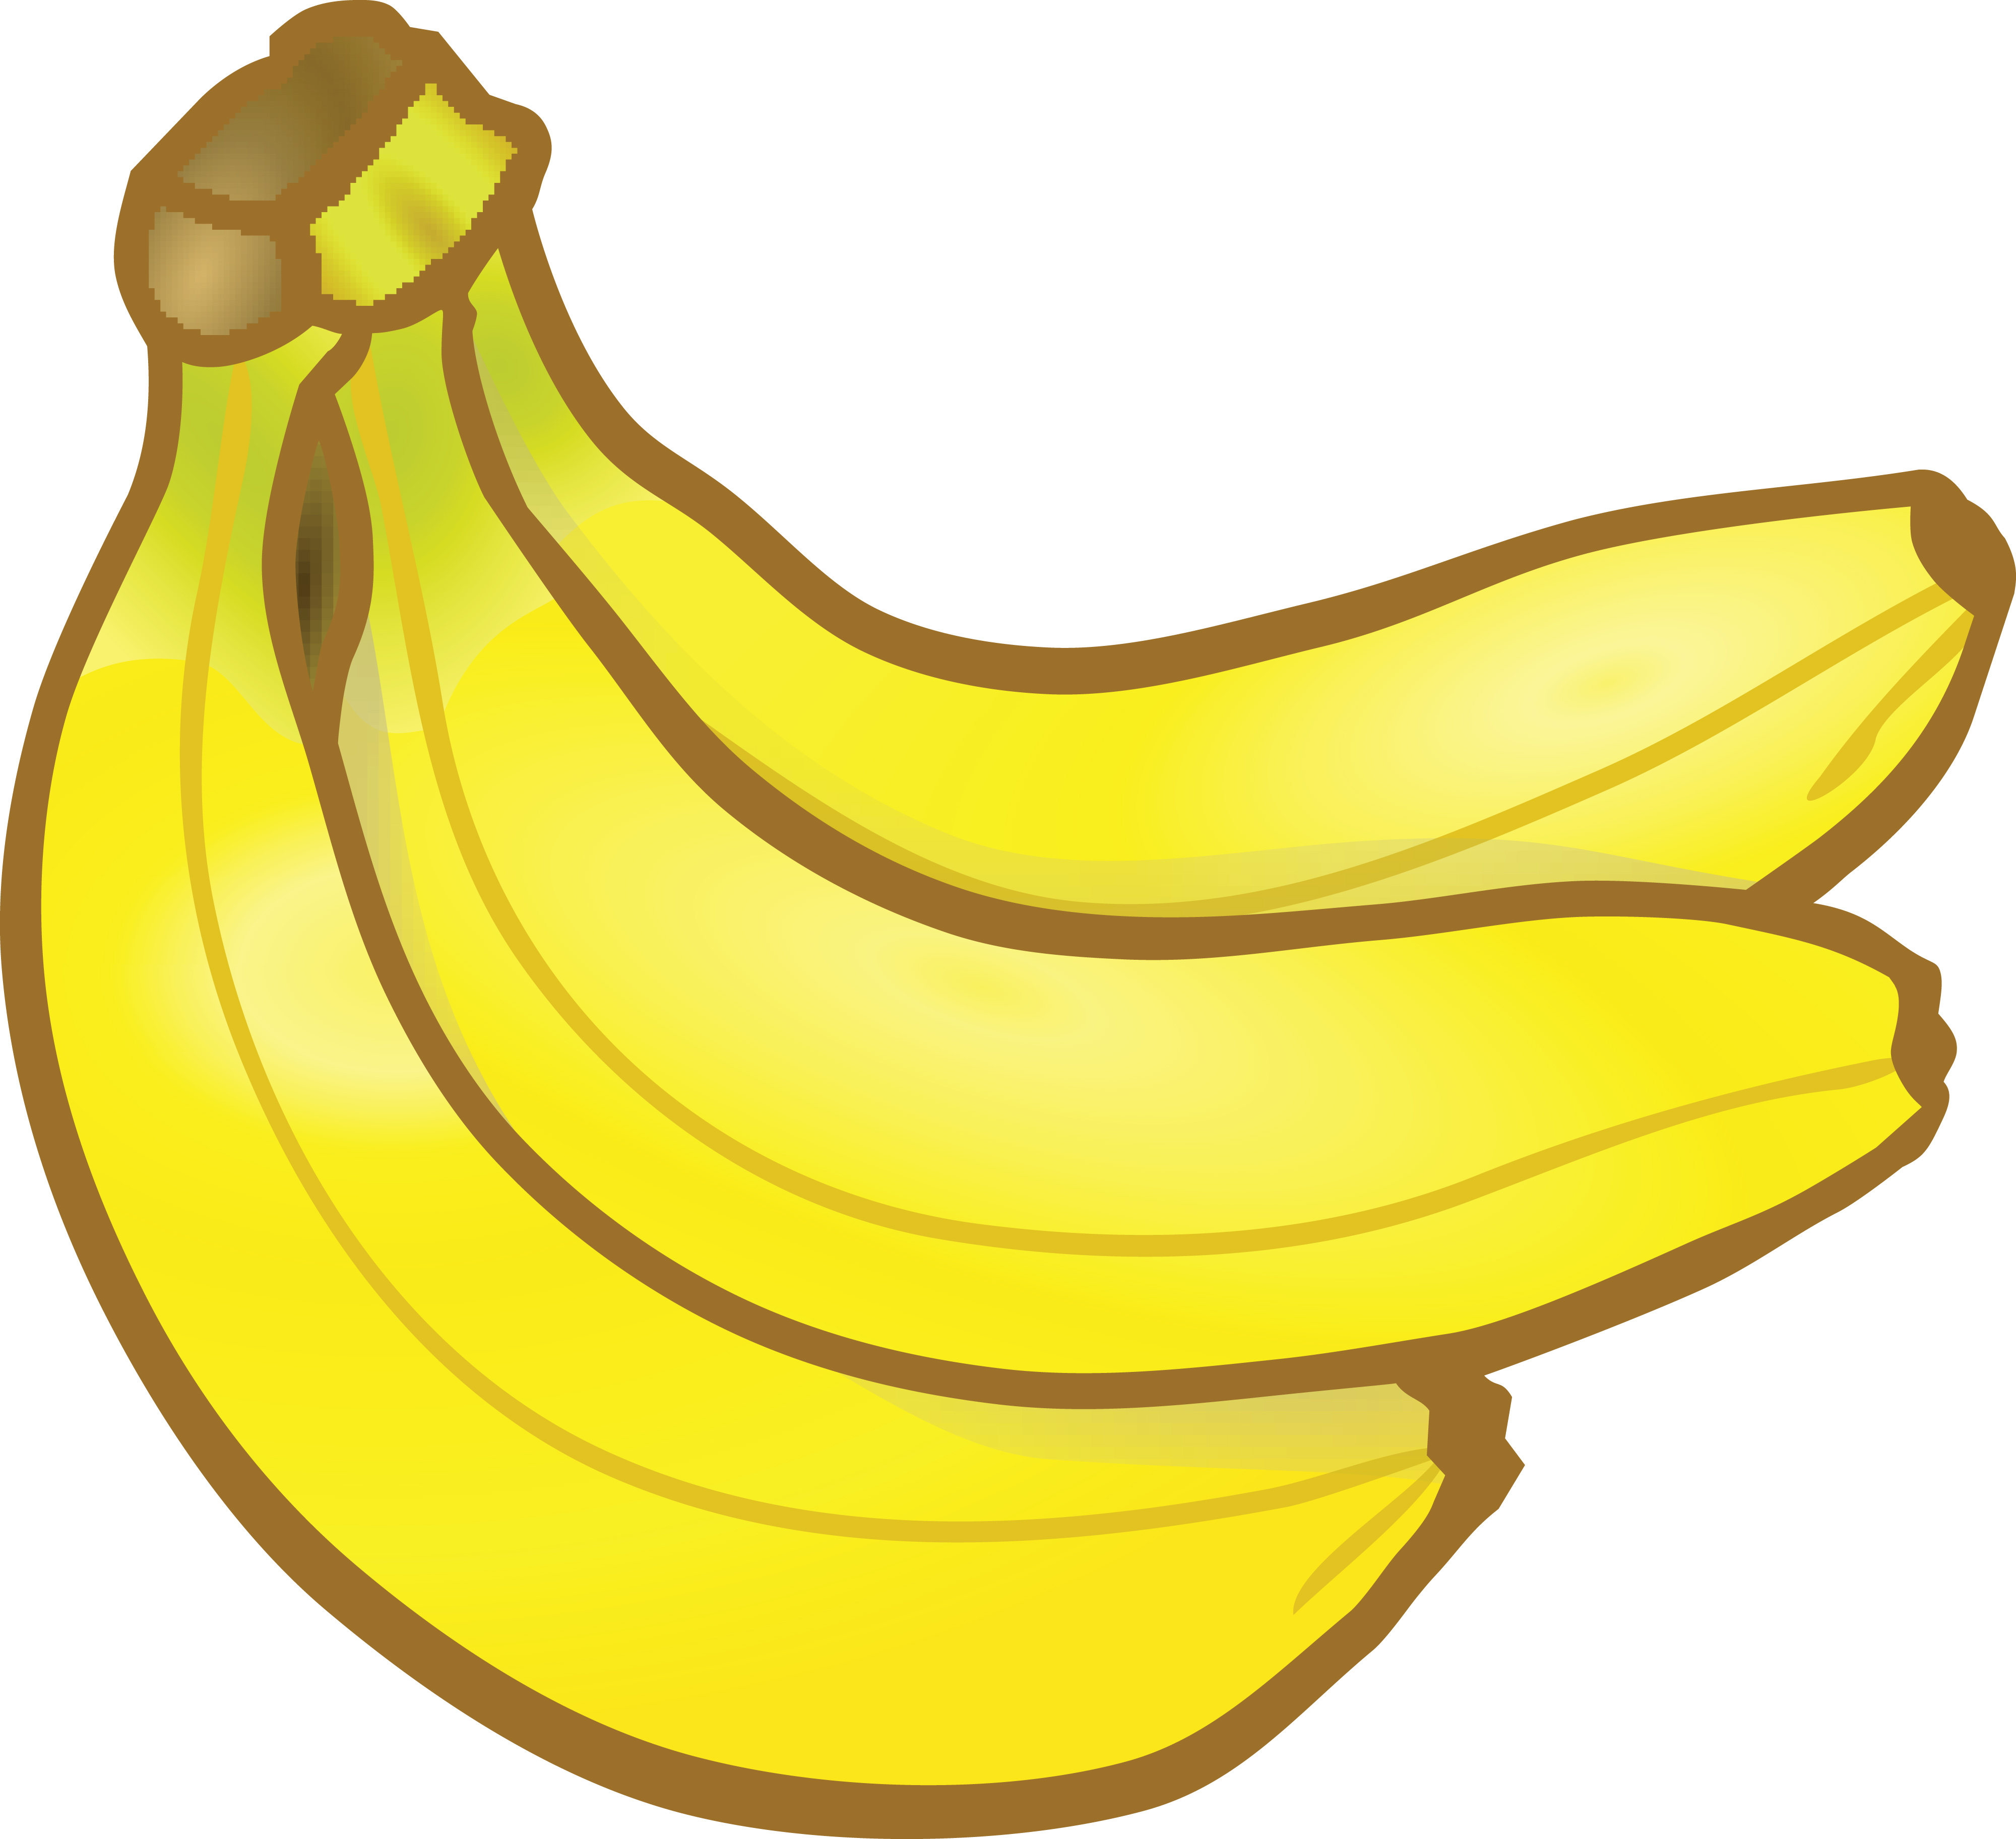 | 40p | Bunch of bananas
 | 50p | Bottle of water
 | £1.50 | Ice cream
 | £1 | Chocolate bar
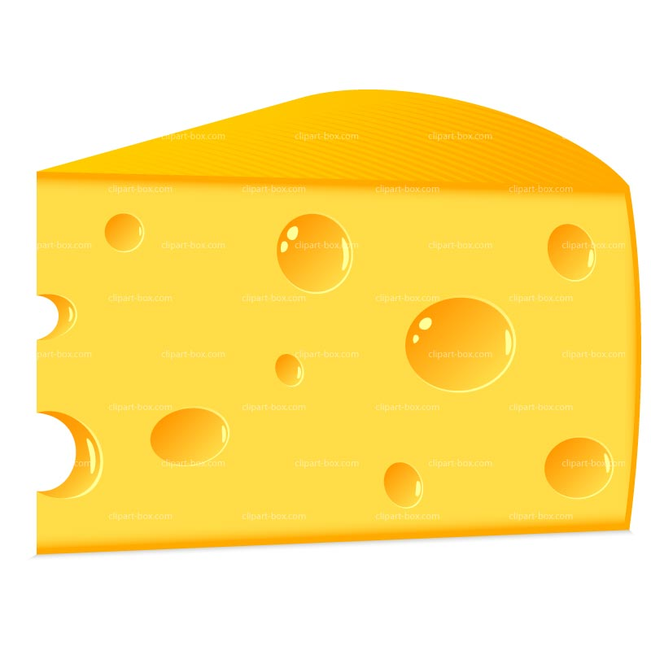 | £3.60 | Cheese
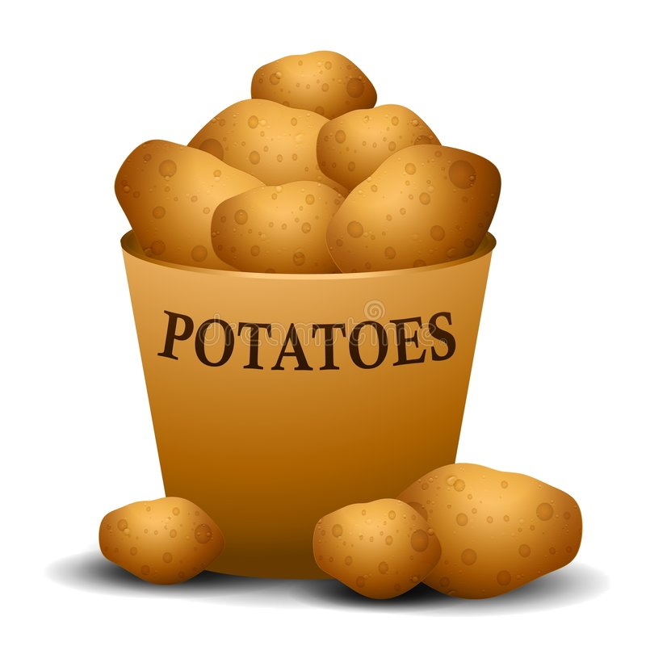 | £2 | Potatoes
 | 10p | Lollypop
Activity:
- What could you buy for £5 exactly? List a least three examples.
- Select 3 items and add them together. Work out the change from £5.
- You have £3.50 – what would you buy from the list?
- I have £3. I want two slices of pizza. Have I got enough for a bottle of water as well? Show me how you worked it out.
EASIER LIST (BONDS TO 100 (£1)
PROBLEM SOLVING
 | 55p | Banana
 | 50p | Packet of sweets
 | 45p | Can of drink
 | 50p | Bottle of water
 | 30p | Packet of crisps
 | 70p | Chocolate bar
 | 10p | Lollypop
 | 20p | Apple
 | 80p | Cheese
Activity:
- How many pairs can you list which total £1?
- What 3 items could you buy for exactly £1?
- How many lollypops could you buy for £1?
- I have £1 and I want a packet of crisps. Have I got enough for a bottle of water as well? Howe much money would I have left? Show me how you worked it out.


