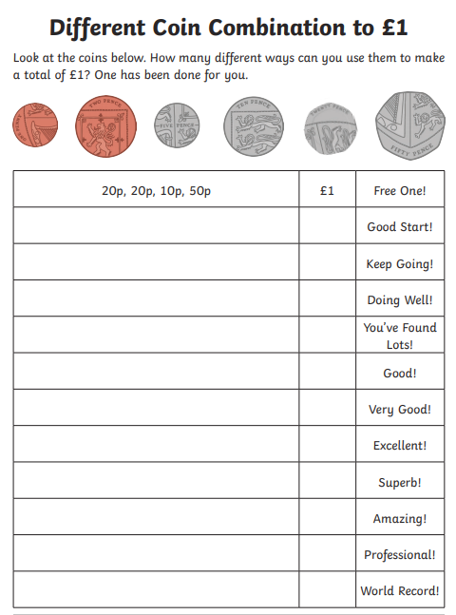
Session 1 Activity 2:
Now have a go at finding as many different combinations to £1 as you can using different coins. You can use them more than once!

