ENGLISH | MATHS | ENQUIRY | ACTIVE
Watch this video to recap what an adjective is: https://www.bbc.co.uk/bitesize/topics/zrqqtfr/articles/zy2r6yc  Then have a go at the activity underneath.  The story of treasure island has lots of adjectives in. Read the story again and write down at least 5 adjectives.  Year 1: Choose an adjective and write your own sentence containing that adjective.  Year 2: Choose at least 3 adjectives and write a sentence containing each adjective. | Watch this video to remember your learning from last week:  https://www.bbc.co.uk/bitesize/topics/zhk82hv/articles/zcmdwxs  Then play this game:  https://mathsframe.co.uk/en/resources/resource/116/telling_the_time#  Click on number 2. ‘Read time to the hour and half hour’ and practise what you learned last week.  Then have a go at this quiz:  https://www.iknowit.com/lessons/a-telling-time-half-hour.html | The deepest part of the ocean is called the Challenger Deep and it is in the Mariana Trench in the Pacific Ocean.  This video is all about the Mariana Trench:  https://www.youtube.com/watch?v=7tiZHrgc8Vc  If you are feeling brave, have a look at some of these creatures that live in deep parts of the ocean:  https://www.nationalgeographic.com/environment/oceans/photos/deep-sea-creatures/  There is a very cute octopus that lives on the deep ocean floor called the Dumbo Octopus. Here are some facts about it:  https://www.aquariumofpacific.org/onlinelearningcenter/species/dumbo_octopus  What other animals live in the deep parts of the Ocean? What can you find out about them? | Choose 2 activities:  - Joe Wicks Workout  - Super Movers  - iMovers  - Sea themed Yoga Poses  (Select 3 poses and practise the same all week as you will add new ones weekly as you build up to compile your own ‘underwater’ yoga sequence (adding music) as the enquiry progresses).
What adjectives could you use to describe Jim Hawkins?  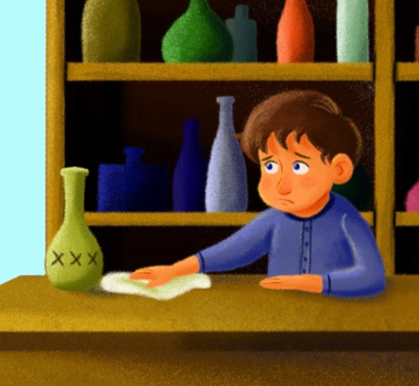  Look at this picture:  Have a discussion with an adult about what he looks like. You could discuss some of these questions:  What does Jim's hair look like?  What colour clothes is he wearing?  How is he standing?  What do you think he is feeling?  Year 1: Write at least one sentence answer to one of these questions. E.g. Jim is wearing a blue shirt with buttons.  Year 2: Write a character description of Jim containing lots of adjectives. Write at least 3 sentences. | Telling time to the nearest 15 minutes.  Here is a video to show you how to tell the time to the nearest 15 minutes. This will show you quarter past, half past and quarter to.  https://www.youtube.com/watch?v=5tmzM_9I4aw  Use the clock you made last week or you could draw a new one.  Can you show these times on the clock?  Quarter past 1  Quarter past 9  Quarter to 3  Quarter to 12  Be careful with the hour hand too! Remember if it is quarter past 1, the hour hand should be a quarter of the way between 1 and 2. | Science  Watch this video explaining what a food chain is:  https://www.bbc.co.uk/bitesize/clips/z96r82p  Choose a sea animal (either from yesterday or from last week) and draw its food chain. What does it eat? Does anything eat it?  Can you describe your food chain to an adult using these words:  predator  prey  carnivore  herbivore  omnivore | Choose 2 activities from the list above.
What adjectives could you use to describe Long John Silver? Think about whether you would use the same adjectives as yesterday. Are they similar characters?  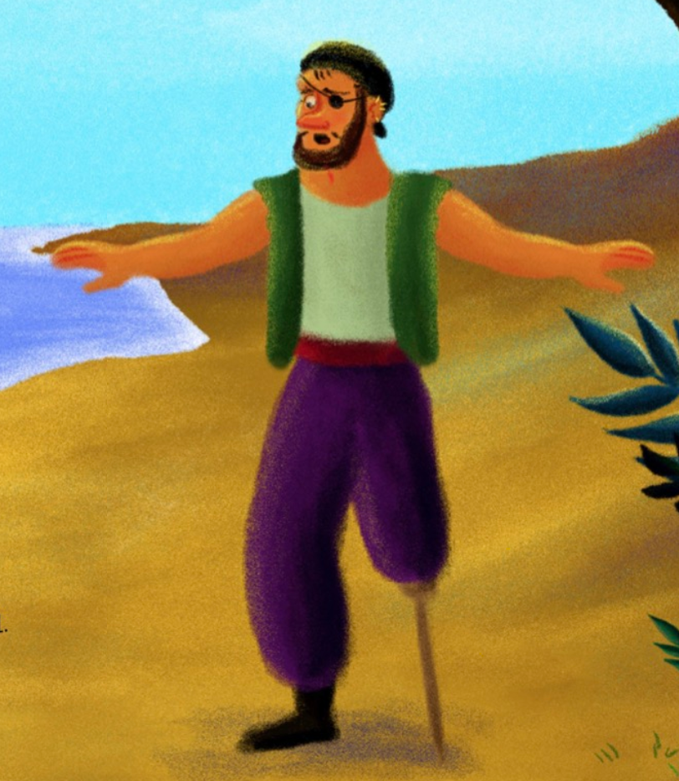  Year 1: Draw a picture of Long John Silver or use the picture above and label him with at least 5 adjectives. Choose at least one of these adjectives and use it in a sentence.  Year 2: Write a character description of Long John Silver containing lots of adjectives. Write at least 3 sentences. If you want to, you can draw a picture to go with your description.  When you have finished, compare your work to yesterday’s. How are the two characters different? | Telling time to the nearest 5 minutes.  Here is a song explaining how to tell time to the nearest 5 minutes:  https://www.youtube.com/watch?v=h6RNkQ7lU8Y  We have done lots of practise of counting in 5s this year! Use the clock you made or draw a new one and practise counting in 5s at each number.  Can you draw/make these times:  5 minutes past 3  20 minutes past 12  35 minutes past 8  4:50  Challenge: Can you draw/make these times:  (If it says to, count how many minutes there are until that hour!)  10 minutes to 2  5 minutes to 6  25 minutes to 5 | HISTORY  To help with your adventure story, we are going to find out a little bit more about pirates. Were pirates real?  Can you research a real-life pirate?  Here are some videos and websites that might help you:  https://www.dkfindout.com/uk/history/pirates/  https://www.youtube.com/watch?v=p3fztn2roaw  http://smugglerscove.ie/fun-facts-about-pirates/  Choose at least one of these activities:  Write your own list of rules for your pirate ship.  Design your own pirate flag.  Write a diary entry of a pirate on their ship.  Choose a real life pirate and write a fact file about them. | Choose 2 of these pirate related activities:  Pirate just dance (A pirate you shall be):  https://www.youtube.com/watch?v=oe_HDfdmnaM  A pirate workout:  https://www.youtube.com/watch?v=jcHDT_gEm3I  Pirate Yoga:  https://www.youtube.com/watch?v=T_0P5grVoyg  Design a pirate obstacle course complete with plank to walk.
Now it is time to start thinking about your own character!  Can you think of 5 things that your character would carry? What makes these items special? Draw these items and label them with a brief description.  For example, my pirate would carry an old, golden compass with a crooked arrow which does not point north. He would wear a torn black hat with a delicate purple feather sticking out of it. He would carry an ancient, stained, crumpled treasure map. He would hold a long, shiny, silver sword and he would keep a special gold coin in his top pocket for good luck. | Use a stopwatch or an online timer. Count how many times you can do each of these things in 30 seconds:  Star jumps  Write your name  Hops on the spot  Can you think of any other activities that take 30 seconds?  What about activities that take 3 minutes?  Which activities would take 30 minutes?  Which would take 3 hours?  Use a stopwatch, clock, sand timer or online timer to time how long it takes to do different activities. E.g. how long does it take you to run around your garden? Do 50 star jumps? Skip 20 times? | Geography  Pirates used to use maps to find treasure! Can you make an indoor treasure hunt? You could hide some treasure in your house and make a map to find it. Remember to use symbols to represent the different areas of your house. 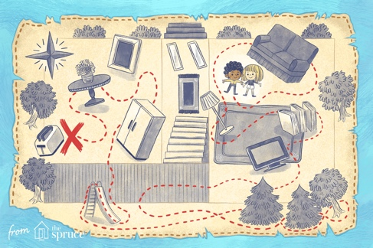  If the weather is nice, you could go for a walk as your daily exercise around your local area and draw a map of where you walked. Remember to use symbols to represent trees, houses and other landmarks you see.  Challenge:  Use a compass to describe how to get to the treasure. Use north, south, east and west, near, far, left and right.  Here is a game to practise using a compass:  https://www.mathsisfun.com/games/direction-nsew-.html | Choose 2 activities from the list above.
Now it is time to design your character.  Year 1: Draw your character in the middle of your page and add at least 5 labels with adjectives to describe them.  Write a sentence to describe whether your character is more like Jim or Long John Silver and explain why you made that choice.  Year 2: Write a character description with at least 3 sentences. Start with a sentence to describe whether your character is more like Jim or Long John Silver and explain why you made that choice.  If you want to, you could draw a picture to go with your description. | Have a go at answering these time word problems:  Captain Jack left his house at 3 o’clock. He walked for half an hour to get to his ship. What time did he arrive at his ship?  The pirate ship leaves the port at 12 o’clock. It takes 2 hours to reach the island. What time does it reach the island?  The second mate started scrubbing the deck at 6:00. He finished at 6:35. How long did he take to scrub the deck?  It takes each pirate 10 seconds to walk the plank. There are 5 pirates walking the plank. How long will they take all together?  Challenge: Now write some time word problems of your own. | Art  Have a look at these amazing sea sponges that live deep under the sea:  https://www.youtube.com/watch?v=nAjrOH3pO1A  There are also some beautiful jelly fish that live deep in the ocean:  https://www.youtube.com/watch?v=reHaY3Ml5pw  https://video.nationalgeographic.com/video/00000154-86e2-d4cc-a9dd-e7fe3b370000  Can you use one of these videos as inspiration to create your own piece of art? Think about the colours and the patterns of the creatures.  