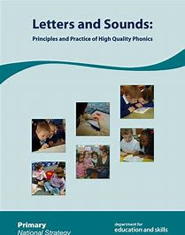

Reception
10 am* | Reception Summer term  Phases 3 & 4 | For Reception children who can blend and read words such as ‘fish’ ‘chat’ and ‘rain’
Release date | Lesson number | Lesson title
Monday 27th April | 1 | ai
Tuesday 28th April | 2 | ee
Wednesday 29th April | 3 | igh
Thursday 30th April | 4 | oa
Friday 1st May | 5 | oo - moon
Monday 4th May | 6 | oo – look
Tuesday 5th May | 7 | ar
Wednesday 6th May | 8 | or
Thursday 7th May | 9 | ur
Friday 8th May | 10 | ow – cow
Monday 11th May | 11 | oi
Tuesday 12th May | 12 | ear
Wednesday 13th May | 13 | air
Thursday 14th May | 14 | ure
Friday 15th May | 15 | er
Monday 18th May | 16 | Review ai, ee, igh
Tuesday 19th May | 17 | Review oa, oo, ar
Wednesday 20th May | 18 | Review or, ur, oo
Thursday 21st May | 19 | Review ow, oi, ear
Friday 22nd May | 20 | Review air, ure, er
Monday 25th May | 21 | Multi-syllable words
Tuesday 26th May | 22 | Multi-syllable words
Wednesday 27th May | 23 | Compound words
Thursday 28th May | 24 | Compound and multi-syllable words
Friday 29th May | 25 | Compound and multi-syllable words

