CHAIPEL CLASS – HOW DOES MY BODY WORK? Autumn 1 2026
Daily/Weekly Tasks
Reading, Reading and more Reading!
You should be aiming to read 5 times per week, but reading every day is better!


KIRFs Autumn 1:
Y5: I know double and halves of two-digit numbers
Y6: I know the square numbers up to 12 x 12.

CURRICULUM SPELLINGS: Keep practising these!
Enquiry Question Homework Tasks
COMPUTING  Create a short animation showing how blood flows through the body. | PE  Design a fitness/obstacle course that challenges both the heart and muscles. | ART  Create a portrait of yourself using one side to represent who you are as a person!  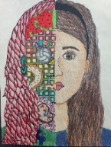  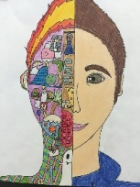 | SCIENCE/DT  Make a 3D model of the Circulatory System!  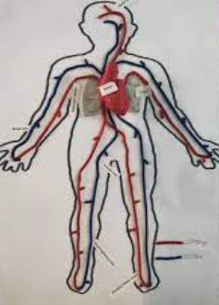
PSHE  Create a ‘Diversity Collage’ using photos, pictures, symbols and words that represent different cultures, abilities and identities. | RE/MATHS  Halal Baking Scaled Recipes  Find a recipe for an Eid celebration treat (like Date Ma'amoul or shortbread). The recipe serves 6 people.  Scale the ingredients using your ratio and proportion skills to serve:  • 3 people (halving)  • 12 people (doubling)  • 9 people |  | CREATIVE  Make a ‘Healthy Heart’ calendar for a month with a different health tip each day.  (drink an extra glass of water, go to bed at 7pm, jog on the spot for 1 minute, walk the dog etc.)

