Landaviddy’s Homework Grid – “What makes the world go around?”
  English  - Write an acrostic poem using WORLD or EARTH. Can you include powerful adjectives and interesting vocabulary?  - Persuasive writing: Write a letter to the people in your town explaining one thing we could do to help look after our planet.  - Read for pleasure: Read a book about space, animals, nature, inventions, travel or the environment. Create a book review when you have finished. |   Maths  Practice, practice, practice those times tables. How quickly can you recall the facts?  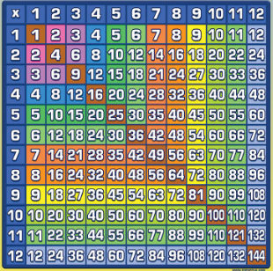 |   Fun Stuff  - Make a working model that shows something moving — a windmill, wheel, pulley, spinner or simple machine.  - Around-the-world food challenge: Cook or taste a food from another country. Find out where it comes from and record the recipe or ingredients.  - Nature hunt: Go outside and find things that are living, things that have never been alive and things that were once alive. Can you make a tally?
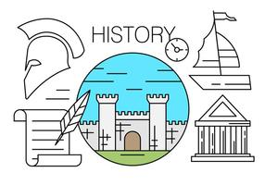 HISTORY  - How have inventions helped make our world go around?  - Choose one invention and create a fact file or mini-booklet.  - Ideas:  the wheel, the steam engine, the telephone, the light bulb, the aeroplane, the car, the bicycle, the printing press | 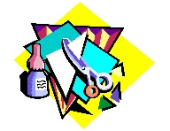  Art  Create a colourful Earth collage using recycled materials. | 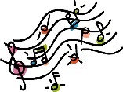  Music  Find a song from a different country. Where is it from? What instruments can you hear?
  Create a “World Word” wordsearch or crossword using at least 12 words linked to the topic. |   Design something that could help our world go around!  Choose a problem and design a solution.  For example:  A machine that cleans rubbish from the ocean.  A vehicle that doesn't pollute the air.  A wind-powered machine.  A robot that helps people recycle.  A machine that helps animals.  A playground powered by children's movement! | 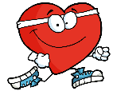  PE  Movement makes the world go around!  Create your own “Around the World” fitness circuit.  Choose 5–8 activities, for example:  🌍 10 star jumps — Europe  - 10 kangaroo jumps — Australia  🐘 10 elephant stomps — Africa  🚀 5 rocket jumps — Space  🌊 10 swimming actions — Oceans  🚲 30-second cycling legs — Transport

