Talland’s Homework Grid – What does Cornwall mean to me?
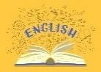  English  Write a fun and entertaining story about a Cornish Myth. You can take the story off in any direction you please…  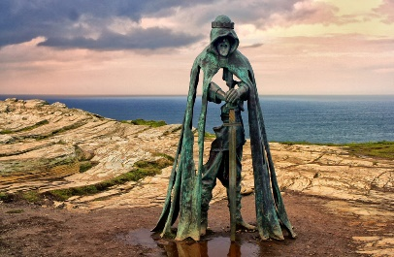 |   Maths  Create a Cornish Monopoly game using places in Cornwall. Make fake money and characters (maybe different Cornish Myths?).  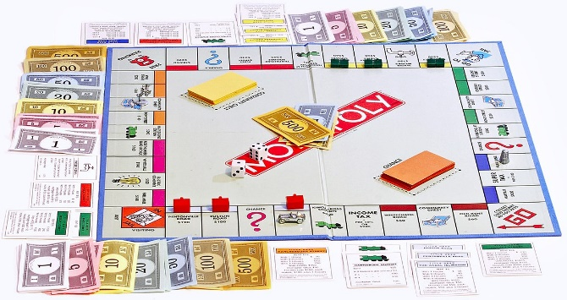 |   Fun Stuff  Make a Cornish delight… maybe a pasty. Choose your fillings and fill up your beautifully baked pastry.  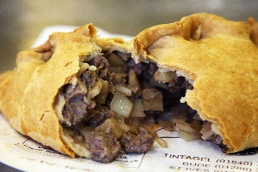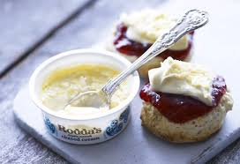
  Enquiry: Science    Based on our research into the Mars Rover, why not build your own Rover set to roam a different planet… | 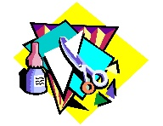  Art  - Pebble Art: Gather smooth pebbles and use them to create scenes, animals, or patterns inspired by the beach.  - Sea Glass Art: Cornwall's beaches are known for their sea glass. Use it in collages, mosaics, or for creating unique jewelry.  - Shell Collages: Create mosaics or pictures using seashells of various shapes and sizes.  - Ocean-Themed Painting: Paint scenes of waves, the sea, or underwater life.  - Natural Material Art: Use found objects like driftwood, branches, and leaves to create sculptures or collages inspired by nature. | 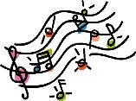  Music  Create a sea shanty song to share with the class.  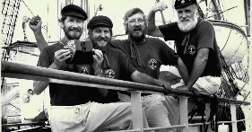
  Create a wordsearch or crossword with at least 12 ‘Cornish themed’ key words in. |   Design, create/build and evaluate a harbour similar to Polperro. Maybe have mechanisms that move (shops opening or boats moving ect… |   PE    Train for sports day. Practice, sprinting, egg and spoon races, 3 legged races, sack races… anything fun and speedy!

