Geography  Find out about a Greek island. Compile all the information in a fact file. | DT  Design and make a labyrinth from an empty cereal box.  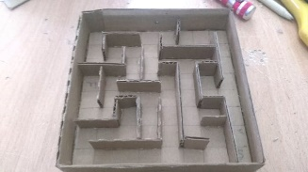 | Art  Create a Greek head-dress. A spartan helmet or a laurel wreath.  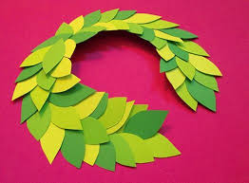
Language  Learn and practice your French with  Duolingo  https://www.duolingo.com/ | Art  Create a piece of art which has a Greek temple. Use any materials you like. | English  Choose an image from pobble365 and practice your writing skills.  http://www.pobble365.com/
Maths  Use Mathletics to practice the skills we have already learnt this year. | Geography  Design a poster to encourage people to live in Crete or Athens. Use persuasive language and imagery. | DT  Design a Trojan Horse for the Greek army. Use any materials you like.  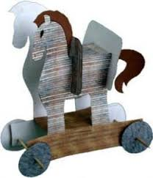
History  Find out about Alexander the Great and create a fact file. | Maths  Use Times Table Rockstars to practice times table facts. | History  Turn yourself into a Greek God/Goddess and create a Top Trump card with your stats using the Greek alphabet.
PE  Be active and practise your learning with https://www.bbc.co.uk/teach/supermovers | Language  Learn some Greek words and phrases on Duolingo  https://www.duolingo.com/  Send a message to a friend in Greek | English  Write your version of Theseus and the Minotaur
Why is this all Greek to me?

