Friday 10th February 2023

Dear Parents and Carers

**World Book Day, Thursday 2nd March 2023**

As part of our drive to maintain, promote and engage pupil interest in reading, the school and nursery are celebrating WORLD BOOK DAY on Thursday 2nd March. During the week, the children will be participating in lots of exciting reading related activities, sharing their own favourite book from home, sharing teachers’ favourite books, and entering a competition to win a book for themselves, see below.

**Come dressed as a Word**

We know that reading improves a child’s vocabulary, so on World Book Day, your child can come to school dressed as a word to enter our vocabulary parade. Your child may like to choose a word from their current enquiry. There will be prizes and certificates for the most unusual and creative ideas. We look forward to seeing your child dressed up for the special day.

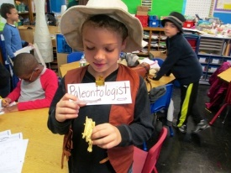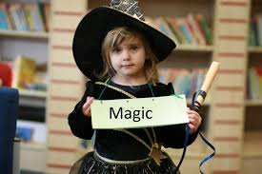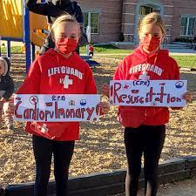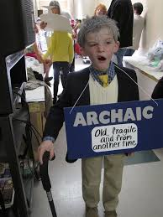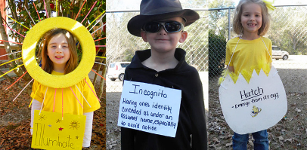

**Vegetable Book Character Competition**

Can you create your favourite book character from a vegetable? Perhaps you can use a potato to make a character from Hogwarts or a Roald Dahl character such as the BFG? Bring your character in to school on World Book Day and you might win a book.

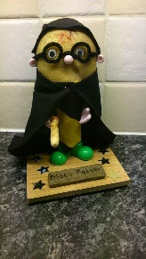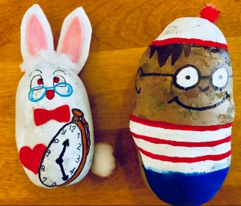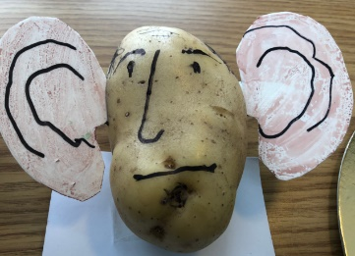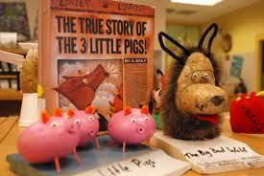

We hope that early notice of both competitions will make it easier to help your child plan their vegetable character design and help them put together a costume for their entry to the vocabulary parade, perhaps over half term.

Thank you for your support.



Anthea Hillman

Head of School and English Lead