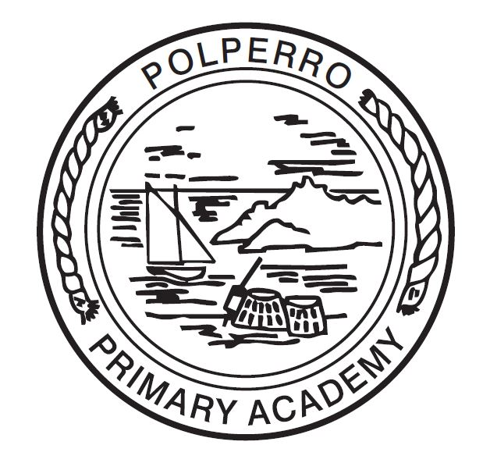
Visible Learning
Polperro Primary Academy
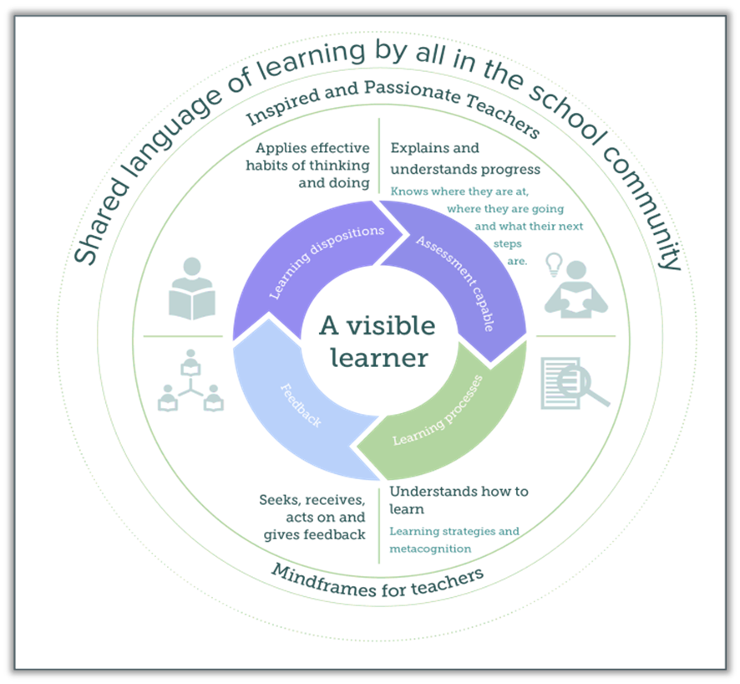
Parent and Carer
Information Booklet

What is Visible Learning?
Visible Learning is an approach to learning & teaching based upon a large amount of evidence from Australian researcher John Hattie. He has collated and ranked the factors which impact positively on teaching & learning, which in turn raise attainment. Here are some of the key ideas from the Visible Learning research:
- The whole school community should have a shared language of learning.
- Learners should be at the centre of a Visible Learning approach surrounded by inspired & passionate teachers.
- When learning is made ‘visible’ (teachers know what they are teaching and learners know what they are learning), achievement increases.
- A visible learning approach supports pupils to become assessment capable learners who know where they are in their learning, where they are going next and how they are going to get there.
- Effective feedback is crucial – it should be personal for each child and ‘just in time’.
- The greatest effects on learning come when pupils are their own teachers and when teachers are learners.

We have identified ten learning dispositions to help support the children on their Visible Learner journey, one of which we introduce to the children every half term.
I know what I need to learn.
I talk about my learning with others (peers, adults).
I know my next steps on the learning journey.
I work hard and I know mistakes are ok.
I set my own goals.
I am curious and ask questions to find answers.
I am willing to take a risk to try out new things.
I can work with others to generate new ideas.
I keep trying until I am proud of my work.
I know what to do when I am stuck.

How can I support my child at home?
To support our work in school on developing a language of learning, we would encourage you to discuss learning at home too. Here are some ideas of questions you might like to use at home:

- Tell me about something you learned or something you did.
- Was there anything you found really tricky? What strategies did you use to help you in your learning?
- Tell me one thing you learned at school today and I’ll tell you one thing I learned today.
- What are you looking forward to at school tomorrow?
- Did you make any mistakes at school today? Tell me what you learned from them.
- What challenged you most today?
- What was the nicest thing you did for someone else today?

